Meeting Religious Leaders with the President Magufuli at the State House which have been held in 23/01/2019
Religious leaders and various denominations in Tanzania have asked the country's president John Pombe Magufuli to allow democracy and freedom of speech be given it is chance
Pastor of the Evangelical Lutheran Church of Tanzania (ELCT) has asked President Magufuli to give the people freedom to speak as far as possible because that is Democracy.
Speaking at a conference organized by President Magufuli to meet and hold talks with religious leaders at the White House in Dar es Salaam,
The pastor said: "Many Tanzanians are afraid, many are not dare to talk, they are afraid; I ask the President if the Father is likely to give up breathing but they will not win
At a conference that included religious leaders and denominations in various Islamic and Christian sects
Vice Chairman of the Association of Tanzania member of the Bohora, Zainuddin Adamjee urged the government to ban the games Gambling.
In the Bible and the Quran written gambling is illegal, but here Tanzani now teenagers gambled through networks. It's a powerful force of our work that gambling, it is problem, "said Zainuddin Adamjee.

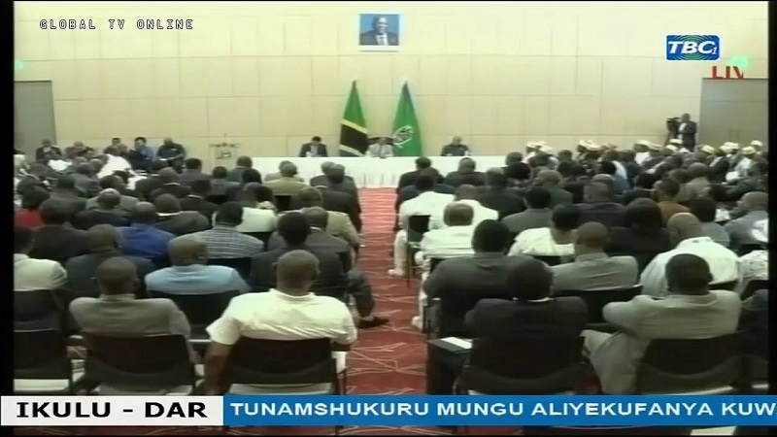

Addressing the meeting, President Magufuli said, he has not stopped political meetings or democracy, but politicians are required to follow procedures to avoid the disadvantage of peace, Political meetings have not been banned.
Despite commendable various stages of development taken by his government, including the cultivation of economic infrastructure and fight corruption
The President of Tanzania is accused of being disregarded by democracy and running a campaign to kill the opposition parties in the country.

