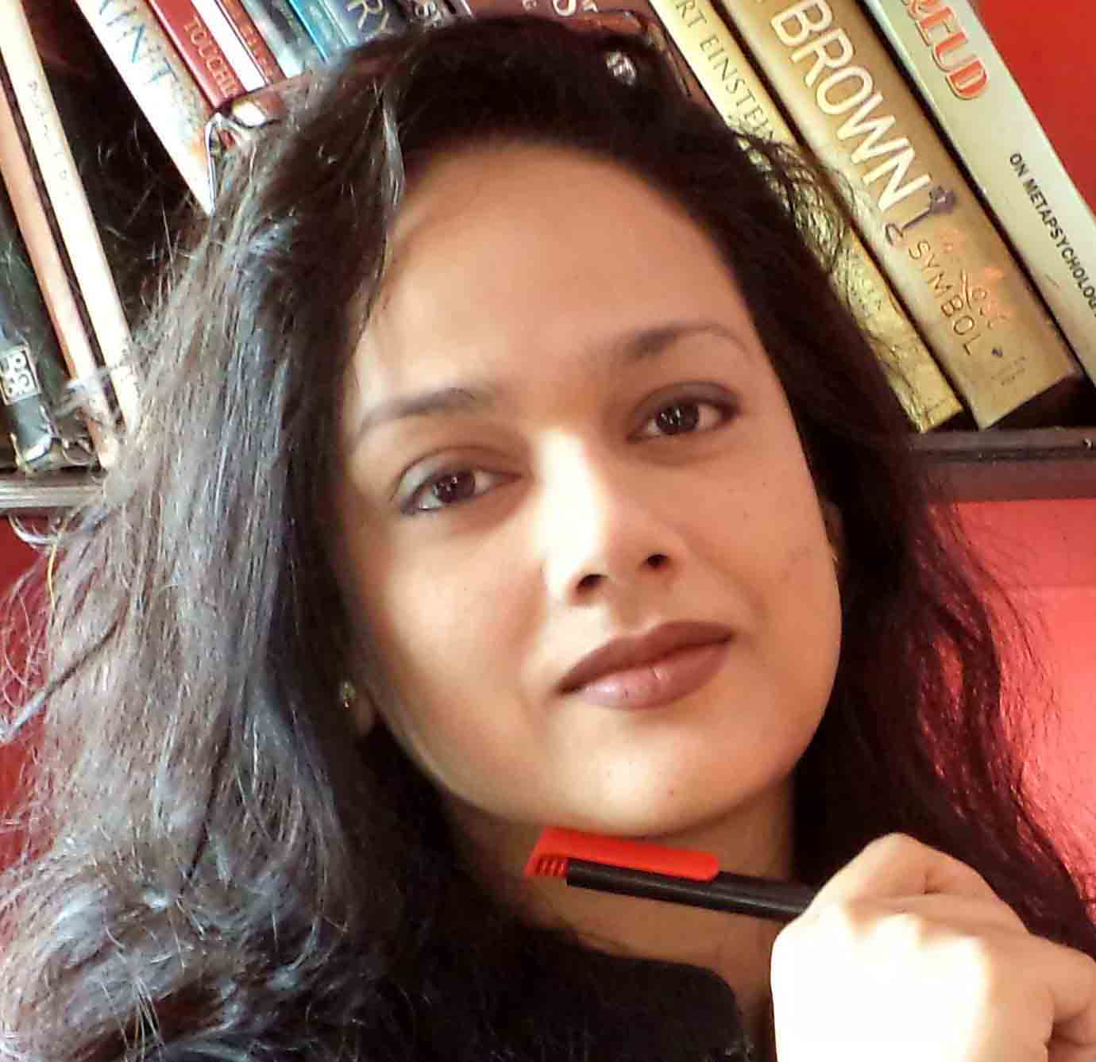 PIU SARKAR

Born: 1976, Kolkata, India

Artist Introduction:

Piu Sarkar’s experiments are meaningful. Here is work that does not serve solely as a mean of expressing the painter’s admiration of nature. Instead, she feels strongly that painting has a task of its own to accomplish in the service of imaginative life. She has developed a style which is in keeping with the thirst of mankind’s innermost needs. Here, there is a greater and starker simplicity, which is expressive natural seeming and free from ornamental impedimenta of any kind. In this way the socio-cultural and cosmic function of the painting is extended. Instead of relying on the fortuitous, the painting is given content by artistic values belonging to all times. Well, it is in some such way a good artist’s work.

Keshav Malik.

Has held several solo exhibitions and participated in many group exhibitions with galleries in U.A.E., Singapore. In India has participated in "Harmony Art Show" by Reliance Group, Drawing and Painting for AIFACS, Lalit Kala Academy etc. Paintings are in collection with many national houses e.g. Onida, R.P.G, Hyatt regency etc. and also in collection of Sushmita Sen, Russi Mody and many national/international art patrons. Last solo exhibition “Unconsciously conscious” was in Hirji Jehangir Gallery.

PIU SARKAR, a Kolkata based artist has fast captured Mumbai through her three solo exhibitions and numerous group exhibitions truly deserves to be called a thinking artist. Proof evident in her latest series of paintings called Matters of mind. Through her paintings Piu Sarkar questions whether dreams lead us or we lead ourselves to our dreams. –BOMBAY TIMES.TIMES OF INDIA.2008.

Popular Kolkata based painter Piu Sarkar shows us how Albert Einstein would have painted had he been an artist-DNA.MUMBAI.2010.

The depth and intensity of her strokes belie her age. Her creations on “Stree shakti” are a story of her journey as women –AFTERNOON.MUMBAI.2007.

Award:
The 10th GR8! Women Awards 2011 Instituted by the GR8! TV Magazine, an initiative of The Indian Television Academy in the category of “Fine Arts”.

Participation:

- Duo exhibition at Welcome Art Gallery at ITC Sonar Hotel organized by Spandan Gallery, Kolkata, 2015.
- Solo exhibition named “Real birds” organized by Gallery Art & Soul, Mumbai, 2014.
- Group exhibition named “Zen moments” in Delhi International Airport Pvt. Ltd organized by Gallerie Nvya, 2014.
- Solo exhibition named “Real birds” organized by Gallery Gold, Kolkata, 2014.
- Group exhibition at Prince of Wales Museum organized by Artland Gallery, Mumbai, 2014.
- Group exhibition at Sridharani Gallery, Delhi, 2013.
- Group exhibition at Prince of Wales Museum, Mumbai, 2012.
- Solo exhibition named “Unconsciously conscious” at Jehangir Art Gallery,”Hirji Gallery”, 2012.
- Group exhibition at Museum Gallery, Mumbai, 2010-2011.
- Group exhibition at Museum Gallery, Mumbai, 2009-2010.
- Group exhibition named “Curtain Raiser” at Jehangir Art Gallery, 2008.
- Solo exhibition named “Matters of Mind” at Museum Gallery, Mumbai, 2008.
- Group exhibition at Jehangir Art Gallery, Mumbai, 2007.
- Solo exhibition named “Women power” at Museum Gallery, Mumbai, 2007.
- Group exhibition by Concern India at Artiste Centre, Mumbai, 2007.
- Group exhibition by Art Mosaic Gallery named “SARASWATI”, Singapore, 2007.
- Group exhibition by Art Mosaic Gallery named “FUSION”, Singapore, 2007.
- Group exhibition by Academy Of Fine Arts, Kolkata, 2007.
- Group exhibition named "COLORS" at Prince of Wales Museum, Mumbai, 2006.
- Solo exhibition named "Rebirth of Kali", Art Land Gallery, Mumbai, 2006.
- Group exhibition named "Harmony Art Show" by Reliance Group, Mumbai, 2006.
- Group exhibition by TRYO for Delhi Tourism, 2006.
- Group exhibition of Drawing and Painting for AIFACS, Delhi, 2006.
- Solo exhibition named “The third eye” based on the poetries of author Sunil Ganguly at Hyatt Regency hotel, Kolkata, 2006.
- Group exhibition named "Forms and Figures" by Kanishka Art Gallery, Kolkata 2006.
- Group exhibition at Lalit Kala Academy, New Delhi, 2005.
- Solo exhibition named ‘In Search of Reality and Red’ at Chitrakoot Art Gallery, Kolkata, 2005.
- Group exhibition at Birla Academy, Kolkata, 2001.

