UNION TANGANYIKA -ZANZIBAR 1964:
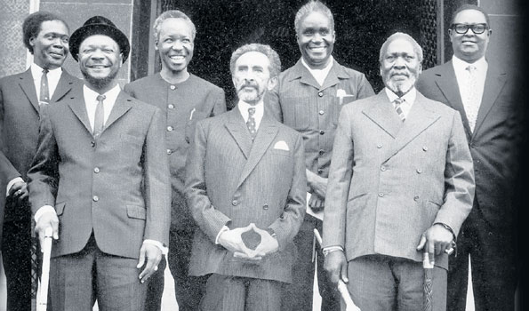

When African leaders have finished their session in Addis Ababa, Ethiopia to call for collaboration to eradicate colonialism and perhaps create one Africa, the environment was not as they expected. In Tanganyika and Zanzibar, the first quarter of 1964 had more political events than at any time. Despite the Addis declaration, Mwalimu Julius Nyerere started with the movement of East Africa to be federation from the end of March to April 1964. But until that time it seems he had no idea of joining Tanganyika and Zanzibar
55 years ago Tanganyika joined Zanzibar and became one country known as Tanzania. There have been many questions about the source of the union and the emergence of the idea. How did Mwalimu Julius Nyerere get the idea of connecting these countries? Why should Tanganyika and Zanzibar be merged?
How would these countries be if they were not united? How is the history of the Union of Tanganyika and Zanzibar? Researchers, analysts and writers have written about the complexity of the emergence of the union. Our correspondent William Shao analyzes different information about the source of the union. Join him in a series of articles about the Union that begins with how the first African leaders saw this exposure to this one voice.
On the night of January 12, 1964 which was on Sunday, a revolution led to the abolition of the Sultan regime in Zanzibar. The coup is part of a series of events that led to the revolt in Tanganyika that took place just a week later — on Sunday, January 19, 1964 — and about 100 days later in Tanganyika and Zanzibar to unite and be Tanzania.
Based on what happened in Zanzibar on January 12, 1964, combined with what happened in Tanganyika on January 19, with the impact on both countries of Tanganyika and Zanzibar, the ideas of the Union of these countries were born in the same period of the first quarter of 1964.
The African Union (OAU), now called AU, was established on May 25, 1963, if it was 11 months before the Union.
At the OAU conference held in Addis Ababa Africa in Ethiopia, Tanganyika president, Julius Nyerere, said: “In our agreement, even until the end of our African continent, we have all agreed in a single statement when using the words it's gone. This is a practical time.
When looking at our brothers the fight has passed, the time has come from now and on to the African Union to help our struggling brothers be free.”

Perhaps in that spirit, Nyerere helped many parties and groups of the liberation of southern Africa, as Frelimo of Mozambique and South Africa's ANC.
During the meeting, the leaders sought to African countries come together to be one country.
On the second day of the conference, Ethiopian leader, Haile Selassie (71), explained the importance of having one voice.
Despite all our efforts of the past years, we had completely missed it the power to enable us to talk to our own sounds all we want to say or make a decision because we need to decide our affairs.

"But today we find the tool will enable us to speak with our own voices all we want to say and make our decision whenever we want to do. I hope this tool will be a true administrator for our hopes and problems.
After Selassie talk, followed Kwame Nkrumah, president of Ghana.
“OAU is the highest organ of any country. It is a tool that can be found in a political way. He should be kept, ”said Nkrumah.
Political and social development in Africa will be available through this tool. There is no other way that will enable Africa to get these things. As we leave here (Addis Ababa) we return to the African people and something to tell them. The promises we give today, to liberate the African continent, be sure to be fulfilled.

So let us now be proud that we do not return to our people with empty hands, but we return to the African Independent Declaration, and we hope that the African Union will last forever, and this is the beginning of the continent of the continent of Africa as one.

Nigeria's Prime Minister, Abubakar Tafawa Balewa spoke about the importance of the areas of agreement. “Nigeria's position is that, if we want this African Union to stay, we must agree on the basic issues,” he said

Firstly, African states must respect each other and agree that the oppression of one African nation is equal to the oppression of all African nations. No matter how small the nation is, it all has its own dollar

Algerian leader, Ben Bella, also made a contribution to the importance of practicing what they agree
We should not let the African Union be an empty word. We will have lost our time and the hopes of our people if we are determined today are empty words, ”he said.

"Then Nyerere stood and add weight in the argument.
“In our agreement, even until the end of our African continent, we have all agreed with one statement that when using empty words has passed. This is a time of action, ”he said.

“When you look at our brothers fighting you are gone. The time has come from now on and on to the African Union to help our struggling brothers become free.

Although Kwame Nkrumah very stressed connectivity to all African countries to be one country, until he was toppled in 1966 was not linked to a single country. On Tuesday, February 21, 1966, Nkrumah went to Hanoi through India, Pakistan and Burma, but behind his government was overturned. 11 months after the establishment of OAU, Tanganyika joined Zanzibar. It is true that African leaders who met in Addis Ababa wanted African countries to unite, so that Africa would be one country, but did that unification be the result of those questions?

