【Artist Information for Publicity】

We are collecting information for press release, marketing and publicity of the exhibition Word Art Tokyo 2020 - Flip Over, See the Rust. It will be mainly used for our website (https://artfairtokyo.com) as well as document and report. Please kindly fill in the fields in the following page and send the completed form to us with your profile photo (headshot) and artwork photo that can be featured for publicity. For your information, you can look at the artist page of the previous year. The design might be renewed for 2020 exhibition but the format is likely to resemble.

Also, we might copyedit your profile to maintain the consistency of format with other participating artists, but all the materials will be checked by the artist before it is publicised. Once the material is finalised, we may share the information with a third party organisation for PR on website or print media without prior consultation with the artist.

https://art-tokyo.jp/wat/2019/en/messages/cd/
https://art-tokyo.jp/wat/2019/artists/

<Example of Artist Profile in 2019>

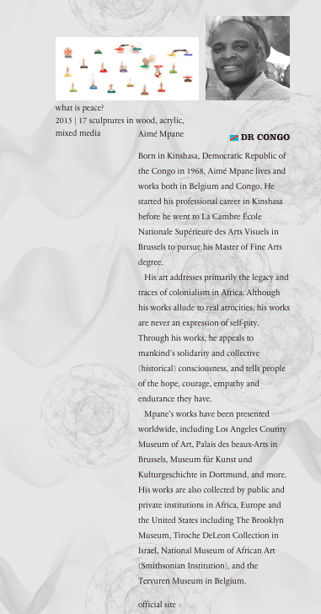

Artist Name
Date of Birth
Place of Birth
Residence
Website link
Profile  Description  (up to 150 words) | *Please write your profile in the third person and start like:  Born in ---------------  Graduated in ----  Please note that This profile will appear on our website

Portrait Photo Credit
©：©

<Artwork Information>
* This information will appear on our website. The artwork could be different from the exhibiting works.

Title
Year
Medium
※Please choose from below
Size

Medium :
collage, crayon, drawing, etching, installation, lithography, mixed media, oil paint, painting, pencil,
performance, photography, printmaking, sculpture, sound art, video, watercolor

*Please send us high-res photos (300 dpi) of your profile and artwork.

