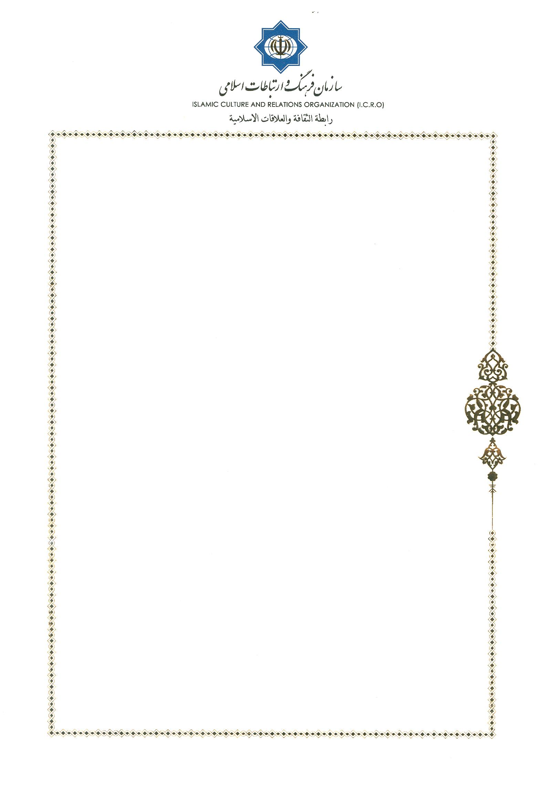

Honorable Dr. Berik Aryn
Commissioner for Promotion of the Goals and Objectives of the Congress

Tehran, Sep.8, 2018
Dear Sir,
With sincere thanks for your invitation to the 17th session of the Secretariat of the Leaders of World and Traditional Religions, it would be my honor to attend this program and be a participant to this positive and blessed step for spreading just peace in the world.
I take this opportunity to express our best complements to you and the brotherly nation of Kazakhstan.

Sincerely Yours


Dr. Mohammad Mahdi Taskhiri

Director General,
Center for Interreligious and Intercultural Dialogue
Office Phone: 0098 21 88153306 Website: http://en.cid.icro.ir
http://fa.cid.icro.ir

