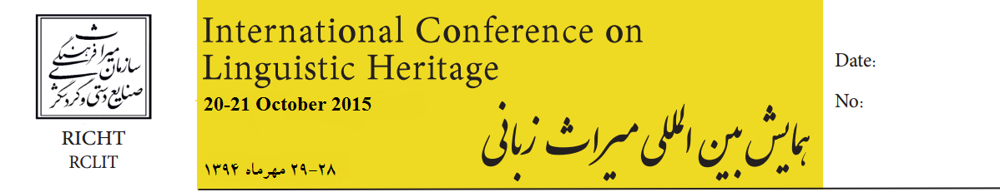
Abstract Submission Deadline: 6 July 2015
Full paper submission Deadline: 23 August 2015

Address:
Imam Khomeini Ave,
30 Tir St.
Opposite of the National
Museum of Iran,
The Research Center for
Linguistics, Inscriptions
And Texts
Tehran, Iran

Tel:
+982166736587-8
+989121968546
rclit.iran@gmail.com
www.richt.ir

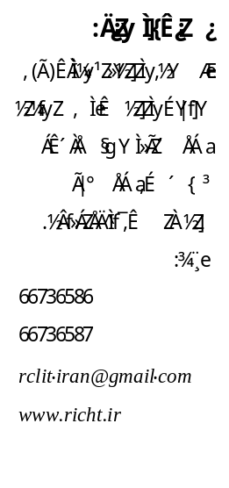

Conference Topics :
- Linguistic researches including dialectology, linguistic diversity, linguistic typology, socio- linguistics
- Epigraphy including ancient and Islamic period inscriptions
- Modern researches in the fields of Iranian old languages, (old Persian, Avestan, Scythic and Medean), Middle Persian (Eastern-Western) and Islamic era
- Numismatics of pre-Islamic and Islamic eras
- Written and lingual heritage, means of transferring knowledge, historical cultures and information
- Historical linguistics, historical documents and deeds, diplomatic, historical texts and resources in the field of lingual heritage
Conference Objectives:
- To introduce unique shared elements which exist among scattered lingual communities throughout Iran
- To strengthen Persian language as a factor of national solidarity
- To unite seemingly Iranian diverse cultures through removing apparent factitious borders of validity that have been established through the ages
- To safeguard and protect the precious lingual works of Islamic Iran
Article Guidelines:
- The title should appear on a separate page and should be followed by the author full name(s) and affiliations.
Place an asterisk after the name of the author to whom enquiries
regarding the paper should be directed and include that author’s telephone and fax numbers and e-mail address
- Articles should include an abstract (maximum 300 words), key words (maximum 7 words), introduction, literature review, methodology, data analysis, conclusion and references
- The entire article should be in Times New Roman of font
size 14.; font size for footnote must be 10; the main title of the article must be 16, bold; the author(s) name and subtitles must be 14,bold. Other font types may be used if needed for special purposes.
- use International Phonetic Alphabet (IPA) or American Phonetic Alphabet to indicate pronunciations, if necessary.

