Marat Azilkanov
Commissioner for the Promotion of the Goals of the Leaders of World and Traditional Religions.

Your Excellency,

Assalamu alaykom,
I would like to congratulate you, your family and your esteemed colleagues on the occasion of Eid al Fetr, on behalf of myself and the Centre for Interreligious and Intercultural Dialogue.
The holy month of Ramadan, begins with divine mercy, continues with His blessings and comes to a close with forgiveness for the believers. Eid Al-Fitr is to celebrate the believers’ success in the sincere worship of the Lord; it is a fitting reward for the servant of God who has been successful in “the greatest jihad”, the struggle against one’s own self, the repellence of Satan, the practice of kindness and charity and the fulfilment of faith with righteous deeds.
Eid Al-Fitr, is a valuable asset for all Muslims to become a suitable example for all believers from every ethnicity, religion and sect, by displaying unity and solidarity, considering the interests of the entire human race, declaring their readiness to establish peace and justice across the world and to battle injustice and ignorance wherever it may be, supporting the oppressed and standing against the oppressors.
Once again, I wish you a happy Eid and pray to the Almighty to free the world from the deadly calamity of Covid-19 and to cast security and health upon people’s lives.
I once again hope for your success and health.

Sincerely yours,

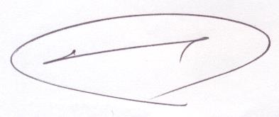
Mohammad Mehdi Taskhiri (PhD)

Head of the Center for Interreligious and Intercultural Dialogue

