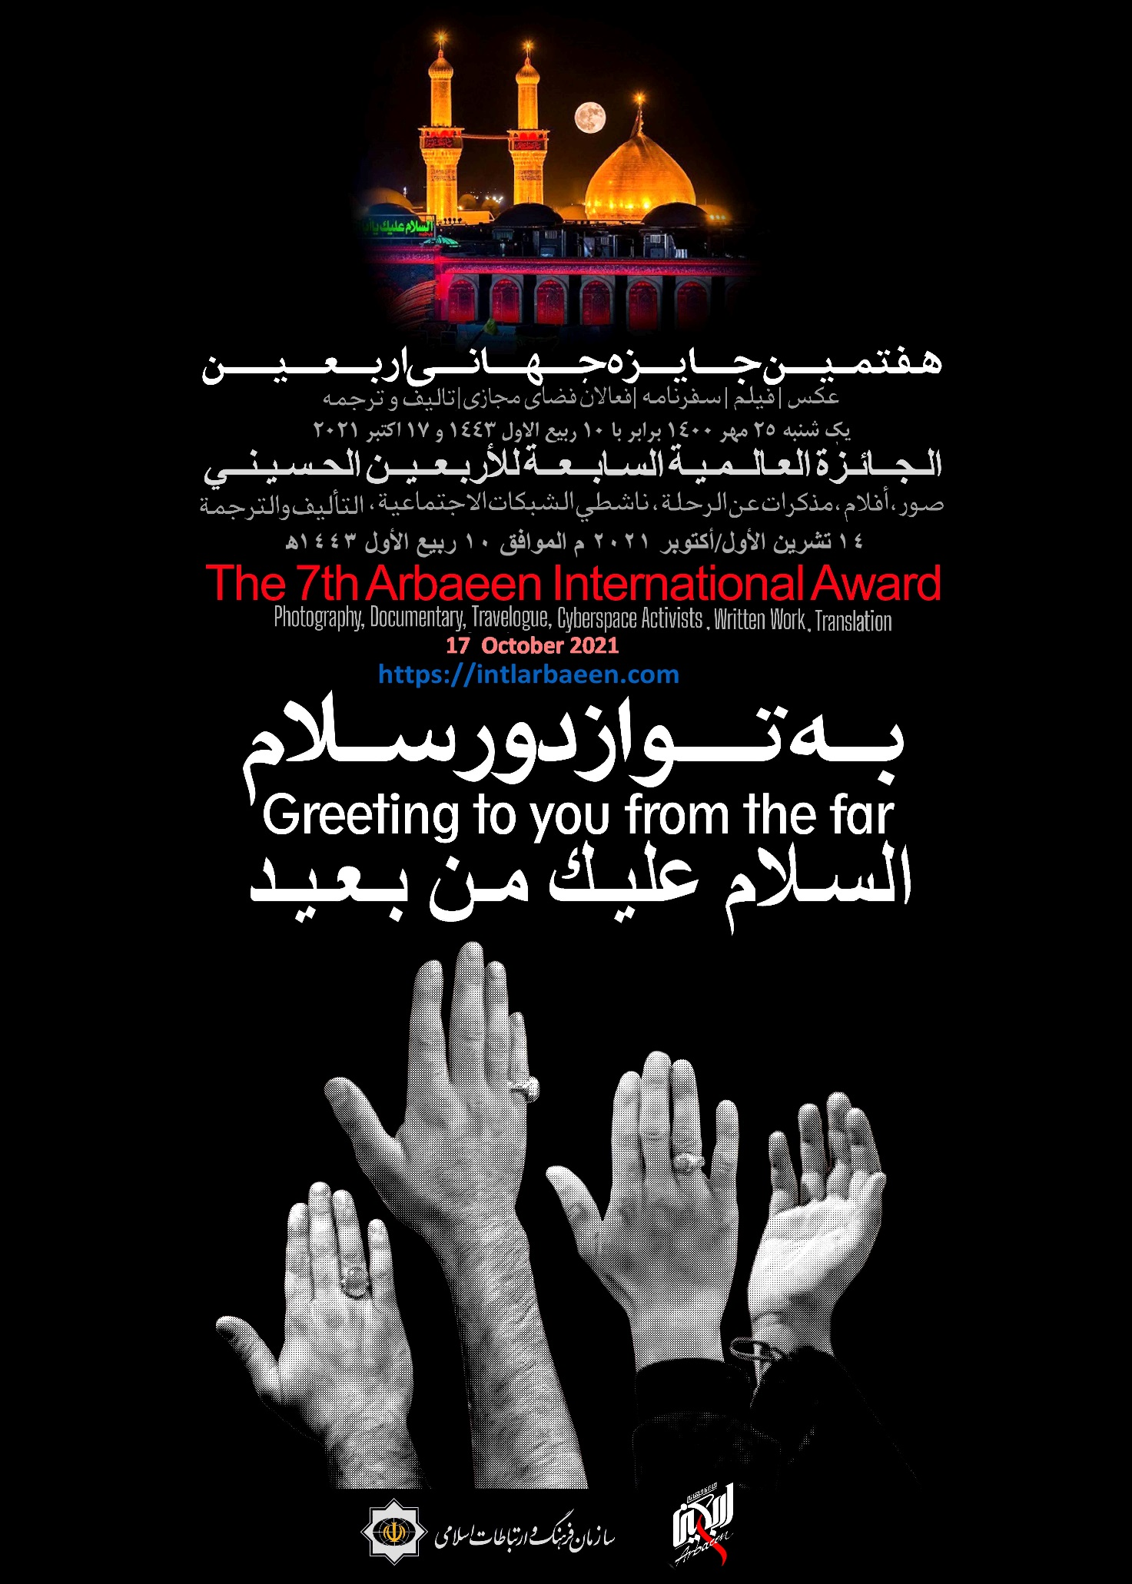
In the name of God, the Most Beneficent, the Most Merciful
The Seventh Arbaeen International Award
Photography, Documentary, Travelogue, Cyberspace Activity, Written Work, Translation
Keeping in view the unique and valuable spiritual dimensions of the Arbaeen of Imam Hussein ibn Ali (as), which inspires millions of his devotees from all over the world to participate in a rally on this day, in the year 2014 the Islamic Culture and Relations Organization (ICRO) decided to hold a transnational competition with the aim of introducing the manifestations of this great international cultural and religious event to the world. Following this decision, the secretariat of the Arbaeen International Award was established in the ICRO and the first round of this award was held with the theme of photography.
Since the idea was welcomed by the followers and devotees of Imam Hussein (as), such themes as film, travelogue, book, and cyberspace activities were also added in the following rounds in order to expand the dimensions of the Award.
With the grace of God Almighty and the blessings of Imam Hussein (as), the secretariat of the “Seventh Arbaeen International Award” officially began its activities on Monday, December 28, 2020; coinciding with the closing program of the Sixth Arbaeen International Award.
Those interested to participate in the Seventh round of this Award can send their works to the secretariat through the official website of the Award intlarbaeen.com or its official social pages. The deadline for submitting works has been extended to October 2, 2021, and the Closing Program of the Seventh Arbaeen International Award will be held on October 17, 2021.
Due to the outbreak of the Corona pandemic, the Closing Program will be held with the participation of a limited number of people at the Imam Khomeini Cultural Complex, which can be reached online through the official website and the Instagram of the Arbaeen International Award.
- Photography Section
Single photographs and Albums
Regulations:
- Participation in this competition is open to all.
- Simultaneous participation in in all three sections of photography, documentary videos and travelogue is permissible; subject to following the related regulations.
- Each photographer can only send five single photographs and/or an album of photos (3 to 5 photos).
- All photographs must be in JPEG format at the maximum resolution of 300 dpi - the small wing being 40 cm - and sent through one of the undermentioned communication ports available at the end of this form.
- Photos that are less than 20 MB in size must be uploaded upon registration.
- As regards the photos the size of which are 20 MB, the participants should save them on a CD and mail them to the secretariat, after completing the registration formalities. Please note that the name of the photographer and the name of the work/s should be mentioned on the CD.

- Photos must have been taken during the last two Arbaeen pilgrimages.
- Participants are required to send their complete information with each photograph: including name and last name, age, educational qualification, exact address, and phone and mobile numbers as well as the title, location and date of each photo.
- Photos sent must be original in their format and should not have been manipulation with any computer software.
- Photos sent must not carry any signature, date, Passe-Partout, frames, watermarks and logos.
- The secretariat just recognizes the person who sends the photograph as the owner of the work and if the opposite is proved, the sent photo/s will be removed from the contest and all privileges attached to it will be nullified.
- The sent photos will not be returned.
- If the sent files are incomplete, they will be exhibited.
- All printing and publishing rights including digital or standard and the right for holding domestic and international exhibition with the received works are preserved for the organizer.
- The works received after the due date will not be included in the contest.
- Sending works to the secretariat means acceptance of conditions on the part of the participant.
- Those photographers whose works will find their way to the exhibition will receive a certificate of participation
- The final decision on any point that is not provided in the present regulations and also the interpretation of the ambiguities lies within the Secretariat of the Award and participants and judges are deprived of any rights in this regard.
- Documentary Section
Short storyboard and documentary (created with mobile phones or cameras (
Regulations:
- Participation in this competition is open to all.
- There is no limit to number of the works to be sent for the contest.
- Simultaneous participation in in all three sections of photography, documentary videos and travelogue is permissible; subject to following the related regulations.
- Maximum length of short story films and documentaries is 30 min.
- The participants should copy the short story film or documentary intended for the contest on a DVD and mail them to the secretariat, after completing the registration formalities. Please note that the name of the film or documentary, director, and the time of work should be mentioned on the DVD. Besides the movie, the DVD needs to include three photos of the movie’s scene and a portrait of the director.

- The secretariat accepts no responsibility for any possible damages caused by mailing.
- Videos with incomplete documents or damaged content will be removed from the competition.
- After announcement of names of final candidates, the original copy of the work should be submitted to the secretariat; otherwise, it will be removed from the competition section.
- The works intended for the contest should be in one of following formats: DVCAM, HD, HDV, and FULL HD.
- The secretariat of the Arbaeen International Awards and the Islamic Culture and Relations Organization preserve the right to use the sent works for producing advertisement and TV works.
- Sending works to the secretariat means acceptance of conditions on the part of the participant.
- The works with real or legal producers, need to submit a letter of approval letter signed by the producer for participating in the competition. The mentioned letter must be sent to the secretariat of the Arbaeen International Award through one of the specified communication ports ASAP; otherwise, the related work will be removed from the competition.
- The final decision on any point that is not provided in the present regulations and also the interpretation of the ambiguities lies within the Secretariat of the Award and participants and judges are deprived of any rights in this regard.
- Travelogue Section
Those interested to participate in this section of the Arbaeen International Award can send their works related to the great procession on the Arbaeen of Imam Hussein (as), description of Arbaeen rituals among different nations, the impact of participating in Arbaeen procession on personal life, personal perception about the great Arbaeen procession, etc.
Regulations:
- Participation in this section is open to all.
- Each participant is allowed to send only a travelogue.
- Simultaneous participation in in all three sections of photography, documentary videos and travelogue is permissible; subject to following the related regulations.
- Travelogues need to be written in one of these languages: Arabic, English, Urdu, Turkish, Azerbaijani, Russian, Croatian, Serbian, Bosnian, French, German, Italian or Spanish.
- Each work should not be less than 20 lines and more than 10 pages (according to the Award’s standard format which is available on ( www.intlarbaeen.com ).
- Works sent to the Arbaeen International Award should not have already been sent to other competitions and awards.
- The theme of the sent works needs to be related to the different sections of the Award. The decision on this issue lies with juries of the Award.
- The sent works need to be compatible with the specified standard format. A sample file with the standard format is available in the rules section of the portal. The works created without this format will not be considered for the Award.
- Using colloquial language, except in the case of direct quotes and conversations between people, is not allowed.
- Travelogues need to be real and the outcome of personal observations.
- Attachment of related evidences including references and images related to the subject of travelogue will be a plus point during the evaluation process.
The writer is obliged to fill all necessary fields related to registration and send his work through the official portal of the Arbaeen International Award.
The selected works will be printed in the form of a book and the secretariat of Arbaeen International Award preserves all the rights in this regard. The names of the writers will be mentioned at the beginning of the respected travelogues.
- The final decision on any point that is not provided in the present regulations and also the interpretation of the ambiguities lies within the Secretariat of the Award and participants and judges are deprived of any rights in this regard.
- Cyberspace Activity Section
Keeping in view the capacities of social networks to achieve the goals of the Award, participation in the section on “Cyberspace Activities” is on the basis of the following conditions.
- Participation in this part of the Award is open to all. (There is no restriction on the nationality of the participants.)
- Simultaneous participation in different sections of the Award is permissible; subject to following the related regulations.
- The works intended for participation in the contest should be in Facebook and Instagram.
- No language restrictions are considered and in addition to Arabic, English, and Persian, books can be submitted in other languages such as Spanish, French, German and Turkish, etc.
- The content framework of the works submitted includes movies, posters, photos and other types of visual and multimedia contents.
How the selected pages are evaluated and judged?
Pages will be evaluated on the basis of their content alignment (the necessary condition to enter the contest), number of followers (coefficient 5), ratio of their posts on Ashura and Imam Hussei (as) to total posts (coefficient 1), the number of positive responses shown (coefficient 4), the number of comments (coefficient 4), the quality of the posted content (coefficient 3), and the number and variety of the posted contents (coefficient 2). From among the selected ones, the three people with the highest score in will be declared as the winners and will be accordingly awarded.
Regulations
• The selected pages should have published the relevant posts publicly.
• The owners of the pages do not have the right to use such contents the intellectual property rights of which belong to others, unless they have complied with the laws of Facebook and Instagram with regard to copyright.
• The posts must be published with a real account. (The account must contain a photograph of the creator and operator of the page).
• Pages must have at least 20 posts and 500 followers. In addition, posts related to the Arbaeen International Award must have received a minimum of 50 responses (positive or negative) to enter the competition. (The searcher will consider this point.)
• Not more than one year should have passed since the last relevant posts.
• Participation in the contest denotes the acceptance of the above regulations.
• The final decision on any point that is not provided in the present regulations and also the interpretation of the ambiguities lies within the Secretariat of the Award and participants and judges are deprived of any rights in this regard.
- Books Section
The Arbaeen World Award is held, every year, with the aim of identifying and introducing valuable books on Imam Hussein’s movement and supporting and encouraging authors, translators, editors, and publishers from different countries as well as spreading the lofty cultural values that Imam Hussein (as) stood for.
Those interested to participate in the book section of the Arbaeen International Award can submit their works on the theme of Arbaeen (Generalities, History, Rijal - authentic narrators of hadiths -, Ethics, Quranic sciences, Hadith, Translation of Islamic Texts, Islamic Culture and Civilization, Islamic Art and Architecture, Contemporary Islamic Studies, and Literature: including poetry, short and long stories, novels for adult and children, documentaries, etc.) to the secretariat on or before the specified date.
Regulations
- Participation in the competition and submission of works is open to all.
- Only books that have been translated and published, for the first time, in the last two years will be included and judged in this award.
- The publisher of the book should complete the registration form provided on the website of the Award and send it to the secretariat along with two copies of the book. Received works will not be returned.
Important Notes
The submitted books should have the following features:
- There should be cohesion between the volume and contents of the book,
- The book should have a proper table of contents
- The chapters of the book should follow a reasonable sequence
- The book should be properly edited and have no printing errors
- In the case of translated books, the translations should be of internationally accepted standard
- Simultaneous participation in different sections of the Award is permissible; subject to following the related regulations.
- No language restrictions are considered and in addition to Arabic, English, and Persian, books can be submitted in other languages such as Spanish, French, German and Turkish, etc.
- The subject of the submitted works must be related to the sections of the competition. The final decision will be made by the judges of the Arbaeen International Award.
- The final decision on any point that is not provided in the present regulations and also the interpretation of the ambiguities lies within the Secretariat of the Award and participants and judges are deprived of any rights in this regard.

