INSPIRED FAITH ACTION AND THE CULTURE OF UN COP26:

REFLECTIONS BY BISHOP PHILIP HUGGINS FOR THE ILC WEBINAR, 27 SEPTEMBER 2021.

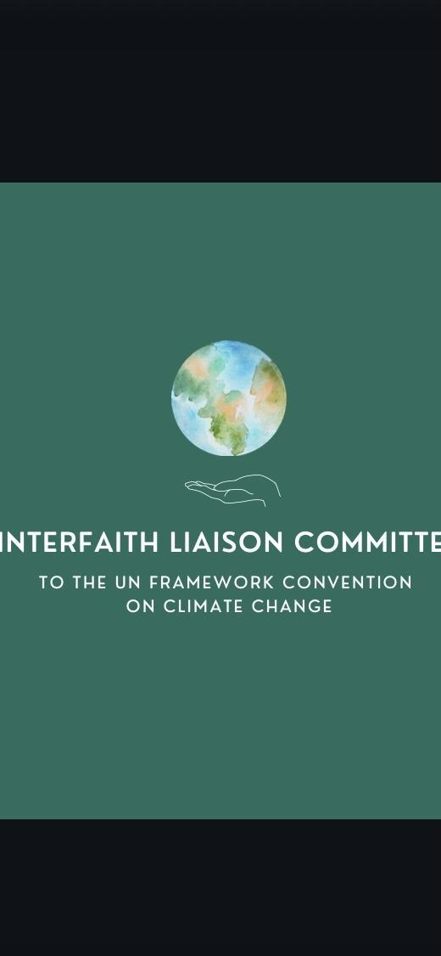

INSPIRED FAITH ACTION CAN TRANSFORM CULTURES!

- Inspired faith action can ensure cultures are healthier in terms of inclusion ; participation ; respectful listening; transparency of information and process; warmth of relationships ; a generous spirit open to learning from others ; reconciled in our diversity and able to take delight in the gift of one another ; grateful for the opportunity to be of service ,each new day dawning.

Inspired faith action is understood to have helped accomplish the Paris Agreement.

Inspired faith action now will help with the successful implementation of the Paris Agreement at UNCOP26!

- ”Culture” is shaped by the way people behave with one another. It is relational behaviour over a period of time.

Our advocacy, meditations and prayers are towards a COP culture in which people impacted by negotiations feel included and able to participate; an atmosphere which is neither cold,nor wilfully adversarial and in which unreconciled matters from history are justly healed and do not blow up progress!An atmosphere that is understanding of the weariness felt by leaders, after months and months of crisis management through the pandemic . An atmosphere, also , that is understanding of the pressure on negotiators,diplomats and officials- the people who know just how dangerously fast the climate is changing and how great, therefore , is their responsibility!

- The Paris Agreement ,signed by some 196 countries, is a wonderful achievement but it is complex.

That is why we want to inspire a quality of co- operation that transcends past limitations and finds a way ,at COP26,to achieve what we know is crucial.

- Based on the best available information now , it would be quite miraculous if we could transcend adversarial divisiveness , vested interests and the poor relationships between some nation states to achieve what is needed at COP26!

We are advocating,meditating and praying for the miraculous to happen in Glasgow !

- Love transforms.Love will and can find a way. The love ,that is . which inspires our faith. The love that unites us as one human family with one shared home which is our planet 🌍 .

As a disciple of Jesus my call is to love God and my neighbours . Love of God flows naturally into love for all God’s creation .

I took a song to COP25 in Madrid . It juxtaposed images of the climate crisis , of war and of people displaced as refugees.The young students of our Melbourne Lowther Hall Anglican Grammar School were the inspiration and artists .
Filmmaker Richard Keddie and I just helped their advocacy - the song in their hearts.

Reworked recently for UN Peace Day 2021 and the opening of the UN General Assembly, it may be a helpful meditation as we seek to offer inspiring faith action towards a truly miraculous UNCOP 26!

As our earth spins slowly in the vastness of this amazing universe, we pray for what the world needs now!

https://www.dropbox.com/s/xozgmwmd2l3yagy/What%20The%20World%20Needs%20Now%20Choir.mp4?dl=0

