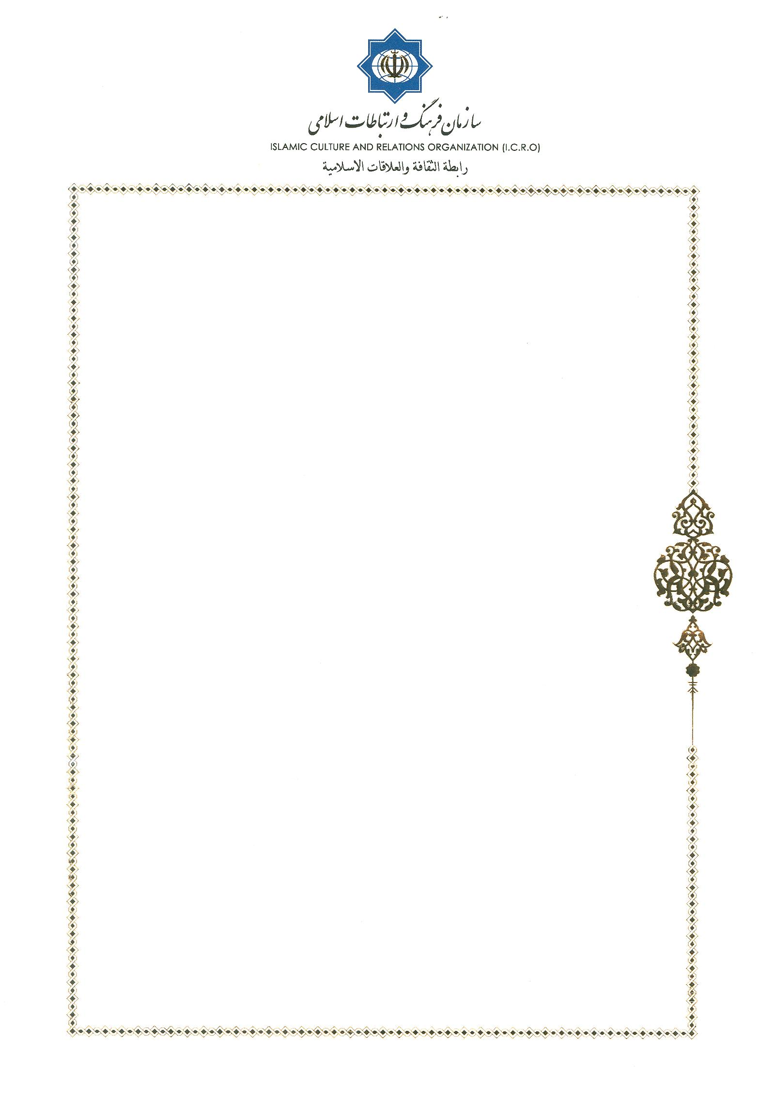
Dr. Erwin Tanner Tizziani
Secretary General of the Swiss Bishops’ Conference (S.C.B)
Secretary, Commission for the Dialogue with Muslim (C.D.M)

Tehran, June 2, 2018
Dr. Erwin Tanner Tizziani
While expressing warmest regards to you and His Excellency, Mgr. Alan de Raemy, President, Commission for the Dialogue with Muslim (C.D.M), and recalling the wonderful memories of being the host to our friends from Swiss Bishops’ Conference during the 5th round of dialogue between the two sides in Tehran, I would like to bring it to your kind attention that as per the understandings reached at the end of the 5th round it was decided that the 6th round of dialogue would be hosted by the Swiss Bishops’ Conference in Switzerland in the year 2019 and the preparatory meeting for this round would be held in the city of Fribourg in 2018 in which I, and in all probability, another member of the Center for Interreligious Dialogue shall participate.
Keeping the above in mind, we would like to propose the following dates for the coming preparatory meeting:
- July 24 and 25, 2018
- September 3 and 4, 2018
Looking forward to a timely response from your end,
Sincerely Yours,
Dr. Mohammad Mahdi Taskhiri
Director General
Center for Interreligious Dialogue

