 | 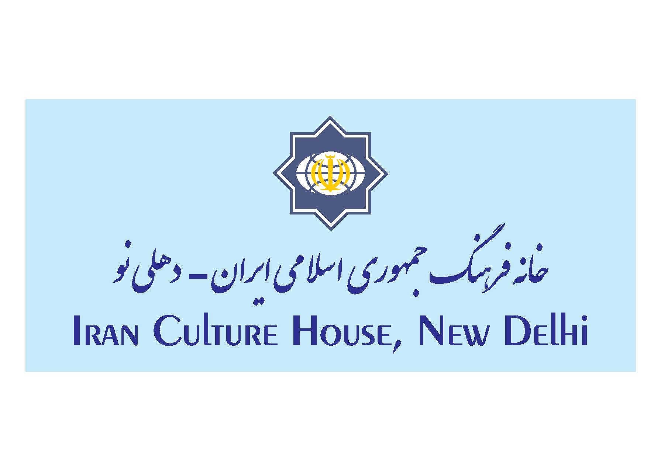 | 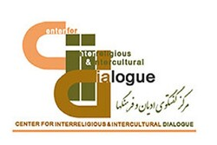 | 

Indo-Iran Interfaith Dialogue-
The Foundations of Interfaith Understanding
Views of Iranian and Indian Thinkers
(3.00 PM to 5.30 PM)
(All respected Speakers are requested to express their valuable Views only in 10 Minutes strictly , due to time-constraint)
 | Conducted by: | Dr Raza Abbas | Manager, MU College, Aligarh, Shia Theology, AMU
3.00 | Tilawat | Qari Majlisi | Department of Shia Theology, MU
3.05 | Welcome Address | Prof Ali Mohammad Naqvi | Director,
3.15 | Inaugural Address | Hojjatul Islam Mohammad Mahdi Taskhiri | Director, of the Center for Interfaith Dialogue Islamic Culture and Communication Organization, Iran
3.25 | Keynote Address | Prof S.R Bhatt | President , Indian Philosophical Congress, Ex-Chairman Indian Council of Philosophical Research (ICPR)
3.35 | SPEECHES OF SCHOLARS & Faith Leaders | His Holiness Swami Shantatmanandji | President, Ramakrishna Mission, Delhi, Eminent Spiritual and Hindu Faith Leader
3.45 | SPEECHES OF SCHOLARS & Faith Leaders | His Holiness Acharya Dr Lokesh Muni | Eminent Jain Faith Leaders, Founder President, Ahimsa Vishva Bharti
3.55 | SPEECHES OF SCHOLARS & Faith Leaders | Archibishop Sebouh Sarkisian | , Bishop of the Armenian Church, Iran, Distinguished Christian Faith Leader
4.05 | SPEECHES OF SCHOLARS & Faith Leaders | Mr Moosa Raza, IAS | Eminent Indian Muslim Intellectual, Chairman, South Indian Educational Trust, Padam Bhushan
4.15 |  | Dr Baqir Talibi Darai | University of Religions and Faiths, Qom
4.25 |  | H.H. Shri Hariprasad Swami ji | President of Sri Vishnu Mohan Foundation, Chennai
4.35 |  | H.H. Haji Syed Salman Chishty | Gaddinashin, Dargahe Ajmer Shareef, Chairman, Chishty Foundation, Ajmer Shareef
4.45 |  | Dr Rasool Rasoolipur | Department of Philosophy , Khwarizmi University
4.55 |  | Prof Akhtarul Wasey | Eminent Musli Personality of India, President, Maulana Azad University, Jodhpur
5.05 |  | Prof Abdur Rahim Kidwai | Director, ,K.A. Nizami Quranic Centre Aligarh Muslim University, and Director UGC Academic Staff College
5.15 |  | Mr S. Tarlochan Singh , IAS | Former Member of Parliament of India and Chairman, of National Minority Commission
5.25 |  | Prof Saud Alam Qasmi | Dean Faculty of Theology, Aligarh Muslim University
5.35 |  | Hujjatul Islam Alizadeh Mousavi | University of Religions and Faiths, Qom
5.45 |  | Dr Abhay Singh | Director, Swami Vivekananda India Culture Centre, Tehran
5.55 | Presidential Remarks | Dr Mohammad Raza Rabbani | Cultural Counselor, Islamic Republic of Iran and Head of Iran Cultural House, New Delhi
 | Thanks | Mr. Najmul Hasan Rizvi | Secretary General MU College, Aligarh and TMT , Luchnow

