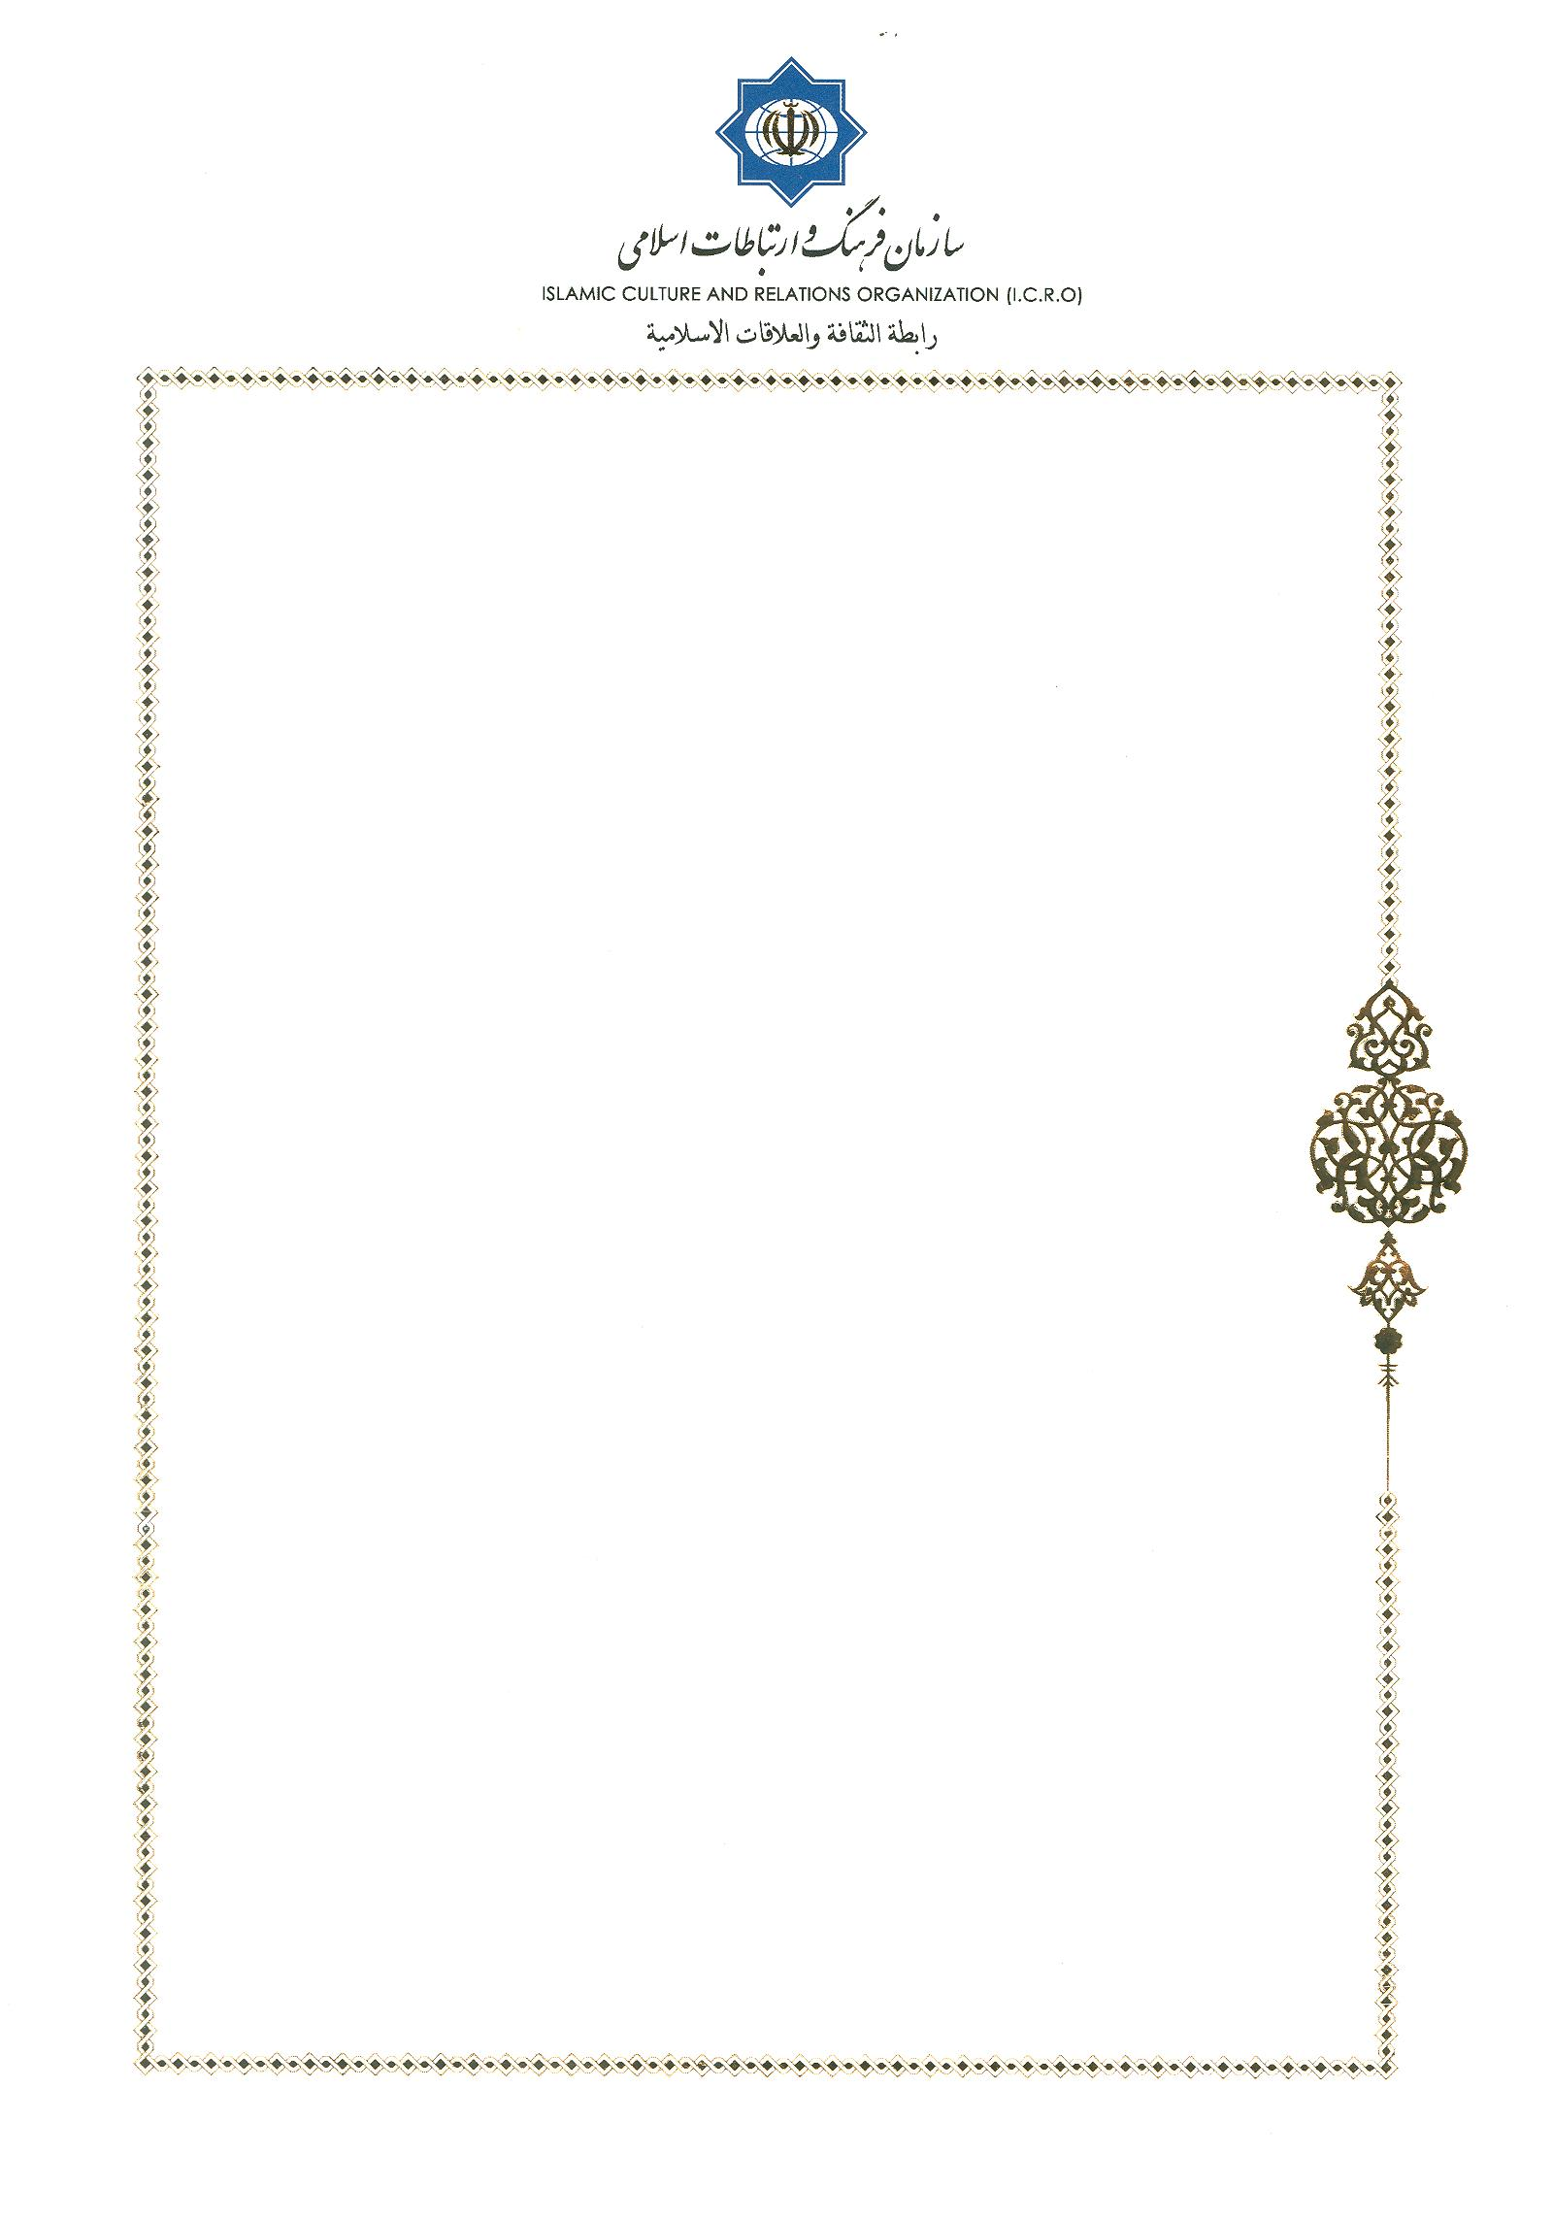
Invitation Letter

No: 64/11627
Tehran, Nov.4, 2019
Sister Nora Ishoui
Charity Sisters, Tehran, Iran

Dear Sister Nora Ishoui
Warmest Greetings!
I am very pleased to invite you for 11th Interfaith Dialogue between Pontifical Council for Interreligious Dialogue (PCID) and Center for Interreligious and Intercultural Dialogue (CIID) on November 11-12, 2019 in Islamic Culture & Relation Organization, Tehran.

I look forward to seeing you soon.
Sincerely yours,


Dr. Mohammad Mahdi Taskhiri

Director General
Center for Interreligious and Intercultural Dialogue

Office Phone: 0098 21 88153690, 91
Email: cid@icro.ir

