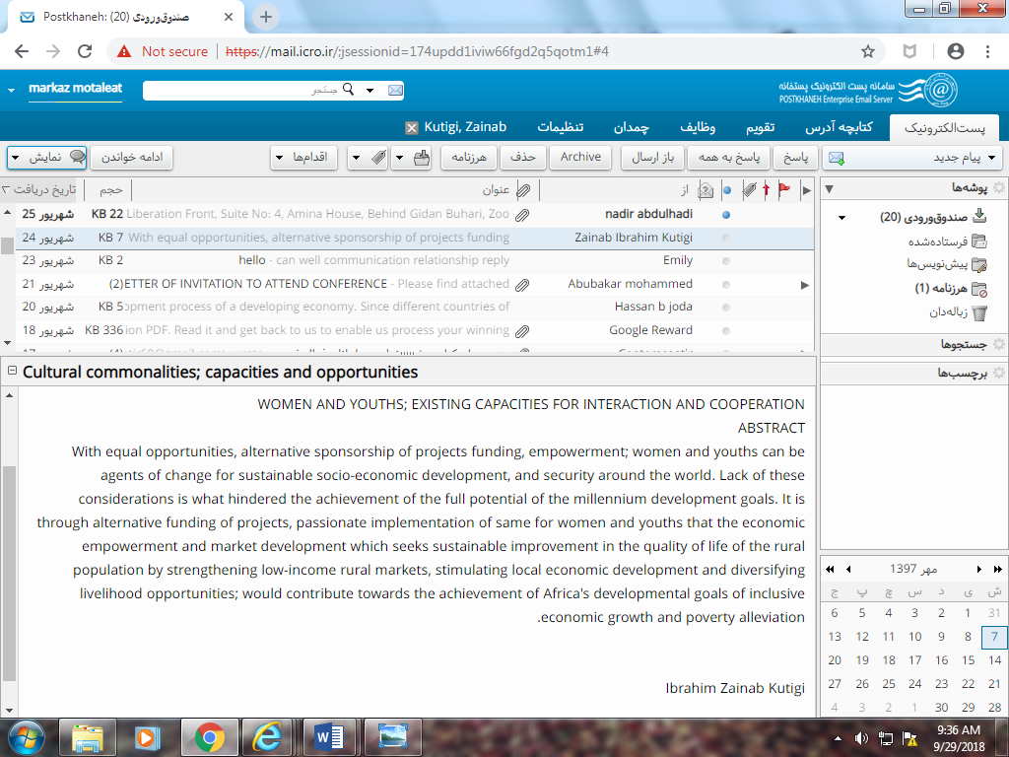
WOMEN AND YOUTHS; EXISTING CAPACITIES FOR INTERACTION AND COOPERATION
ABSTRACT
With equal opportunities, alternative sponsorship of projects funding, empowerment; women and youths can be agents of change for sustainable socio-economic development, and security around the world. Lack of these considerations is what hindered the achievement of the full potential of the millennium development goals. It is through alternative funding of projects, passionate implementation of same for women and youths that the economic empowerment and market development which seeks sustainable improvement in the quality of life of the rural population by strengthening low-income rural markets, stimulating local economic development and diversifying livelihood opportunities; would contribute towards the achievement of Africa's developmental goals of inclusive economic growth and poverty alleviation.
Ibrahim Zainab Kutigi

