President Magufuli urges religious hospital treatment to be cheaper

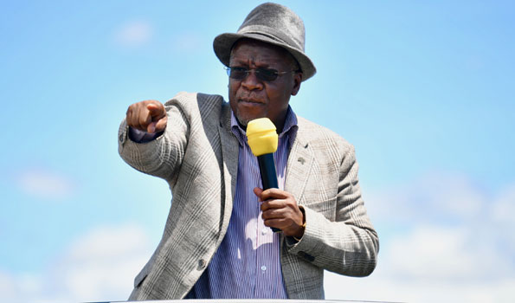

President John Magufuli has called for religious institutions that established hospitals to provide affordable services for citizens so that they can access medical services, exclusivity, religion and ethnicity

He has given the same opinion today Thursday, May 2 when the hospital opened (Union of Christian Revival of Tanzania) in Mbeya city with the capacity to accommodate up to 134 patients per day.

Also, if the patient is not able to afford the treatment that has come to the hospital they should not be dismissed because it is possible the angel has come to test them in service delivery,he said.

President Magufuli has said the government has been trying to contribute to the operation of private hospitals to ensure that the services provided are cost effective and everyone can afford.

"We Tanzanians are not all capable of paying the high cost, there is the contribution of the government, including in the payment of salaries,

Even the sheets that I found even the most possible tools have been provided by the Government so Uwata becomes an administrator in collaboration with the Government so the cost may not be too big and hurt these citizens.

These hospitals are numbered as provide services to the people, that is the place where people rush to get treated and get healing, you stand instead of God, you are standing beside him who had been healed standing and return home without demanding money, "he said.

