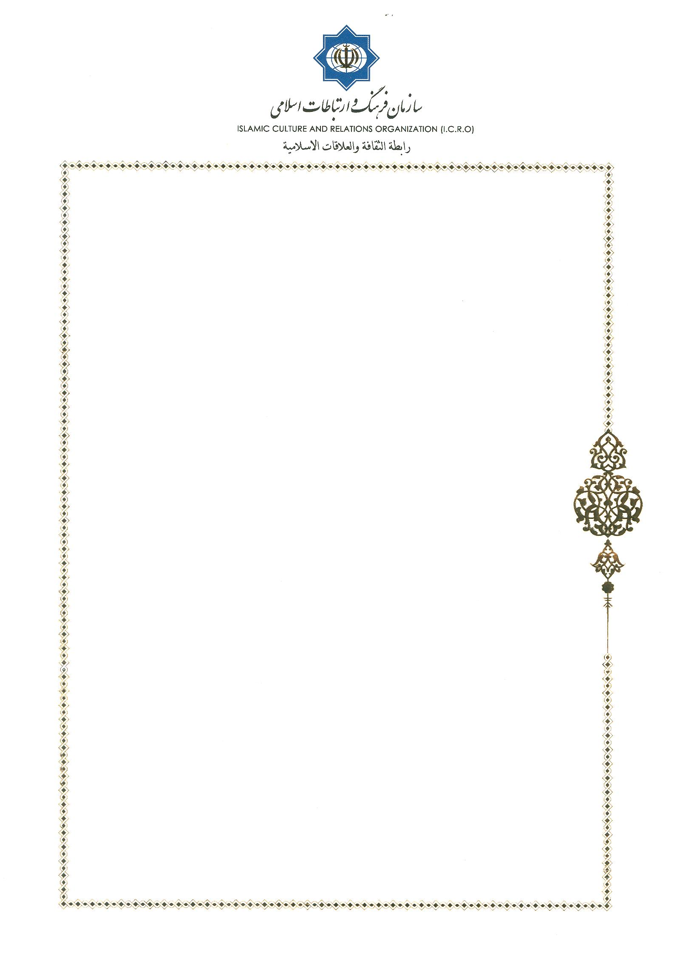
Monsignor Khaled Akasheh
Bureau Chief for Islam
Pontifical Council for Interreligious Dialogue
Vatican City

No: 64/10614
Tehran, Oct9, 2018
Dear Monsignor Khaled Akasheh
I received Your E-mail dated Oct. 1, 2018 .While expressing warmest regards to you and His Excellency, Bishop Miguel Ayuso Guixot, I am pleasure to inform you that the suggested date, Saturday 24 November 2018 is possibility to hold a preparatory meeting for coordination of the 11 rounds of dialogue between Our Center & the Pontifical Council for Interreligious Dialogue of Vatican.
We will be pleased to host Bishop Miguel Ayuso Guixot, the secretary of the Pontifical Council for the Dialogue of the Vatican and you in Tehran
Hope to meet you in Tehran.
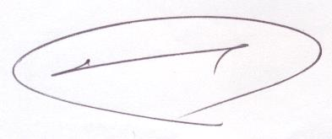
Sincerely Yours,

Dr. Mohammad Mahdi Taskhiri
Director General
Center for Interreligious Dialogue

