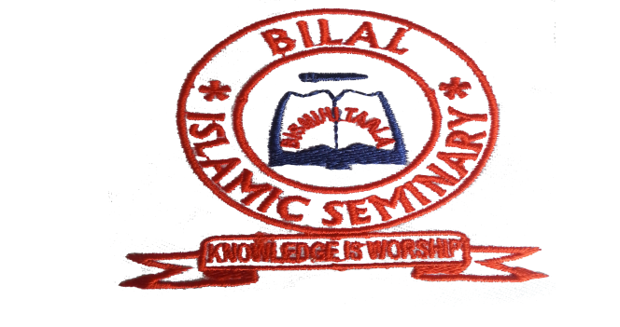
P.O. BOX 760 AMAAN – ZANZIBAR TEL: +255 (24) 2234905
1ST October,2019.
THE CULTURAL CENTRE
OF THE EMBASSY OF ISLAMIC REPUBLIC OF IRAN,
TANZANIA.

RE: RECEING OF COMPUTERS.
This is to confirm that we received the computers from your office through the attaché MR. ALI BAGHERI.
We appreciate your effort on assisting the school.
Looking forward for other assistance and cooperation.
Thanks,

SHIHAB HASSAN TAKI
DIRECTOR
BILAL ISLAMIC SEMINARY.

