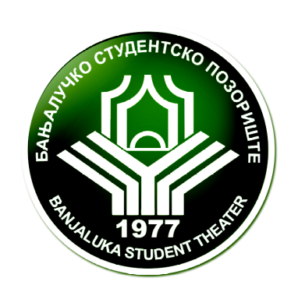

Festival of International Student Theatre
University of.. Banja Luka
Republika Srpska
Bosnia and Herzegovina



How to apply?

Please send us a filled out application form in an e-mail, together with an online link to a video of the entire performance as well as the appendices requested in application form to email: kestenburg@gmail.com

If you have any questions after reading this document, please feel free to contact us by mail.

Application you can download on our web page: www.kestenburg.com

Banja Luka, July 31 – August 09, 2015.

www.kestenburg.com

