Magufuli: Bureau de change were narrow passage of transporting money laundering

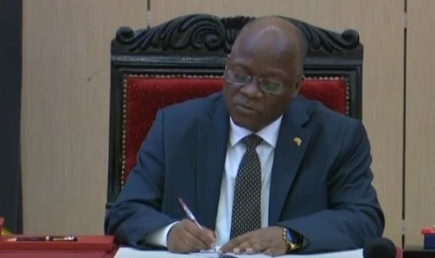
President John Magufuli said bureau de change in the country were being opened as mushrooms (by speed) were narrow passage of transporting money laundering in abroad
President said this today during swearing a new Tanzanian Ambassador to Cuba, Hon.Valentino and received notice of the work of the Prevention and Combating of Corruption Bureau (PCCB).

He said people were stealing money from the Central Bank (BOT) and going to sell in cash to changing shops, but when they were asked they didn't say how much they sold.
He said there was no report that indicating they have sold the amount of money and that the issue was fraud and shaking the country's economy.

“And when they go away (from BOT) they use’ exchange bureau (one currency converter) they sell to their man at a price of Sh1,400. ”
And they take it action as cotation’ that ‘exchange of TSh (Tanzanian currency) has gone up and that is a downgrade (affect) the country's economy, I told the governor to do one job there,”
"It was frauds only intended to shake our economy
Wonderful robberies have been done by the transactions without special order, no countries doing like this, I went to Germany until I showed my passport to converter, until the soldier looks at me and surprised him why I walking with $ 2,000,
President Magufuli said drug money has also been flowing in (money changing shops.

The hanging’s tree in Mwanza have been removed
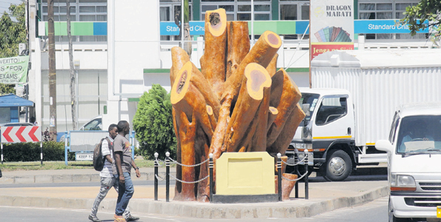
Residents of the city of Mwanza passing nearby the image of the mulberry tree Kemondo area, the city

After the independence of Tanganyika on December 9, 1961 the tree remained in the area as a reference which was not known to many in Mwanza
Famous mulberry tree that was in the roundabout Nyerere, Kenyatta and Makongoro Roads near CCM office has been removed and now set an example trunk of the tree.
Longtime in the area there was a tree used by colonial regime to hang Africans people during their rule.
Before colonialism, the tree according to the city's elders was used for local rituals.
After colonial entry into the country, it changed from the area of local rituals to the part of the offenders convicted during the German rule.

Resident in Mwanza, says the tree was greater than all the trees of the area as well as had been adjacent to a particular area was used as a prison.
He explains that people were hanged in the morning and remained on the rope until evening and then handed over to their families for burial.
You see there in Moili, and there was a building for people who were sentenced to death and from there to here it was not far. Everyone who deserved the death penalty was executed on his special day
Raphael Muruga (67) says according to information from the elders, his uncle, Benedicto Merengo was the keeper of the tree of the gallows Africans who were not loyal to the colonialists.

Location storage
After Independence of Tanganyika December 9, 1961 the tree was left as a memorial area which however was not known to many.
Relations officer of the City of Mwanza, Elirehema Kaaya says the council reached a decision to cut its branches before, and later forced to cut it down and remain stem from its size.
He says later the leadership decided to create a similar image of the original stem to maintain the history of the area.
He says the construction of the statue, which began December 10, 2018 has been completed on January 28 and costing more than Sh13.6 million provided by friends from the city of Würzburg in Germany.
You cannot always delete history, whether it is good or bad, always good will remain just history; that is why despite the history of the tree remain in sad memory among Tanzanians, the city has found it wise to maintain it for present and future generations, ”said Kaaya.
“This statue will be one of the tourist attractions in Mwanza and the council will shut down a special lighting solar lamp to enable visitors to see the tree for 24 hours.
According to the previous 2008 Property Policy,(ancient asset policy) the tree is an ancient asset that has to be maintained due to the reputation of the 100-year-old cultural heritage resources.

