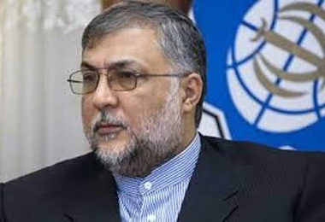

In the name of God, the Most Beneficent, the Most Merciful

Honorable Religions, Dignitaries, Respected Thinkers, and Free People of the World
My sincere greetings to you and all the truth-seekers.
Undoubtedly, it is God Almighty’s wish that all human beings should live in an atmosphere of peace and tranquility; a divine blessing that is, unfortunately, being violated by some people who are depriving others of blessing through oppression and crime. We are, these days, being witness that the usurper Zionist regime is once again engaged in shedding the blood of innocent children, women, and civilians, and surprisingly, this cruel act is being carried out before the eyes of those who claim to be the champions of democracy and human rights and have yet remained silent vis-à-vis these atrocious crimes. This human crime has wounded the souls of all the peace-loving people of the world, who for sure, expect that world religious leaders would not remain indifferent and silent in the face of this shameful act, and take effective action, in accordance with the most fundamental religious teachings, in defending the oppressed and extinguishing the blazing fire of this ongoing crime.
No free human being can remain silent in the face of blatant oppression and persecution, and it goes without saying that expectations from religious leaders and cultural personalities whose personality trait, characteristic and social status is earmarked with “freedom” are manifold.
It should be remembered that, as very rightly stated by the Supreme Leader of the Islamic Revolution, Ayatollah Khamenei, the establishment of lasting peace and security in Palestine will be possible only with the return of Palestinian refugees to the wrongly occupied territories and the collective decision of all its inhabitants - Jews, Christians, and Muslims - with regard to its administration and nothing else.
Therefore, as the Chairman of the Policy-Making and Coordination Council of the Interreligious Dialogue of the Islamic Republic of Iran, which has been working for years to promote greater understanding and cooperation among different religions, I call upon all religious leaders and cultural personalities to strongly condemn these barbaric crimes that are mercilessly going on in Palestine, the birthplace and origin of many great divine prophets, and take appropriate steps in fulfilling the religious and human duty that has been vested on them.
We pray to God Almighty to help us with regard to this important matter.

Dr. Abouzar Ebrahimi Torkaman

Chairman of the Policy-Making and Coordination Council of the Interreligious Dialogue of the Islamic Republic of Iran

