
باز تاب خبری سفر جناب آقای دکتر جنتی وزیر محترم فرهنگ و ارشاد اسلامی
به سوریه

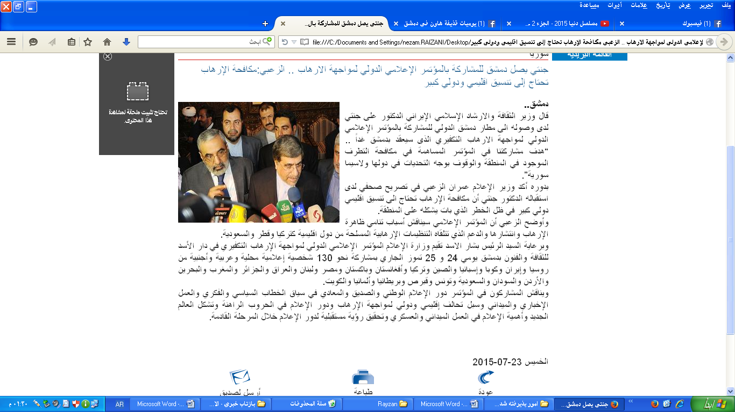
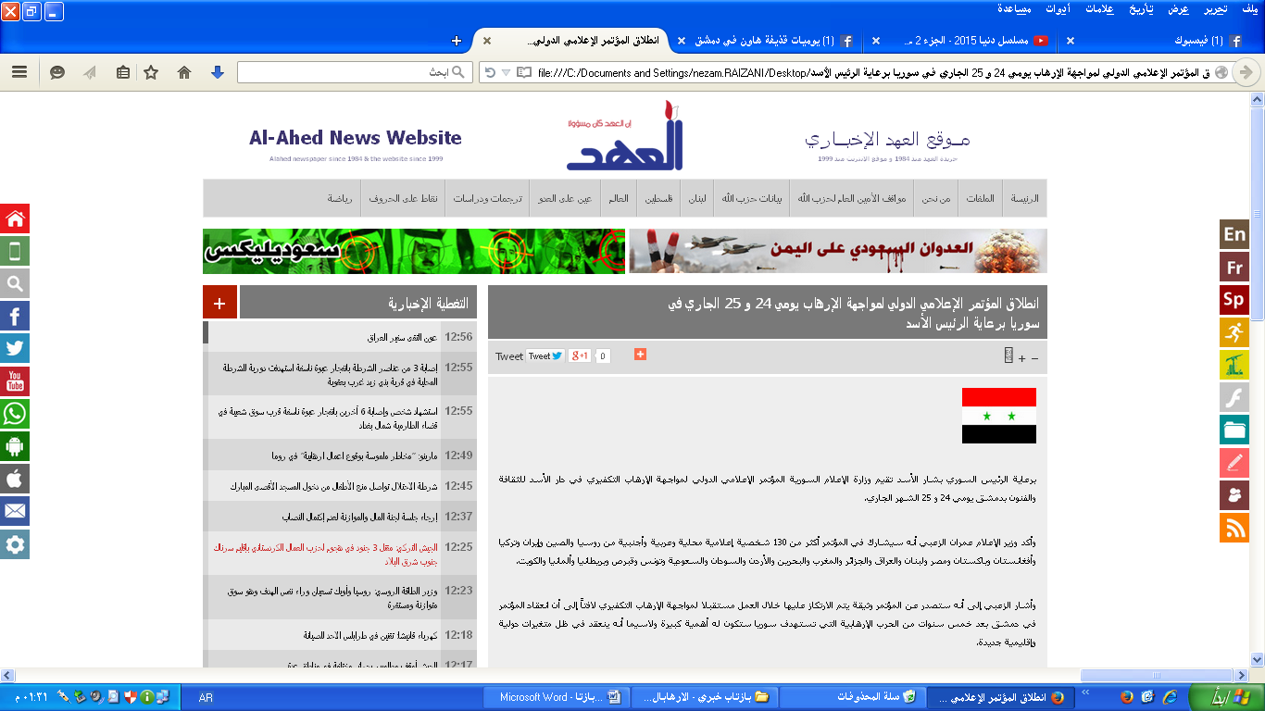

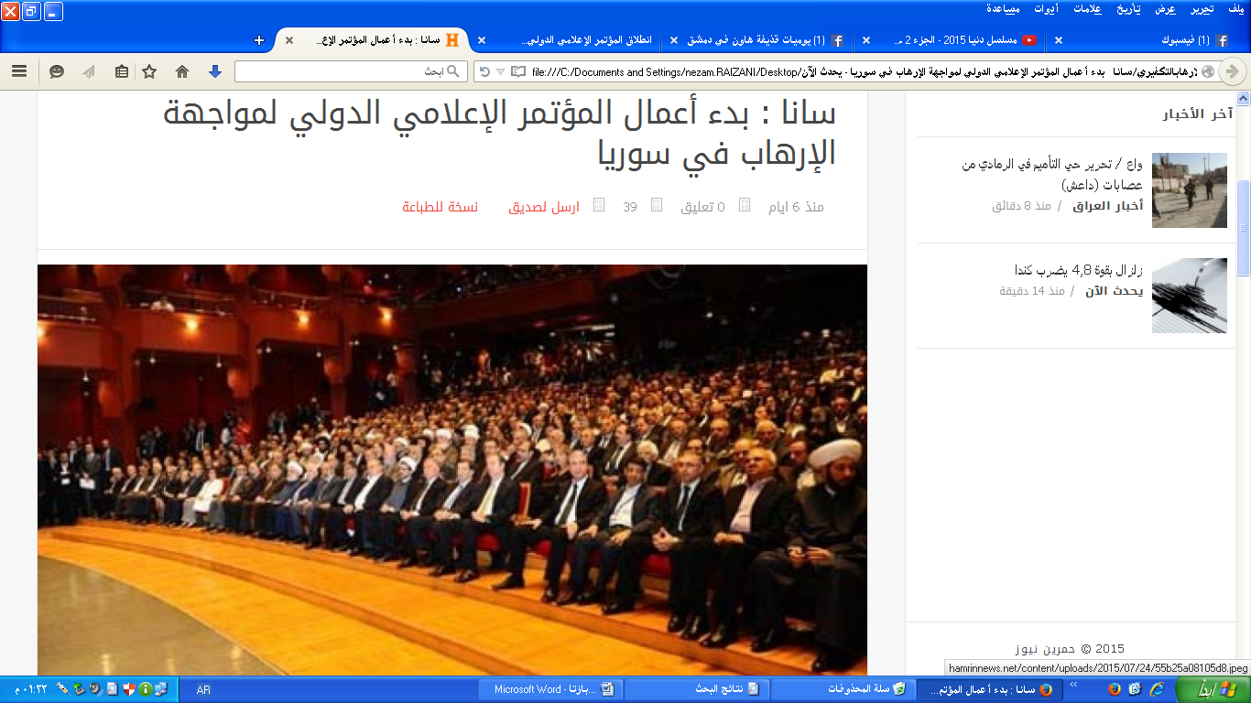

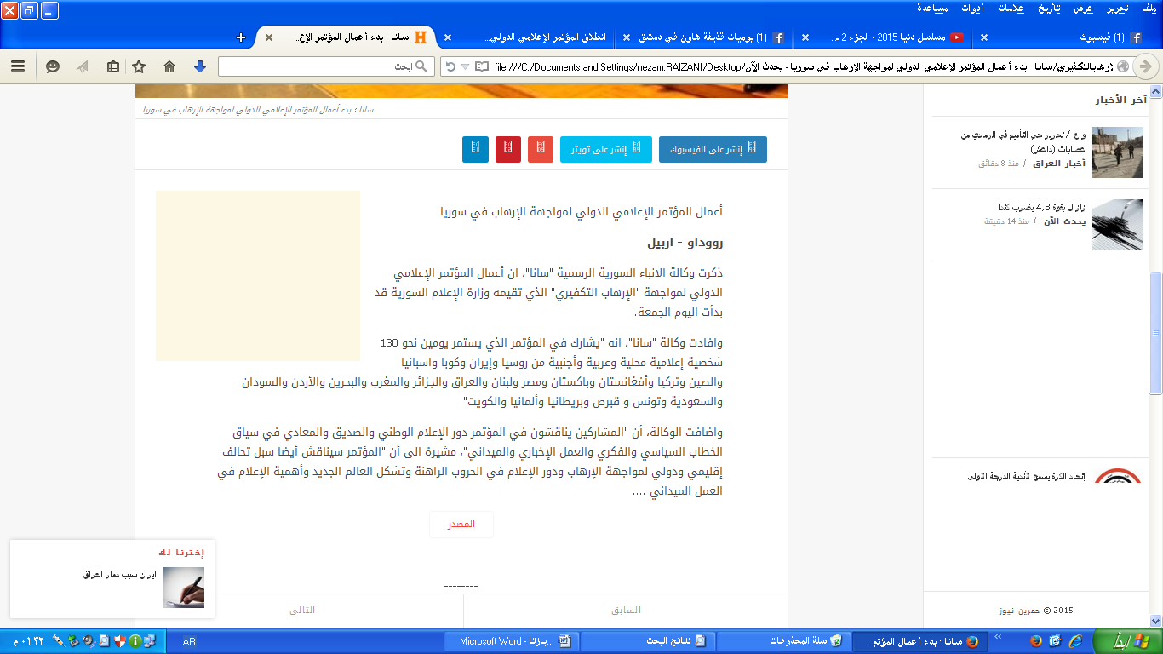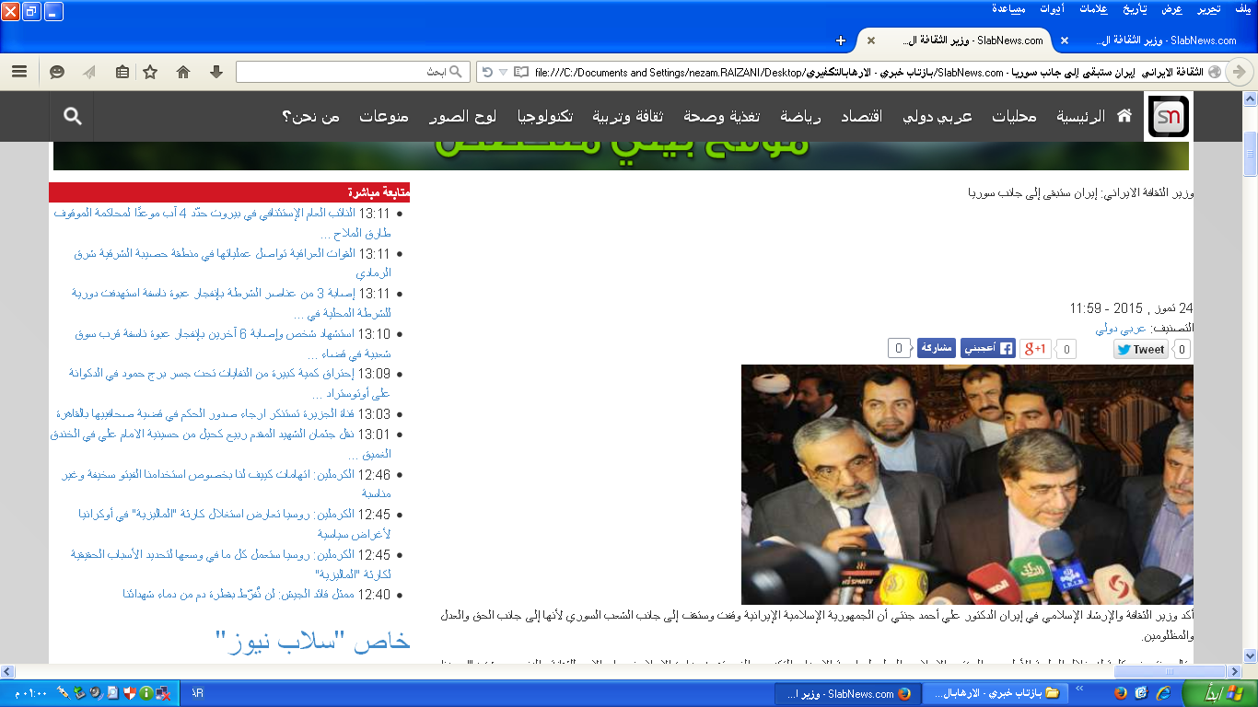

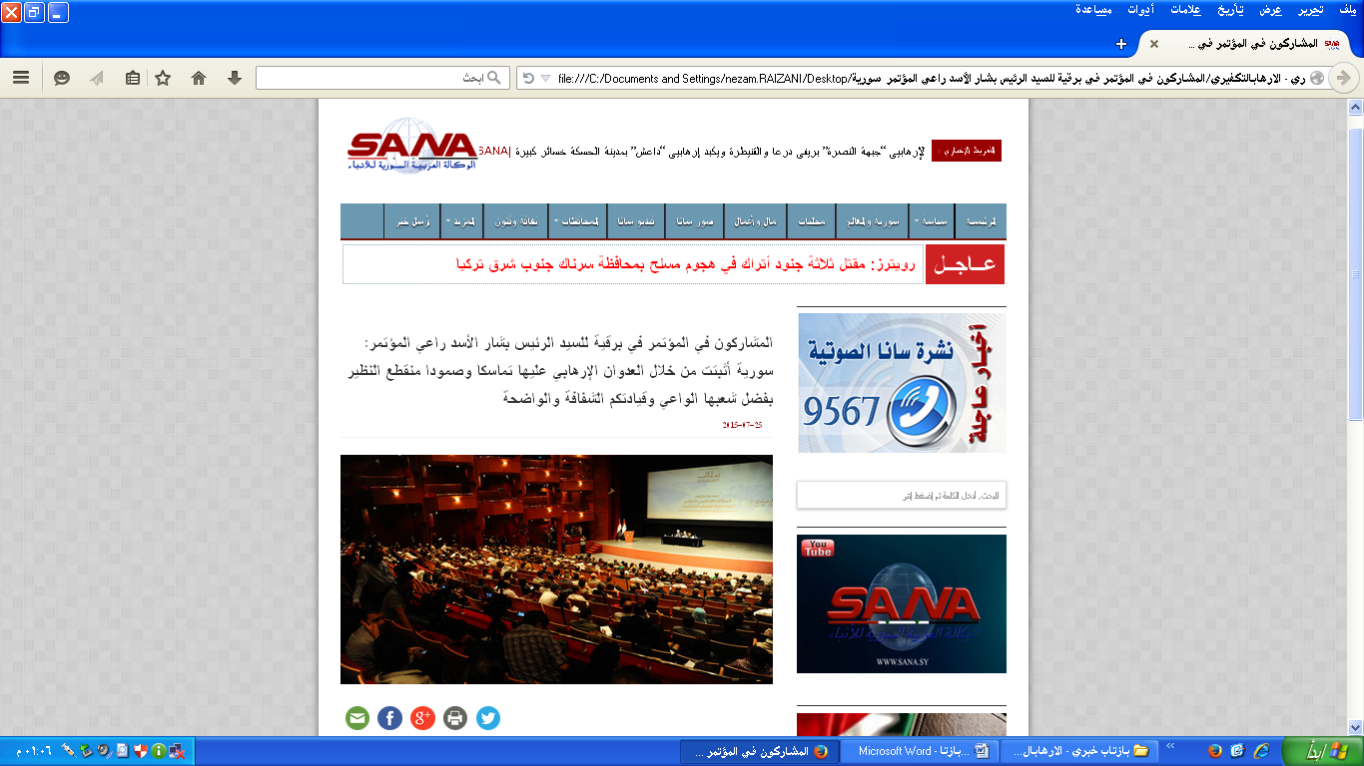

دیگر لینک های بازتاب خبری:

- http://www.dampress.net/?page=show_det&category_id=6&id=62100
- http://www.syria-scope.com/political-news/syria-political-news/38698
- http://www.dampress.net/?page=show_det&category_id=6&id=62100
- http://sana.sy/?p=245211
- http://www.tasnimnews.com/arabic/Home/Single/808029
- http://tishreen.news.sy/tishreen/public/read/343751
- http://www.elnashra.com/news/show/892200/
- http://furat.alwehda.gov.sy/node/244156
- http://www.risalaradio.com/97838/
- http://mobile.assafir.com/Article/178/433013
- http://www.almanar.com.lb/wap/edetails.php?eid=1259465
- http://www.lattakianow.com/2015/07/23/7703/
- http://www.champress.net/index.php?q=ar/Article/view/58946
- https://www.youtube.com/watch?v=W3wtI93AQbM
- https://www.youtube.com/watch?v=KVGPsIWJUgc
- https://www.youtube.com/watch?v=Sp_sRLYz6Tw
- http://www.alquds.co.uk/?p=376949
- http://arabi21.com/story/847111/
- http://www.al-vefagh.com/News/82595.html
- http://www.al-akhbar.com/node/238530
- http://nabaa.tv/archives/45989
- http://emediatc.com/?page=Details&category_id=1&id=24733
- http://www.alalam.ir/news/1723353
- http://hoseinmortada.com/?page=Details&category_id=1&id=4673
- http://alazmenah.com/?page=show_det&category_id=4&id=104644
- http://www.syriandays.com/?page=show_det&select_page=43&id=44338
- http://arabi-press.com/article.php?id=872170
- http://sana.sy/?p=245335
- http://slabnews.com/article/218995
- http://www.al-binaa.com/?article=59008

