EXCLUSIVE INVITATION

Golden Screen Cinemas cordially invites

Mr Pourya Nikfard
Embassy of Islamic Republic of Iran
______________________________________________________

for dinner and a preview screening of
“The Specials (Hors Normes)”

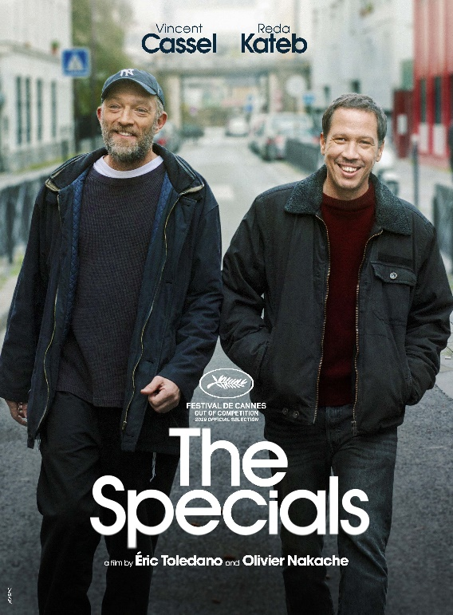 | SYNOPSIS  For twenty years, Bruno and Malik have been living in a world apart, the world of autistic children and teenagers.  Their respective associations train youngsters from difficult neighborhoods to take care for these cases categorized as “extremely complex”. Thus begins a special partnership for special personalities.  Trailer Link:  https://www.youtube.com/watch?v=gRLC6syOqDE

PROGRAMME

Venue: Aurum Theatre
The Gardens Mall, FF-201, 4th Floor
Lingkaran Syed Putra, Mid Valley City, 59200

Link to Aurum Theatre:
https://bit.ly/AurumOnGoogleMaps

Date: August 24, 2020 ( Mon)

Group 1

6.45 pm | Arrival of guests & dinner in Jin Gastrobar (Aurum Theatre)
7.45 pm | Speech by Ms. Koh Mei Lee (Chief Executive Officer, GSC)  Proceed to hall
8.00pm | Screening of “The Specials” (116 mins, Classification: P13)

Kindly RSVP by August 10, 2020 (Monday) to linacheng@gsc.com.my or gaiklian@gsc.com.my

Note:
Kindly note that social distancing guidelines will apply for this dinner event and the number of guests will be limited per dinner session at Jin Gastrobar. We thank you for your understanding.

Attachment - RSVP for 2020 GSC Corporate & Preview Screening (Group 1) for “The Specials” in Aurum Theatre on August 24, 2020 (Monday)

Please mark one of the boxes below and send it back to us:

No. Sorry, I can’t make it.
Kindly note that this invitation is not transferable.
Yes, I will be attending.
Please find my 3-course dinner menu listed as below:
SOUP
French Onion Soup with Garlic Bread
MENU
(Please tick the box below for your preferred selection)
Grilled salmon with mentaiko cream sauce, served with grilled vegetables and couscous
Chargrilled chicken with roasted vegetables and creamy mashed potato
Spinach fettuccine served with vegetable ratatouille
(VEGETARIAN)
DESSERT
Crème caramel with berries

* Free flow fruit-infused water, coffee & tea will be available at the bar
(self-service)

