Tanner Agnew

Module 1.2 Assignment: GitHub Repository Setup

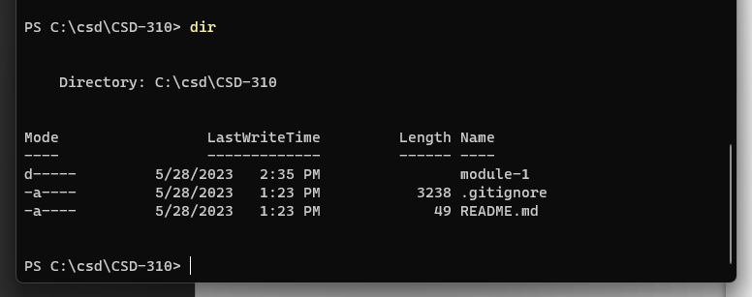

(used Windows Powershell)