**Note1: Theory, results and discussion on the 1D Ising model**

**1D Ising model definition**

In order to study a binary system, i.e a system which is only defined by two values, such as $±1$ or $0$ and $1$, using both regression analysis and classification, we will turn our focus towards a commonly used model known as the Ising model. The Hamiltonian function for the one-dimensional Ising model reads (Mehta et al, 2018)

$$H= -J\sum_{j=1}^{n}{s_{j}s_{j+1}}$$

where $s_{j}∈\{-1,1\}$, $n$ is the total number of spins, $J$ is known as the coupling constant. The coupling constant expresses the strength of the interaction between the adjacent spins. In physics the Hamiltonian is interpreted as state of energy, denoted $E[s]$, where in this context our aim is to learn the coupling constant $J$ from the training data $D=({\left\{s_{j}\right\}}_{j=1}^{N} ,E[s_{j}])$.

The OLS estimator is rewritten in terms of SVD as follows (van Wieringen ,2015)

$${\tilde{β}}_{OLS}={{(X}^{T}X)}^{-1}X^{T}Y \\ ={\left(VDU^{T}UDV^{T}\right)}^{-1}VDU^{T}Y \\ ={\left(VD^{2}V^{T}\right)}^{-1}VDU^{T}Y \\ =VD^{-2}V^{T}VDU^{T}Y \\ = VD^{-2}DU^{T}Y$$

and for the Ridge estimator in terms of SVD (van Wieringen ,2015)

$${\tilde{β}}_{Ridge}={{(X}^{T}X+λI)}^{-1}X^{T}Y \\ ={\left(VDU^{T}UDV^{T}+λI\right)}^{-1}VDU^{T}Y \\ = {\left(VD^{2}V^{T}+λVV^{T}\right)}^{-1}VDU^{T}Y \\ ={V\left(D^{2}+λI\right)}^{-1}DU^{T}Y$$

**An algorithm for computing the OLS and Ridge solutions and estimators are provided in Appendix A (for computing OLS set $λ=0$).**

**1D Ising model: results and discussion**

Before we start, we will rephrase the 1D equation (equation XXXX) to include every pairwise interaction between all spin variables. The equation then reads (Mehta et al, 2018)

$$E\left[s^{i}\right]= -\sum_{j=1}^{n}{\sum_{k=1}^{n}{{J_{j,k}s}_{j}^{i}s_{k}^{i}} }$$

where $J_{j,k}$ is now a matrix of coupling constants. In order to train the $J_{j,k}$ we will define equation XXX in a form which is more familiar from a linear regression point

$$E\left[s^{i}\right]=X^{i}J$$

Where

$$J={\left[J_{1,1},J_{2,1},…,J_{N,1},J_{1,2},J_{2,2},…,J_{N,2},…,J_{N,N}\right]}^{T}$$

giving a $(n^{2} x 1)$-dimensional vector of all coupling constants corresponding to all the possible spin interactions given in the design matrix ${ X}^{i}$. The design matrix is now given by a $(i x{ n}^{2})$-dimensional matrix

$$X^{i}=\left[S_{1}^{i}S_{1}^{i},S_{2}^{i}S_{1}^{i},…,S_{N}^{i}S_{1}^{i},S_{1}^{i}S_{2}^{i},S_{2}^{i}S_{2}^{i},…,S_{N}^{i}S_{2}^{i},…,S_{N}^{i}S_{N}^{i}\right]$$

In this particular case, the design matrix is singular, which will force us to turn to other methods for the OLS estimator. In this case we will turn to SVD for both the OLS and Ridge estimators (even though the Ridge penalty term estimator avoids the singularity issue). The Lasso estimator is computed by an iterative approach using the scikit learn package. The predicted estimators from OLS, Ridge and Lasso (by using a range of different values of $λ$) are presented in Figure XXXXXXXXX.

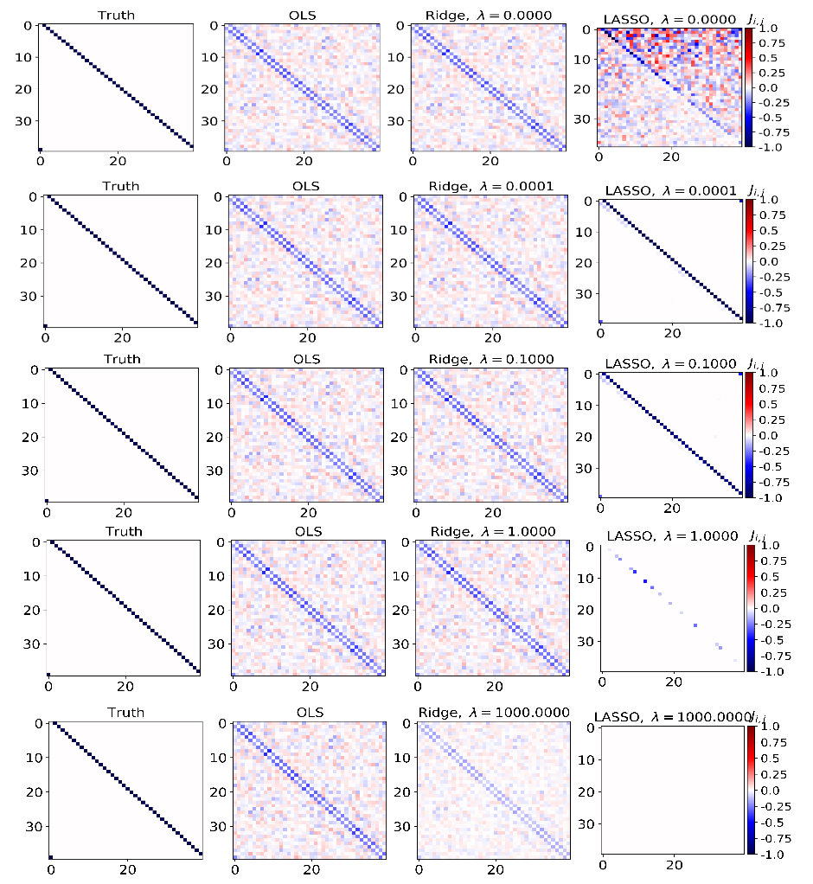

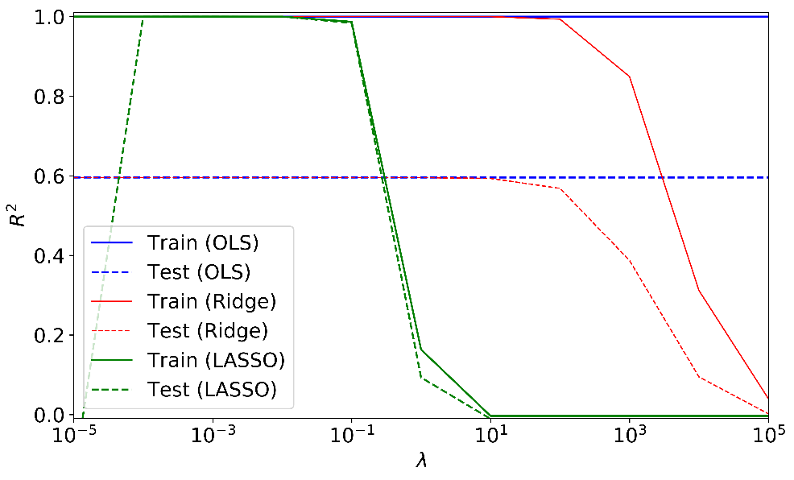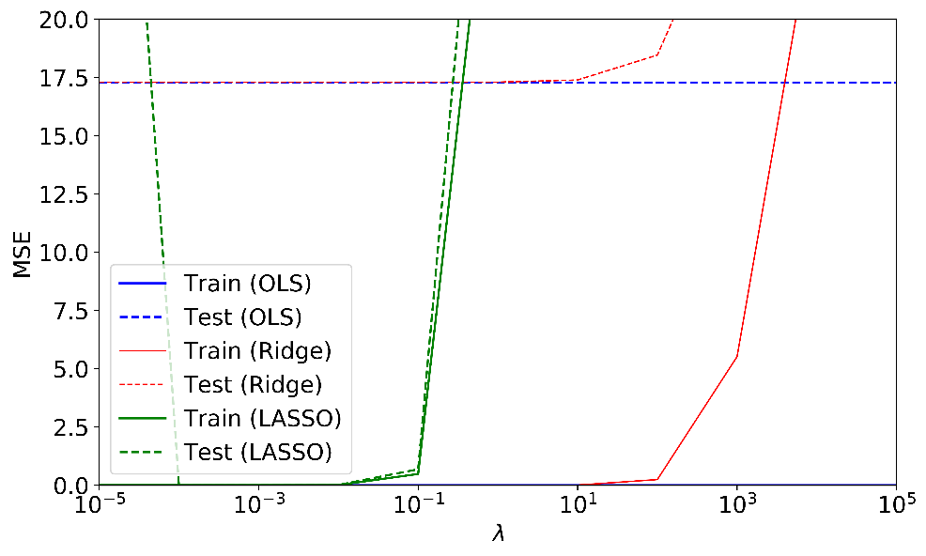

van Wieringen W. N. (2015). *Lecture notes on ridge regression*, arXiv:1509.09169.