**Using the NGINX logs, try the following exercises:**

**Try on your own before checking the answers below!**

**Nginx Access log analysis**

**Question 1:**

Count the total number of requests in an Nginx access log.

cat nginx_access.log | wc -l

**Question 2:**

Calculate the average size of requests (in bytes).

awk '{sum+=$10} END {print "Average request size:", sum/NR, "bytes"}' nginx_access.log

**Question 3:**

Determine the top 5 user agents accessing the server.

awk -F'"' '{print $6}' nginx_access.log | sort | uniq -c | sort -nr | head -5

**Question 4:**

Analyze the distribution of requests by hour of the day.

awk '{print $4}' nginx_access.log | cut -c 14-15 | sort | uniq -c

**Nginx Error log analysis**

**Question 1:**

Count the total number of error entries in the log.

cat nginx_error.log | grep 'error' | wc -l

**Question 2:**

Determine the top 5 IP addresses, domains, or file paths generating errors.

cat nginx_error.log | grep 'error' | awk '{print $NF}' | sort | uniq -c | sort -nr | head -5

**Question 3:**

Analyze the distribution of errors by date or time.

cat apache_error.log | grep 'error' | awk '{print $1}' | sort | uniq -c

**How did you do?**

**Apache access logs**

**Question 1:**



**Question 2:**



**Question 3:**

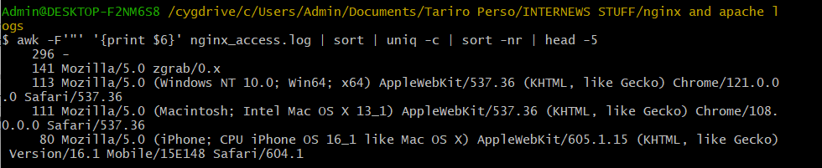

**Question 4:**

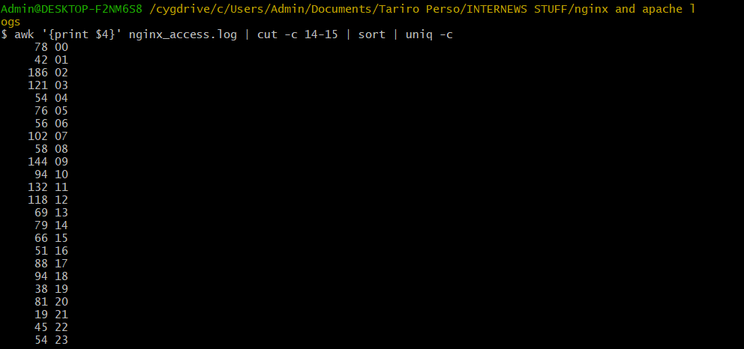

**Apache Error Logs**

**Question 1:**



**Question 2:**

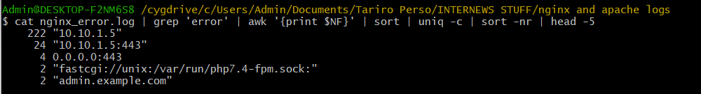

**Question 3:**

