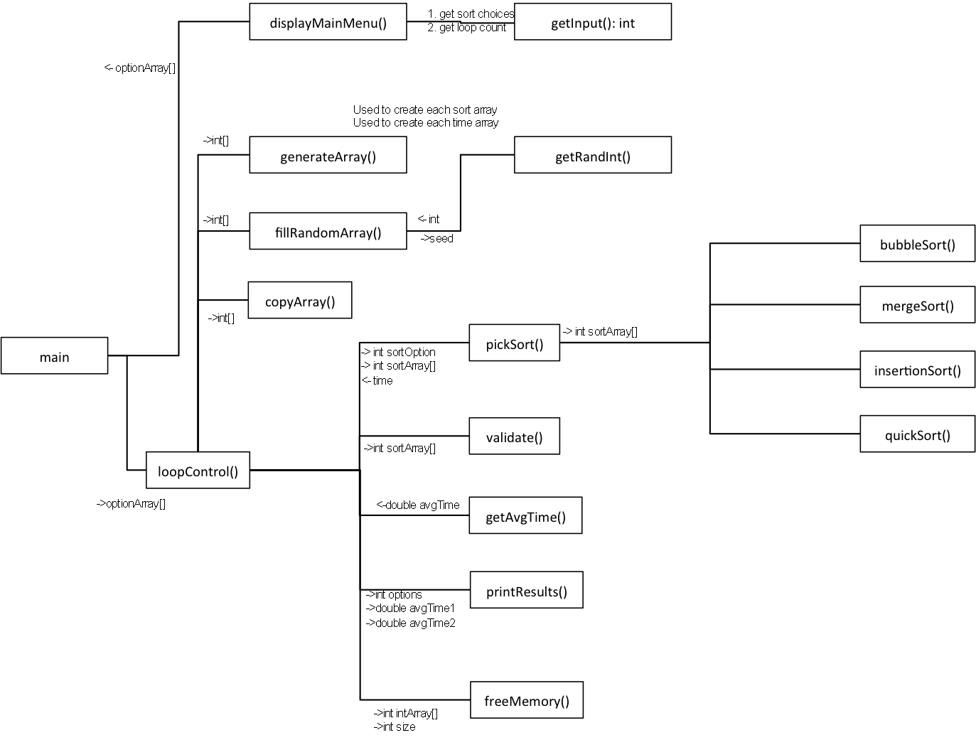

Program ownership:

displayMainMenu – Tatsumoto

getInput – Tatsumoto

generateArray – Townsend

fillRandomArray – Townsend

getRandInt - Townsend

copyArray – Tatsumoto

LoopControl – Tatsumoto

pickSort – Tatsumoto

validate – Townsend

getAvgTime – Townsend

printResults – Tatsumoto

freeMemory – Townsend

bubbleSort – Tatsumoto

mergeSort – Tatsumoto

insertionSort – Townsend

quickSort - Townsend