Tom Heale
Mini Project 3 Write-up

Project Overview:
For my project, I scraped data from Twitter about four Linux distributions and plain-old Linux. I did this using #hashtags, and I used it to determine Twitter's (user's) opinions about which distro is the best. I presented this data using a scatterplot representing pattern sentiment analysis.

Implementation:
I made two scripts (and a redo of a script): one to scrape data from Twitter and one to analyze the data. TwitterMining.py (and quick_TwitterMining.py) uses pattern search engine and pickle to get and store five datasets about Ubuntu, Arch Linux, Redhat, Debian, and general Linux. LinuxRating.py takes the pickle files, finds the average sentiment for each distro, and uses pyplot to create a graphical representation of the gathered data.
Lists are very familiar to me, and they have versatile use. Thus, I utilized them extensively in both scripts. There are places where I could have used dictionaries or tuples, but I didn't see a disadvantage to using lists. If I were storing matrices of higher dimension, tuples might have been more valuable. However, because I was only interested in mean polarity and subjectivity (2 values per dataset). I also used for loops repeatedly to iterate through lists and cycle queries. For loops seemed like the best option because I knew the length of the datasets and the number of times I wanted to query for tweets. I didn't really see a need for recursion, because there were only minimal calculations and I never needed to go more than two layers deep into a list.
When reading through LinuxRating.py, you may have noticed the following statement “if sent != (0.0,0.0):” and wondered why I chose to do that. My intent with this line was to remove tweets that are just shared hyperlinks or terminal commands, thus getting a set that contained only thoughts by the Twitter users. It mat not be a perfect system, but it made the data a little more interesting. Limitations statement: it may also have reduced some sets to minuscule length. Oops.

Results:
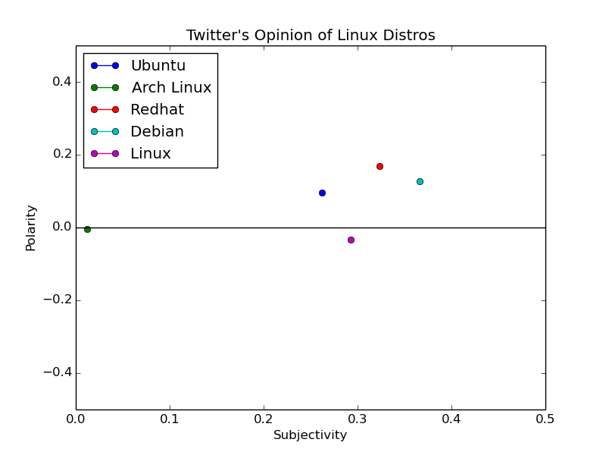
The goal of this project was to determine which distribution of Linux Twitter like most, and I kind of did that!

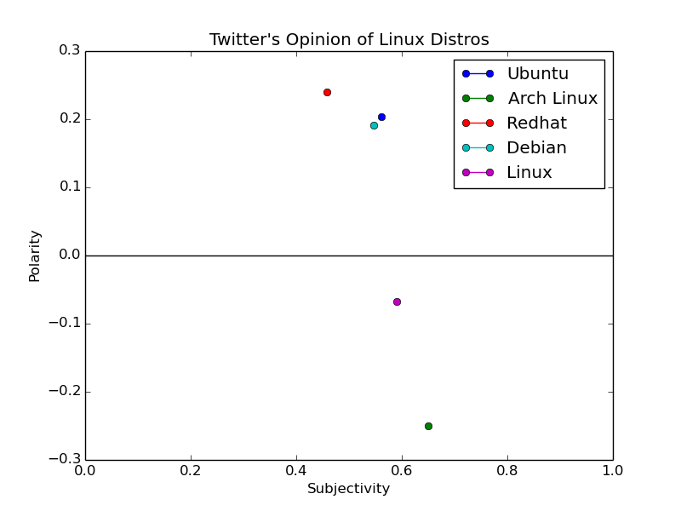

The above graphs are the final output of my scripts, but they are from different iterations of the project. Yet, both display information about the sentiment expressed toward the Linux distributions.

Graph 1: This graph shows the average polarity and subjectivity of all the posts I gathered. It is the output I got before I included the conditional that removed (0,0) entries from the data. Therefore, the subjectivity is low and the polarity is well within the margin of 0.2 from 0.

Graph 2: The data represented in the second graph has been screened for (0,0) entries. Therefore, the subjectivity is higher, and the polarity has a wider spread. I think that this data has greater implications and is more valuable. The only drawback to manipulating the datasets in this way is that they get much shorter. Ubuntu went from 109 points to 51, Redhat went from 109 to 77, and Arch went from 109 to 2... but those two people are very subjective in their dislike of Arch.

Implications of data:

- People are very objective about Arch in general, but if they're going to express opinions they will be negative opinions
- People generally like specific distros of linux more than they do linux as an independent entity/concept
- Redhat is the most positively viewed and the one viewed most objectively. This makes sense because it is geared for corporate use and server management. (if you know enough about Redhat to tweet about it, you probably understand its value)
- Ubuntu and Debian are similarly viewed (positively-ish), which makes sense because Ubuntu is built on Debian.

Reflection:
I am very glad that I read so much documentation on pattern and matplotlib. Also, that I played with pattern and pickle so much in Terminal. It was extremely valuable. My project was achievable, yet interesting. The two things I would must like to change about my project are (1) How much data I was able to scrape and (2) My use of Ctrl + V rather than function definitions. I would have liked to gather hundreds more tweets before running analysis, but I hit some limits when I tried to get 600 tweets/hour for 5 hours. Overall, I happy with my project and the learning that came of it. I now have basic knowledge of data mining, language processing, and python graphical output. I had no idea where to start with any of these three before this project.

