Mini Project Report — My Tiny Web Service
Web Programming 10671204/1. Fill this in and save it as report.docx inside your project folder.

Name | Taha dabeek
Student number | 12505287
My subject | Hebron Glass & Ceramic Crafts
My number of items | 8
My rule | Starts with
Part 1 — Follow one request (18 marks)
Open your page. Press F12 and choose the Network tab. Then press Search. Click on the api.php line that appears. Every answer here must come from your own project.
Q1. Copy the full address of that request, exactly as the Network tab shows it. (3)
http://localhost:8000/api.php?q=ceramic
Q2. Which HTTP method was used, and which status code came back? (2)
GET. Status code:200
Q3. Which Content-Type did the server send back? Why does the browser need to know this? (3)
application/json. The browser needs this so it knows to parse the response body as JSON data rather than displaying it as plain text or trying to render it as HTML
Q4. Which one of your files contains code that runs on the server? (2)
App.php
Q5. Which one of your files does api.php read on the server? Now type that file's own address into the browser, for example http://localhost:8000/data.json. What happened? What does that tell you? (3)
api.php reads data.json. If you type http://localhost:8000/data.json directly into the browser, the raw file loads with no filtering, no length check, and no rule applied — proving that anyone could skip your server logic entirely if app.js talked to data.json directly instead of going through api.php.
Q6. Your page changed without reloading. In one or two sentences: what would the user see differently if api.php sent back a whole HTML page and the browser moved to it instead? (3)
The whole page would flash and reload, and the user would lose their place (scroll position, anything typed) — instead of just the results list quietly updating in place.

Q7. Paste your screenshot of the Network tab, with your api.php request selected. (2)
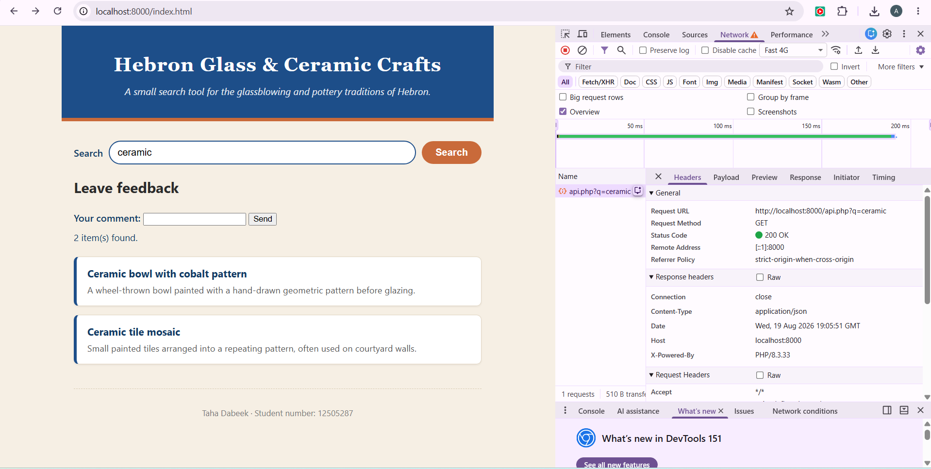

Part 2 — Your own code (15 marks)
Give the line number in your own file, then answer. The line number must be right — a wrong line number scores zero for that question, however good the sentence is.
Q8. In app.js: which line turns the server's answer into a JavaScript value? What does await do on that line? (5)
18

Q9. In api.php: which line decides which items to send back? What happens on that line when the search box is empty? (5)
Line 31if ($q !== '') {
this decides whether filtering happens.
When the search box is empty, $q is '', the condition is false, and $items stays as the full unfiltered list from data.json.

Q10. In app.js: which line puts text into the page? Why did you use textContent and not innerHTML? Use your Safety test <b>bold</b> item to explain what you saw. (5)
Line 48 — name.textContent = item.name; (inside renderItems) — textContent was used instead of innerHTML so the "Safety test <b>bold</b>" item shows up as literal visible text, angle brackets and all. If innerHTML had been used, the browser would actually render that as bold — a small XSS-style risk.

Part 3 — Your AI-use log (8 marks)
You may use any Artificial Intelligence (AI) tool, in any way. You may also use none. The highest mark is the same either way. What is marked here is your thinking, not the tool.
Copy the block below once for every time you used AI. Two or three is normal.

Use 1
"Implement app.php for me. I provided all the project files and the PDF containing the project requirements."

The AI analyzed the provided project files and the requirements in the PDF, then implemented app.php according to the required functionality.

Used it as it was. I used AI to help understand the project requirements and implement the PHP functionality correctly according to the provided instructions, and I used the generated file without making major changes.

Use 2
"Create app.js for me."

The AI implemented the app.js file required for the project and connected the JavaScript functionality to the existing project structure.

Used it as it was. I added the generated app.js file to the project and used it together with the other project files to implement the JavaScript functionality required by the project.

Use 3
"Implement the CSS and index.html files for me."

The AI created the style.css and index.html files according to the project requirements and made them work with the existing PHP and JavaScript files.

Used it as it was. I used AI to help build the user interface and styling and to connect the frontend files with the functionality, then tested the complete project.

Use 4
"Implement the bounus feature sends data with POST and prints it back safely with htmlspecialchars "

The ai sent me feedback.php file and sent me form to add to index.html

Used it as it is and it worked

Required: one thing you did not simply accept (5 of the 8 marks)
Write one thing the AI got wrong, or one suggestion you decided not to use, and say how you knew. Checking it counts. Testing it counts.
I asked him to create data.json for me without me sending him my studentId
and he created it but I refused to take it

If you used no AI at all: write "No AI used" above, and answer this instead — which part took you the longest, and what finally made it work?
Part 4 — Bonus (5 marks, optional)
Did you add the extra form that sends data with POST and prints it back safely with htmlspecialchars? If yes, name the file and say in one line what html special chars protects against.
Yes
File: feedback.php
It protected from htmlspecialchars like <>
