CCPL CYBER SECURITY INTERNSHIP

Local, LLM-Driven
SAST/DAST Testing Tool
Initial Design and Technology Decisions

Prepared For | CCPL Internship Supervisor
Prepared By | Muhammad Saqib | Taha Minhas
Environment | Local virtual machine with 32 GB RAM and 16 CPUs
Inference | CPU-based local inference using Ollama
Date | 30 July 2026
Version | 2

Current Design Direction
Core scope: Four fixed pipelines - Web SAST, Web DAST, Mobile SAST and Mobile DAST.
Selected stack: HTML/CSS/JavaScript, FastAPI, Ollama and Qwen3.5 9B.
Resource rule: One resource-intensive scan at a time on the 32 GB VM.
Report rule: Only reviewed findings appear in the main report; rejected items remain auditable.

Changes From Version 1:
Ram Increased to 32 GB
Cpu Increased to 16
Model changed to Qwen 3.5 9b
Phase 1 Completed
Extended the doc with Web UI & Phase 1 update

1. Introduction 4
2. Problem Statement 4
3. Functional Requirements 4
3.1 Supported Pipelines 4
4. Non-Functional Requirements 5
5. High-Level Architecture 5
6. Technology Selection 6
6.1 Frontend 6
6.2 Backend 6
6.3 Local LLM Runtime 7
6.4 Model Selection 7
6.5 Quantization Strategy 7
7. Scanner Selection 8
7.1 Target Handling 8
8. AI Pipeline 8
8.1 Standard Finding Fields 10
8.2 Failure Handling 10
9. Design Snapshot 10
10. Phase 1 Implementation Upgrades & Web Dashboard (August 2026 Update) 11
10.1 Real-Time Log Streaming 11
10.2 Web Dashboard 11
10.3 Interactive Report Filters 12
10.4 Standalone Reports 12
10.5 Current Status 12
11. Conclusion: 12

1. Introduction
Project aim: build a locally hosted proof-of-concept that runs SAST or DAST against a fixed web or Android target and produces a reviewed security report.
Supported targets: DVWA for web testing and DIVA for Android testing. All scanning, model inference and report processing will remain local.
Team approach: we will first complete one end-to-end pipeline, then reuse the same normalization, LLM review and reporting components for the remaining three pipelines.

2. Problem Statement
Security tools provide useful evidence, but their outputs are different and may include duplicates, weak alerts or false positives. Our project must turn those raw results into one clear and consistent report.
- Route the selected target and test type to the correct local tool.
- Convert tool-specific output into one standard JSON structure.
- Use a local LLM to explain and assess each candidate finding.
- Apply a second review before a finding is accepted as confirmed.
- Work within a 32 GB VM without running several heavy scans at once.

3. Functional Requirements
Requirement | Planned Behavior | Output
Guided selection | Show target type, test type and fixed target in sequence. | One valid pipeline choice.
Scan creation | Validate the choice, create scan_id and start a background job. | Immediate acknowledgement.
Status display | Show queued, scanning, LLM review, reporting, completed or failed. | Clear progress on the UI.
Local assessment | Send normalized evidence to the local Assessor prompt. | Initial structured finding.
False-positive review | Review the original evidence and Pass 1 result independently. | Confirmed, rejected or manual review.
Final reporting | Render confirmed findings with severity, location, evidence and remediation. | HTML/JSON report plus optional appendix.

3.1 Supported Pipelines
Pipeline | Primary Input | LLM Review Focus
Web SAST | DVWA source code and configuration | Code patterns, data flow and missing controls.
Web DAST | ZAP alerts plus HTTP request/response evidence | Evidence of exploitable runtime behavior.
Mobile SAST | DIVA APK decompiled code, manifest and resources | Hardcoded secrets, insecure storage, exported components and weak crypto.
Mobile DAST | MobSF/emulator runtime, traffic and logs | Runtime behavior and mobile attack surface.

4. Non-Functional Requirements
Requirement | Design Decision
Locality and privacy | Scanners, model weights, Ollama and reports stay inside the local environment.
Usability | The UI remains guided and simple; the user always sees the current scan stage.
Resource efficiency | Only one heavy scan job runs at a time on the 32 GB VM.
Responsiveness | The scan runs as a background job while FastAPI answers status and result requests.
Reliability | Timeouts, missing tools and model errors produce a clear failed state.
Auditability | Raw, normalized, confirmed and rejected findings are saved locally.
Maintainability | Scanners, parsers, prompts and reporting are separate modules.
Controlled scope | The first version only accepts DVWA and DIVA; arbitrary targets are excluded.

5. High-Level Architecture
Architecture style: a local orchestration pipeline. The frontend sends the selection to FastAPI; the backend runs one scanner, normalizes the output, calls two logical LLM passes and builds the report.
Important execution decision: the security stages remain sequential because each stage needs the previous result. Background execution is used only to keep the API and status screen responsive.
Initial storage: job status is kept in memory, while raw results and reports are saved as local files. A database is not needed for the first proof-of-concept.
Endpoint | Purpose | Response
POST /api/scan | Create and start a scan job. | 202 + scan_id
GET /api/scan-status/{scan_id} | Return the current stage or error. | Status JSON
GET /api/scan-results/{scan_id} | Return the completed report. | Report metadata/data

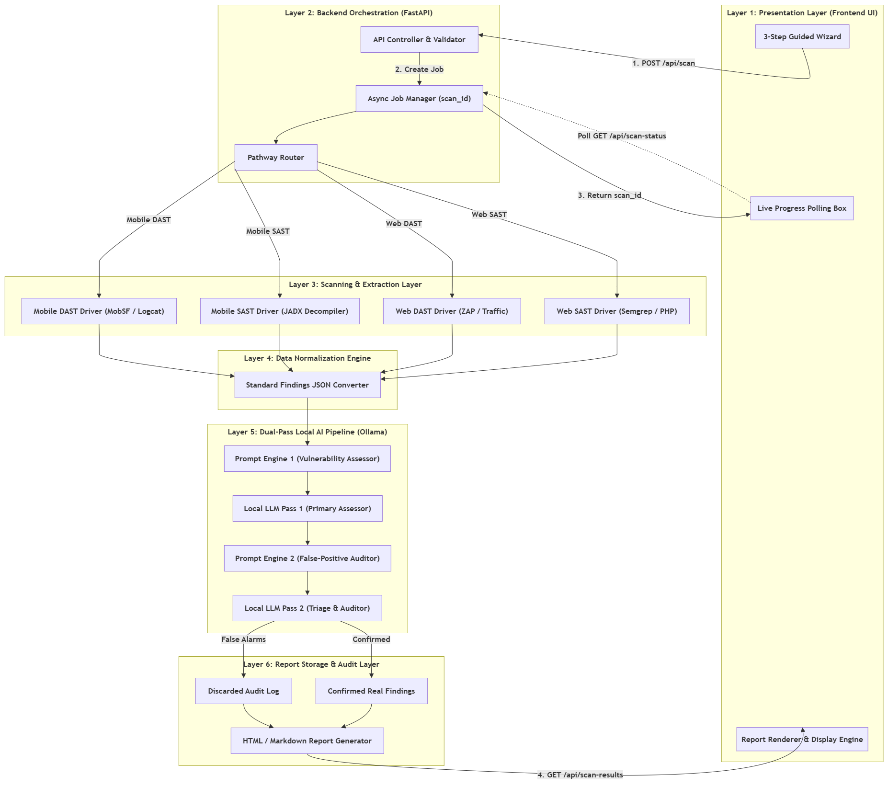
Figure 1. High-Level Layered System Architecture of the Proposed AI-Assisted SAST/DAST Vulnerability Assessment Tool
Figure 1 presents the high-level layered architecture of the proposed AI-assisted SAST/DAST Vulnerability Assessment Tool. The architecture is organized into six logical layers, beginning with the Presentation Layer, where users initiate scans and monitor progress, followed by the Backend Orchestration Layer responsible for request handling and scan routing. The selected security scanner performs the analysis, after which the findings are normalized into a standard JSON format. The normalized results are then processed by a dual-stage local AI pipeline for vulnerability assessment and false-positive validation before the Report Generation Layer produces the final security report for presentation to the user.

6. Technology Selection

6.1 Frontend
Selected: HTML5, Vanilla CSS and Vanilla JavaScript.
- Guided choices, status polling and report viewing are simple enough for Vanilla JavaScript.

6.2 Backend
Selected: FastAPI.
- Python was selected because the project is centered around AI integration, API orchestration, automation and security tooling. Most AI frameworks, local inference runtimes and security tools provide first-class Python support, making integration simpler and reducing development effortBackground jobs keep status and health endpoints responsive.
Feature | FastAPI | Django
Primary Use | REST APIs | Full-stack Web
Performance | High/Fast | Moderate
Async Support | Native | Available but heavier
Swagger Docs | Built-in | Extra packages
AI Integration | Excellent | Good
Project Fit | Excellent | Good

Async Does Not Mean Parallel Scanning
Ordered job: Scanner -> Normalizer -> Assessor -> Reviewer -> Report.
Responsive API: status requests continue, while a single-worker limit protects the 32 GB VM.

6.3 Local LLM Runtime
Selected: Ollama.
Two local inference runtimes were considered: Ollama and LM Studio. Although both can run identical open-source models, Ollama was selected because it provides a REST API, simple CLI management and straightforward backend automation. LM Studio is better suited for interactive experimentation through a graphical interface.

6.4 Model Selection
Selected model: Qwen3.5 9B.
The model must understand code and scanner evidence, form a security reason and return structured output.
Model | Q4 Working Memory* | CPU Speed | Strength | Project Fit
Gemma 3 4B | ~5-7 GB | Very fast | Good for simple tasks | May be weak for complex review.
Qwen2.5-Coder 7B | ~6-8 GB | Fast | Excellent code focus | Strong SAST option.
Qwen3.5 9B - Selected | ~7-10 GB | Fast-moderate | Reasoning + code + structured output | Best balance for our 32 GB VM.
Llama 3.1 8B | ~7-10 GB | Fast-moderate | Strong general reasoning | Good alternative.
Gemma 3 12B | ~10-14 GB | Moderate-slow | Stronger writing/reasoning | Limited memory headroom.
Qwen2.5 14B | ~11-15 GB | Slow | Very strong analysis | Too heavy with scanners on this VM.
*Working-memory values are planning estimates. Actual use depends on context length, cache, operating-system overhead and active tools.
Why Qwen3.5 9B
Reasoning: strong enough for vulnerability explanation and false-positive review.
Code understanding: suitable for PHP, SQL and Android evidence.
Hardware fit: practical on a 32 GB VM when quantized and used one job at a time.
Output control: well suited to structured prompts and JSON responses.

6.5 Quantization Strategy
Selected: Q4_K_M quantization.
- The model remains an 8B-parameter model; parameters are not removed.
- Weights are stored at lower numerical precision, reducing file size and RAM use.
- The trade-off is a small possible quality loss in exchange for more practical CPU inference.

7. Scanner Selection
Pipeline | Selected Tool | Integration | Role
Web SAST | Semgrep | CLI + JSON output | Scan DVWA source and return candidate code findings.
Web DAST | OWASP ZAP/Burp | Local API/automation | Crawl and test the running DVWA instance.
Mobile SAST | JADX | CLI decompilation | Extract code, manifest and resources from DIVA.apk.
Mobile DAST | MobSF + emulator | Local dynamic analysis | Collect runtime, traffic and log evidence.

7.1 Target Handling
- DVWA SAST uses the local source-code folder.
- DVWA DAST uses the URL of the locally running application.
- DIVA SAST uses the APK file without running the app.
- DIVA DAST requires the APK to run in an emulator or approved test device.
Boundary: the tools collect evidence; the local LLM makes the vulnerability judgment.

8. AI Pipeline
1 | Collect Evidence - Run the selected scanner and preserve its raw output.

2 | Normalize - Convert tool-specific fields into one Standard Findings JSON format.

3 | LLM Pass 1 - Assessor - Explain the issue, review context, estimate severity/confidence and suggest remediation.

4 | LLM Pass 2 - Reviewer - Check the original evidence and decide confirmed, rejected or manual review.

5 | Report - Place only confirmed findings in the main report and keep rejected items in an appendix/log.

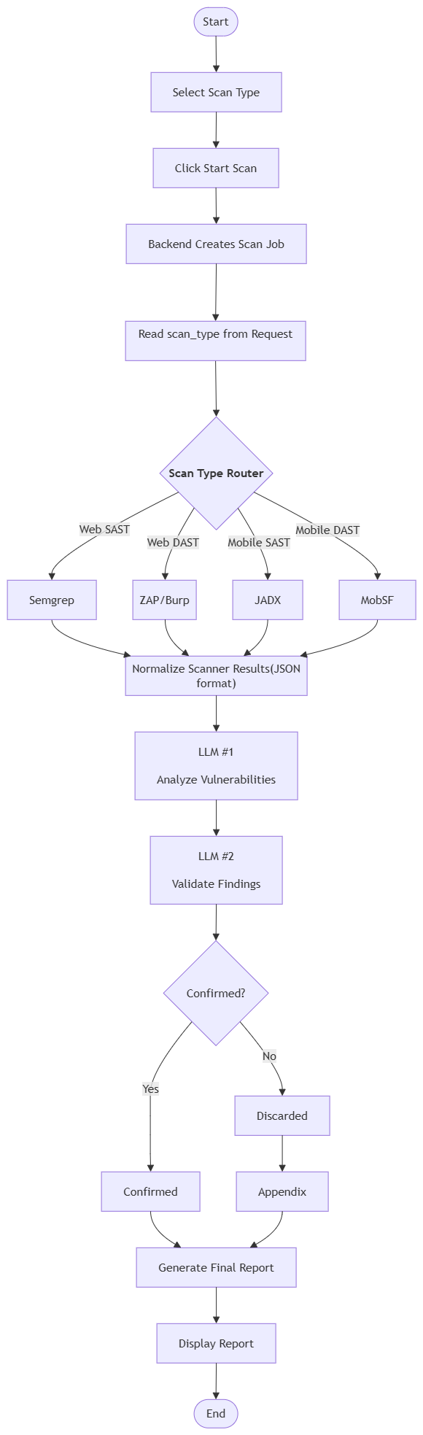
Figure 2 — AI-Based Vulnerability Assessment Workflow

8.1 Standard Finding Fields
Identity | Evidence | Assessment | Decision
scan_id, target type, test type, tool | title, location, code/HTTP/runtime context | severity, confidence, reasoning, remediation | confirmed, rejected or manual review

8.2 Failure Handling
Failure | Planned Response
Scanner missing/crashes | Mark failed, save logs and stop before LLM review.
Scanner timeout | Terminate where possible and show a timeout status.
Ollama/model unavailable | Save evidence, mark AI stage failed and do not confirm alerts.
Invalid LLM JSON | Validate, retry once and then send to manual review.
Job already active | Queue or return a busy response; do not start another heavy job.
Browser refresh | Continue the backend job and reconnect using scan_id in localStorage.

Design Snapshot
Area | Decision | Reason
Scope | Local proof-of-concept | The priority is the reusable testing pipeline, not arbitrary target input.
Targets | DVWA and DIVA | Both are known vulnerable applications suitable for controlled testing.
Backend | FastAPI | Fits Python-based AI/tool orchestration and status APIs.
LLM | Qwen3.5 9B via Ollama | Balanced code understanding, reasoning and memory use.
Execution | Sequential pipeline + responsive status API | Stages depend on each other; the UI must still remain responsive.
Storage | Local JSON/HTML files; no database initially | The first version has no login, scan history dashboard or multi-user data.

Document basis: This design translates the supplied project requirements into a practical implementation plan for our team.

Phase 1 Implementation Upgrades & Web Dashboard (August 2026 Update)
Following the completion of the initial design, the Phase 1 (Web SAST) implementation introduced several practical enhancements to improve usability, transparency and reporting while preserving the original system architecture.

10.1 Real-Time Log Streaming
Background status polling was replaced with Server-Sent Events (SSE) using GET /api/scan/stream. Execution logs are streamed live to the browser terminal with keep-alive messages to maintain stable connections.

10.2 Web Dashboard
- Live terminal console displaying real-time execution logs.
- 6-step pipeline progress bar with Glowing Indigo (active) and Emerald Green (completed) indicators.
- Official CCPL branding integrated into the dashboard and generated HTML reports.
- Responsive layout with improved code formatting to prevent overflow.

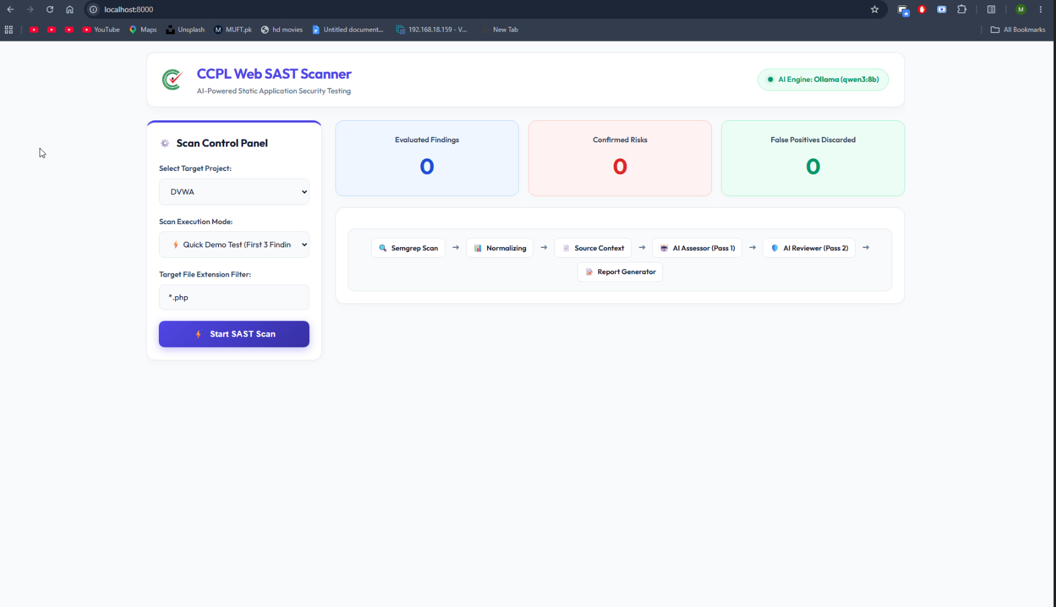

10.3 Interactive Report Filters
Users can switch between Confirmed Risks, Discarded False Positives and All Evaluated findings for easier report navigation.
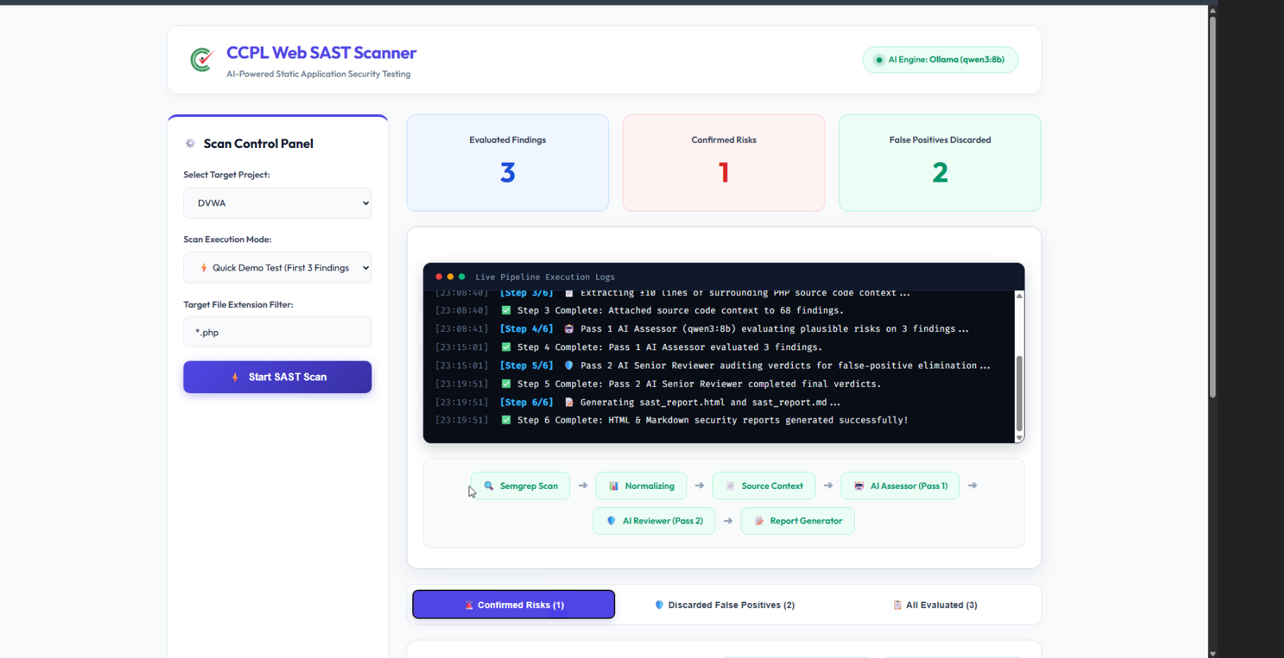

10.4 Standalone Reports
The reporting engine generates standalone HTML and Markdown reports containing an Executive Summary, Confirmed Vulnerabilities and a False-Positive Audit Log.

10.5 Current Status
Phase 1 (Web SAST) has been completed, verified against DVWA and pushed to the GitHub main branch. Phase 2 (Web DAST) has been implemented and integrated to its current stage, with OWASP ZAP performing passive and active scanning, authentication and session handling, and automated scanning, and has produced approximately 219 findings to date. Current work is focused on debugging and tuning the Qwen3.5 9B reasoning stage.

Conclusion:
The proposed local AI-assisted SAST/DAST framework has successfully progressed from the initial design into a working Phase 1 implementation. The completed Web SAST pipeline demonstrates FastAPI orchestration, Semgrep-based scanning, standardized finding normalization, dual-pass LLM assessment using Qwen3.5 9B through Ollama, and automated security report generation.

