CCPL CYBER SECURITY INTERNSHIP

Local, LLM-Driven SAST/DAST Testing Tool
  - Initial System Design, Technology Selection and Architecture Rationale

Document Type | Pre-Implementation Design Document
Version | 0.1
Prepared For | CCPL Internship Supervisor
Prepared By | [Team Member 1] and [Team Member 2]
Development Environment | Local virtual machine - 16 GB RAM, CPU-based inference
Date | 30 July 2026

Status: Design decisions proposed for supervisor review before implementation

Document Purpose and Status
This document records the current understanding of the assigned requirements and the main architecture and technology decisions made before implementation begins. It is intended to provide the supervisor and both project members with one agreed technical direction. Implementation details may be refined after tool installation and proof-of-concept testing, but any major change should be documented with its reason.
Current Key Decision
The first implementation will use a 16 GB RAM virtual machine, FastAPI, a lightweight HTML/CSS/JavaScript frontend, Ollama, and Qwen3 8B in Q4_K_M quantization. Only one resource-intensive scan job will run at a time. The two LLM stages are two logical passes through the same loaded model, not two models loaded simultaneously.

Document Structure
- 1. Introduction
- 2. Problem Statement
- 3. Functional Requirements
- 4. Non-Functional Requirements
- 5. High-Level Architecture
- 6. Technology Selection
- 7. Scanner Selection
- 8. AI Pipeline
- 9. Conclusion

1. Introduction
The assigned project is a locally hosted, LLM-driven security-testing tool for web applications and Android APKs. The system must guide a user through choosing a target type, selecting either Static Application Security Testing (SAST) or Dynamic Application Security Testing (DAST), and running the corresponding testing pipeline automatically. The first proof-of-concept uses fixed targets: Damn Vulnerable Web Application (DVWA) for web testing and Damn Insecure and Vulnerable App (DIVA) for Android testing.
The project is not intended to replace a production-grade security platform. Its purpose is to demonstrate a complete and understandable pipeline in which established security tools collect technical evidence, a locally hosted language model reasons about that evidence, a second review pass removes unsupported or low-confidence findings, and a clear final report is produced.
All scanning, model inference, model weights and report processing must remain on local infrastructure. No cloud LLM API or cloud scanning service is part of the proposed design.

2. Problem Statement
Security tools such as static analyzers, dynamic proxies and mobile-analysis frameworks can produce useful technical findings, but their raw outputs are tool-specific and may contain false positives, duplicate alerts or findings without sufficient application context. A user would otherwise need to operate multiple tools separately, understand different output formats, manually inspect supporting code or responses, and then create a report by hand.
The project therefore needs a single local workflow that can route four fixed testing combinations, collect evidence from the correct supporting tool, convert that evidence into one standard format, and apply consistent reasoning before reporting a vulnerability as real. The central problem is not only detecting suspicious patterns; it is deciding whether the finding is plausible in context and explaining why it should or should not appear in the final report.
Design Goal
Keep the target choices intentionally limited so development effort remains focused on the reusable pipeline: tool execution -> normalized evidence -> LLM assessment -> independent review -> final report.

3. Functional Requirements

3.1 Guided Local Selection Flow
The locally hosted user interface will guide the user through three sequential choices. Each step will appear only after the previous choice has been completed.
- Target type: Web App or APK.
- Test type: SAST or DAST.
- Target instance: DVWA for web testing or DIVA for APK testing.
After confirmation, the frontend will send the selected combination to the backend. The backend will validate the input and route it to exactly one of the four supported pipelines.

3.2 Supported Testing Pipelines
Target | Test Type | Expected Evidence and LLM Role
DVWA | Web SAST | Review DVWA source code and configuration evidence for SQL injection, XSS, CSRF, insecure upload, weak session handling and similar patterns.
DVWA | Web DAST | Interpret live HTTP requests, responses and alerts collected while the local DVWA instance is running.
DIVA APK | Mobile SAST | Review decompiled code, AndroidManifest.xml, resources and strings for hardcoded secrets, insecure storage, exported components and weak cryptography.
DIVA | Mobile DAST | Reason over emulator/device runtime evidence such as MobSF dynamic output, network traffic, logcat and optional instrumentation data.

3.3 Scan Status and Results
- The system will create a unique scan_id when a scan starts.
- The interface will display a clear status such as queued, scanning, normalizing, LLM assessment, LLM review, report generation, completed or failed.
- The frontend will periodically request the current status without blocking the interface.
- After completion, the frontend will fetch and display the final report.

3.4 Local LLM Assessment
Supporting tools may gather source-code findings, HTTP evidence, decompiled files and runtime data. However, vulnerability judgment and explanation will not be based on hardcoded tool rules alone. The local LLM will receive relevant evidence and determine the likely vulnerability, affected location, impact, severity reasoning and remediation.

3.5 Second-Pass False-Positive Review
Every candidate finding will pass through a second logical LLM review before it is included in the main report. Unsupported, contradicted or low-confidence findings will be excluded from the primary findings list and retained separately for audit where appropriate.

3.6 Final Report
Each confirmed finding will contain at least:
- Finding title and severity.
- Affected file and line, URL and parameter, endpoint, or Android component.
- A short technical description.
- Evidence and reasoning explaining why the finding is considered real.
- A practical remediation recommendation.
The report will be generated locally in HTML and JSON during the first implementation. Markdown and PDF export can be added from the same normalized report data.

4. Non-Functional Requirements
The following non-functional requirements are derived from the supplied project brief and the current implementation decisions.
Requirement | Design Interpretation
Locality and Privacy | Scanners, model weights, Ollama inference and report files remain within the local environment. No cloud LLM or cloud scanner is required.
Usability | The interface must be simple, guided and transparent about current scan status. A polished dashboard is not required.
Resource Efficiency | The initial environment is a 16 GB RAM virtual machine with CPU-based inference. Q4_K_M quantization and one active scan at a time will preserve memory headroom.
Responsiveness | Long scans run as background jobs. FastAPI remains available for status, health and report requests while the selected pipeline executes.
Reliability | Tool failures, timeouts, invalid model output and unavailable services must produce clear failed states rather than incomplete reports.
Auditability | Raw scanner output, normalized findings, confirmed findings and discarded findings should be retained as local files for review.
Maintainability | Scanner wrappers, parsers, prompt builders and report generation will remain modular so that a tool or model can be replaced independently.
Security of Operation | The proof-of-concept must only scan the approved local vulnerable targets. Arbitrary URL or APK input is outside the current scope.

5. High-Level Architecture
The system uses an orchestration architecture. The frontend does not run scanners or communicate with the model directly. It sends a scan request to FastAPI, receives a scan_id, polls the job status and later fetches the report. The backend routes the selected pipeline, executes the supporting tool, normalizes the output, invokes two logical LLM passes and generates report files.
The security pipeline itself remains sequential because every stage depends on the previous output: scanner -> parser -> LLM Pass 1 -> LLM Pass 2 -> report. Asynchronous behavior is used only to keep the API responsive while the long-running sequential job is executing. It does not mean that all scanners or both LLM passes run in parallel.

5.1 Initial Job and Storage Model
The proof-of-concept will use a single-worker job manager with a concurrency limit of one active resource-intensive scan. Job status can initially be held in memory, while raw results, normalized JSON and final reports are stored in local folders. A database is not required because the current scope has fixed targets, no user accounts and no requirement for searchable long-term scan history.
A database such as SQLite or PostgreSQL would only become necessary if later requirements introduce multiple users, authentication, persistent scan history, dashboards, searching or cross-scan analytics.

5.2 Initial API Contract
Method and Endpoint | Purpose | Typical Response
POST /api/scan | Validate target/test selection and create a background job. | 202 Accepted with scan_id.
GET /api/scan-status/{scan_id} | Return queued, running stage, completed or failed status. | JSON status object.
GET /api/scan-results/{scan_id} | Return the completed report and links to local report formats. | Final report JSON/HTML metadata.

Figure 1 - Final End-to-End Testing Workflow
Recreated from the Draw.io page named "final".
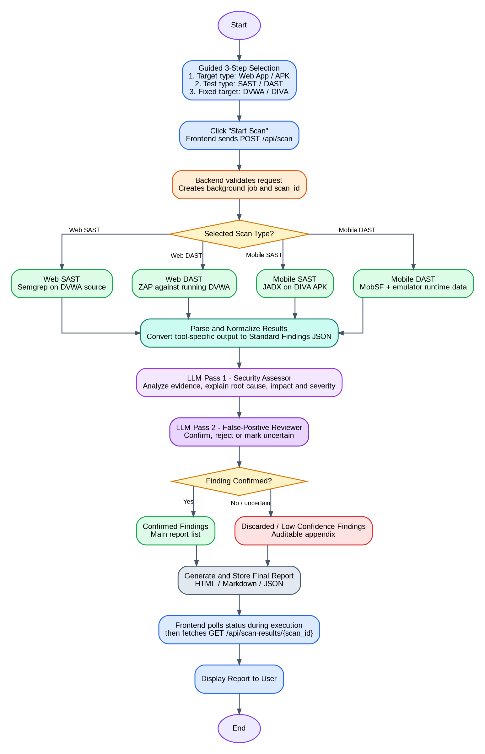
Figure 1. The guided user flow routes one selected scanner, converts its result to a common format, performs assessment and review, and produces confirmed and discarded outputs.

Figure 2 - Layered System Architecture
Recreated from the Draw.io page named "mermaid anti".
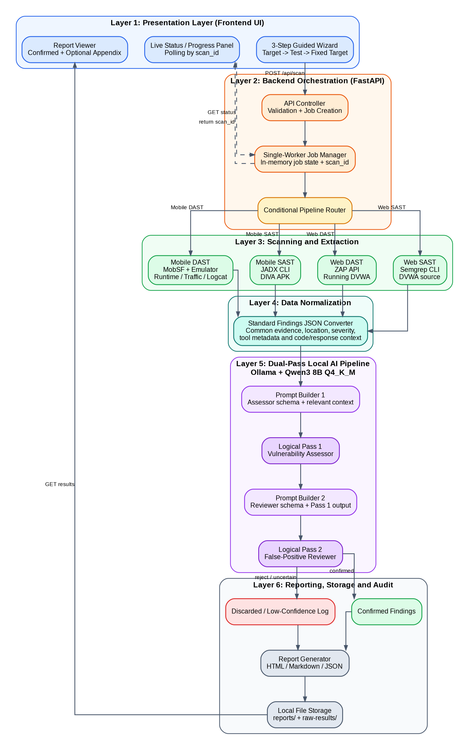
Figure 2. The frontend, FastAPI orchestration, four evidence-collection pathways, normalization, dual-pass local LLM reasoning and auditable report storage are separated into clear layers.

6. Technology Selection

6.1 Frontend
The frontend is not the core focus of this project. It only needs a guided selection interface, a Start Scan action, a live terminal-like or graphical status area, and options to view or download the report. For this reason, HTML5, Vanilla CSS and Vanilla JavaScript are selected instead of a complex frontend framework.
Vanilla JavaScript is sufficient for sending requests with fetch(), saving the current scan_id in localStorage, polling the status endpoint and rendering the final report. This choice reduces dependencies and keeps the project understandable to both team members.

6.2 Backend
FastAPI is selected as the backend framework. Python fits the AI and security-tool ecosystem, and the project is mainly an API orchestration problem. FastAPI provides request validation, JSON handling, automatic OpenAPI documentation and support for asynchronous endpoints.
The reason for asynchronous handling is server responsiveness, not parallel execution of the dependent security stages. When a scanner or model is working, the backend should still answer status and health requests. Because the 16 GB VM has limited shared resources, the first version will intentionally queue additional scan requests instead of running several heavy scans at once.
Important Async Decision
FastAPI will accept a scan, return scan_id quickly, and continue the scan in a managed background job. The scanner, normalizer, Assessor pass and Reviewer pass still execute in order. A single-worker limit prevents CPU and RAM contention.

6.3 Local LLM Runtime
Ollama is selected as the local inference runtime and model manager. Ollama is not the language model itself; it loads and serves models such as Qwen, Llama or Gemma. The FastAPI backend can call Ollama through its local REST API, making it suitable for an automated pipeline.
LM Studio was considered because it provides an accessible graphical chat interface and can also serve models locally. However, the planned system performs inference in the backend and only shows status and results on the frontend. Ollama therefore provides a simpler command-line and API-oriented workflow for this project.

6.4 Model Selection
Qwen2.5-Coder 7B was initially considered because the system must understand PHP, SQL, Java/Android code and scanner evidence. After refining the use case, it became clear that the model is not mainly being used to generate software. It must understand code, form security reasons, compare evidence, identify weak claims and write a structured report. Qwen3 8B therefore provides a better balance of general reasoning, instruction following and coding capability.
Model | Practical Q4 Working Memory* | CPU Speed | Reasoning / Code / Report Quality | Best Fit
Gemma 3 4B | Approx. 5-7 GB | Very fast | Good for simple tasks; lower headroom for complex multi-step security reasoning. | Low-resource experiments and basic summaries.
Qwen2.5-Coder 7B | Approx. 6-8 GB | Fast | Excellent code-focused understanding and structured technical output. | Code review, SAST context and code generation.
Qwen3 8B - Selected | Approx. 7-10 GB | Fast to moderate | Strong balance of reasoning, instruction following, code analysis and report quality. | Vulnerability reasoning, validation and structured reporting.
Llama 3.1 8B | Approx. 7-10 GB | Fast to moderate | Strong general reasoning and stable conversational responses. | General assistants and broad report drafting.
Gemma 3 12B | Approx. 10-14 GB | Moderate to slow | Strong reasoning and writing, but limited memory headroom on a 16 GB VM. | Higher-quality local analysis when more memory is available.
Qwen2.5 14B | Approx. 11-15 GB | Slow on CPU | Very strong reasoning and analytical capability, but impractical alongside scanners in the current VM. | Higher-end local analysis on larger hardware.

*Approximate working-memory ranges, not guaranteed values. Actual use changes with operating-system overhead, context length, runtime cache and other active tools. Ollama lists the Qwen3 8B Q4_K_M model file at approximately 5.2 GB.
Selected Model: Qwen3 8B
The 4B class would run faster but may lose quality on complex vulnerability reasoning. A 12B or 14B model could consume most of the 16 GB VM and reduce response speed while scanners are also active. Qwen3 8B provides the most practical middle point for this proof-of-concept.

6.5 Quantization Strategy
Q4_K_M quantization is selected. An 8B model still contains approximately eight billion parameters; quantization does not delete parameters or turn the model into a smaller parameter-count model. Instead, it stores the learned numerical weights with lower precision.
The trade-off is appropriate for the current hardware: model size and RAM consumption are reduced, CPU inference becomes more practical, and response time improves. Some quality can be lost compared with higher-precision variants, but Q4_K_M is expected to retain acceptable quality for the planned assessment and reviewer prompts.

7. Scanner Selection
Pipeline | Selected Tool | Planned Integration | Reason for Selection
Web SAST | Semgrep | CLI execution with JSON output. | Runs locally, supports source-code security rules and provides machine-readable findings for normalization.
Web DAST | ZAP | Local ZAP API, with CLI/automation as fallback. | Can crawl and actively test a running local DVWA instance and expose alerts through JSON/XML APIs.
Mobile SAST | JADX | CLI decompilation of DIVA.apk. | Produces Java-like source, AndroidManifest.xml and resources for LLM review. It is an extraction/decompilation stage, not the final vulnerability judge.
Mobile DAST | MobSF Dynamic Analyzer | Local MobSF API/UI with an Android emulator; runtime evidence may include traffic, logcat and instrumentation. | Provides an integrated environment for Android runtime testing and evidence collection.

7.1 Target Deployment Interpretation
DVWA is a locally running PHP web application. Web SAST requires access to its source-code directory, while Web DAST requires the local URL of the running DVWA instance.
DIVA is not deployed as a website. For Mobile SAST, the input is the DIVA APK file. For Mobile DAST, the APK must be installed and running inside an Android emulator or approved test device. MobSF and related runtime tools then collect behavior, traffic and log evidence for the LLM.

7.2 Integration Boundary
Each scanner wrapper will only execute the tool and collect raw evidence. It will not generate the final security conclusion. A dedicated parser will convert each output into the same Standard Findings JSON structure before it reaches the LLM.

8. AI Pipeline
The two LLM stages are logical roles using the same Qwen3 8B model served by Ollama. The model remains loaded once; Pass 1 and Pass 2 use different prompt templates and execute sequentially. This avoids doubling model memory inside the 16 GB VM.

8.1 Standardized Input
Raw scanner files will not be sent blindly to the model. The parser will extract the fields required for reasoning and add the smallest relevant code or response context. Large result sets will be processed finding by finding or in controlled batches.
{
"finding_id": "scan-id-tool-index",
"target_type": "web | apk",
"test_type": "sast | dast",
"tool": "semgrep | zap | jadx | mobsf",
"title": "candidate finding title",
"tool_severity": "informational | low | medium | high | critical",
"location": {
"file": "optional path",
"line": "optional line",
"url": "optional endpoint",
"component": "optional Android component"
},
"evidence": "relevant scanner evidence",
"context": "relevant code, response or runtime context"
}

8.2 LLM Pass 1 - Security Assessor
- Identify the likely vulnerability category and affected location.
- Explain the data flow or behavior that makes the issue dangerous.
- Compare the evidence with any visible sanitization, validation or security control.
- Estimate severity and confidence with a written reason.
- Provide a concise remediation recommendation.
- Return a strictly structured JSON object for validation by the backend.

8.3 LLM Pass 2 - False-Positive Reviewer
Pass 2 receives the original normalized evidence and the Pass 1 assessment. Its role is independent review rather than simply rewriting the first response.
- Confirm that the evidence supports the claimed vulnerability.
- Reject findings contradicted by code or runtime context.
- Reduce severity when impact is overstated.
- Mark uncertain findings for the discarded/low-confidence appendix.
- Return a final decision: confirmed, rejected or manual-review-needed.

8.4 Report Assembly
Only confirmed findings will appear in the main report. Rejected or uncertain findings will remain in a separate auditable record. The report generator will not perform new vulnerability reasoning; it will render the validated JSON into consistent HTML, Markdown and JSON formats.

8.5 Failure and Exception Handling
Failure Case | Planned Behavior
Scanner missing, crashes or returns non-zero exit code | Mark job as failed, preserve stderr/stdout logs and do not start the AI assessment.
Scanner timeout | Terminate the child process where possible, record timeout and show a clear failed status.
Ollama unavailable or model not loaded | Retain raw/normalized evidence, mark AI stage failed and do not present scanner alerts as confirmed findings.
LLM returns invalid JSON | Validate against the expected schema, retry once with a corrective prompt, then mark for manual review if still invalid.
Result exceeds context window | Process per finding or in small batches and include only relevant source/response context.
Second scan requested while one is active | Queue or reject with a busy status, depending on the final UI decision; do not launch simultaneous heavy jobs in the first version.
Browser refreshes or closes | The job continues in the backend. The frontend stores scan_id in localStorage and can reconnect to the status endpoint.

8.6 Planned Status Lifecycle
queued -> preparing target -> running scanner -> normalizing -> LLM assessor -> LLM reviewer -> generating report -> completed

9. Conclusion
The proposed design keeps the project focused on its real objective: a reusable local pipeline that connects security evidence collection with explainable AI reasoning and false-positive review. The frontend remains intentionally simple, FastAPI provides the orchestration and status APIs, Ollama serves Qwen3 8B locally, and Q4_K_M quantization makes the model practical in the 16 GB RAM virtual machine.
The design also avoids unnecessary complexity at the proof-of-concept stage. It does not require a database, multiple simultaneous scans or separate model instances. A single-worker job queue, local file storage and two sequential prompt roles provide a clear foundation that can be tested and expanded after the four target pipelines are working.
The next implementation milestone is to establish the repository and interfaces, then complete one vertical slice first: Web SAST on DVWA using Semgrep -> normalized JSON -> Qwen3 Assessor -> Qwen3 Reviewer -> final local report. The remaining pipelines can then reuse the same normalization, AI and reporting components.

References
1. CCPL Project Requirements Document, "Local, LLM-Driven SAST/DAST Testing Tool for Web Apps & APKs," Version 1.0, 27 July 2026.
2. Qwen Team, Qwen3 model documentation and Qwen3-8B model card.
3. Ollama, Qwen3 model registry and local API documentation.
4. FastAPI official documentation: asynchronous programming and background tasks.
5. Semgrep official documentation: local CLI scanning and JSON/SARIF output.
6. ZAP official documentation: programmable API and automated scanning.
7. JADX official repository documentation: APK/Dex decompilation and resource decoding.
8. Mobile Security Framework (MobSF) official documentation: static and dynamic mobile analysis.

