CCPL CYBER SECURITY INTERNSHIP

Local, LLM-Driven
SAST/DAST Testing Tool
Initial Design and Technology Decisions

Document Status | Pre-implementation design for supervisor review
Prepared For | CCPL Internship Supervisor
Prepared By | CCPL Internship Project Team
Environment | Local virtual machine with 16 GB RAM
Inference | CPU-based local inference using Ollama
Date | 30 July 2026

Current Design Direction
Core scope: Four fixed pipelines - Web SAST, Web DAST, Mobile SAST and Mobile DAST.
Selected stack: HTML/CSS/JavaScript, FastAPI, Ollama and Qwen3 8B Q4_K_M.
Resource rule: One resource-intensive scan at a time on the 16 GB VM.
Report rule: Only reviewed findings appear in the main report; rejected items remain auditable.

Design Snapshot
Area | Decision | Reason
Scope | Local proof-of-concept | The priority is the reusable testing pipeline, not arbitrary target input.
Targets | DVWA and DIVA | Both are known vulnerable applications suitable for controlled testing.
Backend | FastAPI | Fits Python-based AI/tool orchestration and status APIs.
LLM | Qwen3 8B Q4_K_M via Ollama | Balanced code understanding, reasoning and memory use.
Execution | Sequential pipeline + responsive status API | Stages depend on each other; the UI must still remain responsive.
Storage | Local JSON/HTML files; no database initially | The first version has no login, scan history dashboard or multi-user data.

Document basis: This design translates the supplied project requirements into a practical implementation plan for our team.

1. Introduction
Project aim: build a locally hosted proof-of-concept that runs SAST or DAST against a fixed web or Android target and produces a reviewed security report.
Supported targets: DVWA for web testing and DIVA for Android testing. All scanning, model inference and report processing will remain local.
Team approach: we will first complete one end-to-end pipeline, then reuse the same normalization, LLM review and reporting components for the remaining three pipelines.

2. Problem Statement
Security tools provide useful evidence, but their outputs are different and may include duplicates, weak alerts or false positives. Our project must turn those raw results into one clear and consistent report.
- Route the selected target and test type to the correct local tool.
- Convert tool-specific output into one standard JSON structure.
- Use a local LLM to explain and assess each candidate finding.
- Apply a second review before a finding is accepted as confirmed.
- Work within a 16 GB VM without running several heavy scans at once.

3. Functional Requirements
Requirement | Planned Behavior | Output
Guided selection | Show target type, test type and fixed target in sequence. | One valid pipeline choice.
Scan creation | Validate the choice, create scan_id and start a background job. | Immediate acknowledgement.
Status display | Show queued, scanning, LLM review, reporting, completed or failed. | Clear progress on the UI.
Local assessment | Send normalized evidence to the local Assessor prompt. | Initial structured finding.
False-positive review | Review the original evidence and Pass 1 result independently. | Confirmed, rejected or manual review.
Final reporting | Render confirmed findings with severity, location, evidence and remediation. | HTML/JSON report plus optional appendix.

3.1 Supported Pipelines
Pipeline | Primary Input | LLM Review Focus
Web SAST | DVWA source code and configuration | Code patterns, data flow and missing controls.
Web DAST | ZAP alerts plus HTTP request/response evidence | Evidence of exploitable runtime behavior.
Mobile SAST | DIVA APK decompiled code, manifest and resources | Hardcoded secrets, insecure storage, exported components and weak crypto.
Mobile DAST | MobSF/emulator runtime, traffic and logs | Runtime behavior and mobile attack surface.

4. Non-Functional Requirements
Requirement | Design Decision
Locality and privacy | Scanners, model weights, Ollama and reports stay inside the local environment.
Usability | The UI remains guided and simple; the user always sees the current scan stage.
Resource efficiency | Only one heavy scan job runs at a time on the 16 GB VM.
Responsiveness | The scan runs as a background job while FastAPI answers status and result requests.
Reliability | Timeouts, missing tools and model errors produce a clear failed state.
Auditability | Raw, normalized, confirmed and rejected findings are saved locally.
Maintainability | Scanners, parsers, prompts and reporting are separate modules.
Controlled scope | The first version only accepts DVWA and DIVA; arbitrary targets are excluded.

5. High-Level Architecture
Architecture style: a local orchestration pipeline. The frontend sends the selection to FastAPI; the backend runs one scanner, normalizes the output, calls two logical LLM passes and builds the report.
Important execution decision: the security stages remain sequential because each stage needs the previous result. Background execution is used only to keep the API and status screen responsive.
Initial storage: job status is kept in memory, while raw results and reports are saved as local files. A database is not needed for the first proof-of-concept.
Endpoint | Purpose | Response
POST /api/scan | Create and start a scan job. | 202 + scan_id
GET /api/scan-status/{scan_id} | Return the current stage or error. | Status JSON
GET /api/scan-results/{scan_id} | Return the completed report. | Report metadata/data

Figure 1 - Final End-to-End Workflow
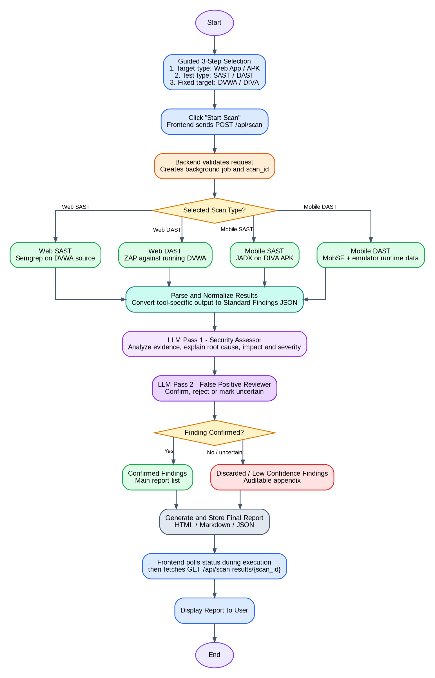
Draw.io page: "final". One selected pipeline moves from tool execution to normalization, two-pass review and final reporting.

Figure 2 - Layered System Architecture
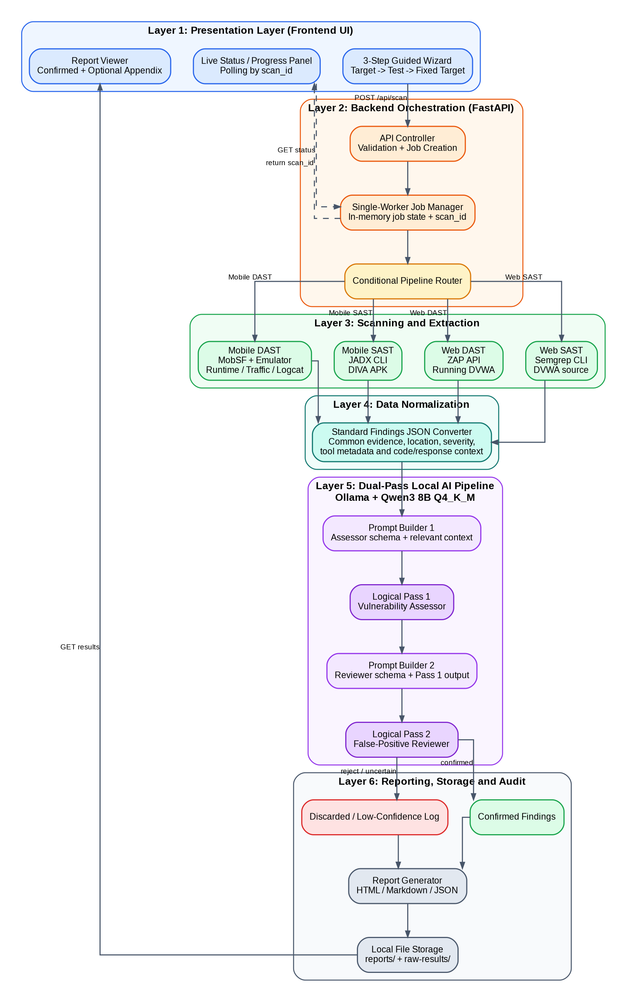
Draw.io page: "mermaid anti". The UI, orchestration, scanners, normalization, local LLM roles and report storage remain separate.

6. Technology Selection

6.1 Frontend
Selected: HTML5, Vanilla CSS and Vanilla JavaScript.
- Guided choices, status polling and report viewing are simple enough for Vanilla JavaScript.

6.2 Backend
Selected: FastAPI.
- Python fits AI and security-tool orchestration; FastAPI adds validation, JSON APIs and automatic documentation.
- Background jobs keep status and health endpoints responsive.
Async Does Not Mean Parallel Scanning
Ordered job: Scanner -> Normalizer -> Assessor -> Reviewer -> Report.
Responsive API: status requests continue, while a single-worker limit protects the 16 GB VM.

6.3 Local LLM Runtime
Selected: Ollama.
- Ollama is the local runtime and inference server; Qwen3 8B is the model.
- FastAPI calls Ollama through a local REST API.

6.4 Model Selection
Selected model: Qwen3 8B.
The model must understand code and scanner evidence, form a security reason and return structured output.
Model | Q4 Working Memory* | CPU Speed | Strength | Project Fit
Gemma 3 4B | ~5-7 GB | Very fast | Good for simple tasks | May be weak for complex review.
Qwen2.5-Coder 7B | ~6-8 GB | Fast | Excellent code focus | Strong SAST option.
Qwen3 8B - Selected | ~7-10 GB | Fast-moderate | Reasoning + code + structured output | Best balance for our 16 GB VM.
Llama 3.1 8B | ~7-10 GB | Fast-moderate | Strong general reasoning | Good alternative.
Gemma 3 12B | ~10-14 GB | Moderate-slow | Stronger writing/reasoning | Limited memory headroom.
Qwen2.5 14B | ~11-15 GB | Slow | Very strong analysis | Too heavy with scanners on this VM.
*Working-memory values are planning estimates. Actual use depends on context length, cache, operating-system overhead and active tools.
Why Qwen3 8B
Reasoning: strong enough for vulnerability explanation and false-positive review.
Code understanding: suitable for PHP, SQL and Android evidence.
Hardware fit: practical on a 16 GB VM when quantized and used one job at a time.
Output control: well suited to structured prompts and JSON responses.

6.5 Quantization Strategy
Selected: Q4_K_M quantization.
- The model remains an 8B-parameter model; parameters are not removed.
- Weights are stored at lower numerical precision, reducing file size and RAM use.
- The trade-off is a small possible quality loss in exchange for more practical CPU inference.

7. Scanner Selection
Pipeline | Selected Tool | Integration | Role
Web SAST | Semgrep | CLI + JSON output | Scan DVWA source and return candidate code findings.
Web DAST | OWASP ZAP | Local API/automation | Crawl and test the running DVWA instance.
Mobile SAST | JADX | CLI decompilation | Extract code, manifest and resources from DIVA.apk.
Mobile DAST | MobSF + emulator | Local dynamic analysis | Collect runtime, traffic and log evidence.

7.1 Target Handling
- DVWA SAST uses the local source-code folder.
- DVWA DAST uses the URL of the locally running application.
- DIVA SAST uses the APK file without running the app.
- DIVA DAST requires the APK to run in an emulator or approved test device.
Boundary: the tools collect evidence; the local LLM makes the vulnerability judgment.

8. AI Pipeline
1 | Collect Evidence - Run the selected scanner and preserve its raw output.

2 | Normalize - Convert tool-specific fields into one Standard Findings JSON format.

3 | LLM Pass 1 - Assessor - Explain the issue, review context, estimate severity/confidence and suggest remediation.

4 | LLM Pass 2 - Reviewer - Check the original evidence and decide confirmed, rejected or manual review.

5 | Report - Place only confirmed findings in the main report and keep rejected items in an appendix/log.

8.1 Standard Finding Fields
Identity | Evidence | Assessment | Decision
scan_id, target type, test type, tool | title, location, code/HTTP/runtime context | severity, confidence, reasoning, remediation | confirmed, rejected or manual review

8.2 Failure Handling
Failure | Planned Response
Scanner missing/crashes | Mark failed, save logs and stop before LLM review.
Scanner timeout | Terminate where possible and show a timeout status.
Ollama/model unavailable | Save evidence, mark AI stage failed and do not confirm alerts.
Invalid LLM JSON | Validate, retry once and then send to manual review.
Job already active | Queue or return a busy response; do not start another heavy job.
Browser refresh | Continue the backend job and reconnect using scan_id in localStorage.

9. Conclusion
Final design direction: a simple local interface, FastAPI orchestration, one selected scanner, standardized evidence, Qwen3 8B Q4_K_M through Ollama, an independent second review and a clear final report.
Why this fits our environment: it keeps the workload controlled on the 16 GB VM and avoids unnecessary components such as a database, concurrent heavy scans or separate model instances.
Next implementation milestone: complete one vertical slice - Web SAST on DVWA using Semgrep -> normalization -> Assessor -> Reviewer -> local report. The other pipelines will then reuse the same core.

