Analyzing the Tooth Growth under some supplements
Taha Bakhouch.
Summary of data
In this project , we will study the data available in the dataFrame ToothGrowth.
Using the summary R command we get :

> summary(ToothGrowth)
len supp dose
Min. : 4.20 OJ:30 Min. :0.500
1st Qu.:13.07 VC:30 1st Qu.:0.500
Median :19.25 Median :1.000
Mean :18.81 Mean :1.167
3rd Qu.:25.27 3rd Qu.:2.000
Max. :33.90 Max. :2.000

TootGrowth contains 3 columns :
-length : the length of a tooth of the pig
-supp : supplement used on that pig
-dose : the dose of the supplement used on the pig
Exploratory Analysis :
In the following figure, we can see boxplots that represent the lengths of Tooths under a particular dose (0,5 - 1 or 2) of a particular supplement (OJ or VC).
We can remark two type of relations :

- For the same quantity of the dose, it seems that the length of tooths of OJ suppliment are bigger that the length of tooths of PJ suppliment .
- Using the same supplement , we can see for highier dose : It seems , we get bigger length
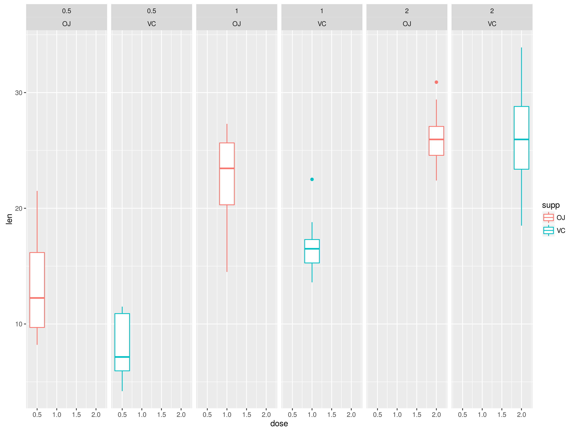
> groupedData<-group_by(ToothGrowth,supp)
> qplot(dose, len,data = groupedData,geom = c("boxplot"),facets = .~dose*supp, colour=supp)

let's extract data before testing hypotheses .
##extracting data
ToothOneDose<-ToothGrowth[ToothGrowth$dose==0.5,]
Oj1<-ToothOneDose[ToothOneDose$supp=="OJ",]
Vc1<-ToothOneDose[ToothOneDose$supp=="VC",]
ToothTwoDose<-ToothGrowth[ToothGrowth$dose==1.0,]
Oj2<-ToothTwoDose[ToothTwoDose$supp=="OJ",]
Vc2<-ToothTwoDose[ToothTwoDose$supp=="VC",]
ToothTreeDose<-ToothGrowth[ToothGrowth$dose==2,]
Oj3<-ToothTreeDose[ToothTreeDose$supp=="OJ",]
Vc3<-ToothTreeDose[ToothTreeDose$supp=="VC",]

Testing : Highier Dose => More Growth ?

To test this hypothese , we will perform the student test under the following hypotheses :

H0 : Mean(d1(supplement_i)) = Mean(d2(supplement_i))

Ha : Mean(d1(supplement_i)) = Mean(d2(supplement_i))

where d1(supplement_i) is the sample of tooths that mesured with supplement_i and dose 0,5 .
supplement_ i can be either OJ or VC.

The results of computing the p-values ,using R :
 | OJ | VC
Dose from 0,5 to 1 | 4.39246e-05 | 3.405509e-07

So we can reject the H0 hypotheses under 5% of risk1 and accept that by increasing the dose from 0,5 to 1 , we have bigger tooths

>t.test(x=Oj1$len ,y= Oj2$len,paired = FALSE ,alternative = c("less"))$p.value
>t.test(x=Vc1$len ,y= Vc2$len,paired = FALSE ,alternative = c("less"))$p.value

We do the same thing, comparing the doses of 1 and 2 , we get :

 | OJ | VC
Dose : from 1 to 2 | 0.01959757 | 4.577802e-05

The experiences confirm that more dose implies more more growth.
>t.test(x=Oj2$len ,y= Oj3$len,paired = FALSE ,alternative = c("less"))$p.value
>t.test(x=Vc2$len ,y= Vc3$len,paired = FALSE ,alternative = c("less"))$p.value

Testing: Highier OJ => More VC?
For this test , we will try to see if the data can confirm that OJ is better than VC

We will realize the test for each dose.

The null hypotheses are : OJ has the same effect as VC.the alternative hypotheses are that OJ mean are better that VC.
Dose | 0,5 | 1 | 2
p_Value | 0.003179303 | 0.0005191879 | 0.5180742

For dose of 0,5 or 1 , p values are too lows , we can reject the null hypotheses and accept the fact of that OJ is better VC.

However , for the dose = 2 , p value is too high , we can't reject the null hypothese.

## for 0.5 of dose
t.test(x=Oj1$len ,y= Vc1$len,paired = FALSE ,alternative = c("greater"))$p.value
## for 1 of dose
t.test(x=Oj2$len ,y= Vc2$len,paired = FALSE ,alternative = c("greater"))$p.value
## for 2 of dose
t.test(x=Oj3$len ,y= Vc3$len,paired = FALSE ,alternative = c("greater"))$p.value

