**ERD :**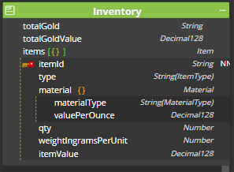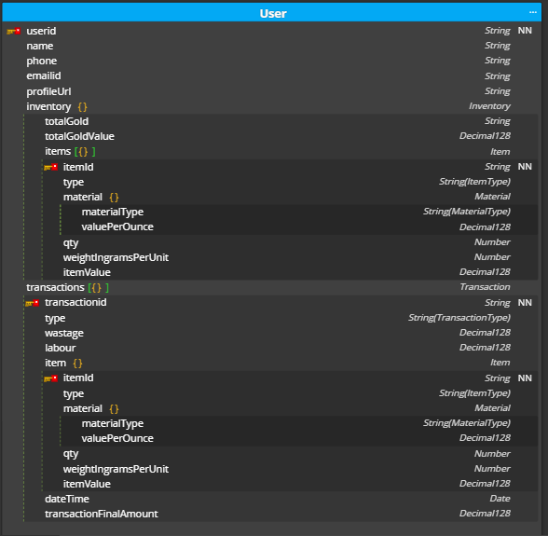

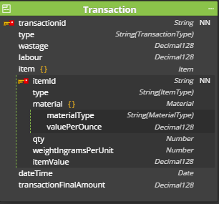

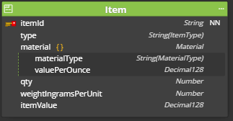

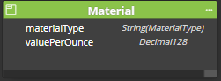

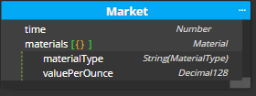

**Schema/Script:**

var mongoose = require('mongoose');

var Schema = mongoose.Schema;

var User = new Schema({

userid: {

type: String,

required: true

},

name: {

type: String

},

phone: {

type: String

},

emailid: {

type: String

},

profileUrl: {

type: String

},

inventory: {

totalGold: {

type: String

},

totalGoldValue: {

type: Schema.Types.Decimal128

},

items: [{

itemId: {

type: String,

required: true

},

type: {

type: String,

enum: ["ring", "earring", "pendant", "chain", "bangle", "bracelet", "necklace", "nosepin"]

},

material: {

materialType: {

type: String,

enum: ["gold", "silver"]

},

valuePerOunce: {

type: Schema.Types.Decimal128

}

},

qty: {

type: Number

},

weightIngramsPerUnit: {

type: Number

},

itemValue: {

type: Schema.Types.Decimal128

}

}]

},

transactions: [{

transactionid: {

type: String,

required: true

},

type: {

type: String,

enum: ["buy", "sell"]

},

wastage: {

type: Schema.Types.Decimal128

},

labour: {

type: Schema.Types.Decimal128

},

item: {

itemId: {

type: String,

required: true

},

type: {

type: String,

enum: ["ring", "earring", "pendant", "chain", "bangle", "bracelet", "necklace", "nosepin"]

},

material: {

materialType: {

type: String,

enum: ["gold", "silver"]

},

valuePerOunce: {

type: Schema.Types.Decimal128

}

},

qty: {

type: Number

},

weightIngramsPerUnit: {

type: Number

},

itemValue: {

type: Schema.Types.Decimal128

}

},

dateTime: {

type: Date

},

transactionFinalAmount: {

type: Schema.Types.Decimal128

}

}]

});

var mongoose = require('mongoose');

var Schema = mongoose.Schema;

var Market = new Schema({

time: {

type: Number

},

materials: [{

materialType: {

type: String,

enum: ["gold", "silver"]

},

valuePerOunce: {

type: Schema.Types.Decimal128

}

}]

});