TREASURY RISK REPORT

Cash Flow Pattern Analysis
  - Weekly stress, volatility, confidence intervals, and seasonality
Module 4 | Historical period: January 2021 - December 2024

EXECUTIVE SIGNAL
All 210 weekly aggregates are negative. The analysis therefore ranks relative vulnerability using the bottom decile; the result should be reconciled to bank-settled cash before funding decisions.

Executive summary
Treasury vulnerability is broad rather than isolated: every weekly aggregate is negative. The 21 most severe weeks (bottom 10%) are treated as stress weeks, with the worst week beginning 23 January 2023 at $-121.6 million.
A simple rolling forecast is directionally useful but not decision-grade on its own. Its nominal 95% prediction interval covered 90.9% of one-step observations, below the target, and averaged $53.6 million wide. Executives should use ranges and liquidity scenarios, not point estimates.
No reliable recurring annual seasonality is detected: week-of-year ANOVA p=0.715 and lag-52 autocorrelation=-0.069. May-July have the weakest average profiles, but this does not repeat strongly enough to call a stable seasonal cycle.

Decision dashboard
Measure | Result | Executive interpretation
Weeks analyzed | 210 | Complete weekly coverage over the observed period
Relative stress weeks | 21 (10%) | Bottom-decile early-warning set
Worst week | 23 Jan 2023 | -$121.6m | Largest observed weekly shortfall
95% interval coverage | 90.9% | Under target; uncertainty is understated
Average interval width | $53.6m | Material forecast dispersion
Annual seasonality | Not supported | Do not rely on fixed annual timing alone

1. Weekly cash flow and central tendency
Weekly cash flow remains below zero throughout the sample. The 13-week rolling mean smooths short-term noise but confirms that the negative pattern is persistent rather than confined to a few outliers.
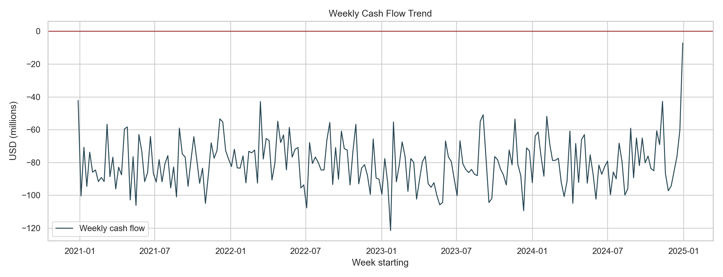
Figure 1. Weekly cash flow trend; zero is shown as the risk reference line.
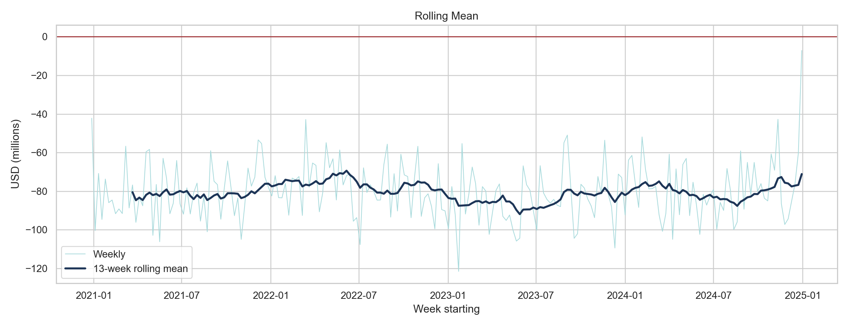
Figure 2. Weekly cash flow and 13-week rolling mean.

2. Volatility and forecast uncertainty
Volatility varies materially over time. The average one-step 95% prediction range is $53.6 million wide. Empirical coverage of 90.9% means roughly 9.1% of realized weeks fell outside the nominal band, so the rolling-normal model is overconfident.
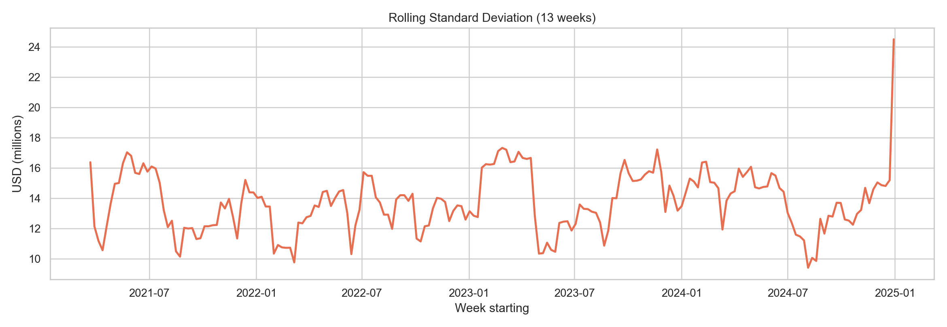
Figure 3. Rolling 13-week cash-flow volatility.
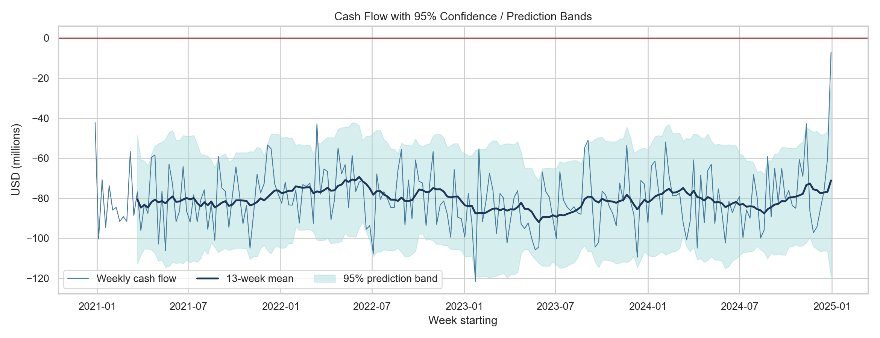
Figure 4. Rolling mean with 95% prediction bands (mean +/- 1.96 standard deviations).

3. Treasury stress periods
Because all weekly aggregates are negative, a zero-based shortage flag would label the entire period. For prioritization, stress is defined retrospectively as the lowest 10% of weekly cash flows. This is a relative severity rule, not a solvency test.
Rank | Week starting | Cash flow | 13-week volatility
1 | 23 Jan 2023 | $-121.6m | $16.0m
2 | 11 Dec 2023 | $-109.5m | $14.8m
3 | 04 Jul 2022 | $-107.7m | $15.7m
4 | 17 May 2021 | $-106.2m | $16.3m
5 | 22 May 2023 | $-105.9m | $10.6m
6 | 01 Nov 2021 | $-105.0m | $13.7m
7 | 08 Apr 2024 | $-105.0m | $16.0m
8 | 18 Sep 2023 | $-104.5m | $15.6m
9 | 29 May 2023 | $-104.4m | $10.5m
10 | 03 May 2021 | $-102.9m | $15.0m
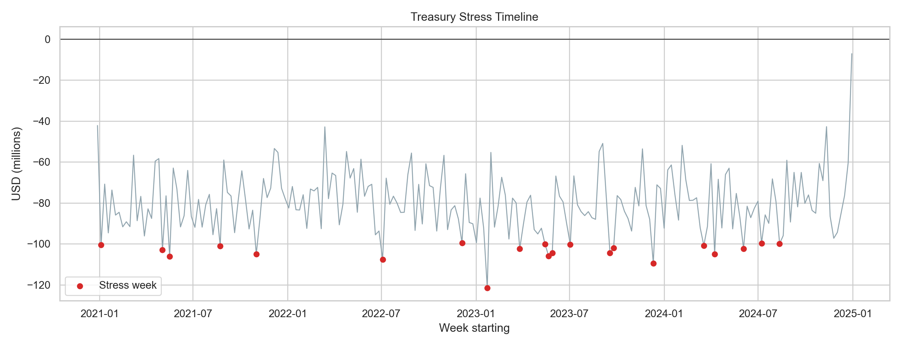
Figure 5. Bottom-decile treasury stress weeks highlighted in red.

4. Seasonal pattern analysis
Cash-flow fluctuations do not show convincing annual recurrence. The week-of-year comparison is not statistically significant (p=0.715), while lag-52 correlation is near zero (-0.069). May, June, and July are weakest on average, but the evidence supports monitoring them as watch months rather than treating them as predictable seasonal shortages.
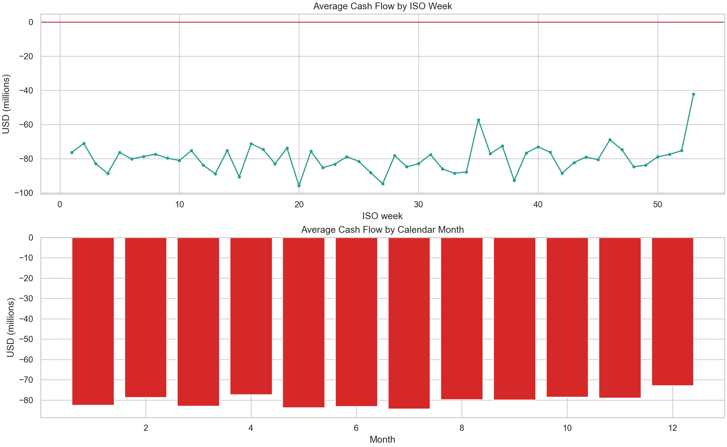
Figure 6. Average cash flow by ISO week and calendar month.

5. Activities coinciding with shortages
Stress weeks coincide with lower revenue and higher operating, penalty, logistics, and procurement costs. These comparisons are associations and do not establish causality.
Activity | Stress difference | Normal mean | Stress mean
Revenue | -10.0% | $6.36m | $5.72m
Procurement cost | +2.8% | $2.25m | $2.31m
Logistics cost | +8.1% | $0.14m | $0.15m
Operational cost | +16.0% | $0.15m | $0.17m
SLA penalties | +11.7% | $0.24m | $0.27m
Transaction count | +5.3% | 313 | 329
Priority investigation: operational costs (+16.0%), SLA penalties (+11.7%), logistics costs (+8.1%), and revenue (-10.0%) show the largest relevant shifts during stress weeks.

6. Executive answers and recommendations
During which weeks is treasury most vulnerable? The bottom-decile weeks in the table and timeline are most vulnerable. The peak observed shortfall is the week of 23 January 2023 at -$121.6 million.
Are fluctuations seasonal? Not reliably. May-July are weak on average, but formal tests do not show stable annual recurrence.
Which activities coincide with shortages? Lower revenue and higher operational costs, SLA penalties, logistics costs, and procurement costs coincide with stress weeks. These are investigation leads, not causal proof.
How confident can executives be? Moderate at best for broad ranges, low for point forecasts. Nominal 95% bands achieved only 90.9% coverage and were $53.6 million wide on average.

Recommended controls
- Reconcile transaction-level cash_flow_usd to bank-settled movements and opening/closing cash balances.
- Use a 13-week rolling forecast with base, downside, and severe-downside liquidity scenarios.
- Trigger review when forecast cash enters the historical bottom decile or realized cash breaches the lower prediction band.
- Create operating-owner alerts for revenue softness, operational-cost spikes, SLA penalties, and logistics overruns.
- Recalibrate interval coverage quarterly; widen buffers if empirical coverage remains below 95%.

Methodology and limitations
Records were aggregated into Monday-starting ISO weeks. Rolling mean and sample standard deviation use 13 weeks. The displayed confidence bands are prediction intervals, not confidence intervals for the mean. One-step coverage uses only prior observations. Seasonality was assessed using week-of-year ANOVA, lag-52 autocorrelation, and monthly profiles.
The source does not provide explicit bank reconciliation, payment due dates, opening liquidity, credit-facility availability, or causal event labels. All weekly sums are negative, which may reflect accounting construction or data-quality/sign conventions. The stress rule is retrospective and relative. Operational associations may be confounded by transaction volume and business scale.

