Hospital Appointment System

System Design

v1.1

15.12.2019

Atanur Demir
Şükrü Taha Demirer

Prepared for
SE301 Software Engineering


Table of Contents
1. Introduction 1
1.1. Purpose of the System 1
1.2. Design Goals 1
1.3. Definitions, Acronyms, and Abbreviations 1
1.4. References 1
2. Survey of Current Architectures for Similar Systems 1
3. Proposed Software Architecture 1
3.1. Overview 1
3.2. System Decomposition 1
3.3. Hardware Software Mapping 2
3.4. Persistent Data Management 2
3.5. Access Control and Security 2
3.6. Global Software Control 2
3.7. Boundary Conditions 2
4. Subsystem Services 2
5. References 2

Introduction
This System Design Document for HAS (called as Hospital Appointment System) project provides the complete description of the system. This document also mostly follows the functionalities identified in the SDD document of the project, however some changes has been made in the structural arrangement of the system and all these changes were stated under the related subsections.

As we identified before starting the project, HAS is a web development project and we wrote this project using the Python language and its framework, Django. In addition, we used the MYSQL database for HAS. This database is kept on an online platform (Heroku) in accordance with our web development project.

The concepts and explanations (determination of functional and nonfunctional requirements, writing scenarios, drawing the use-case diagram etc.) that are of great importance in the project development process can be found in the RAD document that we have submitted before.

Purpose of the System
HAS is a replica of an existing hospital appointment system called as MHRS. MHRS acts as a website where only patients can make appointments, view them, change them etc. Doctors do not use this system, each doctor uses a system specific to their own hospital to view appointments and patients, etc. Our aim is to bring both the doctor and the patient together on the same platform within the HAS system.

Design Goals
- Usability: We aim to ensure that the majority of users, both doctors and patients, can easily use the system. In order to achieve this, we try to comply with the template design and the other design methodologies.

- Reusability: In our system, all users can perform their own operations more than once. Functions can be used multiple times without any need to make changes to the system.

- Privacy: Users' personal data (user names, user id no, user phone numbers etc.) should be kept confidential in the system. Our design goal is to keep user data free from potential threats.

- Learnability: We emphasize that the functions within the system are easy to understand. In order to achieve this, we pay attention to the descriptions of the functions, the placement of the buttons and the warning messages on the designed .html pages.

- Accessibility: We aim to make HAS system suitable for every user and a place where every user can be reached. Our system can be accessed online from every interface, and will be available to different users, such as visitors, doctors, admin and patients.

- Maintainability: Has system should be designed in such a way that it is suitable for external intervention whenever required. In order to achieve this, we have given the necessary permissions to the Admin. Administrators will be able to intervene in any aspect of the system and provide the necessary maintenance.

- Reliability: Our system should be in a structure that will not collapse and continue to function in case of potential problems. In accordance with HAS project and the languages we use, we preferred Heroku hosting system. Thanks to this system, the system will be able to continue to operate in a reliable structure without any problems.

- Performance: Our users should not experience performance problems in the system. Users should not wait more than five seconds while being transferred from one page to another. Likewise, users should not wait more than five seconds when login or logout. Our design goal is that the reaction rate of HAS does not exceed the time we have determined.

Definitions, Acronyms, and Abbreviations
HAS | Hospital Appointment System
SDD | System Design Document
RAD | Requirements Specification and Analysis
MHRS | Merkezi Hekim Randevu Sistemi
MVT | Model – View – Template
MVC | Model – View – Controller
RBAC | Role-Based Access Control

References
MHRS Website: https://www.mhrs.gov.tr/

Survey of Current Architectures for Similar Systems
Django websites:
- Disqus
- Bitbucket
- Instagram
- Mozilla Firefox
- Pinterest
- NASA
- Onion
- Mahalo
- The Washington Post
- Eventbrite

All of these uses MVT design pattern with Django Framework

Proposed Software Architecture
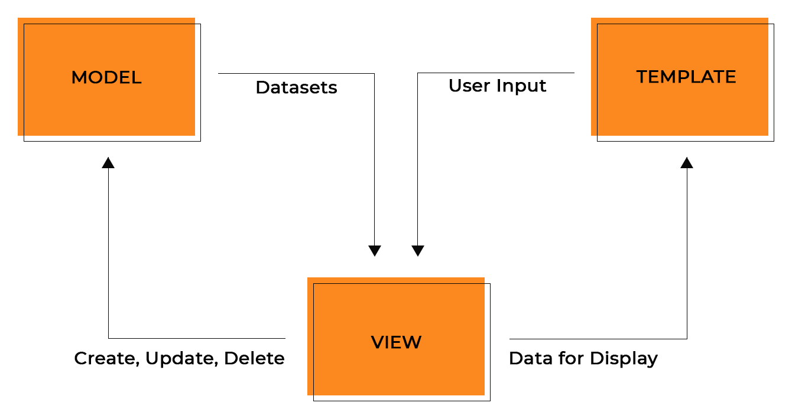

Overview
The HAS system uses Django, a framework for Python language. Django is a high-level Python web framework that enables rapid development of secure and maintainable websites. In addition, it has a design pattern in itself called as MVT pattern.

In a traditional data-driven website, a web application waits for HTTP requests from the web browser (or other client). When a request is received the application works out what is needed based on the URL and possibly information in POST data or GET data. Depending on what is required it may then read or write information from a database or perform other tasks required to satisfy the request. The application will then return a response to the web browser, often dynamically creating an HTML page for the browser to display by inserting the retrieved data into placeholders in an HTML template.

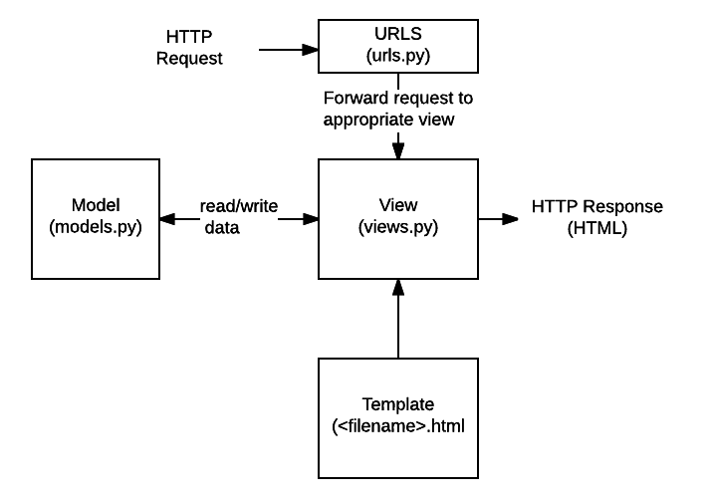
Django web applications typically group the code that handles each of these steps into separate files:

URLs: While it is possible to process requests from every single URL via a single function, it is much more maintainable to write a separate view function to handle each resource. A URL mapper is used to redirect HTTP requests to the appropriate view based on the request URL. The URL mapper can also match particular patterns of strings or digits that appear in a URL and pass these to a view function as data.

View: A view is a request handler function, which receives HTTP requests and returns HTTP responses. Views access the data needed to satisfy requests via models, and delegate the formatting of the response to templates.

Models: Models are Python objects that define the structure of an application's data, and provide mechanisms to manage (add, modify, delete) and query records in the database.

Templates: A template is a text file defining the structure or layout of a file (such as an HTML page), with placeholders used to represent actual content. A view can dynamically create an HTML page using an HTML template, populating it with data from a model. A template can be used to define the structure of any type of file; it doesn't have to be HTML!

System Decomposition
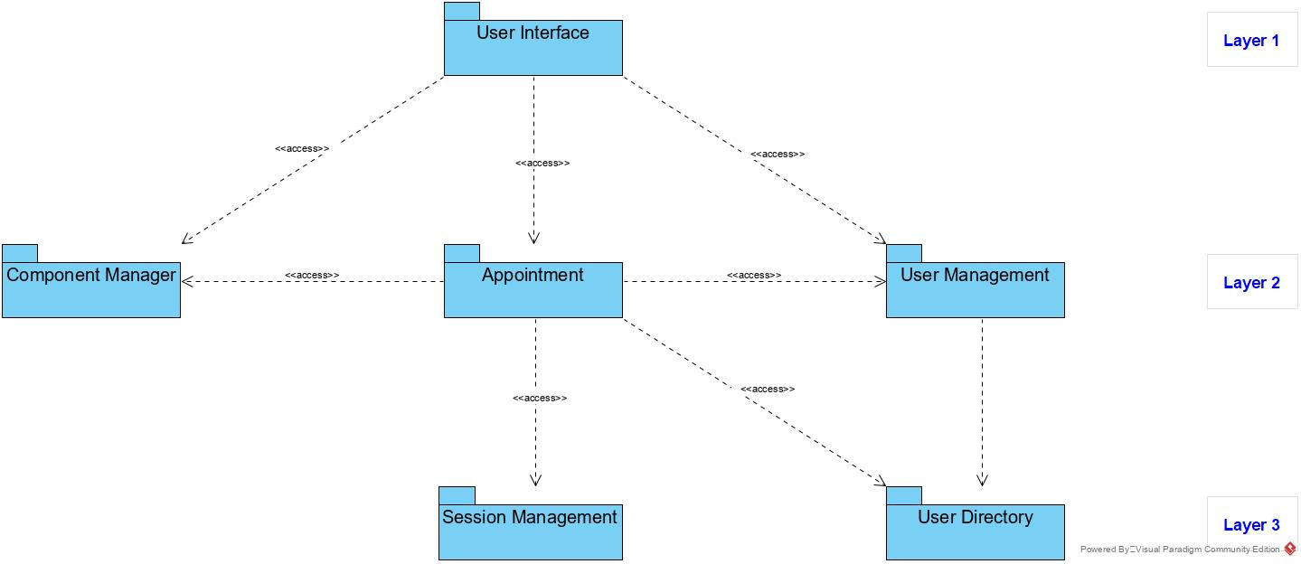

- User Interface: UI, in the industrial design field of human–computer interaction, is the space where interactions between humans and machines occur. In our system, whichever type of user you are, you are greeted with an interface that suits your user type. This includes a page with admin functions for admins, pages where patients and doctors can perform their own functions, and even a home screen for visitors. All operations are maintained and performed within the UI subsystem.

- User Management: Administers user accounts stores in this subsystem. This subsystem provides the necessary conditions for the admin. These conditions include storing admin account data and granting admin permissions.

- Appointment: It is the authorized subsystem for making, viewing, editing and deleting appointments. User inputs related to the appointments go to ‘Appointment’ and are performed in this subsystem.

- User Directory: Stores different user profiles. These are first & second names, usernames, passwords, birth dates, genders, addresses, id no, phone numbers and occupations.

- Component Management: Stores appointments, patient lists, hospitals, doctor lists, districts and provinces, permissions and user groups. Unlike other subsystems, it collects data on an online platform. Therefore, it is an online subsystem.

Hardware Software Mapping
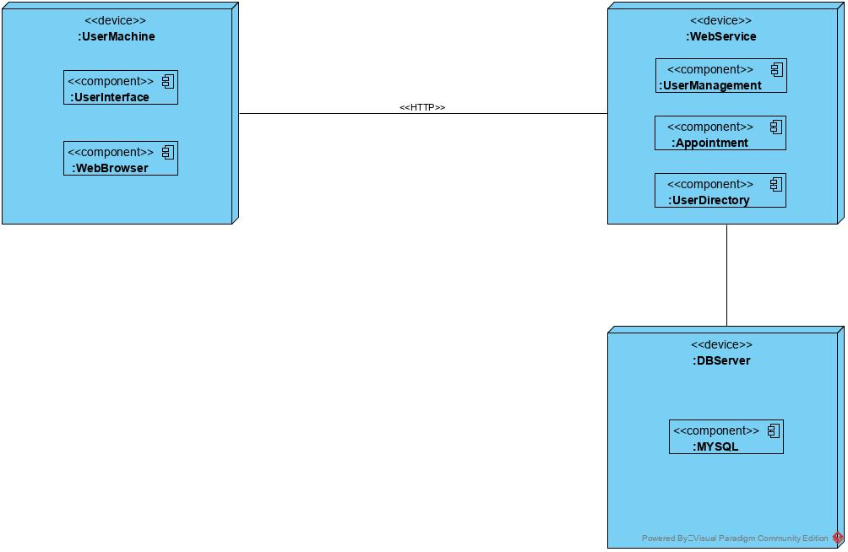

Persistent Data Management
The persistent data will be stored (at least in the first build) in the file system. The used file types include

- WDL files (workflow description language)
- HTML and media files (for UI)
- XML files, for example for the world model or for configuration files

Furthermore, the protocol data for a taskflow as well as the car history has to be stored. The file formats for those still have to be determined.

Hospital Appointment System is a web application that allows taking appointments and viewing them to its users. Therefore, it stores user accounts. System stores names, usernames, passwords, id no, phone numbers, addresses and occupations of the users by using MYSQL Database. The system also stores appointments info to carry out to our main services (for functions: view appointment, edit appointment)

The system stores date joined, email address, first name, last name, last login, user type, password and username of the users using MYSql. The system also stores carry out its main services. In addition, system stores permissions and the user groups to which these permissions are connected. User groups connected with functions (and naturally, subsystems) These functions are: login and logout, forgot password, change user info, register hospitals, register doctors, register patients (and view all of them), take appointment, give prescription and sending comments to admin.

Access Control and Security
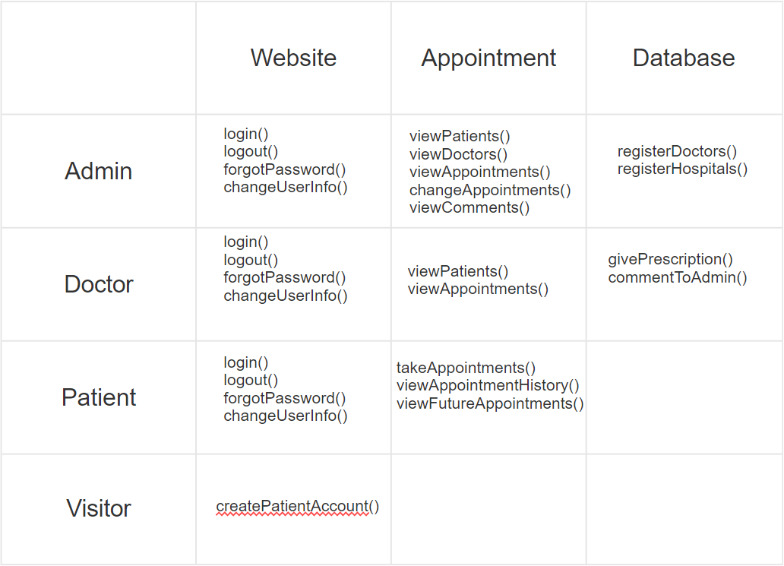

Access control is a security technique that regulates who or what can view or use resources in a computing environment. It is a fundamental concept in security that minimizes risk to the business or organization. Our HAS system uses ‘RBAC’ access control.

HAS have 4 different types of user:
- Admin
- Doctor
- Patient
- Visitor

Each one has different role and permissions. This control mechanism can easily be seen on the above scheme. For instance, Visitors don’t create a doctor account, they can online create a patient accounts. As opposed to this, admins can create doctors and hospitals.

RBAC: A widely used access control mechanism that restricts access to computer resources based on individuals or groups with defined business functions -- executive level, engineer level 1 -- rather than the identities of individual users. The role-based security model relies on a complex structure of role assignments, role authorizations and role permissions developed using role engineering to regulate employee access to systems. RBAC systems can be used to enforce MAC and DAC frameworks.

Global Software Control
- Login Request: It can only be used by doctor, admin and patient. This request goes to the user directory.
- Logout Request: It can only be used by doctor, admin and patient. This request goes to the user directory.
- Register Request: It can only be used by visitor and admin. This request goes to the user directory.
- Appointment Operations Request: Available only to registered users. This request goes to the ‘Appointment’ subsystem.
- Add Info to Database Request: Available only to registered users. This request goes to the ‘Component Management’ subsytem.
- View Info from Database Request: Available only to registered users. This request goes to the ‘Component Management’ subsytem.

Boundary Conditions
- Start-up: Any type of user enters the site via a browser. Depending on the type of user, the system will display the appropriate user page to her/him. When the user type changes, the page shown also changes.
- Shutdown: As long as the system is hosted on an online system, it does not shut down. It can only be maintenance by admins. In this case, the site is completely closed and non-admin users cannot access the site.
- Error: In some cases, users may receive error messages. The first is that the site tries to enter a wrong link. The second is that the wrong user type attempts to access the wrong page. The last one is to try to access the closed site.

Subsystem Services
- User Interface: All .html files.
- User Management: Store admin user accounts.
- Appointment: Take appointment, view appointment, edit appointment.
- User Directory: Stores different user account infos.
- Component Management: Stores appointments, patient lists, hospitals, doctor lists, districts and provinces, permissions and user groups.

References
- https://kubernetes.io/
- https://searchsecurity.techtarget.com/
- https://www.softwaretestinghelp.com/
- http://ddi-dev.com/
- https://www.djangoproject.com/

