IŞIK UNIVERSITY

ENGINEERING FACULTY

COMPUTER SCIENCE AND ENGINEERING DEPARTMENT

CSE342

2nd PROJECT PROPOSAL

“Seed Sowing Robot Arm”

Project Team: Şükrü Taha Demirer

Emre Yasin Nalbant

Requirements:

* 4x MG996R Servo Motors
* Robotic arm components
* ESP8266 NodeMCU
* Jumper Wires
* Push Buttons
* 10K Ohm Resistors

Summary:

In Agricultural Sector, planting/sowing seeds are a problem which consumes so much time and demands so much human power. To decrease these outgoings, a robot arm will be helpful and beneficial. With that automated robotic system, time and human power needed will decrease.

Design:

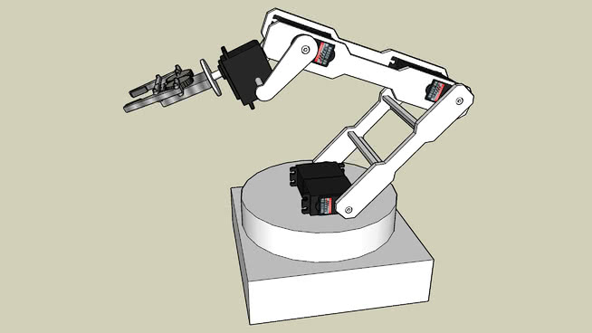

Robotic Arm Design

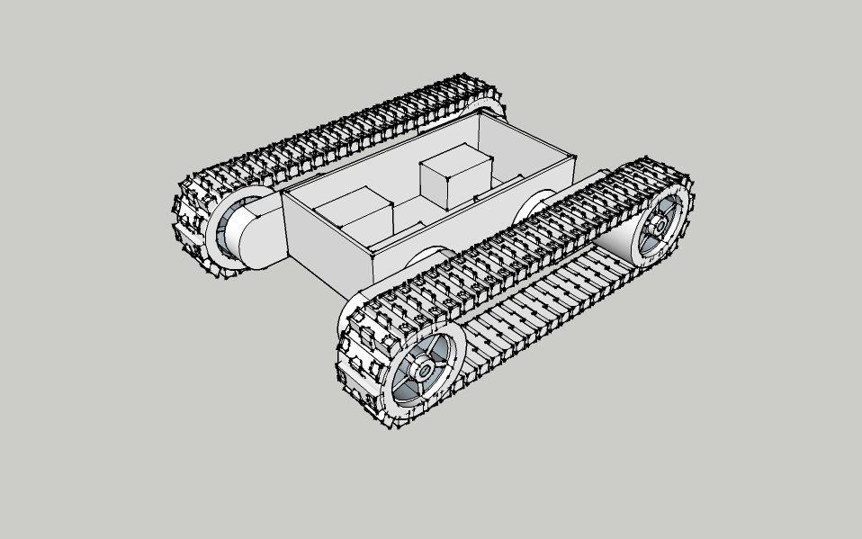

Lower Tank Chassis Design

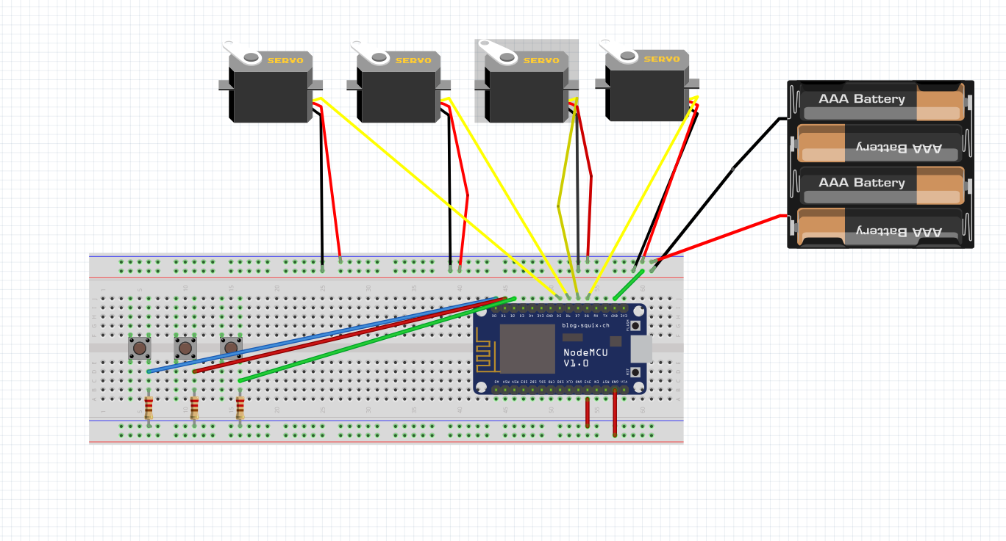

Circuit Diagram

Implementation:

* Source Code is in at ZIP file named CSE342PROJE.

Results:

Robotic arm is implemented successfully and worked correctly with the WiFi module working on Blynk App.

With the push buttons, a program can be uploaded step by step and runs automatically.

With the third button, ESP8266 module goes to Deep Sleep for 5 secs.