Tumor Microenvironment Imaging Signatures for Predicting Immunotherapy Response in Melanoma: A Multiplexed Ion Beam Imaging Feasibility Analysis
Short title: Imaging signatures of immunotherapy response in melanoma

Abstract
Background: Multiplexed ion beam imaging (MIBI) resolves the spatial organization of the tumor microenvironment (TME) at single-cell resolution. Whether MIBI-derived spatial features of the melanoma TME predict response to immunotherapy remains incompletely established in small, publicly available cohorts.
Methods: We analyzed a publicly available, processed MIBI dataset of 54 melanoma patients treated with immunotherapy (54,989 segmented cells, 29-marker protein panel, cell centroid coordinates). Cells were assigned to lineages (tumor, T-cell subsets, B cells, NK cells, myeloid cells, endothelium, stroma, lymphatics) using per-marker 80th-percentile positivity gating. Per-patient features were engineered across four domains: immune cell density, spatial proximity (nearest-neighbor distance, NND), spatial clustering (a Ripley's K-derived index), and PD-L1 expression. A random forest classifier was evaluated for responder (CR/PR) versus non-responder (SD/PD) discrimination using leave-one-out cross-validation (LOOCV), pre-specifying an 11-feature hypothesis-driven model. Baseline clinical stage was evaluated as a comparator.
Results: The pre-specified imaging-feature classifier did not discriminate responders from non-responders (LOOCV AUC = 0.33, accuracy 44%), performing worse than chance. No individual imaging feature reached statistical significance in univariate comparison (all p > 0.10), although CD8+ T-cell fraction and CD8+T-to-tumor proximity trended in the biologically expected direction. Baseline clinical stage alone significantly discriminated response (LOOCV AUC = 0.60; Spearman rho = -0.41, p = 0.002).
Conclusions: In this small, single-cohort feasibility analysis, MIBI-derived spatial and compositional TME features did not provide a validated predictive biomarker of immunotherapy response and did not outperform simple clinical staging. These results argue for cautious interpretation of small-cohort spatial-imaging biomarker studies and for validation in larger, multi-cohort datasets before clinical application.
Keywords: multiplexed ion beam imaging; tumor microenvironment; melanoma; immunotherapy; biomarker; spatial analysis; PD-L1

Introduction
Immune checkpoint blockade has transformed the treatment of advanced melanoma, but only a subset of patients achieve durable responses, and pre-treatment biomarkers that reliably predict benefit remain limited in clinical practice. The tumor microenvironment (TME) - the spatial arrangement and composition of tumor, immune, and stromal cells within a lesion - has long been proposed as a source of predictive information beyond bulk molecular assays, since spatial context (e.g., whether cytotoxic T cells infiltrate the tumor core, are excluded to the tumor margin, or are absent altogether) is associated with response to anti-PD-1 therapy in melanoma.
Multiplexed ion beam imaging (MIBI) enables simultaneous, spatially resolved quantification of dozens of proteins at single-cell resolution in intact tissue sections, making it well suited to testing whether TME spatial organization carries predictive information. We used a publicly available, previously processed MIBI dataset of 54 melanoma patients who received immunotherapy to ask a focused question: can imaging-derived features of immune cell density, spatial proximity, spatial clustering, and PD-L1 expression predict binary response to immunotherapy, and how does any such signature compare with a single readily available clinical variable (stage at diagnosis)?
We pre-specified our feature-engineering and modeling plan around four analysis domains (density, proximity, clustering, PD-L1/clinical correlation) before examining outcome associations, and we report results from that pre-specified analysis alongside an honest account of the methodological decisions and their limitations, documented in full in an accompanying workflow decisions log.

Methods

Data source
We used a processed, publicly available MIBI dataset (Mendeley Data, DOI 10.17632/79y7bht7tf.1; Vesely and Johnson, Yale University School of Medicine), comprising 54 melanoma patients who received immunotherapy. The dataset provided, per cell: denoised and normalized expression of 29 proteins, centroid (x, y) coordinates and estimated cell area, and patient-level clinical variables (age tertile, stage at diagnosis, and binary and multi-category [CR/PR/SD/PD] RECIST-based response). The dataset contained 54,989 segmented cells (mean 1,018 per patient, range 489-1,784), with no missing values in any of the three source files.

Cell-lineage assignment
Because the 29-marker panel includes markers for tumor cells (SOX10), endothelium (CD31), stroma (smooth muscle actin), lymphatics (podoplanin), and myeloid cells (CD68, CD163, CD11b, CD11c, CD14) in addition to T-cell markers, all segmented cells were treated as the full cellular content of the imaged tumor microenvironment rather than a pre-sorted T-cell-only population (see Workflow Decisions Log, Decision 1). Unsupervised k-means clustering and two-component Gaussian mixture model gating were both evaluated for cell-lineage assignment and rejected because marker distributions were heavily zero-inflated, causing both methods to separate near-zero background signal rather than biologically distinct populations (Decision 2). We instead used per-marker positivity thresholds set at the 80th percentile of that marker's pooled expression across all cells, combined with a fixed-priority hierarchical decision rule (tumor > T-cell subsets/B/NK/myeloid > endothelial > lymphatic > stromal > unclassified) to assign each cell to a single lineage.

Feature engineering
For each patient we computed: (1) cell-type composition (percentage of each lineage) and density, normalized to convex-hull tissue area in the absence of a provided pixel-to-micron calibration (Decision 3); (2) spatial proximity, defined as the mean nearest-neighbor distance (NND) from CD8+ T cells to the nearest tumor cell and to the nearest myeloid cell (Decision 4); (3) a spatial clustering index for immune cells, derived from a bivariate Ripley's K statistic at a fixed radius of 50 pixels, normalized to the value expected under complete spatial randomness (Decision 6); and (4) PD-L1 expression, summarized as the mean expression in tumor cells, in immune cells, and overall, plus the percentage of PD-L1-positive cells using the same 80th-percentile convention. Four patients had no detectable CD8+ T cells and/or tumor cells under the gating scheme; per explicit analysis decision, these were coded as a distinct 'immune desert' category via binary indicator flags rather than treated as missing data (Decision 5).

Statistical analysis
Binary response (responder = CR/PR, non-responder = SD/PD, per the dataset's response_binary field) was the primary outcome. Group comparisons for individual features used the Mann-Whitney U test; the relationship between ordinal clinical stage and response used Spearman correlation and chi-square test of independence. A random forest classifier (500 trees, maximum depth 2-4, minimum leaf size 4) was evaluated using leave-one-out cross-validation (LOOCV), which was chosen over a single train/test split or k-fold CV to make full use of the small sample (n=54) while avoiding information leakage. We pre-specified an 11-feature model reflecting the four analysis domains above as the confirmatory analysis; a 35-feature model using all engineered variables was evaluated as an exploratory comparison only. A logistic regression model using clinical stage alone (ordinal, stage I-IV) was evaluated identically as a baseline comparator. All analyses were performed in Python (pandas, scikit-learn, scipy, scipy.spatial). No data were excluded from the cohort. The complete, locked analytical dataset (54 patients x 44 features) and all analytical decisions are provided as supplementary files.

Results

Cohort characteristics
Of 54 patients, 23 (43%) were classified as responders (CR/PR) and 31 (57%) as non-responders (SD/PD). Stage distribution was: stage I, 8 patients; stage II, 11; stage III, 23; stage IV, 12 (Table 1). Age at diagnosis was distributed approximately evenly across tertiles (19/17/18 patients).
Table 1. Cohort characteristics (n = 54).
Characteristic | n (%)
Response: Responder (CR/PR) | 23 (42.6%)
Response: Non-responder (SD/PD) | 31 (57.4%)
Stage I | 8 (14.8%)
Stage II | 11 (20.4%)
Stage III | 23 (42.6%)
Stage IV | 12 (22.2%)
Age tertile 1 (youngest) | 19 (35.2%)
Age tertile 2 | 17 (31.5%)
Age tertile 3 (oldest) | 18 (33.3%)
CR, complete response; PR, partial response; SD, stable disease; PD, progressive disease.

Cell-lineage composition and representative spatial architecture
Across the cohort, the gating scheme classified a mean 16.4% of cells as tumor, 16.7% as endothelial, 20.0% as immune (summed T-cell/B/NK/myeloid subsets), 7.5% as stromal, and 6.7% as lymphatic; 32.6% of cells did not meet the positivity threshold for any lineage marker and were labeled unclassified. Figure 2 shows a representative single-patient spatial map illustrating the resulting tumor/immune/stromal architecture used to derive all subsequent features.
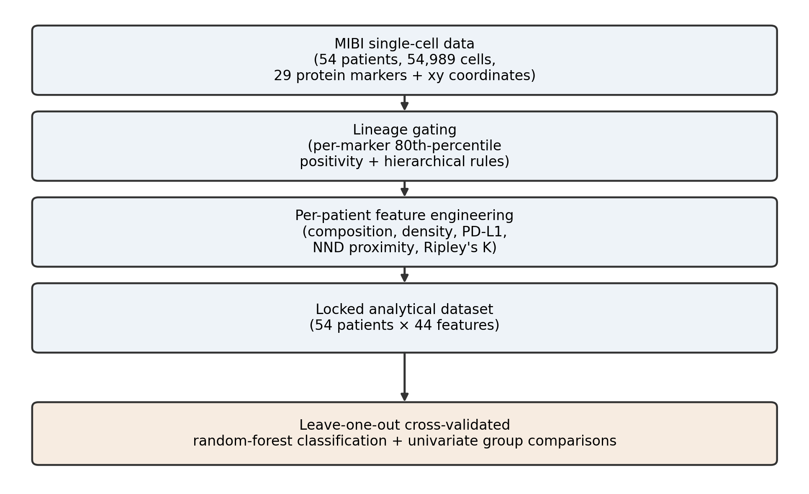
Figure 1. Analysis workflow, from raw MIBI single-cell data through lineage gating, feature engineering, and leave-one-out cross-validated classification.
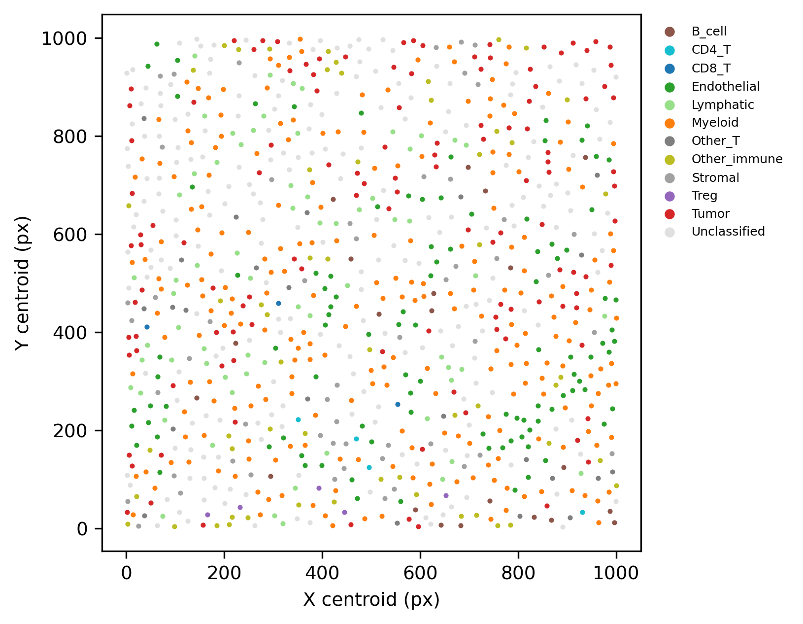
Figure 2. Representative single-patient spatial map of assigned cell lineages (patient R10C2), plotted at cell centroid coordinates.

Imaging-derived features by response group
Table 2 summarizes the pre-specified imaging features by response group. No feature reached statistical significance (all p > 0.10). CD8+ T-cell fraction was numerically higher in responders (median 1.3% vs. 0.8%, p = 0.137), and CD8+T-to-tumor and CD8+T-to-myeloid proximity were numerically shorter (closer) in responders, consistent with the expected direction of a T-cell-infiltrated, non-excluded phenotype, but neither reached significance (p = 0.211 and p = 0.278, respectively). PD-L1 expression (tumor, immune, or overall) and the Ripley's K immune-clustering index did not differ meaningfully between groups.
Table 2. Imaging-derived features by response group.
Feature | Responder  median [IQR] | Non-responder  median [IQR] | p-value
Total immune cell fraction (%) | 18.0 [12.2–27.1] | 18.9 [12.0–23.6] | 0.807
CD8+ T-cell fraction (%) | 1.3 [0.51–3.33] | 0.8 [0.27–1.86] | 0.137
CD8+ T-cell density (cells/1000 px²) | 0.0101 [0.0056–0.0329] | 0.0091 [0.0025–0.0198] | 0.162
CD8+T-to-tumor mean NND (px) | 92.9 [50.5–120] | 100 [58.3–181] | 0.211
CD8+T-to-myeloid mean NND (px) | 84.6 [63.3–112] | 102 [61.6–153] | 0.278
Immune-immune mean NND (px) | 38.1 [31.9–44.3] | 39.2 [34.2–48.0] | 0.363
Immune Ripley's K clustering index | 0.168 [0.069–0.396] | 0.216 [0.094–0.530] | 0.564
Mean tumor-cell PD-L1 expression | 0.0083 [0.0062–0.0133] | 0.0073 [0.0040–0.0119] | 0.421
Mean immune-cell PD-L1 expression | 0.0141 [0.0077–0.0222] | 0.0113 [0.0087–0.0165] | 0.540
PD-L1-positive cells, all types (%) | 21.7 [9.1–34.0] | 14.1 [8.8–24.8] | 0.401
Tumor cell fraction (%) | 13.3 [6.1–20.4] | 12.0 [5.7–20.7] | 0.875
Values are median [interquartile range]. p-values from two-sided Mann-Whitney U tests, uncorrected for multiple comparisons. NND, nearest-neighbor distance; IQR, interquartile range.
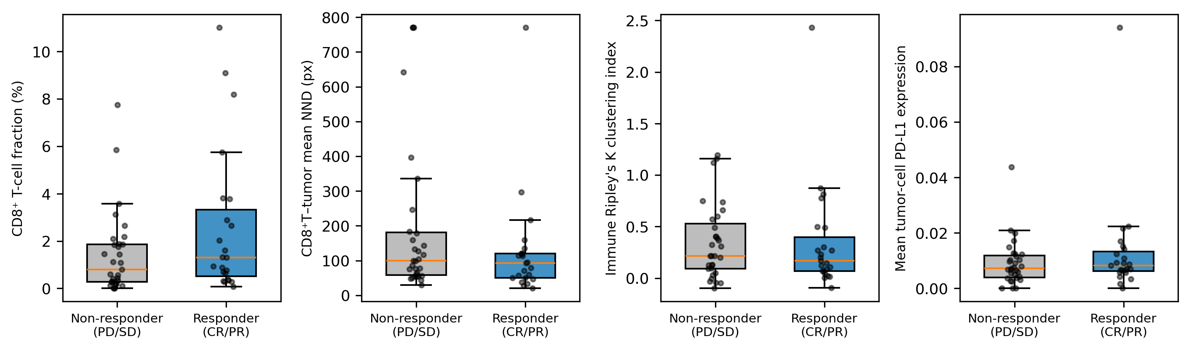
Figure 3. Distribution of four representative imaging features by response group. Boxes show median and interquartile range; points show individual patients. None of the four comparisons reached statistical significance (Table 2).

Classifier performance and comparison with clinical stage
The pre-specified 11-feature random forest classifier, evaluated by leave-one-out cross-validation, achieved an AUC of 0.33 (accuracy 44%), performing worse than chance (Figure 4). The exploratory 35-feature model performed similarly poorly (AUC 0.27-0.36 across tested tree depths). By contrast, a logistic regression model using only clinical stage at diagnosis (ordinal, stage I-IV) achieved an LOOCV AUC of 0.60, and stage was significantly associated with response (Spearman rho = -0.41, p = 0.002; chi-square test of independence across stage categories, p = 0.026): response rates were 75% (6/8) in stage I, 64% (7/11) in stage II, 35% (8/23) in stage III, and 17% (2/12) in stage IV.
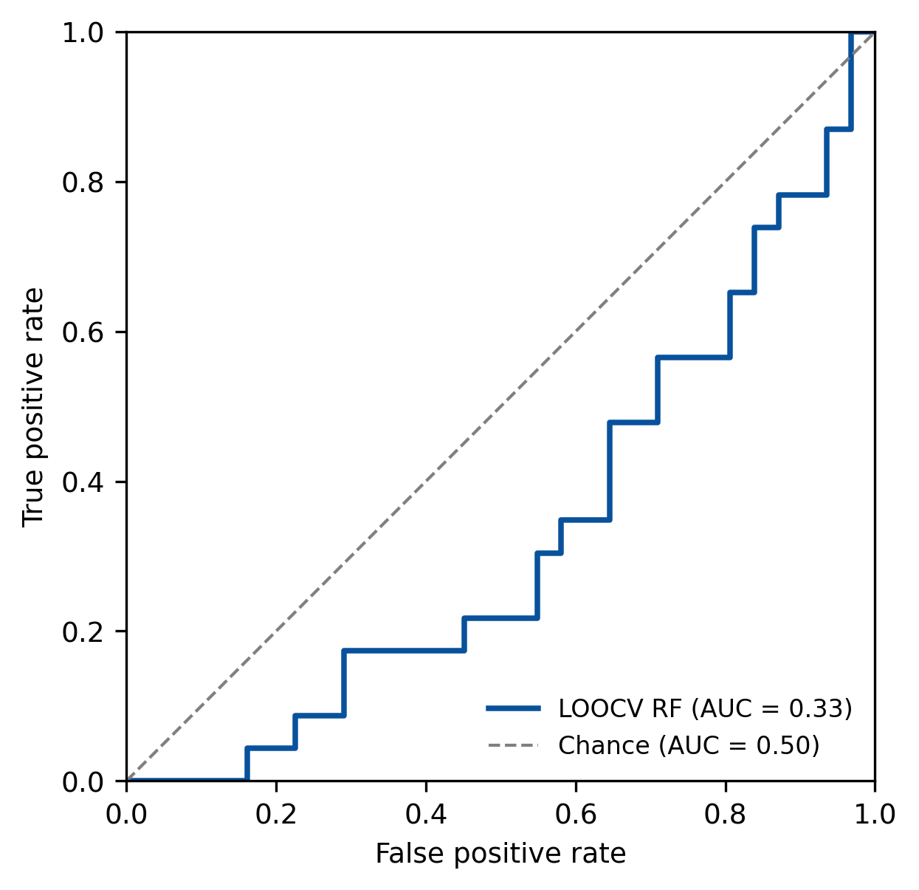
Figure 4. Receiver operating characteristic curve for the pre-specified 11-feature imaging classifier under leave-one-out cross-validation (AUC = 0.33), plotted against the chance diagonal (AUC = 0.50).

Discussion
In this feasibility analysis of a publicly available, 54-patient MIBI dataset, imaging-derived spatial and compositional features of the melanoma tumor microenvironment did not provide a validated predictive biomarker of immunotherapy response, and a pre-specified classifier built from these features performed worse than chance under honest leave-one-out cross-validation. This negative result stands in contrast to a substantial published literature linking CD8+ T-cell infiltration, spatial exclusion, and myeloid-T-cell proximity to immunotherapy response in melanoma. Two individual features here - CD8+ T-cell fraction and CD8+T-to-tumor proximity - trended in the expected biological direction, but the effect sizes were small relative to what a 54-patient cohort can resolve, and neither reached statistical significance.
Notably, a single readily available clinical variable - stage at diagnosis - significantly outperformed the full imaging-feature classifier in this cohort (LOOCV AUC 0.60 versus 0.33). This comparison is, in our view, the most clinically relevant finding of this analysis: it argues against over-interpreting small-cohort spatial-biomarker signals in isolation, and for benchmarking any proposed imaging biomarker against simple, already-available clinical covariates before ascribing it independent predictive value.
Several methodological factors likely limit the sensitivity of this analysis and should inform interpretation. First, cell-lineage assignment relied on a percentile-based gating threshold (80th percentile per marker) rather than a validated clinical cutoff, chosen because the marker expression distributions were too zero-inflated for standard unsupervised or mixture-model gating to succeed; misclassification of cell lineages would attenuate any true biological signal. Second, no pixel-to-physical-area calibration was available, so density features are reported in arbitrary units, and no edge correction was applied to nearest-neighbor or Ripley's K calculations, which can bias spatial statistics for cells near tissue-section boundaries. Third, and most importantly, a sample of 54 patients provides limited statistical power to detect small-to-moderate effect sizes, particularly once multiple candidate features are considered; a classifier evaluated by LOOCV on this sample size has wide confidence intervals around any point estimate of AUC.
These limitations do not indicate that MIBI-based spatial biomarkers are uninformative in melanoma immunotherapy; rather, they indicate that this particular 54-patient dataset, analyzed with this feature-engineering and gating strategy, does not support a validated classifier, and that any imaging biomarker proposed on the basis of small single-cohort analyses of this kind should be treated as hypothesis-generating rather than confirmatory. Larger, ideally multi-institutional MIBI cohorts with harmonized cell-segmentation and gating pipelines, and pre-registered analysis plans benchmarked explicitly against clinical covariates, are needed before spatial TME imaging features can be considered for clinical decision support in melanoma immunotherapy.

Limitations
This analysis has several limitations beyond those discussed above: (1) it is a single-cohort, retrospective, hypothesis-generating analysis without an independent validation cohort; (2) cell-lineage gating thresholds were not validated against orthogonal ground truth (e.g., pathologist-annotated regions); (3) tissue area was approximated by the convex hull of cell centroids in the absence of provided image calibration; (4) multiple comparisons across engineered features were not formally corrected, though our pre-specification of a reduced feature set was intended to limit this risk; and (5) the dataset's response labels reflect RECIST-based clinical response criteria whose relationship to the specific timing of the imaged tissue sample (e.g., pre- versus on-treatment biopsy) was not independently verifiable from the processed data provided.

Conclusions
MIBI-derived spatial and compositional features of the melanoma tumor microenvironment did not predict immunotherapy response in this 54-patient feasibility analysis, and did not outperform baseline clinical stage. CD8+ T-cell infiltration and tumor proximity trended in the expected direction without reaching significance. These results support cautious, well-powered, and clinically-benchmarked validation of spatial imaging biomarkers before their adoption as predictive tools in melanoma immunotherapy.

Data and code availability
The source dataset is publicly available at Mendeley Data (DOI 10.17632/79y7bht7tf.1). The locked analytical dataset (analytical_dataset.csv) and a complete log of analytical decisions (Workflow_Decisions.docx) generated during this analysis are provided as supplementary files.

Acknowledgments
We thank the original data contributors (M. Vesely, D. Johnson, Yale University School of Medicine) for making the processed MIBI dataset publicly available.

References
1. Ptacek J, Vesely MD, Rimm D, et al. Characterization of the tumor microenvironment in melanoma using Multiplexed Ion Beam Imaging (MIBI). J Immunother Cancer. 2021;9(Suppl 3):A59.
2. Vesely MD, Johnson D. Processed Multiplexed Ion Beam Imaging (MIBI) of tumor microenvironments of 54 melanoma samples following immunotherapy. Mendeley Data, V1, 2025. DOI: 10.17632/79y7bht7tf.1.
3. Tumeh PC, Harview CL, Yearley JH, et al. PD-1 blockade induces responses by inhibiting adaptive immune resistance. Nature. 2014;515(7528):568-571.
4. Keren L, Bosse M, Marquez D, et al. A structured tumor-immune microenvironment revealed by multiplexed ion beam imaging. Cell. 2018;174(6):1373-1387.
5. Society for Immunotherapy of Cancer. SITC cancer immunotherapy resource document: a compass in the land of biomarker discovery. J Immunother Cancer. 2020.
6. Ripley BD. The second-order analysis of stationary point processes. J Appl Probab. 1977;13(2):255-266.

