CLINICAL RESEARCH REPORT

Hypertension
Epidemiology, Pathophysiology, Diagnosis and Evidence-Based Management

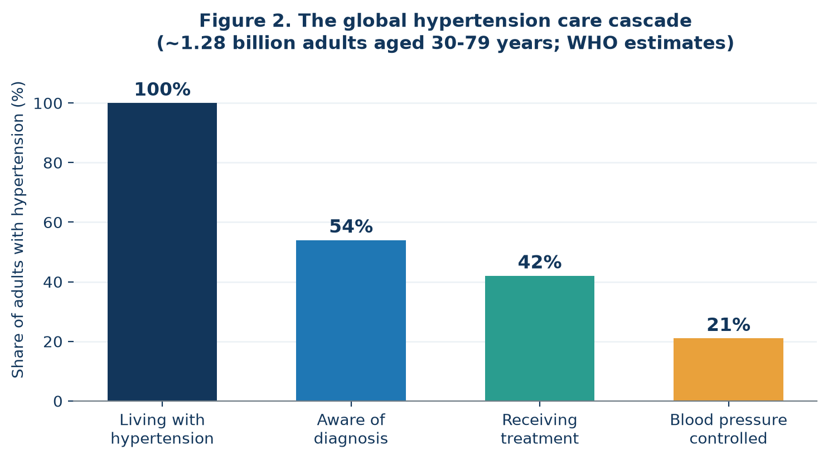

Prepared as an evidence review of the WHO Global Report on Hypertension,
the 2025 ACC/AHA High Blood Pressure Guideline and the 2024 ESC Guidelines
for the Management of Elevated Blood Pressure and Hypertension

Table of Contents
1. Executive Summary
2. Introduction and Definitions
3. Global Burden and Epidemiology
4. Pathophysiology and Risk Factors
5. Clinical Presentation and Complications
6. Diagnosis and Blood-Pressure Measurement
7. Non-Pharmacological Management
8. Pharmacological Management
9. Special Populations and Resistant Hypertension
10. Hypertensive Crises
11. Prevention and Public-Health Strategy
12. Conclusion
13. References

1. Executive Summary
Hypertension, or persistently raised arterial blood pressure, is the single largest modifiable contributor to cardiovascular disease and premature death worldwide. The World Health Organization estimates that about 1.28 billion adults aged 30-79 years live with hypertension, roughly one in three adults in that age band, and that two thirds of them live in low- and middle-income countries. The condition is usually silent: close to half of affected adults are unaware of their diagnosis, only about 42 per cent receive treatment, and only about 21 per cent achieve control.
The clinical case for action is strong and quantifiable. Meta-analyses of randomised trials show that lowering systolic blood pressure by 10 mm Hg reduces major cardiovascular events by roughly one fifth, stroke by about one quarter and heart failure by about one quarter to one third. Contemporary guidelines therefore emphasise accurate measurement, earlier risk-based treatment, lower treatment targets and simplified drug regimens built around single-pill combinations.
Key message: hypertension is common, largely asymptomatic, inexpensive to detect and highly treatable. Most of the lost benefit is not caused by a lack of effective drugs but by gaps in diagnosis, treatment initiation, titration and long-term adherence.

2. Introduction and Definitions
Blood pressure is the force exerted by circulating blood on the arterial wall. It is reported as systolic pressure (during ventricular contraction) over diastolic pressure (during ventricular relaxation) in millimetres of mercury. Risk rises continuously from systolic values as low as 115 mm Hg, so any diagnostic threshold is a pragmatic convention chosen to identify people who benefit from intervention rather than a biological cut-off.
The American College of Cardiology and American Heart Association define hypertension as an office blood pressure of 130/80 mm Hg or higher; the 2025 guideline retains the categories introduced in 2017 but places greater weight on estimated cardiovascular risk, calculated with the PREVENT equations, when deciding who should start drug therapy. The 2024 European Society of Cardiology guideline keeps the traditional 140/90 mm Hg diagnostic threshold but adds an intermediate category of 'elevated blood pressure' (120-139/70-89 mm Hg) in which treatment is decided by overall risk.
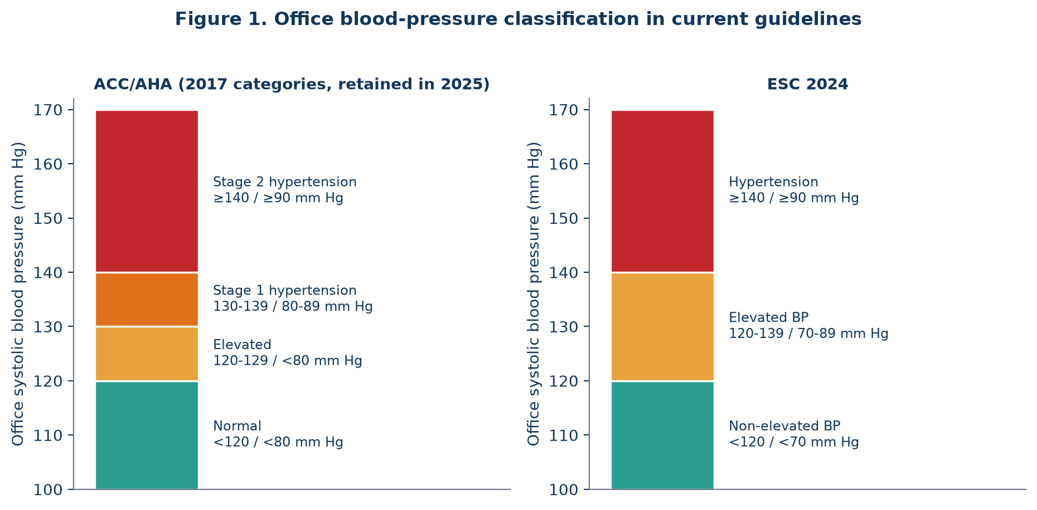
Figure 1. Office blood-pressure categories in the ACC/AHA and ESC frameworks. Both systems now treat blood pressure as a continuous risk factor rather than a simple normal/abnormal dichotomy.
Category | Systolic (mm Hg) | Diastolic (mm Hg) | Usual initial action
Normal | < 120 | and < 80 | Reassess periodically; reinforce healthy lifestyle
Elevated | 120-129 | and < 80 | Structured lifestyle therapy; repeat measurement
Stage 1 hypertension | 130-139 | or 80-89 | Lifestyle therapy; add drugs if cardiovascular risk is high
Stage 2 hypertension | ≥ 140 | or ≥ 90 | Lifestyle therapy plus drug treatment, usually two agents
Hypertensive crisis | > 180 | and/or > 120 | Immediate reassessment; emergency care if organ damage is present
Table 1. ACC/AHA blood-pressure categories for adults and the corresponding first management step.

3. Global Burden and Epidemiology
Global prevalence of hypertension in adults aged 30-79 years doubled in absolute terms between 1990 and 2019, from roughly 650 million to 1.28 billion people, driven mainly by population growth, ageing and rising obesity. Age-standardised prevalence has been broadly stable at about one third of adults, but the geography has shifted decisively: prevalence has fallen in many high-income countries while rising in low- and middle-income regions, which now carry roughly two thirds of the global caseload.
Raised blood pressure is implicated in around 10 million deaths each year, including about half of all deaths from stroke and ischaemic heart disease. The care cascade shown in Figure 2 explains most of that toll: attrition occurs at every step from awareness to sustained control. Modelling by WHO suggests that scaling effective treatment coverage to 50 per cent of adults with hypertension could prevent about 76 million deaths between 2023 and 2050.

Figure 2. The hypertension care cascade. Roughly half of affected adults are unaware of their condition and only about one in five reaches blood-pressure control.
Indicator | Global estimate | Practical implication
Adults living with hypertension (30-79 y) | ~1.28 billion | One in three adults in this age group
Living in low- and middle-income countries | ~2 of every 3 | Health-system capacity is the binding constraint
Aware of their diagnosis | ~54% | Opportunistic screening remains essential
Receiving antihypertensive treatment | ~42% | Treatment initiation is delayed or never happens
Blood pressure controlled on treatment | ~21% | Under-titration and non-adherence dominate
Annual deaths attributable to raised BP | ~10 million | Leading single modifiable cause of death
Table 2. Headline global indicators for hypertension (WHO Global Report on Hypertension and related NCD Risk Factor Collaboration analyses).

4. Pathophysiology and Risk Factors
Arterial pressure is the product of cardiac output and systemic vascular resistance. In about 90-95 per cent of cases no single cause is identified; this primary (essential) hypertension results from the interaction of genetic susceptibility with environmental exposures acting through several overlapping mechanisms: impaired renal sodium handling and volume expansion, inappropriate activation of the renin-angiotensin-aldosterone system, sustained sympathetic over-activity, endothelial dysfunction with reduced nitric-oxide availability, and progressive stiffening of the large arteries with age.
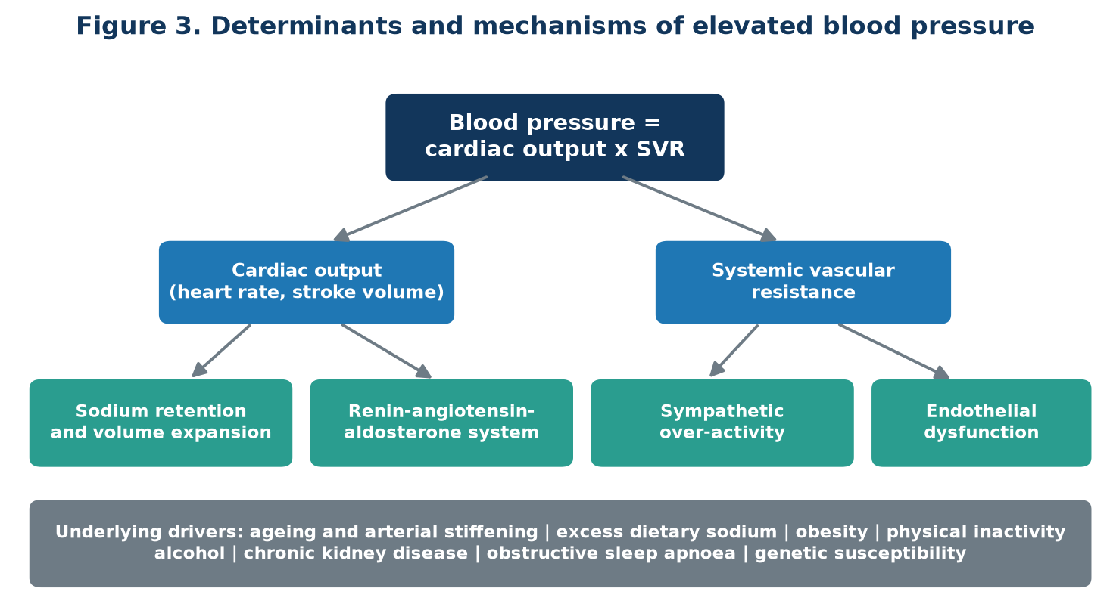
Figure 3. Physiological determinants of blood pressure and the mechanisms that raise it in primary hypertension.

4.1 Modifiable risk factors
- High dietary sodium intake (most populations consume roughly twice the WHO limit of 5 g of salt per day) and low potassium intake.
- Overweight and obesity, especially central adiposity, and insulin resistance.
- Physical inactivity and low cardiorespiratory fitness.
- Excess alcohol consumption; the 2025 ACC/AHA guideline advises avoidance rather than mere moderation.
- Tobacco use, which raises pressure acutely and accelerates arterial damage.
- Chronic psychosocial stress, short or poor-quality sleep, and untreated obstructive sleep apnoea.

4.2 Non-modifiable and secondary contributors
Age, male sex before mid-life, family history, and ancestry-related susceptibility cannot be changed but sharpen screening priorities. Secondary hypertension accounts for 5-10 per cent of cases and should be considered when hypertension is severe, resistant, of abrupt onset, or presents before the age of 30. Recognised causes include primary aldosteronism (the most common and frequently under-diagnosed), chronic kidney disease, renal artery stenosis, phaeochromocytoma, Cushing syndrome, thyroid and parathyroid disorders, coarctation of the aorta, obstructive sleep apnoea, and drugs such as non-steroidal anti-inflammatory agents, combined oral contraceptives, decongestants, glucocorticoids, ciclosporin and stimulants.

5. Clinical Presentation and Complications
Hypertension is usually asymptomatic, which is why it is described as a silent killer. When symptoms occur they are non-specific: headache, dizziness, palpitations, epistaxis or visual disturbance, and they generally reflect severe elevation rather than typical disease. Consequently the diagnosis depends on measurement, not on how the patient feels, and the clinical importance of hypertension lies in the cumulative damage it inflicts on target organs.
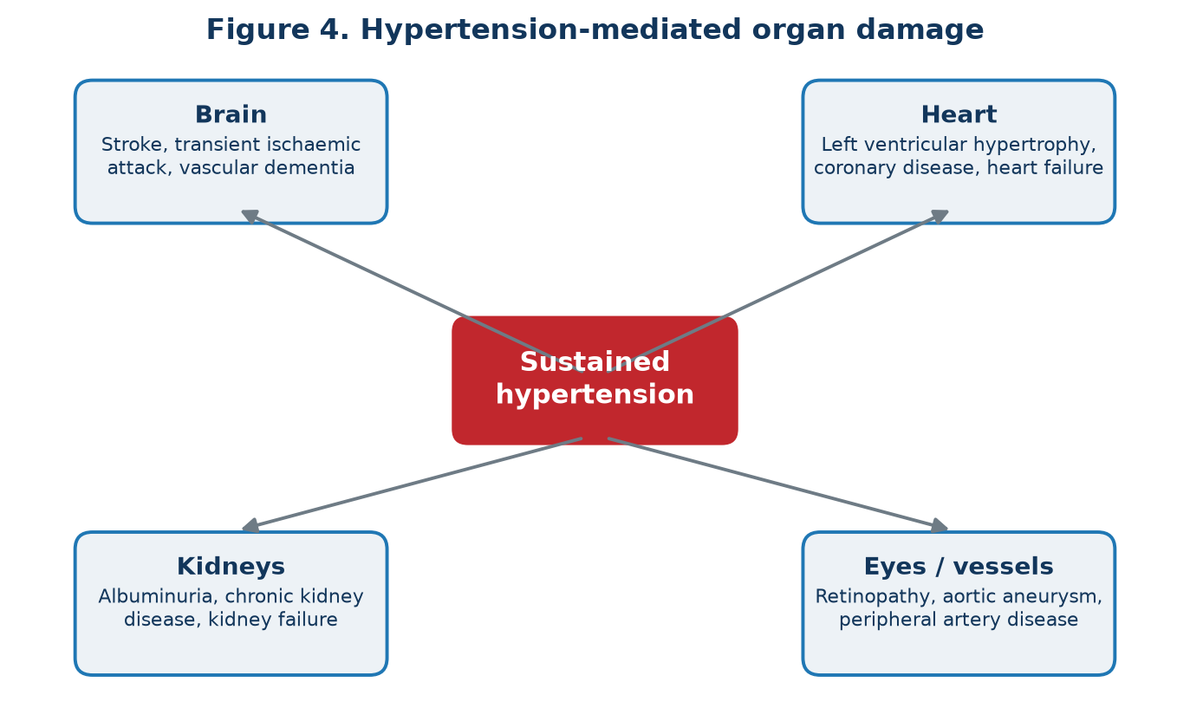
Figure 4. Hypertension-mediated organ damage. Injury develops silently over years before the first clinical event.
Left ventricular hypertrophy, heart failure with preserved or reduced ejection fraction, atrial fibrillation, ischaemic and haemorrhagic stroke, vascular cognitive impairment, chronic kidney disease, hypertensive retinopathy, aortic aneurysm and peripheral artery disease are all strongly and causally linked to long-standing raised pressure. Early detection of organ damage, for example albuminuria or electrocardiographic hypertrophy, identifies patients who benefit most from intensive treatment.

6. Diagnosis and Blood-Pressure Measurement
Because treatment decisions rest on the number obtained, measurement technique is a clinical intervention in its own right. Readings should be taken with a validated device and correctly sized cuff after five minutes of rest, with the patient seated, back supported, legs uncrossed, feet flat and the arm supported at heart level, and without talking. At least two readings should be averaged on two or more occasions.
Out-of-office measurement is now recommended to confirm the diagnosis. Home monitoring and 24-hour ambulatory monitoring identify white-coat hypertension, in which office readings are raised but out-of-office readings are normal, and masked hypertension, in which the reverse is true and cardiovascular risk is substantially underestimated. Ambulatory monitoring also reveals nocturnal non-dipping, an independent risk marker.
Assessment method | Hypertension threshold | Main clinical value
Standardised office reading | ≥ 140/90 (ESC) or ≥ 130/80 (ACC/AHA) | Screening and initial classification
Home monitoring (average) | ≥ 135/85 | Confirmation, self-management, adherence support
Ambulatory, 24-hour average | ≥ 130/80 | Reference standard; detects nocturnal patterns
Ambulatory, daytime average | ≥ 135/85 | Confirms white-coat or masked hypertension
Ambulatory, night-time average | ≥ 120/70 | Identifies non-dipping and high-risk phenotypes
Table 3. Diagnostic thresholds by measurement method.
The baseline work-up complements measurement: history and examination, electrocardiogram, serum electrolytes, creatinine with estimated glomerular filtration rate, fasting glucose or HbA1c, lipid profile, urinalysis with urine albumin-to-creatinine ratio, and a formal cardiovascular risk estimate (PREVENT in the United States, SCORE2 or SCORE2-OP in Europe). Screening for primary aldosteronism with an aldosterone-to-renin ratio is recommended in resistant and other high-suspicion cases.

7. Non-Pharmacological Management
Lifestyle therapy is recommended for every person with elevated blood pressure, both as initial treatment and alongside drugs. Its effects are additive and, taken together, can match the effect of a single antihypertensive agent.
Intervention | Practical target | Typical systolic reduction
Sodium reduction | < 2 g sodium (~5 g salt) per day | 4-6 mm Hg
DASH-type dietary pattern | Vegetables, fruit, whole grains, low-fat dairy, low saturated fat | 5-11 mm Hg
Weight loss | About 1 mm Hg per kilogram lost | 5 mm Hg or more
Aerobic physical activity | 90-150 minutes per week, most days | 5-8 mm Hg
Dynamic or isometric resistance training | 2-3 sessions per week | 4-5 mm Hg
Alcohol reduction | Avoid or minimise intake | 4 mm Hg
Increased dietary potassium | 3.5-5 g per day unless kidney disease | 4-5 mm Hg
Table 4. Evidence-based lifestyle interventions and their approximate effect on systolic blood pressure.

8. Pharmacological Management
Drug treatment is indicated for all adults with stage 2 hypertension, for adults with stage 1 hypertension and elevated cardiovascular risk, established cardiovascular disease, diabetes or chronic kidney disease, and for anyone whose pressure remains above target after a trial of lifestyle therapy. Contemporary guidelines favour starting with a low-dose two-drug single-pill combination rather than sequential monotherapy, because combination therapy lowers pressure faster, is better tolerated than high-dose monotherapy, and markedly improves adherence.
Drug class | Representative agents | Notes and cautions
ACE inhibitors | Ramipril, lisinopril, perindopril | Kidney and heart protective; cough; avoid in pregnancy
Angiotensin receptor blockers | Losartan, valsartan, telmisartan | Similar benefit without cough; avoid in pregnancy
Calcium channel blockers | Amlodipine, nifedipine (long-acting) | Effective in older and Black patients; ankle oedema
Thiazide-type diuretics | Indapamide, chlortalidone, hydrochlorothiazide | Monitor sodium, potassium, uric acid and glucose
Mineralocorticoid antagonists | Spironolactone, eplerenone | Preferred fourth agent in resistant hypertension
Beta blockers | Bisoprolol, metoprolol succinate | Reserved for specific indications such as ischaemia or heart failure
Table 5. Principal antihypertensive drug classes.
The usual treatment goal is a systolic pressure below 130 mm Hg under the ACC/AHA framework and a target range of 120-129 mm Hg under the ESC framework, provided the regimen is tolerated; less intensive, individualised goals apply to frail older adults, people with symptomatic orthostatic hypotension and those with limited life expectancy. Response should be reviewed after four to eight weeks and treatment escalated promptly, since therapeutic inertia is a principal reason for poor control.
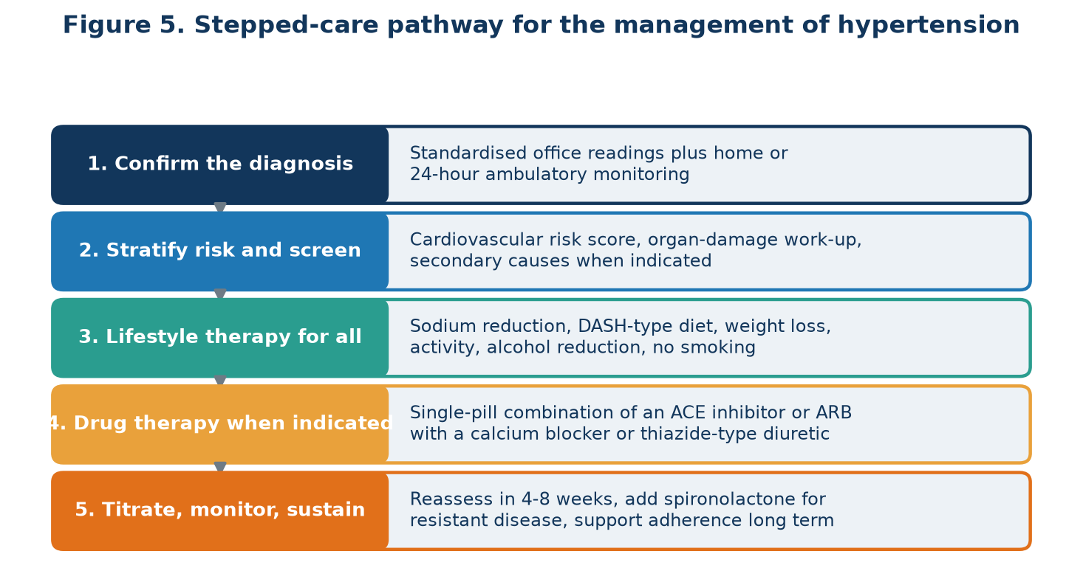
Figure 5. A stepped-care pathway from confirmation of the diagnosis to sustained long-term control.
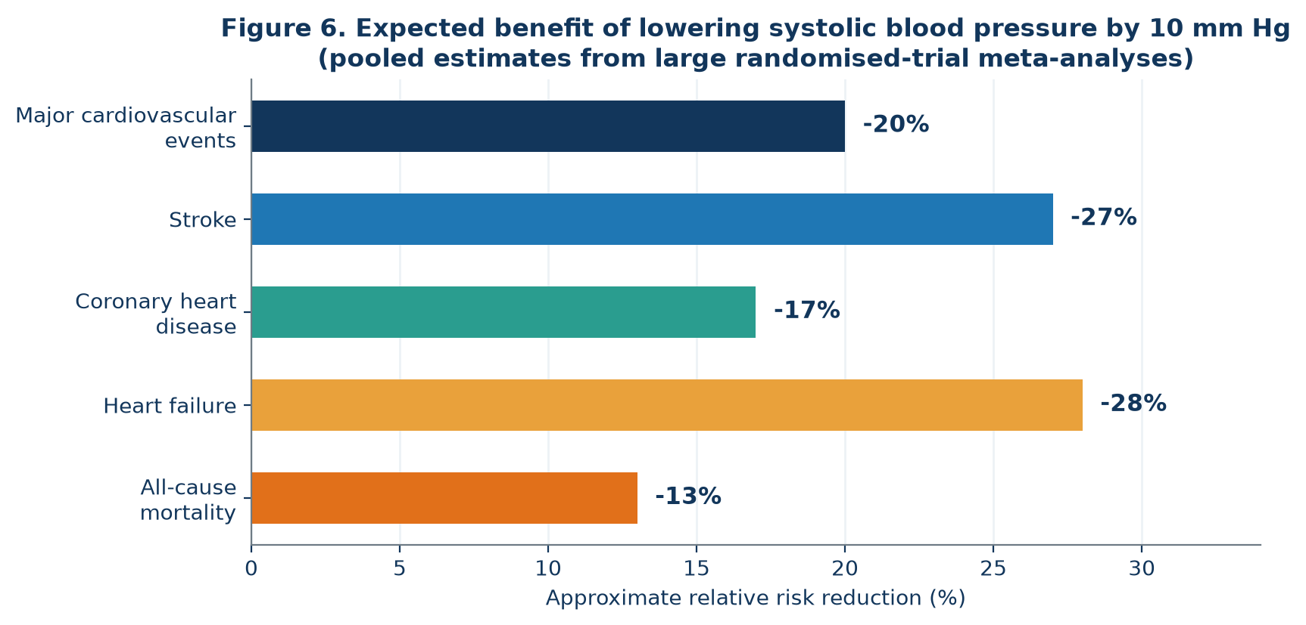
Figure 6. Approximate relative risk reductions associated with a sustained 10 mm Hg fall in systolic blood pressure, as reported in large randomised-trial meta-analyses.

9. Special Populations and Resistant Hypertension
Chronic kidney disease requires a renin-angiotensin system blocker when albuminuria is present, with careful monitoring of potassium and kidney function. In diabetes, blood pressure lowering delivers cardiovascular and renal benefit that complements glycaemic control. Older and frail adults benefit from treatment but need slower titration, standing blood-pressure checks and review of falls risk. In pregnancy, labetalol, nifedipine and methyldopa are the agents of choice, ACE inhibitors and angiotensin receptor blockers are contraindicated, and low-dose aspirin is used to reduce the risk of pre-eclampsia in high-risk women.
Resistant hypertension is defined as blood pressure that remains above target despite three appropriately dosed agents including a diuretic, or that requires four or more agents. Management begins by excluding pseudo-resistance from poor technique, white-coat effect and non-adherence, then removing interfering substances, screening for secondary causes, optimising diuretic therapy, and adding spironolactone. Renal denervation is recognised in recent guidelines as an adjunctive option in carefully selected patients treated at experienced centres.

10. Hypertensive Crises
A blood pressure above 180/120 mm Hg constitutes a crisis. In a hypertensive emergency there is acute hypertension-mediated organ damage such as encephalopathy, stroke, acute coronary syndrome, pulmonary oedema, aortic dissection, acute kidney injury or eclampsia; this requires admission and intravenous therapy with controlled, gradual reduction, typically no more than 25 per cent within the first hour, except in aortic dissection or where thrombolysis is planned, when faster and lower targets apply. In hypertensive urgency there is no acute organ damage, and pressure should be lowered over hours to days with oral agents and prompt outpatient follow-up; rapid reduction is harmful and should be avoided.

11. Prevention and Public-Health Strategy
Because risk rises continuously, population-wide measures deliver benefits that individual clinical care cannot. WHO's HEARTS technical package operationalises this through healthy-lifestyle counselling, evidence-based standard treatment protocols, access to essential medicines and technology, risk-based management, team-based care with task sharing, and systems for monitoring. Mandatory sodium reformulation of processed foods, front-of-pack labelling, tobacco and alcohol control, urban design that supports physical activity, and inclusion of fixed-dose combinations in essential medicine lists are among the most cost-effective interventions available to any health system.
At the service level, the practical priorities are simple: measure blood pressure accurately at every opportunity, use a single standard protocol so that any team member can escalate treatment, prescribe single-pill combinations to reduce pill burden, and track control rates as a routine quality indicator rather than an audit exercise.

12. Conclusion
Hypertension remains the leading modifiable cause of cardiovascular disease and premature death, yet it is one of the most tractable problems in medicine. The tools required, accurate measurement, a handful of inexpensive generic drug classes and well-established lifestyle interventions, are already available almost everywhere. The decisive gap is implementation: finding people who do not know they are affected, starting effective combination therapy without delay, titrating to target and sustaining control over decades. Closing that gap, supported by population-level prevention, would prevent tens of millions of deaths within a generation.

13. References
[1] World Health Organization. Hypertension fact sheet. Geneva: WHO.
[2] World Health Organization. Global Report on Hypertension: the race against a silent killer. Geneva: WHO, 2023.
[3] World Health Organization. HEARTS technical package for cardiovascular disease management in primary health care. Geneva: WHO.
[4] American Heart Association / American College of Cardiology. 2025 Guideline for the Prevention, Detection, Evaluation and Management of High Blood Pressure in Adults. Circulation / Journal of the American College of Cardiology, 2025.
[5] Whelton PK, Carey RM, Aronow WS, et al. 2017 ACC/AHA/AAPA/ABC/ACPM/AGS/APhA/ASH/ASPC/NMA/PCNA Guideline for the Prevention, Detection, Evaluation and Management of High Blood Pressure in Adults. Hypertension. 2018;71(6):e13-e115.
[6] McEvoy JW, McCarthy CP, Bruno RM, et al. 2024 ESC Guidelines for the management of elevated blood pressure and hypertension. European Heart Journal. 2024;45(38):3912-4018.
[7] NCD Risk Factor Collaboration. Worldwide trends in hypertension prevalence and progress in treatment and control from 1990 to 2019. The Lancet. 2021;398(10304):957-980.
[8] Ettehad D, Emdin CA, Kiran A, et al. Blood pressure lowering for prevention of cardiovascular disease and death: a systematic review and meta-analysis. The Lancet. 2016;387(10022):957-967.
[9] Blood Pressure Lowering Treatment Trialists' Collaboration. Pharmacological blood pressure lowering for primary and secondary prevention of cardiovascular disease across different levels of blood pressure. The Lancet. 2021;397(10285):1625-1636.
[10] SPRINT Research Group. A randomized trial of intensive versus standard blood-pressure control. New England Journal of Medicine. 2015;373(22):2103-2116.
[11] Appel LJ, Moore TJ, Obarzanek E, et al. A clinical trial of the effects of dietary patterns on blood pressure (DASH). New England Journal of Medicine. 1997;336(16):1117-1124.
[12] Khan SS, Matsushita K, Sang Y, et al. Development and validation of the American Heart Association PREVENT equations. Circulation. 2024;149(6):430-449.
All figures in this report were produced by the authors specifically for this document; no third-party images are reproduced. This report is an educational evidence review and does not replace individual clinical judgement.

