**D.E ASSESSMENT SOLUTION DOCUMENT**

**PYTHON**

**Q 1.) Fill None Values: Given a list, replace None values with the previous non-None value. If consecutive Nones occur, fill each with the last non-None value. Example: [1, None, 1, 2, None] becomes [1, 1, 1, 2, 2].**

num = [1,2,3,None,4,None]

for i in range(len(num)):

if num[i] == None:

num[i] = num[i-1]

print(num)

Q2.) **Mismatched Words Finder: Write a function that returns a list of words present in two strings that don't match in case. Example: Input: "Datumlabs is an awesome place", "Datumlabs.io Is an AWESOME place". Output: ["is", "Is", "awesome", "AWESOME"].**

def mismatched_words():

a = "Cars are fast"

b = "Bikes are Fast"

not_matched = []

str_a = a.split()

str_b = b.split()

for words in str_a:

if words not in string_b:

not_matched.append(words)

for words in str_b:

if words not in string_a:

not_matched.append(words)

print(not_matched)

mismatched_words()

**Q 3.) Character Frequency Counter: Create a function to count the occurrences of a specific character in a string. Example: 'mississippi', 's' should return 3**

def counter():

a = "Python is a programming language"

counter = a.count('a')

print(counter)

counter()

**Q4.) Nth Largest Value Key Finder: Write a function to find the key of the nth largest value in a dictionary. Example: For {a: 1, b: 2, c: 100, d: 30}, and n = 2, return 'd'**

def key_finder():

num = {'a':1000, 'b': 55,'c': 455,'d':37,'e':900, 'f':999}

n2 = sorted(num.keys())[-1]

print(n2)

key_finder()

**SQL QUESTIONS:**

**1. Percentage of Paid Customers Who Bought Both Product A and Product B: Given a table CustomerPurchases with columns customer_id, product_id, purchase_date, price, and payment_status, calculate the percentage of customers who bought both productsA and B and paid for them.**

FIRST QUERY OUT OF CUSTOMER WHO PAID (FOR PRODUCT A and B, including Unpaid- Need clarity)

SELECT ROUND(CAST(PAID_CUSTOMERS AS DECIMAL) / CAST(TOTAL_CUSTOMERS AS DECIMAL) * 100, 2) AS PAID_PERCENTAGE

FROM (

SELECT count(cp1.customer_id) AS PAID_CUSTOMERS

FROM customerpurchases cp1

**FIRST QUERY**

I’ve used self-join here where customers bought both Product A and Product B and filtered with Product_id ‘A’ and ‘B’ in the first and joining with where payment status = paid for both products in Sub1 sub query.

Sub2, used the same logic but excluded payment status to get all customers who bought Product A and B

**SECOND QUERY**

I’ve used the same logic overall but for denominator I’ve grabbed all distinct customers.

JOIN customerpurchases cp2 ON cp1.customer_id = cp2.customer_id

WHERE TRIM(cp1.product_id) = 'A'

AND TRIM(cp2.product_id) = 'B'

AND cp1.payment_status = cp2.payment_status

) SUB1

JOIN (

SELECT Count(cp1.customer_id) TOTAL_CUSTOMERS

FROM customerpurchases cp1

JOIN customerpurchases cp2 ON cp1.customer_id = cp2.customer_id

WHERE TRIM(cp1.product_id) = 'A'

AND TRIM(cp2.product_id) = 'B'

) SUB2

ON 1 = 1

**Ans: 66.67%**

SECOND QUERY OUT OF ALL DISTINCT CUSTOMERS (NEED CLARITY)

SELECT ROUND(CAST(PAID_CUSTOMERS AS DECIMAL) / CAST(TOTAL_CUSTOMERS AS DECIMAL) * 100, 2) AS PAID_PERCENTAGE

FROM (

SELECT count(cp1.customer_id) AS PAID_CUSTOMERS

FROM customerpurchases cp1

JOIN customerpurchases cp2 ON cp1.customer_id = cp2.customer_id

WHERE TRIM(cp1.product_id) = 'A'

AND TRIM(cp2.product_id) = 'B'

AND cp1.payment_status = cp2.payment_status

) SUB1

JOIN (

SELECT count(DISTINCT customer_id) AS TOTAL_CUSTOMERS

FROM customerpurchases

) SUB2

ON 1 = 1

**ANSWER**: 50 %

2. Percentage of Sales Attributed to Promotions on First and Last Days: With the Sales table (columns: sale_id, product_id, sale_date, amount, promotion_id) and Promotions table (columns: promotion_id, start_date, end_date, discount_rate), compute the percentage of sales attributed to promotions on their first and last days

SELECT *

FROM (

SELECT Round(fd_amount / total_sales * 100, 2) AS First_day_percentage

FROM (

SELECT total_amount AS FD_amount

FROM (

SELECT SUM(amount) AS total_amount

,CASE

The green highlighted part will retrieve Percentage for **First Day promotions**. The inner join on promotion id will exclude NONE in promotion_id. Then I’ve used a case statement with if sale date matches with start date this will be considered first day and if not that will be considered last day.

The blue highlighted part will retrieve Percentage for **Last Day promotions**.

The purple highlighted part will retrieve sum of both first and last day promotions which will be used as a denominator.

WHEN s.sale_date = pr.start_date

THEN 'First Day'

WHEN s.sale_date > start_date

AND s.sale_date <= end_date

THEN 'Last days'

END AS PR_days

FROM Sales s

INNER JOIN promotions pr ON TRIM(pr.promotion_id) = TRIM(s.promotion_id)

GROUP BY PR_days

) FD

WHERE pr_days = 'First Day'

) join_1

JOIN (

SELECT Sum(total_amount) Total_sales

FROM (

SELECT SUM(amount) AS total_amount

,CASE

WHEN s.sale_date = pr.start_date

THEN 'First Day'

WHEN s.sale_date > start_date

AND s.sale_date <= end_date

THEN 'Last days'

END AS PR_days

FROM Sales s

INNER JOIN promotions pr ON TRIM(pr.promotion_id) = TRIM(s.promotion_id)

GROUP BY PR_days

) Total_amount

) Join_2 ON 1 = 1

) CL_JOIN

JOIN (

SELECT Round(fd_amount / total_sales * 100, 2) AS Last_day_percentage

FROM (

SELECT total_amount AS FD_amount

FROM (

SELECT SUM(amount) AS total_amount

,CASE

WHEN s.sale_date = pr.start_date

THEN 'First Day'

WHEN s.sale_date > start_date

AND s.sale_date <= end_date

THEN 'Last days'

END AS PR_days

FROM Sales s

INNER JOIN promotions pr ON TRIM(pr.promotion_id) = TRIM(s.promotion_id)

GROUP BY PR_days

) FD

WHERE pr_days = 'Last days'

) join_1

JOIN (

SELECT Sum(total_amount) Total_sales

FROM (

SELECT SUM(amount) AS total_amount

,CASE

WHEN s.sale_date = pr.start_date

THEN 'First Day'

WHEN s.sale_date > start_date

AND s.sale_date <= end_date

THEN 'Last days'

END AS PR_days

FROM Sales s

INNER JOIN promotions pr ON TRIM(pr.promotion_id) = TRIM(s.promotion_id)

GROUP BY PR_days

) Total_amount

) Join_2 ON 1 = 1

) CL_JOIN_2 ON 2 = 2

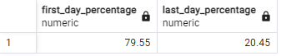

3**.) 3. Top 5 Complementary Products for Product A: Identify the top 5 products bought alongside Product A (NEED CLARITY ON ALONGSIDE PRODUCTS)**

SELECT

s1.product_id,

s2.product_id,

COUNT(*) AS frequency

FROM

There’s only product B which is bought 3 times.

I would need some clarity on these queries which I will discuss on call

customerpurchases s1

JOIN

customerpurchases s2 ON s1.customer_id = s2.customer_id AND s1.product_id <> s2.product_id

where Trim(s1.product_id) = 'A'

group by s1.product_id,s2.product_id

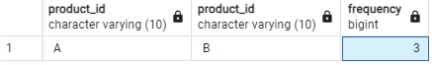

PYSPARK

Q1 1. **Monthly Active Users (MAU) for January 2024: Count of unique users active in January 2024.**

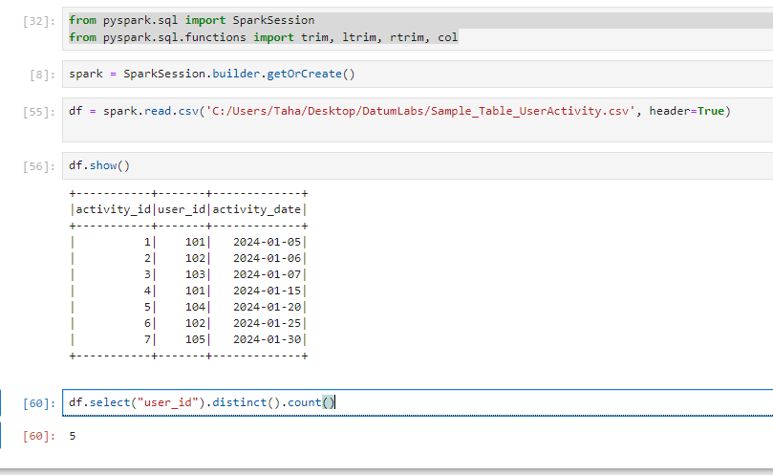

from pyspark.sql import SparkSession

from pyspark.sql.functions import trim, ltrim, rtrim, col

spark = SparkSession.builder.getOrCreate()

df = spark.read.csv('C:/Users/Taha/Desktop/DatumLabs/Sample_Table_UserActivity.csv', header=True)

df.show()

df.select("user_id").distinct().count()

**2. Total Sales Revenue for January 2024: Sum of sales in January 2024.**

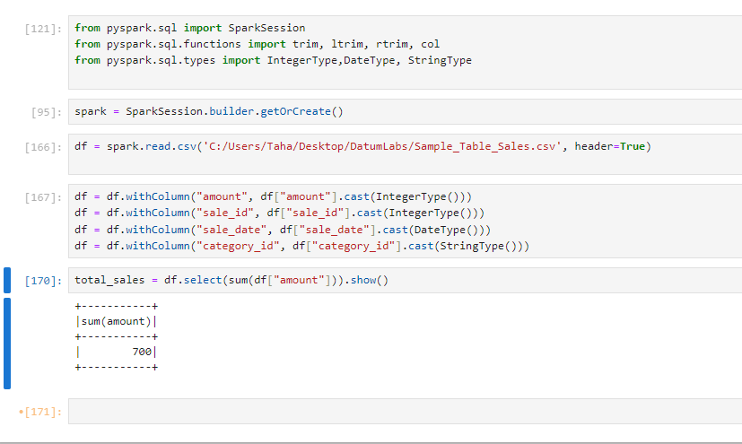

from pyspark.sql import SparkSession

from pyspark.sql.functions import trim, ltrim, rtrim, col

from pyspark.sql.types import IntegerType,DateType, StringType

df = spark.read.csv('C:/Users/Taha/Desktop/DatumLabs/Sample_Table_Sales.csv', header=True)

total_sales = df.select(sum(df["amount"])).show()

**3. Average Sale Amount Per Category for January 2024.**

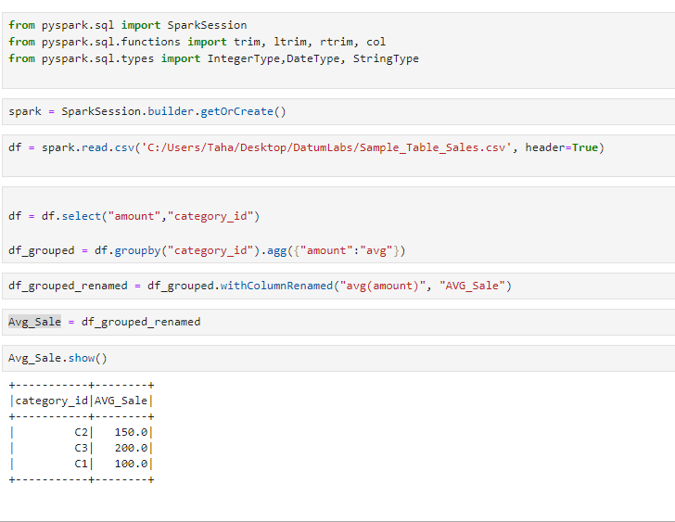

df = df.select("amount","category_id")

df_grouped = df.groupby("category_id").agg({"amount":"avg"})

df_grouped_renamed = df_grouped.withColumnRenamed("avg(amount)", "AVG_Sale")

Avg_Sale = df_grouped_renamed

Avg_Sale.show()

4. NOT CLEAR

5. Top Selling Product Category in January 2024: Product category with highest sales in January 2024.

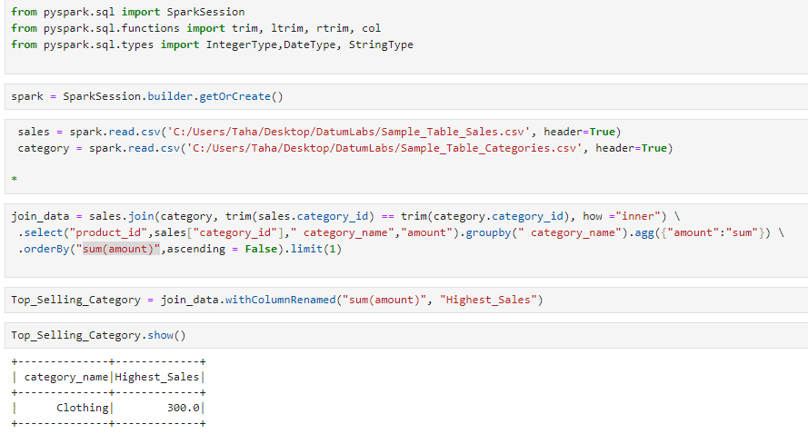

sales = spark.read.csv('C:/Users/Taha/Desktop/DatumLabs/Sample_Table_Sales.csv', header=True)

category = spark.read.csv('C:/Users/Taha/Desktop/DatumLabs/Sample_Table_Categories.csv', header=True)

join_data = sales.join(category, trim(sales.category_id) == trim(category.category_id), how ="inner") \

.select("product_id",sales["category_id"]," category_name","amount").groupby(" category_name").agg({"amount":"sum"}) \

.orderBy("sum(amount)",ascending = False).limit(1)

Top_Selling_Category = join_data.withColumnRenamed("sum(amount)", "Highest_Sales")

Top_Selling_Category.show()