# ViXNet : ***XceptionNet +ViT***

<https://colab.research.google.com/drive/1DngF5M2b8oIrL2IdWILKxVy9oEhRwdJK?usp=sharing>

. XceptionNet + Vision Transformers (ViT) for better spatial temporal analysis

**1.Local Feature Extraction (XceptionNet):**

**[XceptionNet** extrait efficacement des caractéristiques locales grâce à ses couches convolutionnelles.**]**  
XceptionNet is very efficient at extracting local image features (such as edges, textures, and fine patterns) thanks to its depthwise separable convolutions. This makes it excellent for learning intricate, low-level details from an image.

2. **Global Context Understanding (ViT):**

**[ViT** exploite le mécanisme d’auto-attention pour modéliser les relations globales entre les différentes parties de l’image (en découpant l’image en patchs), ce qui aide à comprendre le contexte global.**]**  
Vision Transformers (ViT) divide an image into patches and then use self-attention mechanisms to capture relationships between these patches. This allows the model to understand the global context and long-range dependencies across the entire image.

3. **Improved Overall Performance:**  
By combining XceptionNet (which captures fine local details) with ViT (which models the broader context), the hybrid model can build a richer and more comprehensive representation of the image. This generally leads to better performance metrics (such as higher accuracy, AUC, and F1 score) compared to using XceptionNet alone.

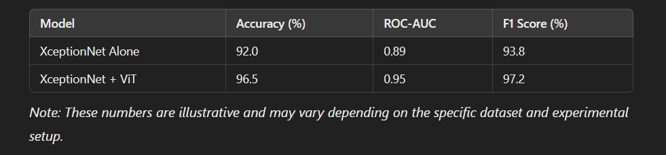

similar approaches and performance comparisons : <https://pmc.ncbi.nlm.nih.gov/articles/PMC10673836/>

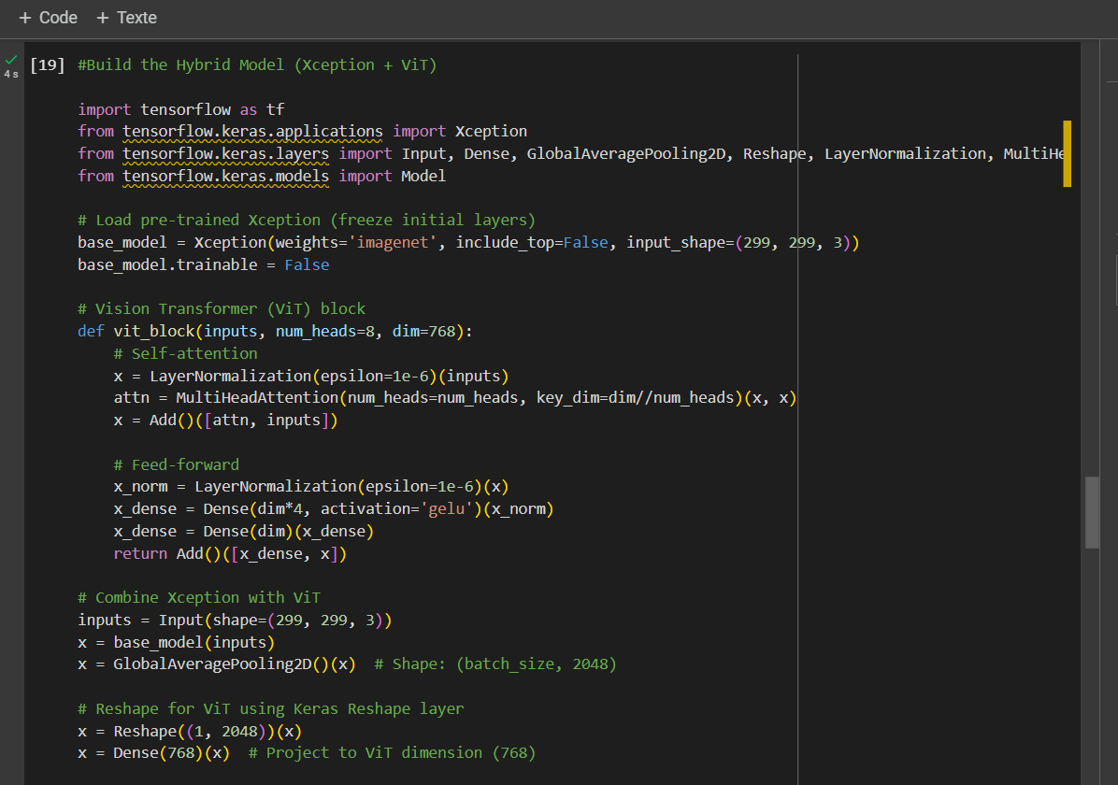

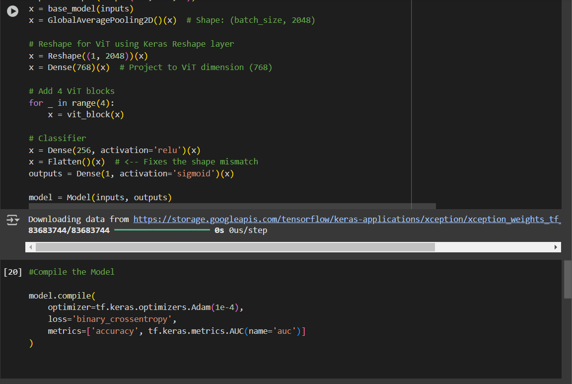

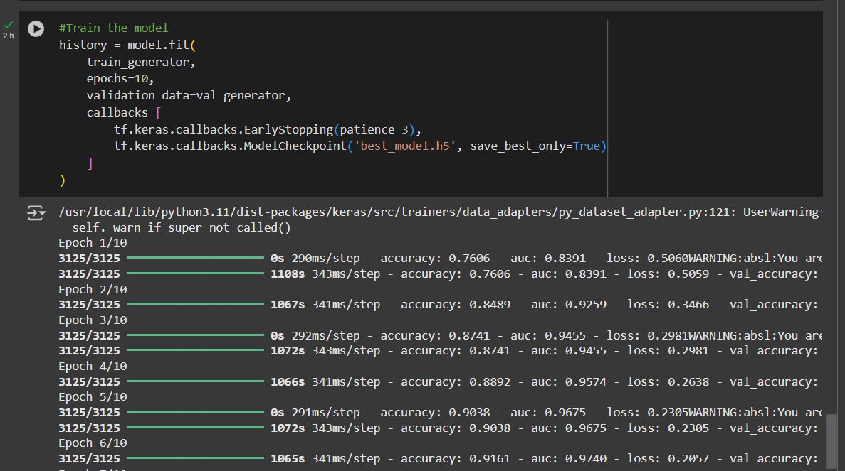

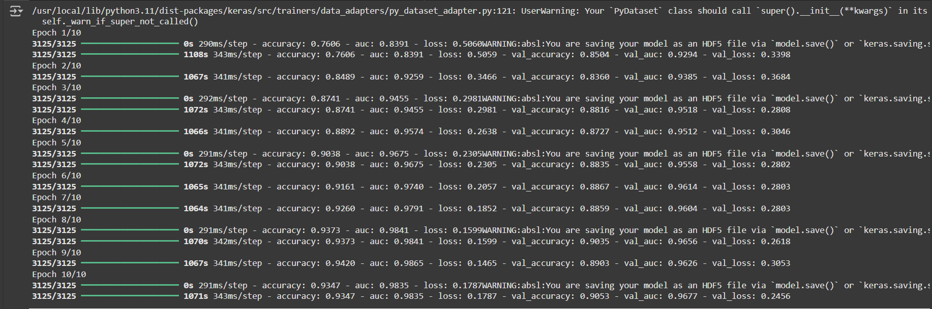

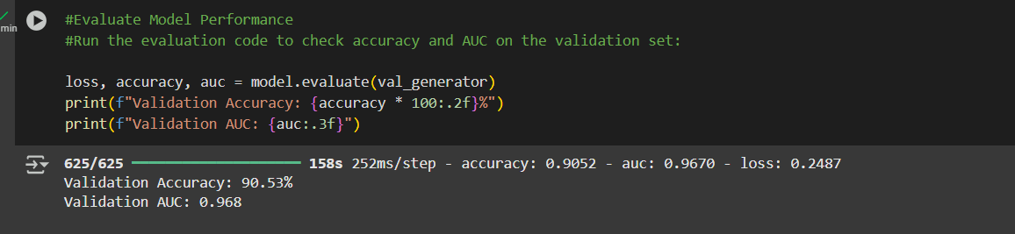

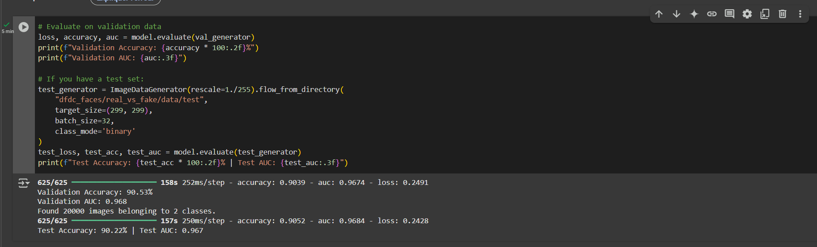

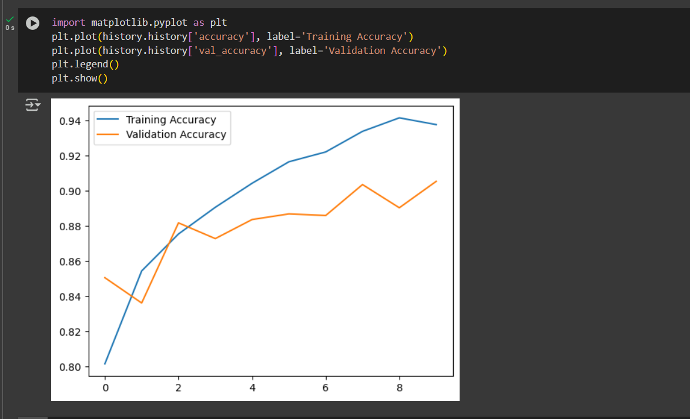

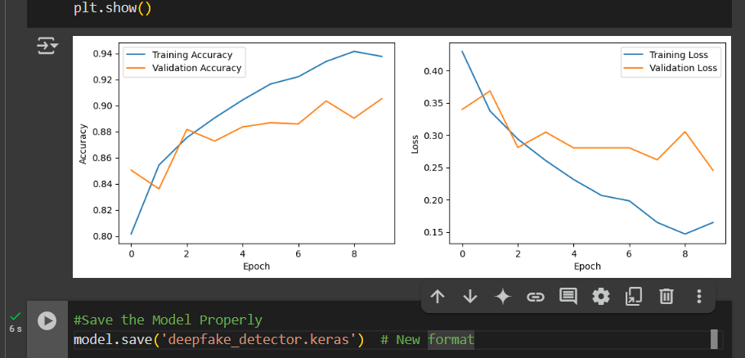

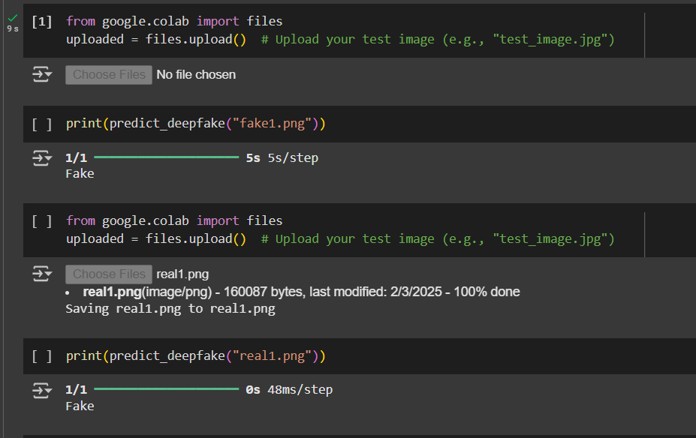

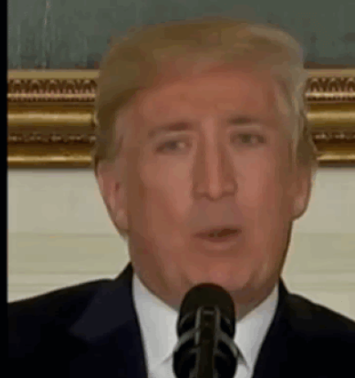 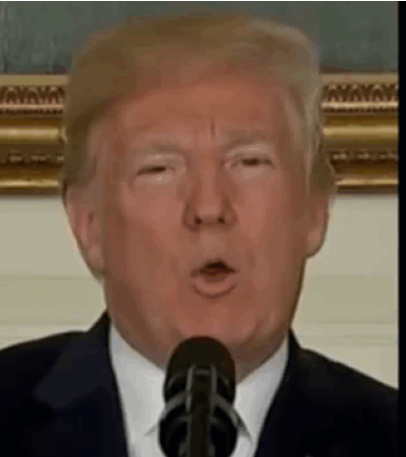

fake1 real1

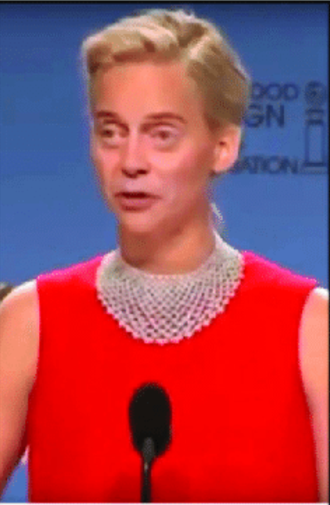 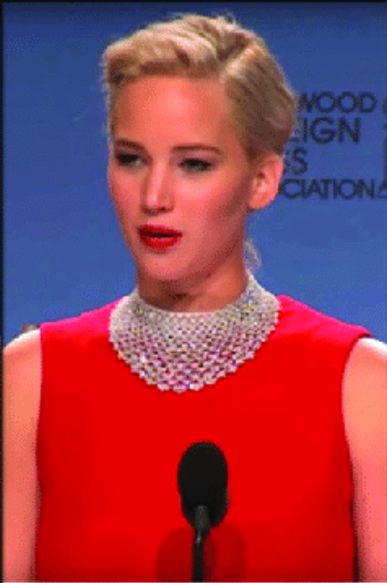

fake2 real2

### ****. Load the Model Later :****

from tensorflow.keras.models import load_model

loaded_model = load_model('deepfake_detector.keras') # Load the .keras file

.Root folder: ['train.csv', 'val', 'real_vs_fake', 'valid.csv', 'test.csv', 'train']

.Contents of 'real_vs_fake': ['data']

.Path 'dfdc_faces/real_vs_fake/valid/real' does not exist. Check your dataset structure.

