Assignment 2

Muhammed Taha Yilmaz

17 01 2022

# Assignment 2 Part 1

## Q1 : Calculate the five-number summary statistics (minimum-Q1-median-Q3-maximum) of covid-19 daily new cases for each country within each month. (you can use quantile() function to get the quartiles)

| location | month | min | Q1 | Q2 | Q3 | max |
| --- | --- | --- | --- | --- | --- | --- |
| Albania | 3 | 2 | 8.50 | 15.0 | 17.50 | 20 |
| Albania | 5 | 4 | 4.00 | 4.0 | 4.00 | 4 |
| Albania | 6 | 20 | 29.25 | 38.5 | 47.75 | 57 |
| Albania | 7 | 85 | 95.25 | 105.5 | 115.75 | 126 |
| Albania | 8 | 112 | 112.00 | 112.0 | 112.00 | 112 |
| Albania | 9 | 132 | 140.75 | 149.5 | 158.25 | 167 |
| Albania | 10 | 297 | 297.00 | 297.0 | 297.00 | 297 |
| Albania | 11 | 381 | 559.00 | 737.0 | 786.00 | 835 |
| Albania | 12 | 801 | 801.00 | 801.0 | 801.00 | 801 |
| Andorra | 3 | 0 | 6.00 | 12.0 | 18.00 | 24 |

## Q2 : Find the highest daily cases and deaths separately for each country.

| location | max_case | max_death |
| --- | --- | --- |
| France | 86655 | 1340 |
| United Kingdom | 36931 | 691 |
| Italy | 32961 | 889 |
| Spain | 31785 | 923 |
| Germany | 31480 | 510 |
| Russia | 28701 | 548 |
| Poland | 21854 | 472 |
| Switzerland | 17309 | 107 |
| Belgium | 16746 | 417 |
| Ukraine | 14864 | 279 |

## Q3 : Identify the month in which the mean daily cases is the highest for each country.

| location | month | Mean_of_dailycases |
| --- | --- | --- |
| Albania | 12 | 801.000 |
| Andorra | 11 | 56.000 |
| Austria | 11 | 6203.500 |
| Belarus | 12 | 1896.000 |
| Belgium | 10 | 16746.000 |
| Bosnia and Herzegovina | 12 | 1008.333 |
| Bulgaria | 11 | 4297.000 |
| Croatia | 12 | 2967.000 |
| Cyprus | 12 | 371.000 |
| Finland | 12 | 379.000 |

## Q4 : Select 3 country and plot the distribution of daily cases by month. Use location as clusters (i.e., color=location) to show the difference between countries.

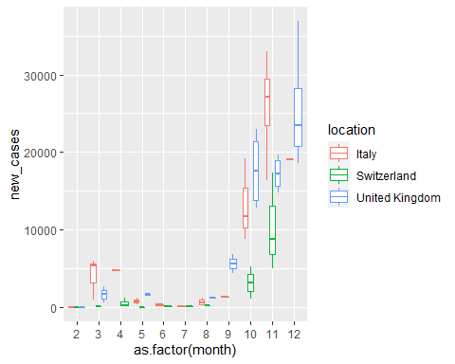

Figure 1. The Distribution of daily cases by chosen location(United Kingdom”,“Italy”,“Switzerland”).

# Assignment 2 Part 2

## Q1 : Find words which are starting with “a” and ending with “e”.

| x |
| --- |
| are |
| arrive |
| apple |

## Q2 : Calculate the number of words which have more than 3 vowels.

## [1] 3

| x |
| --- |
| sometimes |
| sausage |
| deepened |

## Q3 : List the five longest word in your data

| words2 | longest |
| --- | --- |
| background | 10 |
| sometimes | 9 |
| shimmered | 9 |
| shortened | 9 |
| promptly | 8 |

## Q4 : Try to find word(s) which contain any of these words: age, any, day, exp, her, pro, the.

| x |
| --- |
| the |
| then |
| product |
| these |
| promptly |
| lathe |
| any |
| they |
| Mondays |
| sausage |
| prone |
| there |
| Many |
| There |
| others |
| leather |
| clothes |