SMART RADAR SYSTEM (Object Tracking System)

1. Team Members
- طه عبد السميع طه
- طه محمد طه
- حازم محمد صلاح
- أمين رضا امين
- حسن مصطفى حسن
- إبراهيم حسن ابراهيم
- عبد الرحمن أحمد عبد الشافي
- أحمد السعودي جاد
- عيسى علي حامد
- أحمد زيدان مختار
- ماجد قاسم حماد

2. Project Overview
The Smart Radar System is an IoT-based object tracking system designed for real-time surveillance and automatic target tracking. The system uses an HC-SR04 ultrasonic sensor to scan the surrounding area in 180 degrees. When an object is detected, the Arduino UNO controls two servo motors to rotate toward the target and keep tracking it automatically.
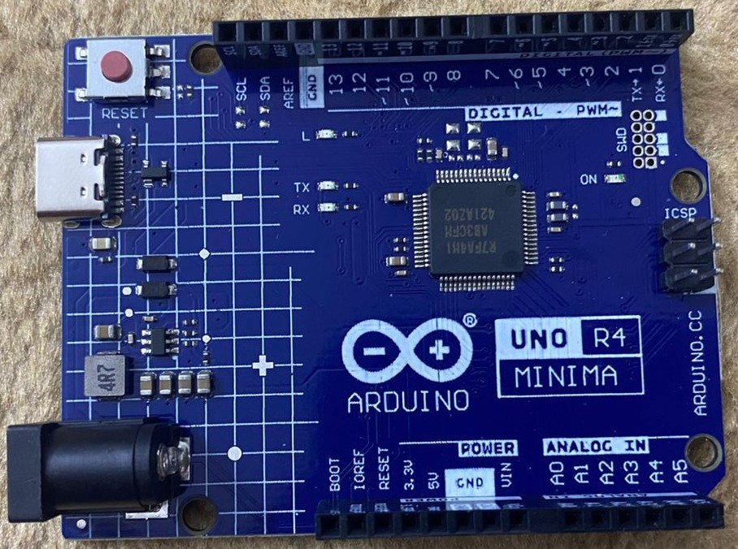
The project includes:
- HC-SR04 Ultrasonic Sensor (Radar Scanning)
- Dual Servo Motors (Pan-Tilt base for 2-axis movement).
- Laser diode for targeting
- Buzzer for alerts
- Python computer vision support
- Arduino UNO R4 Minima for hardware control
- Breadboard (Used for circuit assembly and power distribution)
- Jumper Wires (Male-to-Male and Male-to-Female)

3. Circuit Connections
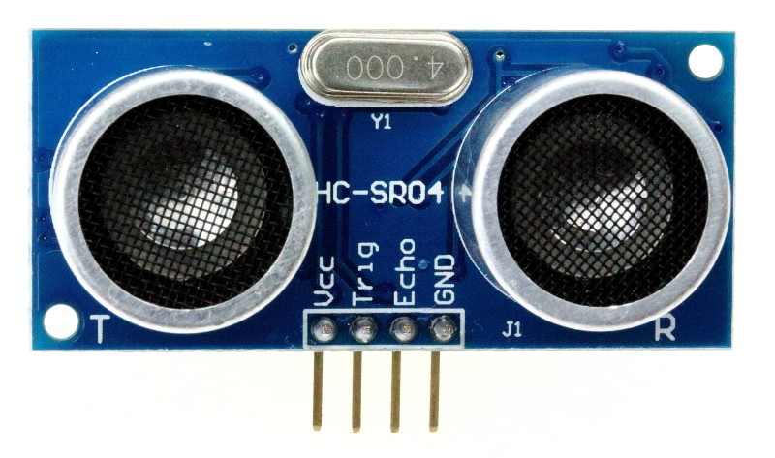
Ultrasonic Sensor (HC-SR04)
- VCC → 5V
- GND → GND
- TRIG → Pin 4
- ECHO → Pin 5

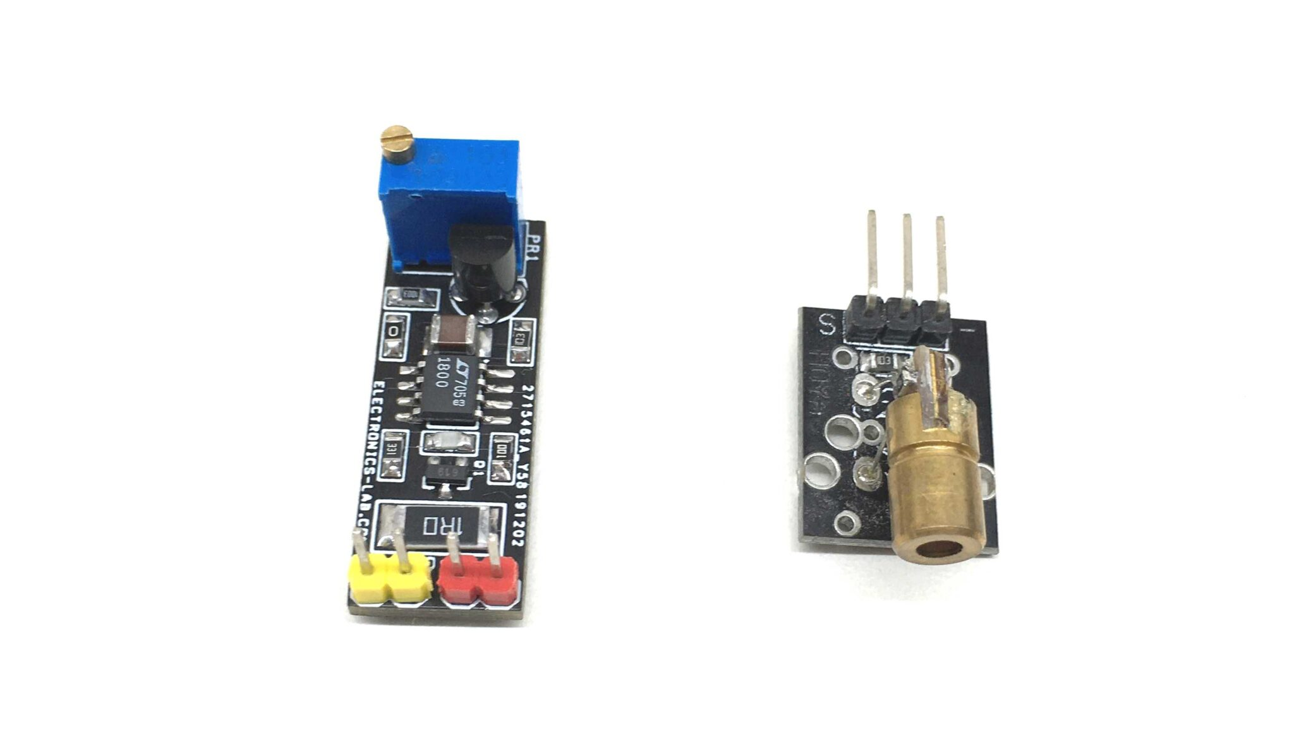
Laser Module
- Positive → Pin 7
- Negative → GND
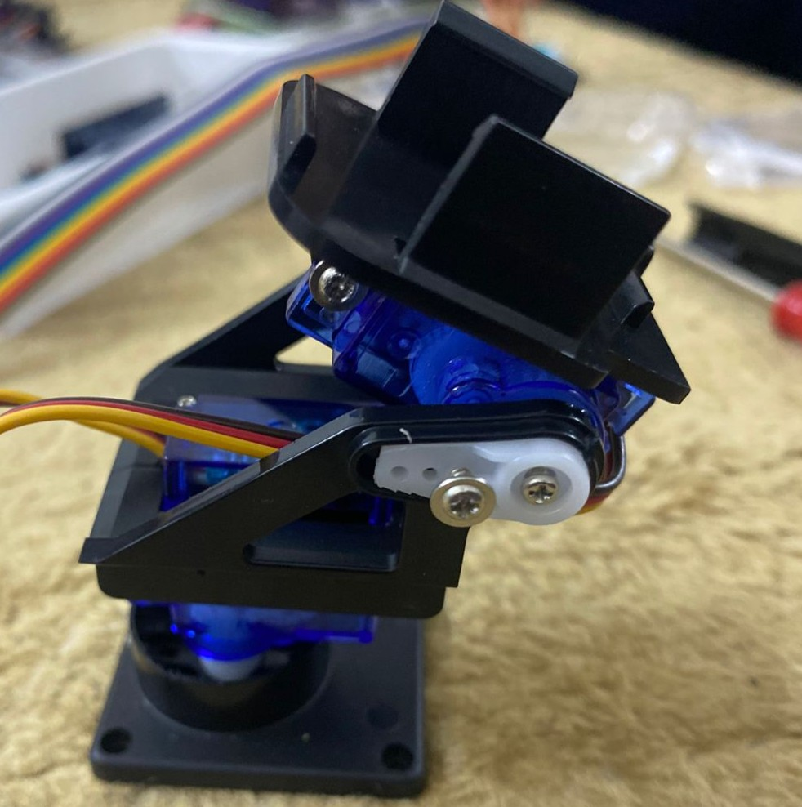
Servo Motors
- Pan Servo Signal → Pin 9
- Power Wire (Red) → Breadboard (5V)
- Ground Wire (Brown) → Breadboard (GND)

- Tilt Servo Signal → Pin 10
- Power Wire (Red) → Breadboard (5V)
- Ground Wire (Brown) → Breadboard (GND)
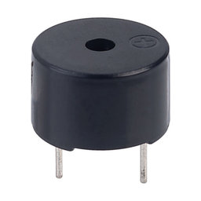
Buzzer
- Positive → Pin 6
- Negative → GND

4. Code Overview

Arduino Code (C++): Responsible for reading sensor data, controlling servo motors, activating buzzer and laser, and serial communication.
Python Script: Responsible for object detection using the camera and sending coordinates to the Arduino for tracking.

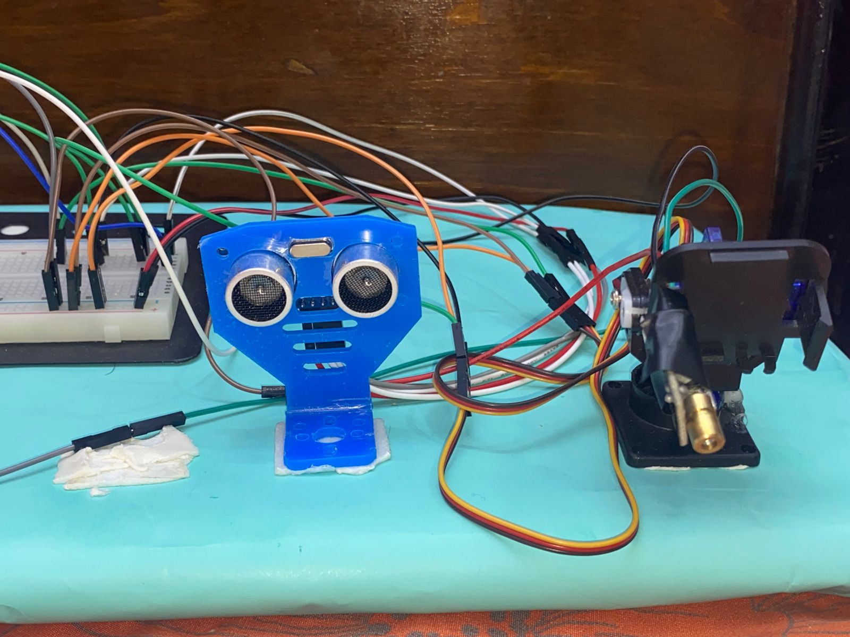
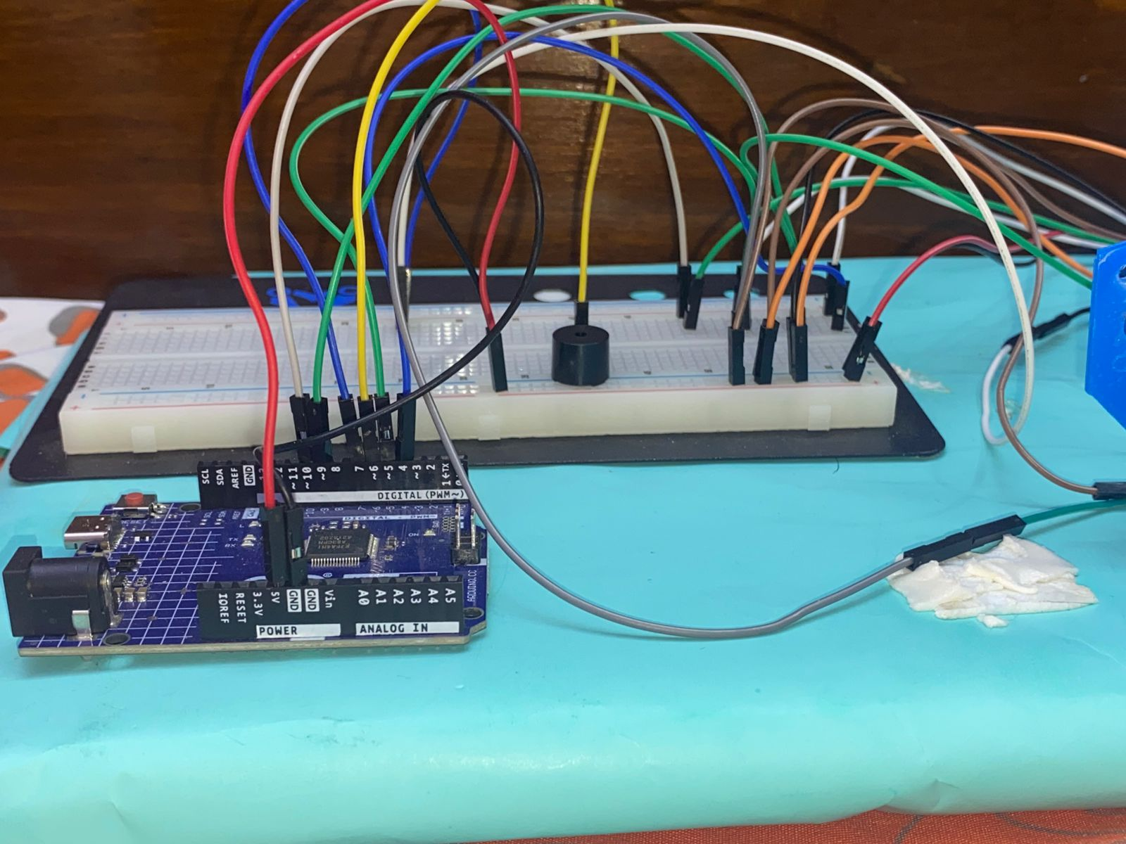
5. Photos & Screenshots of the Project

