5. Results
Conditional expanded evidence synthesis (26 independent cohorts): statistical reconstruction with transparent imputation sensitivity. The 26-cohort estimate does not represent 26 independently approved studies and must not be described as the final principal effect.

5.1. Expanded evidence accounting
The archived data consist of 53 bibliographic entries, 49 provisionally distinct reports, 64 canonical sample IDs and 481 extracted outcome rows. A previously reconstructed set of 22 independent cohorts was expanded to 26 by incorporating one primary story-novelty contrast from Doshi and Hauser (2024) and three non-overlapping discipline cohorts from Fisher et al. (2026). These additions do not add four bibliographic reports: they contribute four cohort-level comparisons from two reports. The full 26-cohort analysis sums 4,600 cohort enrolments, a count that differs from a harmonized contrast-level sample size because some studies contain multiple arms and not all enrolled participants enter the selected contrast.
Fisher et al. reported a 2 × 2 analysis with error df=198 for Entrepreneurship and Marketing (N=202) and a separate Management test with error df=120 (N=122). The exact discipline-by-arm allocation is not recoverable from the archived statistics. The conditional reconstruction allocates 100 participants to Entrepreneurship (50/50) and 102 to Marketing (51/51), and 122 to Management (61/61); the parenthetical values in the tables are treated as standard errors. Doshi and Hauser contributed 293 independent writers, but 3,519 evaluator judgments; the reconstruction uses the author-reported five-idea novelty coefficient and regression standard error with N=100 intervention writers and N=98 controls, not the evaluator count as independent N. Because this is a rating-level regression rather than a raw writer-level SMD, this conversion is explicitly assumption-dependent.

5.2. Primary pooled synthesis and distribution
In the 26-cohort conditional analysis, the random-effects restricted maximum likelihood model with Knapp–Hartung adjustment yielded a pooled standardized effect of g = 0.571 (SE = 0.275, 95% CI [0.004, 1.138]). The 95% prediction interval was [-2.204, 3.347]. Heterogeneity was pronounced (Q(25) = 873.02, p < .001, τ² = 1.733, I² = 98.6%). This average therefore does not imply consistently positive effects across settings. The 22-cohort pre-expansion reconstruction yielded g = 0.620 [95% CI -0.063, 1.302], whereas the lower-assumption 18-cohort panel yielded g = 0.271 [95% CI -0.207, 0.750]. The divergence underscores estimator and eligibility uncertainty.

Table 4. Overall meta-analytic results
Analysis | k | N* | g (HKSJ SE) | 95% CI | 95% prediction interval | Q (df) | I² (%) | τ²
Expanded 26-cohort assumption-inclusive scenario | 26 | 4600 | 0.571 (0.275) | [0.004,1.138] | [-2.204,3.347] | 873.0 (25) | 98.6 | 1.733
Previous recovered 22-cohort panel | 22 | 3983 | 0.620 (0.328) | [-0.063,1.302] | [-2.496,3.736] | — | 98.9 | 2.124
Lower-assumption 18-cohort panel | 18 | 3658 | 0.271 (0.227) | [-0.207,0.750] | [-1.757,2.299] | — | 97.6 | 0.864

Note. N* is summed independent cohort enrolment, not a fully verified contributing writer-level denominator for every selected contrast. The expanded estimate includes explicit unconfirmed conversion and allocation assumptions. The 22- and 18-cohort models are sensitivity comparators.

5.3. Meta-regression and subgroup analysis
Moderator analyses used univariable random-effects meta-regression with Knapp–Hartung variance adjustment, and an exploratory joint model when its design matrix was full rank. Inferences are conditional on the same recovered, partly imputed effect estimates. Category assignments were reviewed to avoid treating online adults of unknown expertise as professionals. Estimated coefficients are differences from the displayed reference group; the reference-row coefficient denotes the intercept, not a group contrast. Pseudo-R² is the reduction in estimated between-study variance relative to the intercept-only model and is descriptive rather than a causal variance-explained statistic.

Table 5. Meta-regression results
Moderator | Category (reference *) | k | b | SE | t | p | Pseudo-R² %
Modality | Other assistance * | 18 | 0.647 | 0.320 | 2.02 | 0.055 | 6.3
Modality | Collaborative | 6 | 0.240 | 0.651 | 0.37 | 0.716 | 6.3
Modality | Editor/draft | 2 | -1.724 | 1.021 | -1.69 | 0.105 | 6.3
Expertise_group | Novice/student * | 17 | 0.251 | 0.303 | 0.83 | 0.416 | 16.2
Expertise_group | Professional | 2 | 2.731 | 0.988 | 2.76 | 0.011 | 16.2
Expertise_group | Unspecified | 7 | 0.464 | 0.559 | 0.83 | 0.414 | 16.2
Rubric | Other quality * | 14 | 0.576 | 0.385 | 1.50 | 0.147 | -5.2
Rubric | Originality | 12 | -0.007 | 0.565 | -0.01 | 0.990 | -5.2
Domain | Verbal/writing/ideation * | 17 | 0.270 | 0.334 | 0.81 | 0.427 | 0.9
Domain | Technical/problem | 5 | 0.694 | 0.700 | 0.99 | 0.332 | 0.9
Domain | Visual/design | 4 | 1.154 | 0.792 | 1.46 | 0.159 | 0.9

5.4. Sensitivity, influential studies and heterogeneity
A leave-one-cohort-out analysis produced pooled estimates from 0.413 to 0.683. Removing the unusually high Lee and Chung Experiment 2b effect (g approximately 1.88) yielded a different pooled estimate; additional scenarios removed very large nonstandardized/paired contrasts and limited comparators to unaided humans. The assumed discipline allocation in Fisher et al. was also varied while preserving the N=202 joint sample from the reported ANOVA. These are model sensitivity analyses, not grounds for retrospectively dropping unfavorable observations.
Sensitivity scenario | k | g | 95% CI | I² (%)
Expanded 26-cohort assumption-inclusive scenario | 26 | 0.571 | [0.004,1.138] | 98.6
Previous recovered 22-cohort panel | 22 | 0.620 | [-0.063,1.302] | 98.9
Lower-assumption 18-cohort panel | 18 | 0.271 | [-0.207,0.750] | 97.6
Without Lee & Chung Exp 2b | 25 | 0.518 | [-0.062,1.099] | 98.6
Without very large S0030 & S0062 | 24 | 0.320 | [-0.087,0.727] | 97.5
Unaided comparator only | 20 | 0.660 | [-0.088,1.408] | 98.7
Fisher-excluded, Doshi included | 23 | 0.613 | [-0.036,1.262] | 98.9
Doshi-excluded, Fisher included | 25 | 0.576 | [-0.018,1.169] | 98.7
Fisher subgroup allocation: Entrepreneurship n=64, Marketing n=138 | 26 | 0.568 | [0.001,1.135] | 98.6
Fisher subgroup allocation: Entrepreneurship n=100, Marketing n=102 | 26 | 0.571 | [0.004,1.138] | 98.6
Fisher subgroup allocation: Entrepreneurship n=134, Marketing n=68 | 26 | 0.576 | [0.009,1.143] | 98.6

5.5. Small-study effects and publication bias
The classical Egger standard-normal-deviate regression across the 26 candidate cohorts yielded an intercept of 1.608 (SE = 3.402, t(24) = 0.473, p = 0.641). Rosenthal’s unweighted fail-safe N was 1664. Under extreme heterogeneity, diverse measurement designs, approximate variances and incomplete source inclusion, these measures cannot establish the absence of reporting bias. The supplied R script computes Duval–Tweedie trim-and-fill using metafor on the same analysis file; the trim-and-fill result is not represented as computed here because the current Python environment does not execute that estimator.
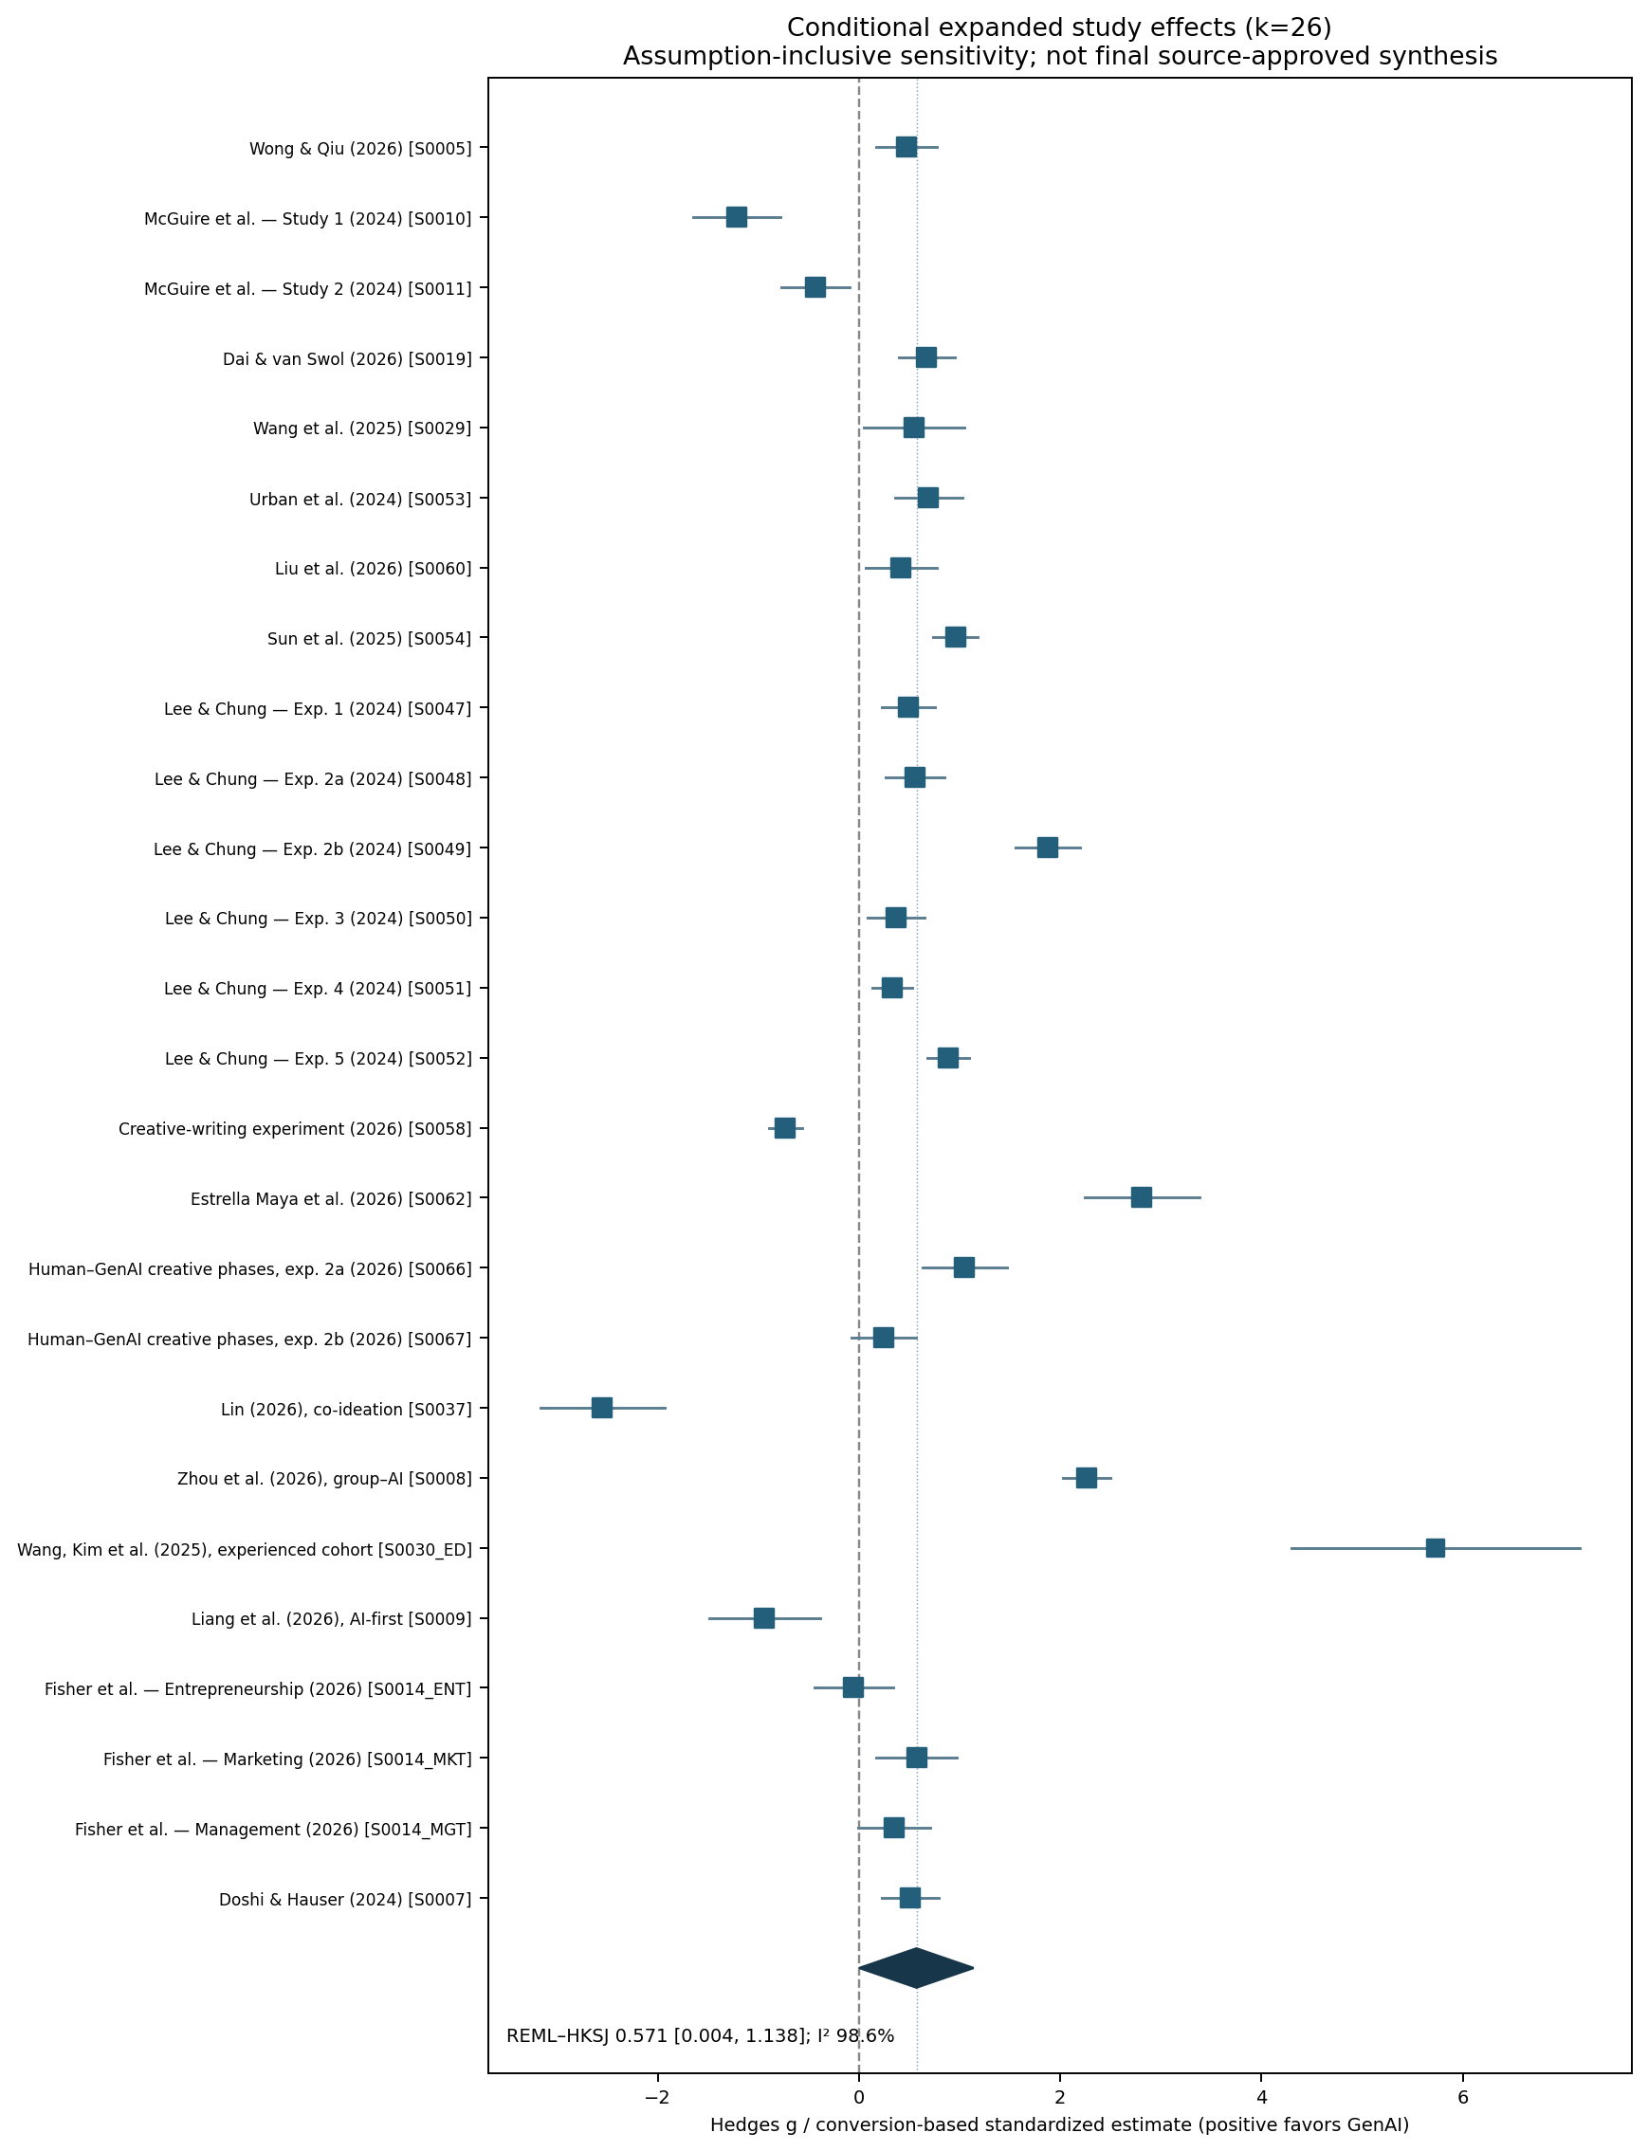
Figure 5. Conditional 26-cohort forest plot. Squares denote inverse-variance random-effects weights; the diamond represents the Knapp–Hartung interval.

Table 6. Cohort-level forest blueprint
Cohort | Task/outcome | N enrolled | g [95% CI] | Weight %
Wong & Qiu (2026) [S0005] | Originality | 196 | 0.475 [0.173, 0.778] | 3.9
McGuire et al. — Study 1 (2024) [S0010] | Overall creative quality | 96 | -1.214 [-1.651, -0.777] | 3.8
McGuire et al. — Study 2 (2024) [S0011] | Overall creative quality | 152 | -0.429 [-0.769, -0.089] | 3.9
Dai & van Swol (2026) [S0019] | Originality | 212 | 0.675 [0.398, 0.952] | 3.9
Wang et al. (2025) [S0029] | Overall creative quality | 64 | 0.545 [0.046, 1.045] | 3.8
Urban et al. (2024) [S0053] | Overall creative quality | 145 | 0.693 [0.357, 1.029] | 3.9
Liu et al. (2026) [S0060] | Originality | 124 | 0.419 [0.063, 0.775] | 3.9
Sun et al. (2025) [S0054] | Overall creative quality | 250 | 0.959 [0.735, 1.183] | 3.9
Lee & Chung — Exp. 1 (2024) [S0047] | Overall creative quality | 233 | 0.488 [0.224, 0.753] | 3.9
Lee & Chung — Exp. 2a (2024) [S0048] | Overall creative quality | 291 | 0.559 [0.269, 0.848] | 3.9
Lee & Chung — Exp. 2b (2024) [S0049] | Overall creative quality | 200 | 1.875 [1.556, 2.194] | 3.9
Lee & Chung — Exp. 3 (2024) [S0050] | Overall creative quality | 194 | 0.369 [0.085, 0.652] | 3.9
Lee & Chung — Exp. 4 (2024) [S0051] | Overall creative quality | 400 | 0.329 [0.130, 0.529] | 3.9
Lee & Chung — Exp. 5 (2024) [S0052] | Overall creative quality | 383 | 0.890 [0.684, 1.097] | 3.9
Creative-writing experiment (2026) [S0058] | Overall creative quality | 600 | -0.730 [-0.896, -0.565] | 3.9
Estrella Maya et al. (2026) [S0062] | Originality | 96 | 2.809 [2.240, 3.379] | 3.8
Human–GenAI creative phases, exp. 2a (2026) [S0066] | Originality | 42 | 1.050 [0.628, 1.472] | 3.9
Human–GenAI creative phases, exp. 2b (2026) [S0067] | Originality | 44 | 0.246 [-0.078, 0.569] | 3.9
Lin (2026), co-ideation [S0037] | Originality | 32 | -2.548 [-3.168, -1.928] | 3.7
Zhou et al. (2026), group–AI [S0008] | Originality | 96 | 2.262 [2.026, 2.498] | 3.9
Wang, Kim et al. (2025), experienced cohort [S0030_ED] | Overall creative quality | 21 | 5.729 [4.293, 7.164] | 3.0
Liang et al. (2026), AI-first [S0009] | Overall creative quality | 112 | -0.937 [-1.486, -0.388] | 3.8
Fisher et al. — Entrepreneurship (2026) [S0014_ENT] | Originality | 100 | -0.051 [-0.443, 0.341] | 3.9
Fisher et al. — Marketing (2026) [S0014_MKT] | Originality | 102 | 0.571 [0.175, 0.968] | 3.9
Fisher et al. — Management (2026) [S0014_MGT] | Originality | 122 | 0.350 [-0.008, 0.708] | 3.9
Doshi & Hauser (2024) [S0007] | Originality/Novelty index | 293 | 0.506 [0.223, 0.789] | 3.9
Pooled diamond | REML/HKSJ | 4600 | 0.571 [0.004, 1.138] | 100.0

Table 7. Report dispositions and direct-performance eligibility
Reports were retained in the evidence inventory when they were empirically informative but did not identify the primary AI-versus-unaided direct-performance contrast. Huang (2025) compares GenAI intensities without a human-only control; Kumar et al. (2025) include immediate and withdrawal experimental phases but the archived omnibus tests do not identify a single contrast-specific g with sampling variance; Chen and Chan (2024) report advertising effectiveness and semantic-divergence outcomes rather than a verified direct creative-quality score. Wadinambiarachchi et al. (2024) reported Bayesian multilevel effects on originality; Lin and Xie (2026) used within-person comparisons requiring the corresponding covariance. The under-18 cohort S0059 is outside the adult estimand. These studies remain candidates for other properly defined streams, rather than being treated as null effects or study failures.
Record/cohort | Primary-status reason | Alternative use
Huang (2025) S0001–S0003 | Intensity-only interventions / survey | AI dose-response and associations
Kumar et al. (2025) S0055–S0056 | No validated contrast-specific variance in archive | Immediate/withdrawal source recovery
Chen & Chan (2024) S0013 | Direct creative rating not identified | Advertising performance
Wadinambiarachchi (2024) S0027 | Bayesian multilevel coefficient ≠ independent SMD | Originality design-aware separate model
Lin & Xie (2026) S0028 | Repeated measures require paired variance | Within-participant creative-performance model
S0059 | Under 18 | Outside adult synthesis

Reproducibility note: this Section 5 is a conditional sensitivity reconstruction, not a submission-cleared primary meta-analysis. It includes Fisher arm allocations and Doshi t-based conversion assumptions that must be replaced by source-verified participant-level variances before treating any k=26 estimate as definitive. No original approval gates were overwritten.

