EXACT FINANCIAL
ARITHMETIC ENGINE
A Complete Technical Explanation
How the engine, the API, and the desktop GUI calculate money without ever losing a fraction of a cent

Prepared for project review

Table of Contents
1. Executive Summary
2. Why Ordinary Floating-Point Arithmetic Fails
3. The Core Idea: Exact Rational Arithmetic
4. How an Expression Is Actually Calculated
5. Three Separate Concepts: Exact, Display, and Settlement
6. System Architecture
7. The Desktop GUI Application
8. Banking Use Cases Implemented
9. Security and Safety Guardrails
10. Quality Assurance
11. How to Run It
12. Suggested Presentation Script
13. Summary and Key Takeaways

1. Executive Summary
Ordinary computer arithmetic (the binary floating-point “float” type used by almost every calculator and spreadsheet) cannot represent most decimal fractions exactly. When a financial system rounds a value in the middle of a calculation — before the calculation is actually finished — it permanently destroys information. That lost fraction of a cent, multiplied across thousands or millions of transactions, becomes a real, auditable discrepancy in a bank's books.
This project is an arithmetic engine, a REST API, a command-line demo, and a full desktop GUI application, all built around one rule: every value is stored as an exact rational number (a numerator over a denominator) for as long as it lives inside the system, and rounding only ever happens at one explicit, clearly-labelled moment — never silently, and never by accident.
The clearest possible proof of why this matters is a single expression:
100 / 3 * 3
A calculator that rounds early gives 33.33 × 3 = 99.99 — one cent has vanished. This engine gives exactly 100, every time, because it never rounds until it is explicitly told to.

2. Why Ordinary Floating-Point Arithmetic Fails
Binary floating point represents numbers using powers of two (halves, quarters, eighths…). Many everyday decimal fractions — including 1/3, 1/10, and plenty of ordinary monetary amounts — have no exact representation in base 2, in the same way 1/3 has no exact, finite representation in base 10 (it is 0.333… forever).
Every floating-point arithmetic operation on such a value carries a small, silent rounding error. Individually these errors look negligible. Accumulated across a real banking workload — thousands of interest calculations, currency conversions, and transaction splits — they become real, measurable, and auditable money.

2.1 What “Precision Loss” Actually Means
Precision loss is not “a slightly different-looking number.” It is the permanent destruction of information. Once a calculation replaces 100/3 with 33.33, there is no way to recover the original 100 from any further arithmetic performed on 33.33. The exact value is gone — forever — from that point in the calculation onward.

3. The Core Idea: Exact Rational Arithmetic
Instead of storing a rounded decimal like 33.33, the engine stores the pair of whole numbers 100 and 3 — a numerator and a denominator — using Python's built-in Fraction type, wrapped by this project's own ExactNumber value object.
A fraction of two whole numbers, combined with another fraction of two whole numbers using addition, subtraction, multiplication, or division, is always exactly another fraction of two whole numbers. No approximation is ever introduced by the arithmetic itself — only an explicit, deliberate rounding step can introduce one, and every such step is fully recorded.

3.1 A Safety Net: Floats Are Structurally Rejected
The engine's core number type refuses to be constructed from, or combined with, a raw Python float at all. Attempting it raises a specific, named error (AccidentalFloatError) rather than silently accepting an imprecise value. This turns “never use floats for money” from a coding guideline that a tired developer might forget, into a rule the program itself enforces.

4. How an Expression Is Actually Calculated
This is the section most worth walking through slowly, because it answers the question “how does this actually work?” step by step, using the example expression 100 / 3 * 3.

4.1 Step One — Tokenizing
The raw text is scanned character by character into a flat list of tokens: a NUMBER, a SLASH, a NUMBER, a STAR, a NUMBER. Any character that is not a digit, a decimal point, one of + - * / ( ), or whitespace is rejected immediately with a clear error — nothing ambiguous is ever passed further into the system.
100 / 3 * 3
→ NUMBER(100) SLASH NUMBER(3) STAR NUMBER(3)

4.2 Step Two — Parsing With Correct Precedence
A small, hand-written parser (technically: a recursive-descent parser) turns the token list into a result, using this grammar:
expression := term (('+' | '-') term)*
term := factor (('*' | '/') factor)*
factor := NUMBER | '(' expression ')' | '-' factor
Because term (which handles multiplication and division) is nested inside expression (which handles addition and subtraction), multiplication and division are always evaluated first. This is exactly why 2 + 3 * 4 correctly equals 14, not 20 — the grammar itself enforces standard mathematical order of operations. Parentheses simply route back into the top-level expression rule, which is what lets them override the default order.

4.3 Why the Engine Does NOT Use eval()
Python has a built-in eval() function that can turn text directly into a running calculation. It was deliberately not used here, for a serious reason: eval() executes arbitrary Python code with the full permissions of the program running it. A malicious piece of “expression” text handed to eval() could delete files, read private data, or run any command on the machine — not just do arithmetic.
Writing a small, purpose-built parser instead means the program is structurally only capable of arithmetic. There is no code path from a typed expression to arbitrary code execution, because the parser was never given the ability to do anything except recognise numbers and the four operators.

4.4 Step Three — The Exact Arithmetic Formulas
Once two fractions a/b and c/d need to be combined, the engine applies the standard rules of fraction arithmetic exactly, with arbitrarily large whole numbers on both sides:
Operation | Expression | Exact Formula
Addition | a/b + c/d | (a·d + c·b) / (b·d)
Subtraction | a/b - c/d | (a·d - c·b) / (b·d)
Multiplication | a/b x c/d | (a·c) / (b·d)
Division | a/b / (c/d) | (a·d) / (b·c), c not 0

4.5 Step Four — Reduction to Lowest Terms
After every single operation, the result is reduced using the greatest common divisor (GCD), found with Euclid's algorithm — the same method taught in school for simplifying fractions:
gcd(10, 6) = 2
10/6 → (10÷2) / (6÷2) = 5/3
This keeps the numbers as small as possible at every step and guarantees the fraction shown is always in its simplest form.

5. Three Separate Concepts: Exact, Display, and Settlement
This is the single most important idea in the whole project, and the one most worth emphasising in a presentation.
- Exact value — what the engine calculates with, internally, forever — e.g. 100/3. This never changes no matter what else happens to it.
- Decimal display — a human-readable rendering of the exact value, computed by ordinary long division out to however many digits are requested — e.g. 33.333333… If the true decimal never terminates, the display is clearly marked as repeating/truncated. Changing how many digits are displayed never changes the stored exact value.
- Settlement (rounding) — the one explicit moment the system is asked “what is the real, payable amount?” — e.g. 33.33 USD. Every settlement records the original exact value, the rounded value, and the exact difference between them, so nothing is ever rounded silently.
A financial system that conflates these three ideas is exactly the kind of system that loses a cent here and there without anyone noticing. Keeping them as three distinct, clearly-labelled concepts throughout the codebase is what prevents that.

6. System Architecture
The codebase follows Clean Architecture: each layer is only allowed to depend on the layer “below” it, and the core mathematical rules never depend on any framework, database, or user interface at all.
Layer | Responsibility | Depends on
Domain | Pure business rules: ExactNumber, Money, Currency, RoundingPolicy, the expression parser, interest/allocation math. | Nothing (no framework, no database, no GUI)
Application | Use cases that orchestrate the domain: EvaluateExpression, RoundValue, ConvertCurrency. | Domain layer only
Infrastructure | Concrete, swappable implementations: in-memory store, SQLAlchemy/MySQL repositories, logging. | Application layer (implements its interfaces)
Presentation | How a human or another system talks to the engine: the desktop GUI, the REST API, the CLI demo. | Application layer only

The practical benefit of this layering: the desktop GUI, the REST API, and the command-line demo are three different presentation layers that all call the exact same underlying calculation code. The math is written once and is guaranteed to behave identically no matter which interface is used to reach it.

7. The Desktop GUI Application
The GUI is a native Python desktop application — not a website, not a browser page — built with CustomTkinter, a modern-themed layer over Python's standard Tkinter toolkit. It is organised into three tabs, each demonstrating a real banking workflow.

7.1 Calculator Tab
A full calculator button grid on the left; on the right, a live “Calculation Trace” panel explaining exactly how the on-screen result was reached, a scrollable history of past calculations, and a “Settle as Money” panel where a currency and rounding mode can be chosen to see the real, payable amount and the precise rounding difference it introduced.
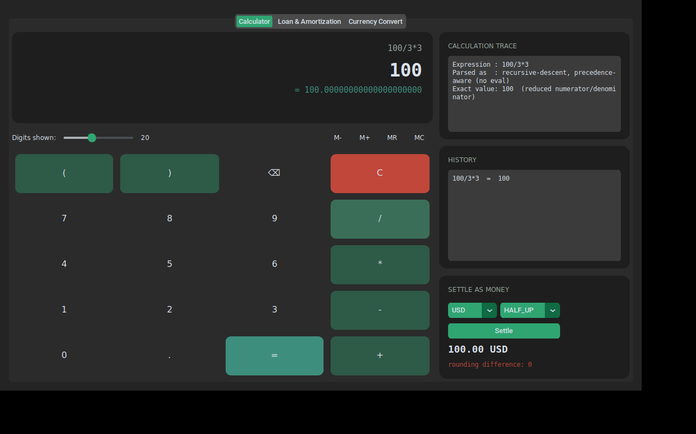
Figure 1 — Calculator tab: 100 / 3 * 3 evaluates to exactly 100, and settles to 100.00 USD with zero rounding difference.

7.2 Loan & Amortization Tab
Given a principal amount, an annual interest rate, a payment frequency, and a term in years, this tab builds a full month-by-month (or period-by-period) loan repayment schedule: each row shows the payment, how much of it is interest, how much is principal, and the remaining balance — calculated so that the running balance is carried forward as an exact value between rows, never re-derived from an already-rounded number. The final row's balance always reaches exactly zero.
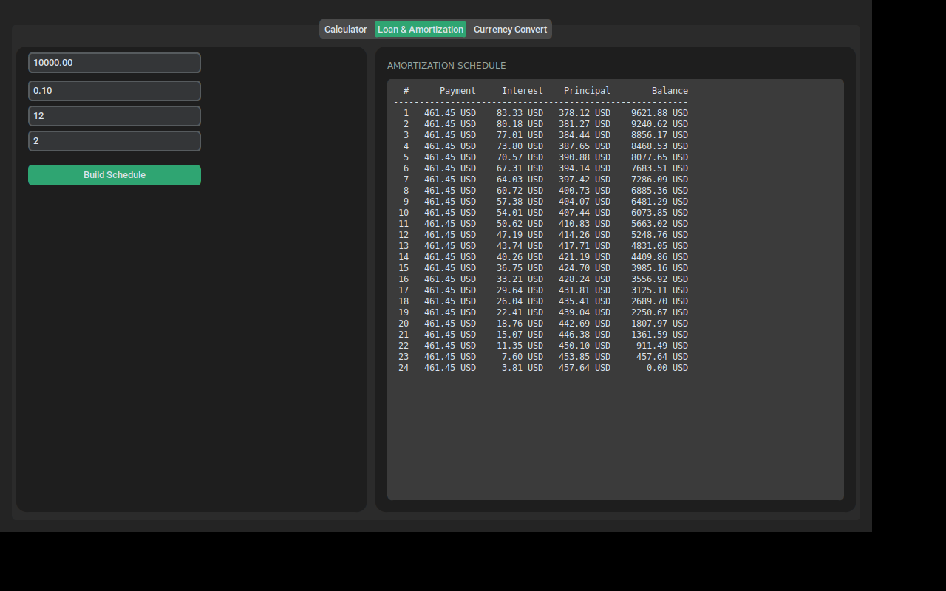
Figure 2 — Loan & Amortization tab: a full repayment schedule, balance reaching exactly zero on the final payment.

7.3 Currency Convert Tab
Converts an amount from one currency to another using an exact exchange rate, showing the full-precision converted amount and the currency-settled (payable) amount side by side, along with the rounding difference between them.
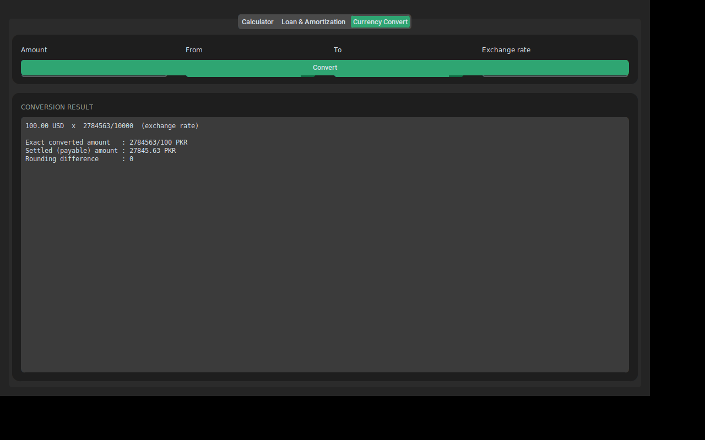
Figure 3 — Currency Convert tab: exact and settled amounts shown explicitly, side by side.

8. Banking Use Cases Implemented
- Simple & compound interest — Principal × Rate × Time, and standard compound growth, computed with exact exponentiation for a whole number of compounding periods.
- Loan amortization — A full payment schedule where the exact remaining balance is carried forward between periods.
- Currency conversion — An exact exchange rate applied without rounding until an explicit settlement step.
- Transaction splitting (allocation) — Splitting an exact total (e.g. 100.00) into N real, payable parts (e.g. 33.33 / 33.33 / 33.34) that always sum back exactly to the original total, using the standard “largest remainder” allocation method used in real accounting systems.

9. Security and Safety Guardrails
- No eval(), ever — user-typed expressions can only reach a purpose-built parser that understands numbers and four operators — nothing else.
- A dedicated exception for every failure mode — division by zero, an invalid or unsupported currency, an invalid rounding mode, an invalid expression, and an accidental float are each their own named, catchable error — never a generic or swallowed exception.
- Explicit allow-lists — currency codes and rounding-mode names are checked against a known registry and rejected loudly if unrecognised, rather than silently guessed at.

10. Quality Assurance
The engine is covered by 80 automated tests, organised into three groups:
- Unit tests — each domain building block (ExactNumber, rounding, decimal display, the parser, Money, allocation, interest) tested in isolation.
- Integration tests — the use cases and the REST API tested end to end, including error responses.
- Financial regression tests — the exact required scenarios from the specification — 100/3, (100/3)×3 = 100, 1/3 + 1/3 + 1/3 = 1, 10/6 = 5/3, division by zero, negative numbers, repeating and terminating decimals — plus dedicated tests confirming a raw float can never enter the system.
All 80 tests pass, and the codebase passes a full static type check (mypy, in strict mode) with zero issues, meaning every function's inputs and outputs are verified to be internally consistent throughout the project.

11. How to Run It

11.1 Install dependencies
pip install -r requirements.txt

11.2 Run the desktop GUI
python -m app.presentation.gui.calculator_app_modern

11.3 Run the REST API
uvicorn app.presentation.api.main:app --reload
# then open http://127.0.0.1:8000/docs

11.4 Run the command-line demo
python -m app.presentation.cli.demo

11.5 Run the automated tests
pytest
mypy app

12. Suggested Presentation Script
A short, ordered script for demonstrating this project live:
- Open with the problem — state the one-cent example — “33.33 × 3 = 99.99, but the true answer to 100/3 × 3 is 100. That missing cent is what this whole project prevents.”
- Open the Calculator tab — type 100/3*3, press equals, and point at the result: exactly 100. Then point at the Calculation Trace panel and explain what happened.
- Press Settle — show the result becomes 100.00 USD with a rounding difference of exactly 0 — proving nothing was lost even after converting to real currency.
- Switch to Loan & Amortization — build a schedule and point out the balance reaches exactly zero on the final row — no leftover fraction of a cent anywhere in the middle.
- Switch to Currency Convert — show the exact and settled amounts side by side, and explain that a multi-step conversion never rounds until the very last step.
- Close with the architecture — explain in one sentence that the GUI, the API, and the command line all call the exact same calculation code underneath — so the answer is guaranteed to be identical no matter which one is used.

13. Summary and Key Takeaways
- The problem — ordinary floating-point arithmetic silently loses precision, and in a financial system that means silently losing money.
- The solution — store every value as an exact fraction (numerator/denominator) using arbitrary-precision whole numbers, and never round until explicitly asked.
- The proof — 100/3 × 3 = 100 exactly, every time, in this engine — and the engine can show its work at every step.
- The safety — no eval(), a named exception for every failure mode, and floats are structurally rejected from ever entering the system.
- The delivery — one core calculation engine, reused identically by a desktop GUI, a REST API, and a command-line tool, backed by 80 passing automated tests.

