MESCO TRUST
Website Content & Change Requirements
Prepared by: Muzaffar Shaikh

1. About MESCO — Founding Story
WEBSITE LOCATION About Us → Our Founding Story

Draft website copy
Modern Educational Social & Cultural Organisation (MESCO) was established in 1968 by seven classmates who shared a desire to support people in need. What began as a small effort to help students gradually developed into an organisation focused on improving the lives of underprivileged communities.
Education became a central part of MESCO’s work, alongside medical assistance and relief of poverty. Through educational scholarships, healthcare support, family relief and livelihood initiatives, MESCO works to connect donors and well-wishers with people who need support.
As a secular charitable trust, MESCO continues to work towards a better tomorrow by supporting meaningful education, health and community development.
Content status: Draft based on publicly described organisational history. MESCO should approve the final wording and confirm historical details before publication.

Developer requirements
- Provide a rich-text content field and optional hero/archival image.
- Allow one or more supporting images with captions and alt text.
- Allow the content editor to update the section without code changes.

2. Milestones Timeline
WEBSITE LOCATION About Us → Milestones
The user will provide a separate timeline reference image for the developer to follow.
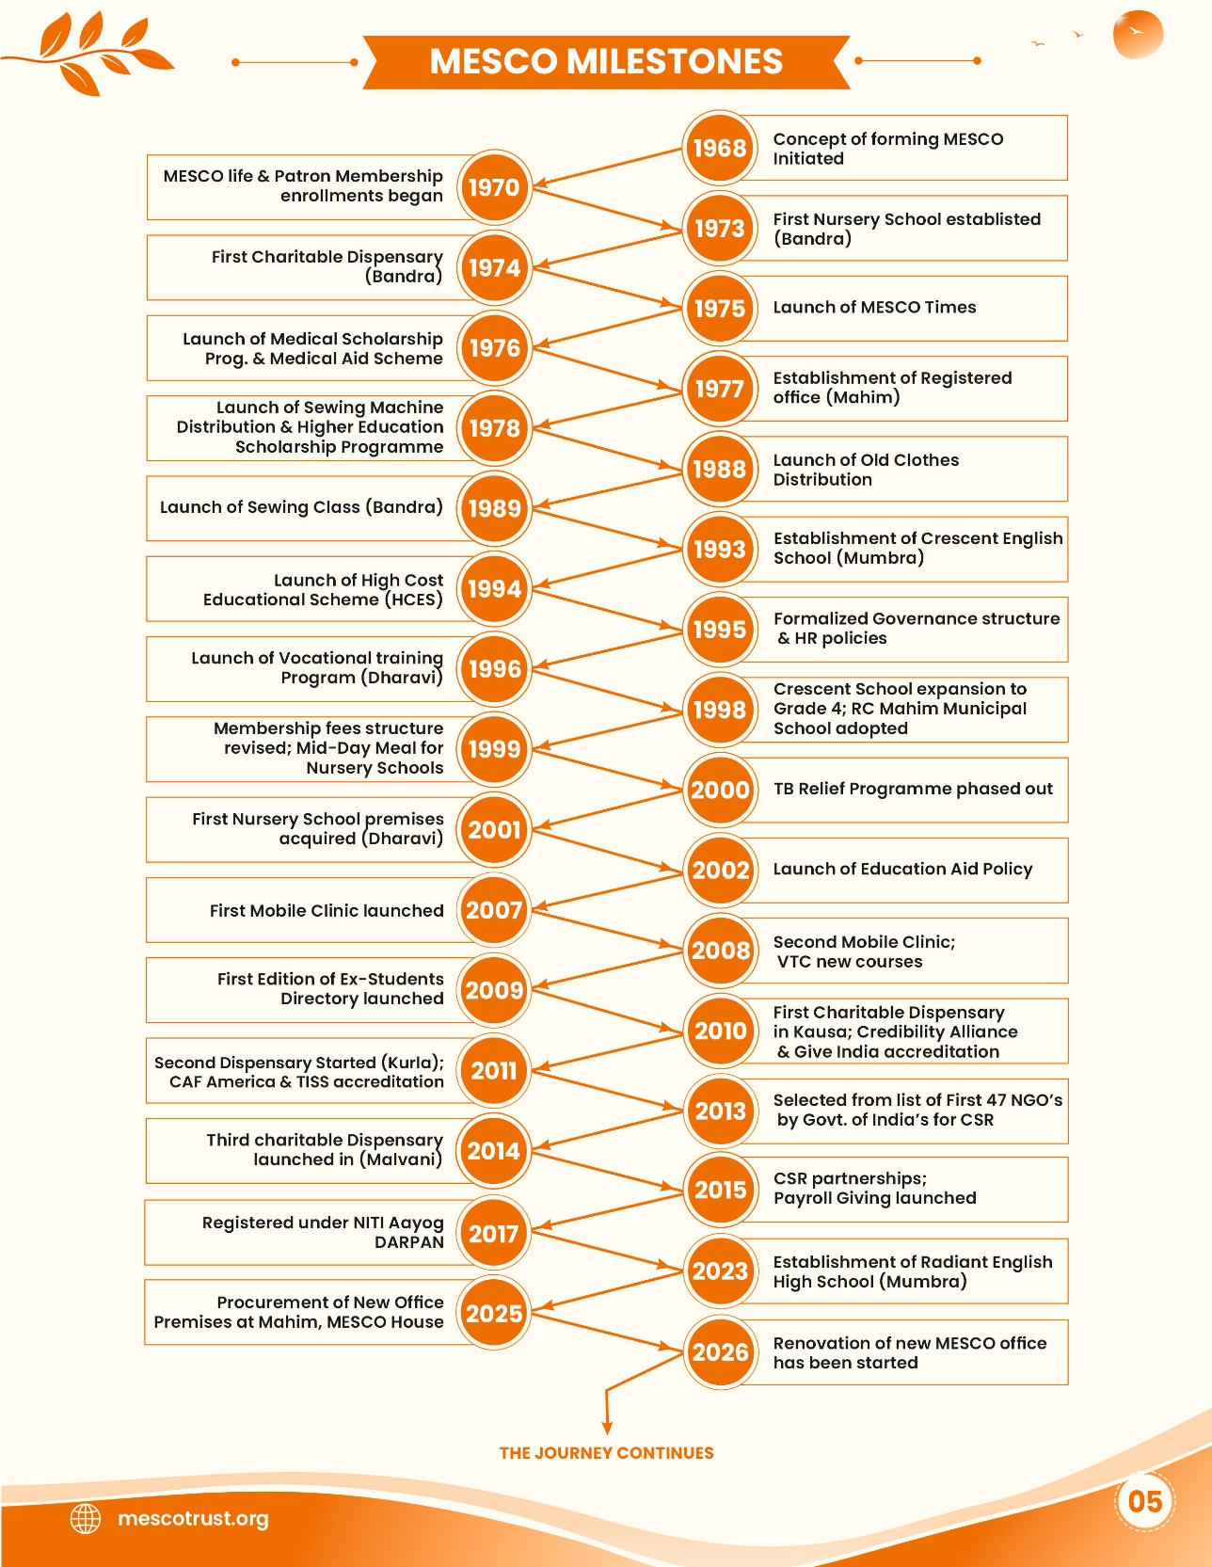

3. Mission, Vision & Objectives
WEBSITE LOCATION About Us → Mission & Vision

Vision
To help the underprivileged and marginalized live a better tomorrow through various interventions.

Mission
Strive to improve the quality of life of the financially disadvantaged by promoting meaningful education and health.

Aims and objectives
- Promote education among weaker sections of society, primarily, and others generally.
- Promote science and literature through education.
- Work towards the social upliftment of disadvantaged sections of society.
- Encourage a better understanding and appreciation of universal cultural values.

Developer requirements
- Provide editable text fields and optional icons/cards for Vision, Mission and Objectives.

4. Campaigns and Crowdfunding
WEBSITE LOCATION Campaigns listing page
Aiolos is currently developing a dedicated crowdfunding platform for MESCO Trust. The MESCO Trust website must include a dedicated Campaigns page to showcase ongoing fundraising campaigns and direct visitors to the crowdfunding platform.

- Create a Campaigns listing page displaying active campaigns with their title, image, short description and a Donate Now / Know More button.
- Integrate the crowdfunding platform being developed by Aiolos by adding a prominent link or button on the Campaigns page and other relevant sections of the website.
- Where feasible, link each campaign directly to its respective page on the crowdfunding platform.
- Display campaign details, fundraising targets, amounts raised and progress indicators wherever this information is available and verified.
- Ensure the campaign information and links can be managed through the admin panel or synchronised with the crowdfunding platform, depending on the integration method agreed upon with Aiolos.
- The final crowdfunding platform URL and integration approach will be confirmed once provided by Aiolos.

Expected Outcome: Visitors should be able to explore MESCO Trust's fundraising campaigns on the website and proceed to Aiolos' crowdfunding platform to make donations.

5. Department Contacts — Inside of contact us
WEBSITE LOCATION In the Contact Us
“Department Contacts” page so visitors can identify the correct team for their enquiry. Use clear department cards or rows with a search/filter option if there are many departments.

Admin fields
- Department name, short description, contact person, designation, department email, telephone/mobile, office hours, location, enquiry link, display order and publish status.

Department directory — populate and confirm
Department | Contact person / designation | Email | Phone | Status / notes
Donations & Fundraising | [To be confirmed] | [To be confirmed] | [To be confirmed] | Pending internal confirmation
Scholarships / Educational Aid | [To be confirmed] | [To be confirmed] | [To be confirmed] | Pending internal confirmation
Volunteering | [To be confirmed] | [To be confirmed] | [To be confirmed] | Pending internal confirmation
Medical Assistance | [To be confirmed] | [To be confirmed] | [To be confirmed] | Pending internal confirmation
Relief of Poverty | [To be confirmed] | [To be confirmed] | [To be confirmed] | Pending internal confirmation
CSR / Partnerships | [To be confirmed] | [To be confirmed] | [To be confirmed] | Pending internal confirmation
General Enquiries | MESCO Trust office | mescotrust@mescotrust.org | +91 22 24441442 / +91 22 24448637 | Verify details before publishing

6. FAQs
WEBSITE LOCATION Dedicated FAQ page + optional contextual FAQs on programme pages
Create a dedicated FAQ page with category filters and searchable questions. The same FAQ entries should optionally be displayed on relevant programme pages.
Category | Question | Draft answer
About MESCO | What is MESCO Trust? | MESCO Trust is a secular charitable organisation established in 1968. It works in education, medical assistance and relief of poverty.
About MESCO | What are MESCO’s main areas of work? | MESCO focuses on educational support, medical assistance and poverty-relief initiatives, alongside community and livelihood programmes.
Donations | How can I support MESCO? | Please use the official donation facility or contact MESCO for current donation procedures.
Donations | Which programmes can I support? | Available programmes may include education, medical assistance, poverty relief and livelihood initiatives. Please check current approved campaigns.
Scholarships | Does MESCO provide scholarships? | MESCO provides educational assistance to eligible students. Scheme-specific eligibility and application details should be checked in the current official announcement.
Scholarships | How do I apply for a scholarship? | Follow the latest application instructions published by MESCO for the relevant scheme and academic year.
Scholarships | Which documents are required? | Required documents vary by scheme and academic year. Refer to the current official application instructions.
Medical Assistance | Does MESCO provide medical assistance? | MESCO supports eligible individuals through medical-assistance programmes, subject to programme criteria and available resources.
Relief of Poverty | Can families request relief support? | Contact MESCO to enquire about current relief programmes, eligibility and application procedures.
Volunteering | How can I volunteer with MESCO? | Express your interest through the official website’s volunteering section or contact MESCO directly.
Partnerships | Can an organisation collaborate with MESCO? | Organisations can contact MESCO to discuss potential support and collaboration opportunities.
Contact | How can I contact MESCO? | Use the official Contact Us page or the approved Department Contacts directory.

7. Advisors, Sub - Committees & Volunteers
WEBSITE LOCATION Dedicated people directory page with tabs / filters
Create a people directory with separate tabs/filters for Advisors, Sub-Committees and Volunteers, as applicable. The admin panel must support profile updates as memberships change.

Profile fields
- Full name and approved designation/role.
- Group/category (Advisory Board, Committee, Volunteer, etc.).
- Short biography and professional background, where approved.
- Official profile photograph with alt text.
- Optional organisation/affiliation and areas of expertise.
- Display order and publish/unpublish status.

Developer requirement
- Do not hard-code names or photos into the page. Use repeatable admin-managed profile records and show only published profiles.

8. Internships & Careers
WEBSITE LOCATION Careers → Internships section (or dedicated Internships page)
Add an Internships section to Careers or create a dedicated Internships page if active opportunities need to be displayed independently. The page should support an empty state when no internships are open.

Suggested content
Internship Opportunities at MESCO Trust
MESCO Trust works across education, healthcare, poverty relief and community development. Individuals interested in contributing their skills and gaining experience may contact MESCO to enquire about available opportunities.
Potential categories for MESCO to consider (not confirmed vacancies):
- Social Media and Digital Marketing
- Graphic Design and Video Editing
- Content Writing and Communications
- Website Development and IT Support
- Research and Data Management
- Programme Coordination
- Fundraising and CSR Support

Internship listing fields
Field | Requirement
Role title / department | Required
Description and responsibilities | Required for each active role
Eligibility / skills | Approved criteria
Location and work mode | Office / hybrid / remote, if applicable
Duration and stipend | Publish only when confirmed
Start date / application deadline | Optional but recommended
Application method | Approved email, form or careers link
Status | Open, closed, draft; closed roles should not accept applications

9. Testimonials
WEBSITE LOCATION Donor Testimonials page + selected sections on relevant pages
Retain the existing Donor Testimonials page and make testimonial records reusable across the website. Add selected approved testimonials to relevant pages where they help explain programme impact.
Page / section | Recommended testimonial type
Home | Short, high-impact approved testimonial
About Us | Organisational history, values or community impact
Scholarships / Educational Aid | Student, alumni or education sponsor
Medical Assistance | Patient/family, only with explicit consent and privacy safeguards
Relief of Poverty | Beneficiary, only with explicit consent
Women’s Livelihoods | Participant in an approved livelihood initiative
Donations / Fundraising | Donor or CSR partner
Volunteering | Volunteer or programme contributor
Campaign detail pages | Testimonial related to that campaign
Donor Testimonials | Full approved donor testimonial collection

Testimonial admin fields
- Quote/text, name or approved anonymous attribution, role/relationship, category, image (optional), consent/approval confirmation, display location, display order and publication status.

10. Awards & Recognition
WEBSITE LOCATION

We’ll Make the changes.

— End of document —

