### THE ROYAL MARINES

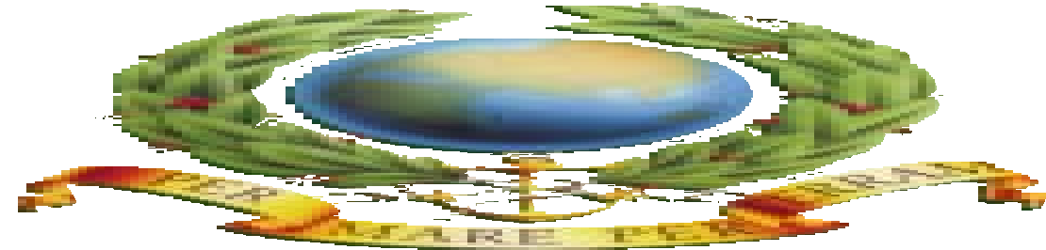

Cricket

**CONTENTS**



Student Notes Teacher Notes

Prepared for The Royal Navy in Association with The National Cricket Association and produced by Education & Youth Ltd, London.

If there is any support you feel The Royal Navy can give regarding this project please contact 0870 333 0423.

## Acknowledgements

**These notes have been compiled by** Bob Carter – National Coach, (Coach Education) The National Cricket Association

Technical Editor: **P Edwards M.A.**

MESSAGE FROM THE NATIONAL CRICKET ASSOCIATION 3

INTRODUCTION TO THE MODULE 3

SKILLS DEVELOPMENT SHEET 4

|  |  |  |
| --- | --- | --- |
| **UNIT 1** | **INTRODUCTION TO CRICKET MODULE** | **5** |
| **UNIT 2** | **TECHNIQUES AND SKILLS** | **6** |
|  | **1 FIELDING** | **6** |
|  | **2 BOWLING** | **9** |
|  | **3 BATTING** | **14** |
|  | **4 WICKET KEEPING** | **22** |
| **UNIT 3** | **TACTICS AND FIELD PLACEMENT** | **25** |
| **UNIT 4** | **UMPIRING** | **28** |
| **UNIT 5** | **PHYSICAL CONDITIONING FOR CRICKET** | **30** |
| **UNIT 6** | **HISTORY OF CRICKET** | **34** |
| **UNIT 7** | **THE COMPETITIVE STRUCTURE OF THE SPORT.** | **35** |
| **UNIT 8** | **USEFUL INFORMATION** | **36** |

##### Module Objectives:

# Message from The National Cricket Association

The National Cricket Association, founded in 1968 has several objectives, two of which are especially relevant with reference to this publication.

They are as follows:

* to encourage the playing of cricket in accordance with the Laws of Cricket and in the best traditions of Sportsmanship;
* to administer a coaching scheme on a national basis on behalf of the Cricket Council.

The National Coaching Scheme is highly regarded by all cricketing nations as being in the vanguard of educational and coaching methods at all levels. Additionally, two separate Proficiency Award tests are run and administered by the NCA for primary and secondary school children.

This instruction booklet is intended as a basic guide to students in secondary schools wishing to follow the basic GCSE or equivalent course as set out in the syllabi by the various examining boards. However, anyone wishing to delve deeper into this subject should consult the list of books for recommended reading, or if over the age of 18, consider enrolling on a locally run Coaching Award Course.

Further information on the latest educational and coaching ideas are published in ‘Cricket Coach’, the journal of the Association of Cricket Coaches, or in ‘Cricket World’, an independent publication which provides a forum for NCA official policy and news.

# Introduction to the Module

##### Method:

After completing the Module students should be able:

* to understand the basic principles of the skills of the game, tactics, field placement and umpiring signals
* to apply this knowledge to improve their performance and enjoyment in both practice and the game
* to discuss the development of the game in recent times.

Teachers should provide:

* encouragement, support and motivation to students studying this module
* access to facilities for practice and also suitable for the game bearing in mind the ability of the players
* the opportunity for students to discuss and study any topics not fully covered in the module due to lack of space, e.g. advanced techniques, the Laws etc.

# Skills Development Sheet

The beginning stage of learning cricket is the exploratory phase, where the player is attempting to learn the correct sequence of movements of all the basic skills e.g. Batting, bowling, fielding. A number of errors may be made and players will require feedback to recognise and correct these errors.

During the intermediate stage a player will perform more consistently. Timing and anticipation will improve, although skills may break down under the pressure of a game situation.

At the advanced stage all the basic skills are automatic and a player will concentrate on more detailed aspects of the skill and the tactics required in the game eg. Position of fielders.

|  |  |
| --- | --- |
| **Name of Module** | **Cricket** |
| Basic Skills | Fielding, bowling, batting, wicket keeping (pages 6-24) |
| Game-play Skills | Good basic skills, techniques. A good understanding of the basic principles and tactics. Ability to vary strokes and bowling techniques. Demonstrates good concentration and alertness in the field (pages 6-24) |
| Tactical Skills | Bowling: Encouraging dangerous strokes. Varying pace, flight, length, spin and width of crease.  Batsmen: Judgement and decision making; looking for gaps in the field; noting ability of fielders and exploiting weaknesses.  Fielders: Placing to   1. Catch batters 2. Stop runs. Adjusting field according to batter (pages 25-27) |
| Training Skills | Aerobic endurance, anaerobic endurance, flexibility (pages 30-33) |
| Rules | “The Laws of Cricket” can be obtained from the MCC. Address page 36. |

## UNIT 1

**Introduction to Cricket Module**

Cricket is a game steeped in tradition, in which it is often how you play the game that is as important as winning. The expression “That’s not cricket” embodied the ideal of “fair play” and good sportsmanship which teachers and coaches should endeavour to foster at all levels.

There are may different levels of the game ranging from the Five Day Test Match, the afternoon club match, the indoor six a side adults, Kwik Cricket, Cricket Pairs game played by 10 year olds to the simplest single wicket game of one bowler and one batsman. Each require different degrees of ability, fitness, skills and commitment. Early exposure to the skills required is a great help in the making of a successful player, though some players have turned to the game at a later age and achieved a good standard.

Learning the skills can be a very enjoyable experience with a great deal of physical activity involved. It is also possible to structure the skill learning so that simple competitions and small sided games prevent the practices from becoming boring. They also provide opportunities of introducing to beginners, in stages, small sections of the 42 Laws governing the playing of the adult game.

The material covered in this book does not relate to any specific Examination Board’s syllabus, but is intended to provide a *basic* resource which should be supported and supplemented by reference to the texts listed in *Recommended Reading.*

## UNIT 2

**Techniques and Skills**

In order to play cricket to examination level, students should have a good practical and theoretical grasp of the 4 major activities of the game:

* Fielding
* Bowling
* Batting
* Wicket keeping

**1 Fielding**

Essentially this involves catching and throwing in a variety of circumstances both static or on the move.

##### CATCHING

##### The High Catch

*Objective:* To catch a ball which is dropping quickly.

*Method:* Sight the ball.

Move quickly to where it will come down.

Stand still with hands up above eye level and palms facing ball, fingers spread out, little fingers touching.

Hands “give” as ball is caught. Finish close to chest (see Figure 1).

##### The Skim Catch

*Objective:* Primarily to catch a flat trajectory ball arriving about head high.

*Method:* Sight the ball, palms facing ball, fingers pointing upwards, thumbs touching.

Hands give as ball is caught.

If ball is caught directly in front of head, move head to side as hands give (see Figure 2).

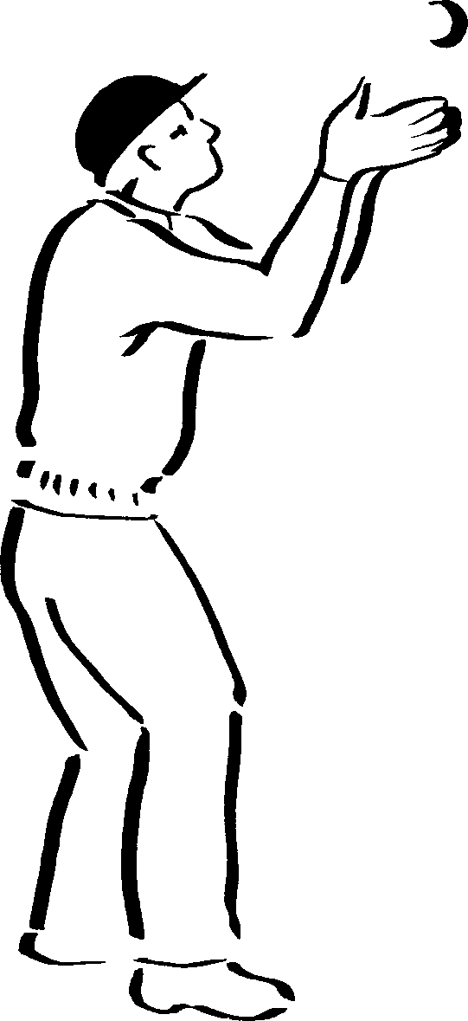

*Figure 1*

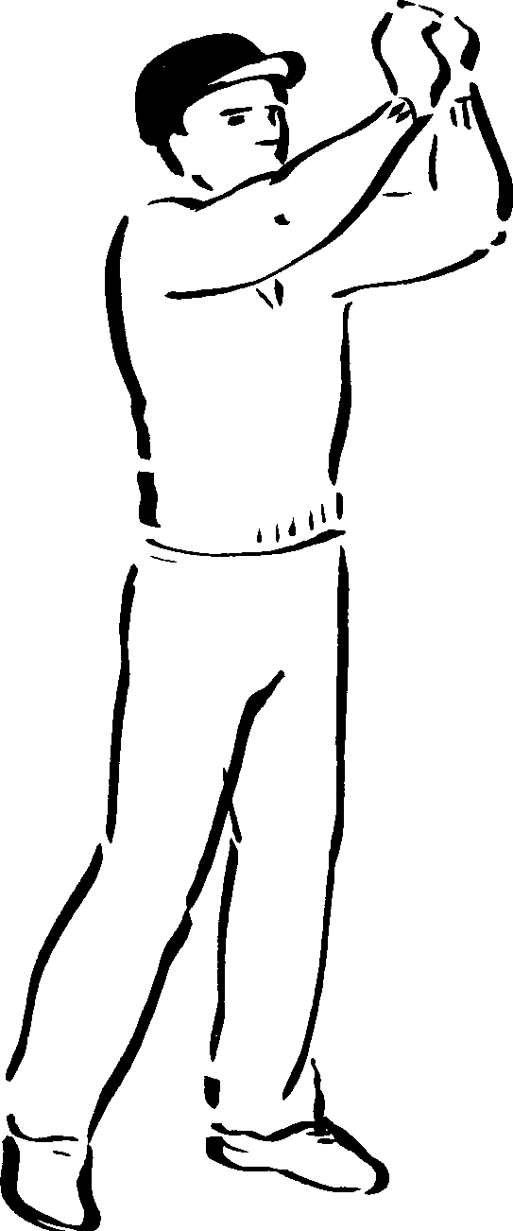

*Figure 2*

##### The Close Catch

*Objective:* Primarily to deal with catches close to the wicket.

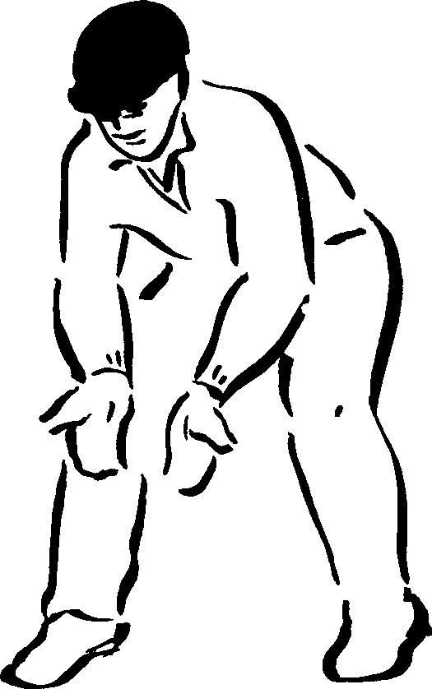*Method:* Eyes level.

Head still.

Palms facing anticipated line of ball.

Fingers pointing down, elbows clear of body. Weight on balls of feet.

Hands give as ball is caught (see Figure 3).

*Figure 3*

##### INTERCEPTING AND RETURNING

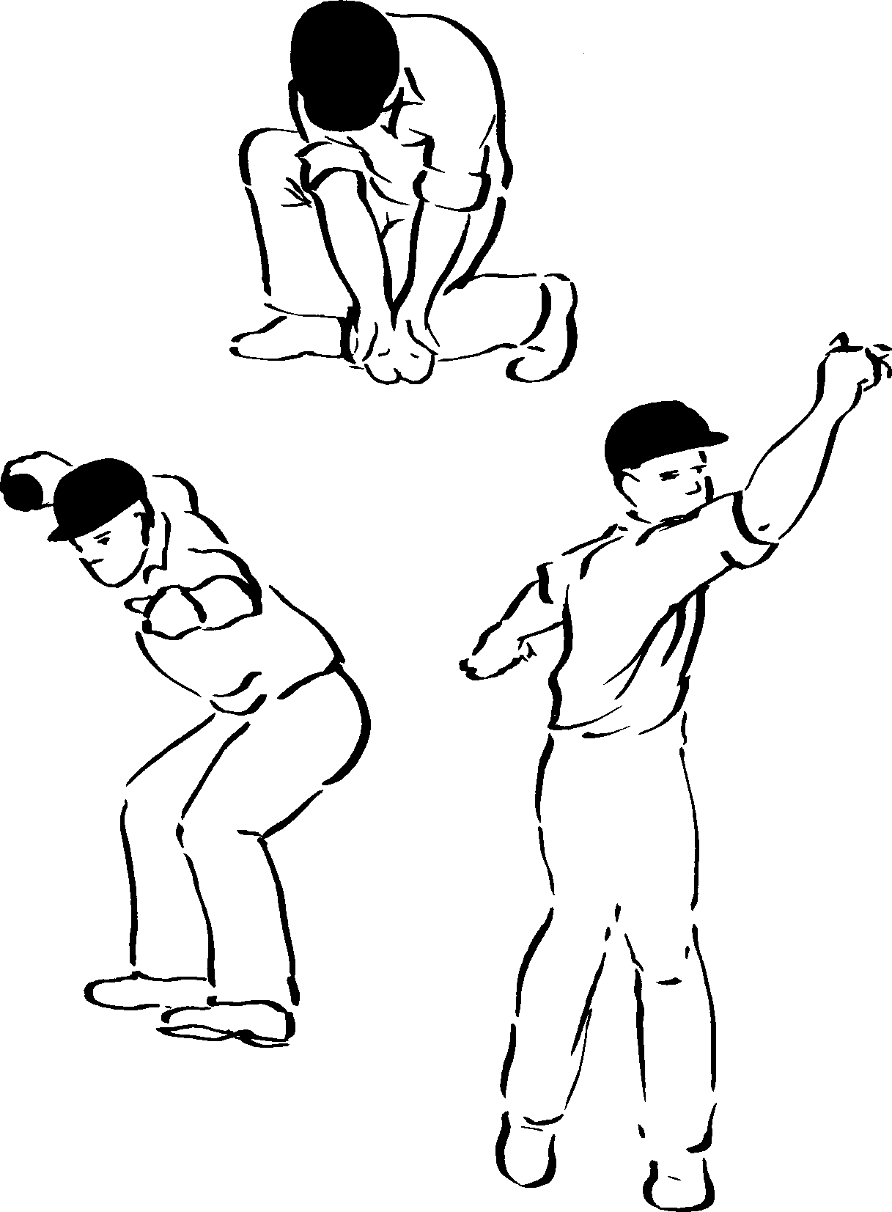

*Figure 4*

##### The Long Barrier and Throw

*Objective:* The long barrier is used to ensure the ball is stopped.

*Method:* Head on line of ball.

Left knee on ground, overlapping right heel.

Palms facing ball, fingers pointing down.

Holding ball in right hand, stand up taking a pace towards target with left foot.

Aim with left arm.

Weight on back foot which is at right angles to line of throw.

Throw ball; follow-through over left leg with right arm and right leg (see Figure 4).

##### CHASING AND RETRIEVING

##### The Short Throw

*Objective:* Run inside line of ball to enable right foot to land beside it.

*Method:* Weight well back. Head over right knee, left foot trailing.

Pick ball up.

Turn to left into throwing position.

Aim and throw without further steps (see Figure 5).

(If the ball is moving quickly it may be necessary to take several braking strides before turning and throwing.)

##### The Long Throw

*Objective:* To retrieve a ball after picking up near the boundary.

*Method:* Ensure left foot is forward alongside ball.

Bend down keeping seat well back. Pick ball up.

Push hard on left foot.

Turn to left, fling left arm into aiming position and throw (see Figure 6).

##### Throwing on the Turn

NB This is an advanced technique, used to prevent runs, or to secure a run out.

*Method:* Run inside line of ball.

Pick up ball alongside right foot. Step onto left foot.

Jump, turning in the air. Aim at target with left arm.

Throw while still in the air (see Figure 7).

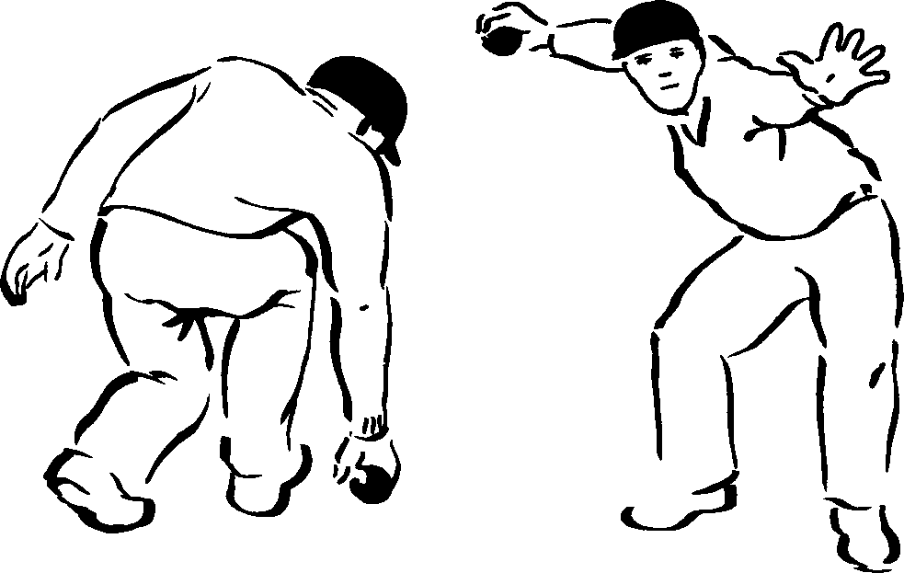

*Figure 5*

*Figure 6*

*Figure 7*



**General points for fielders**

Expect every ball to come to you but do not anticipate its line, If not fielding the ball, back up at either end to reduce height or speed. the chance of over-throws.

All fielders except close catchers should be moving in towards If you are close to the bowler’s wicket and he cannot get the striker as the bowler delivers the ball. back to it, move to it to take the return.

Slips, leg slip and wicketkeeper can watch the ball from the Concentrate all the time, keeping an eye on your captain bowler’s hand; others watch the bat. who may wish to move you.

Sight the ball before moving off in a particular direction; then If there is a possibility of two fielders colliding when move quickly. going for the same ball the nearest should call ‘mine’ or Whenever possible use two hands and get some part of the body the captain should shout the name of the player who is

behind the ball unless this action would prevent a run out. to field the ball.

Having fielded a ball, throw it immediately to the wicketkeeper or, On cold days keep your muscles and hands warm to if there is a chance of a run out, at the stumps. prevent injury and to be ready for instant action.

**2 Bowling**

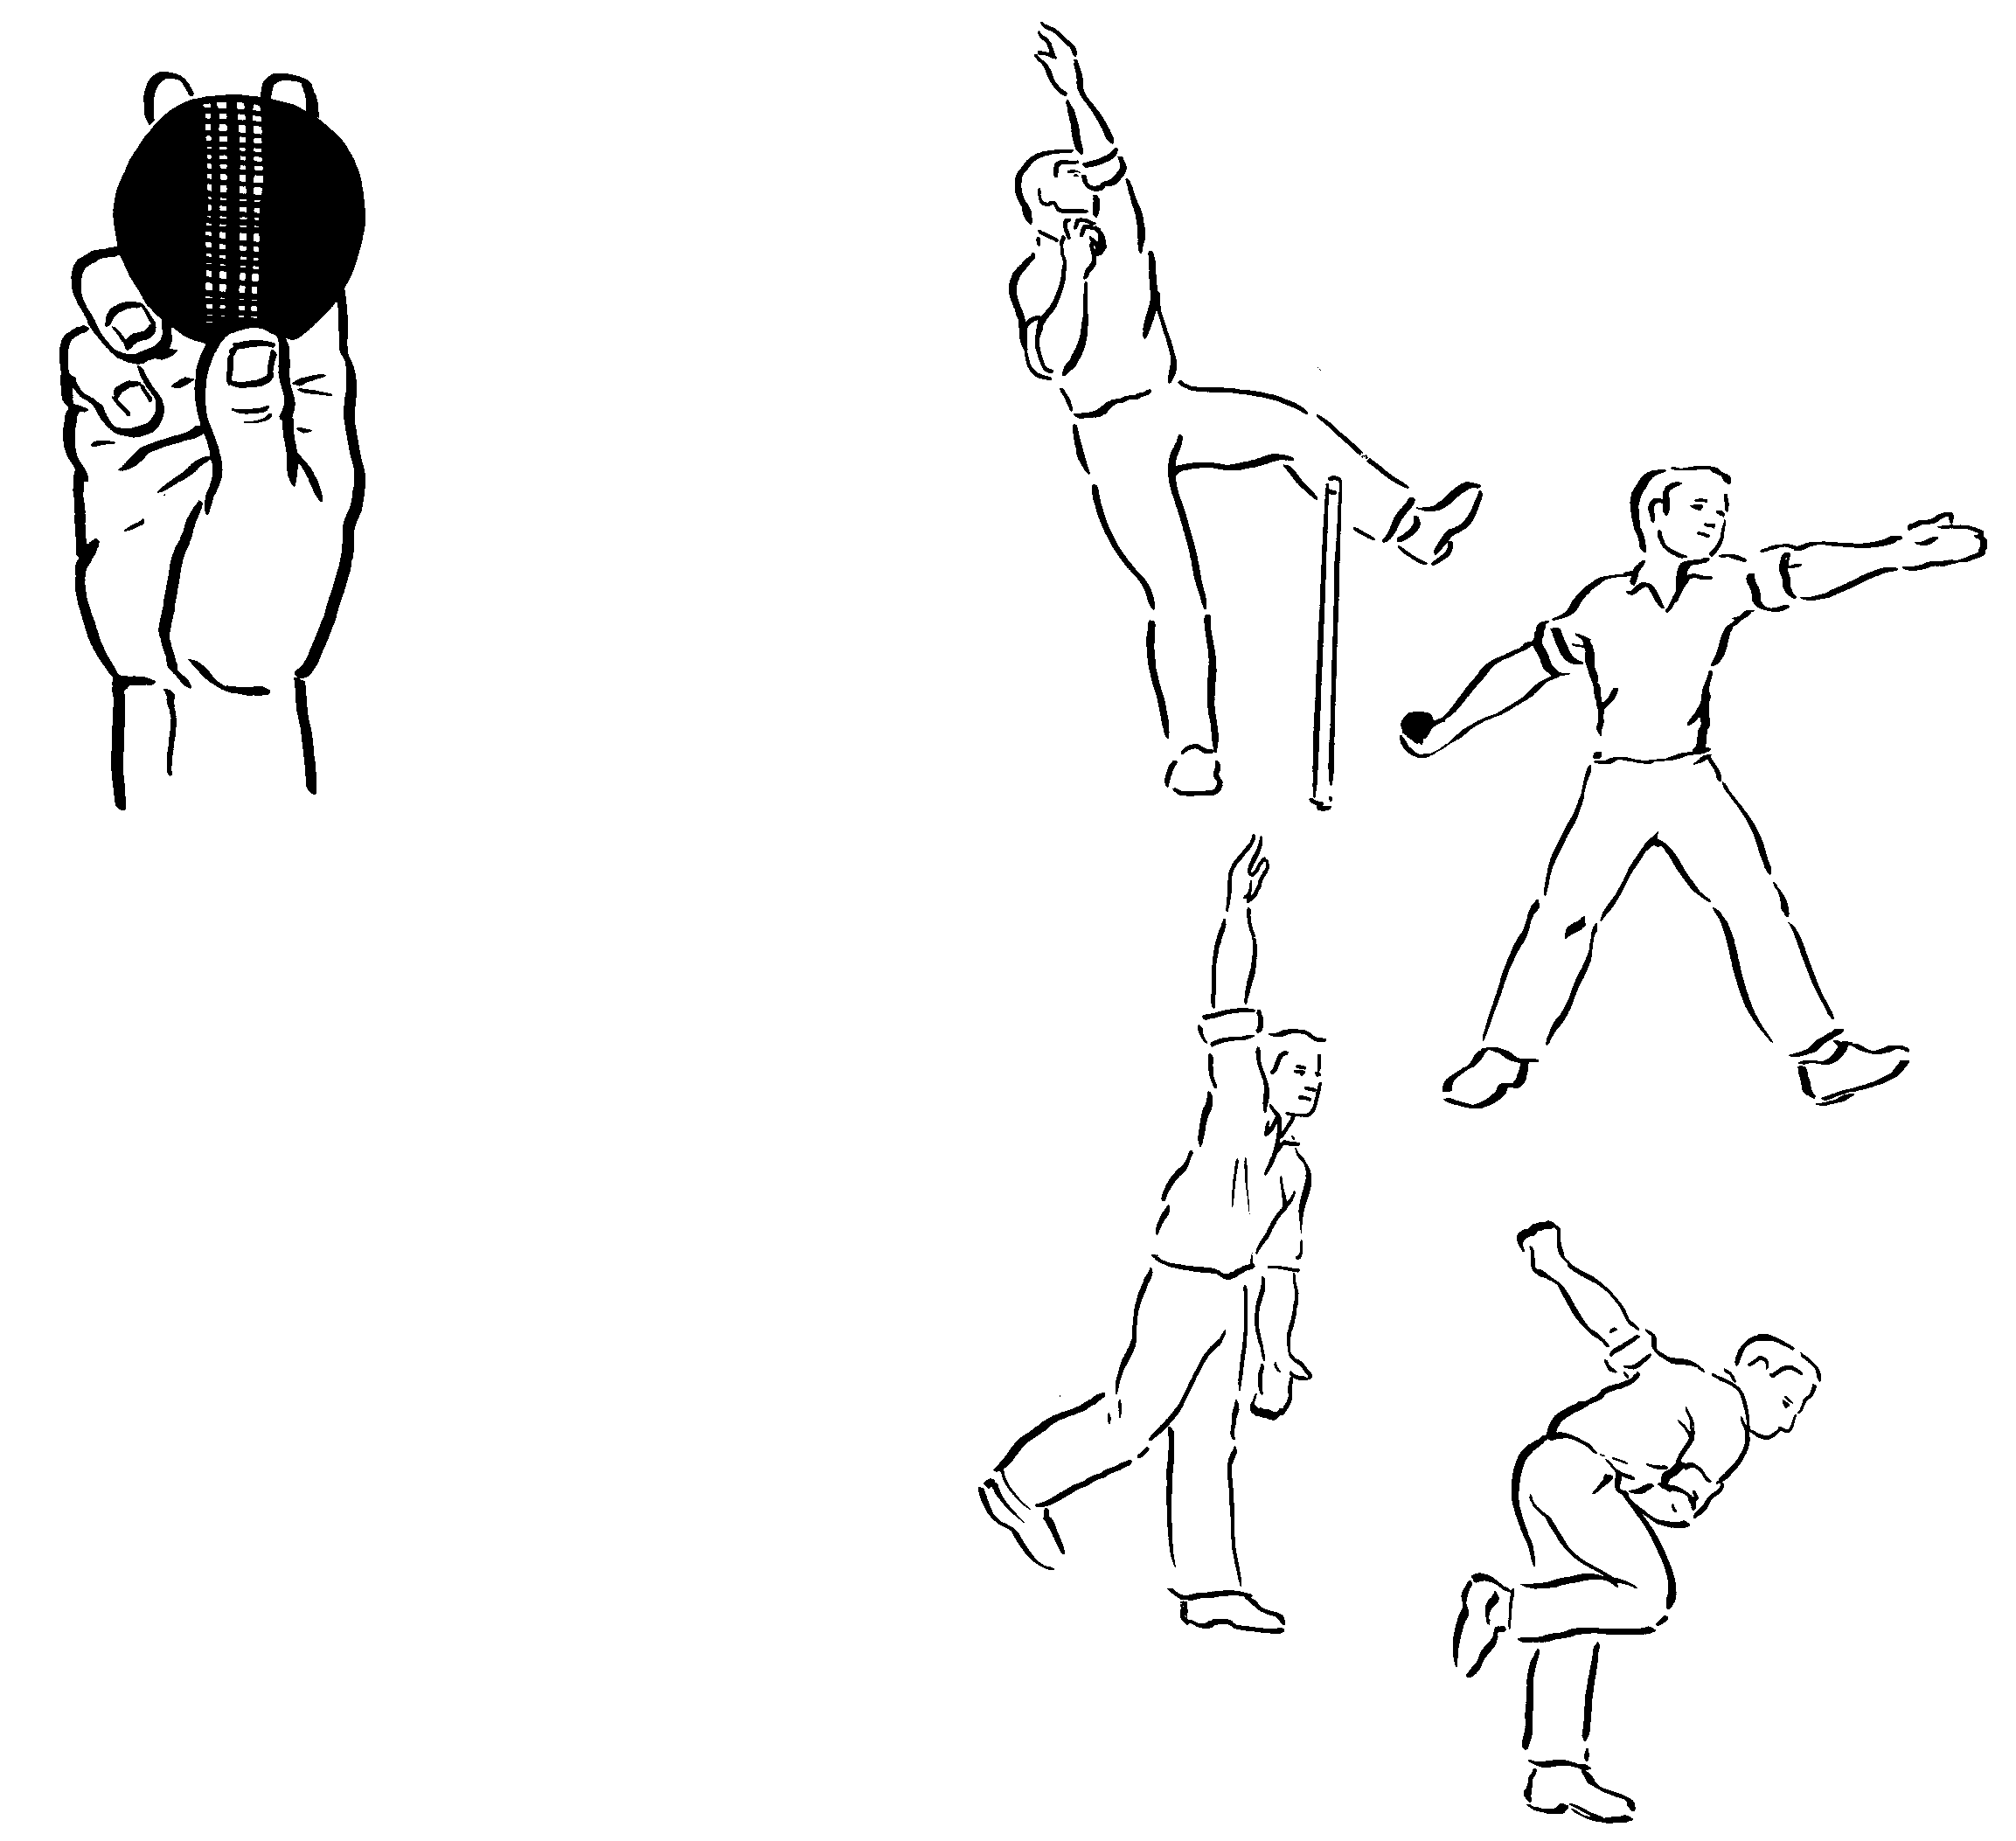

The first essential of effective bowling is that the student adopts the correct grip (see Figure 8).

##### THE BASIC GRIP

*Method:* Seam vertical.

Thumb on edge of seam; first two fingers slightly apart; third finger bent and supporting ball (see Figure 8).

Having achieved this, the whole skill should be introduced in a simplified form, using the following steps.

*Figure 8*

##### Step 1

##### Bowling from the Coil Position

*Objective:* To introduce the bowling action to beginners.

*Method:* Raise front arm. Look over shoulder. Bowling hand across chest.

Lean back. Lift front knee. Arch back slightly. Look down intended line of delivery.

Swing bowling arm downwards and then backwards.

Swing front arm forwards. Stamp down with front foot. Continue rotation of arms. Keep front arm close to body. Straighten front leg. Keep head upright. Release ball as arm passes head. Keep hand behind ball.

Swing front arm high behind body. Follow-through with bowling arm across body. Bring back leg through, bent and close to other leg. Bowling shoulder points to target.

Follow-through by taking steps forward (see Figure 9).

*Figure 9*

##### Step 2

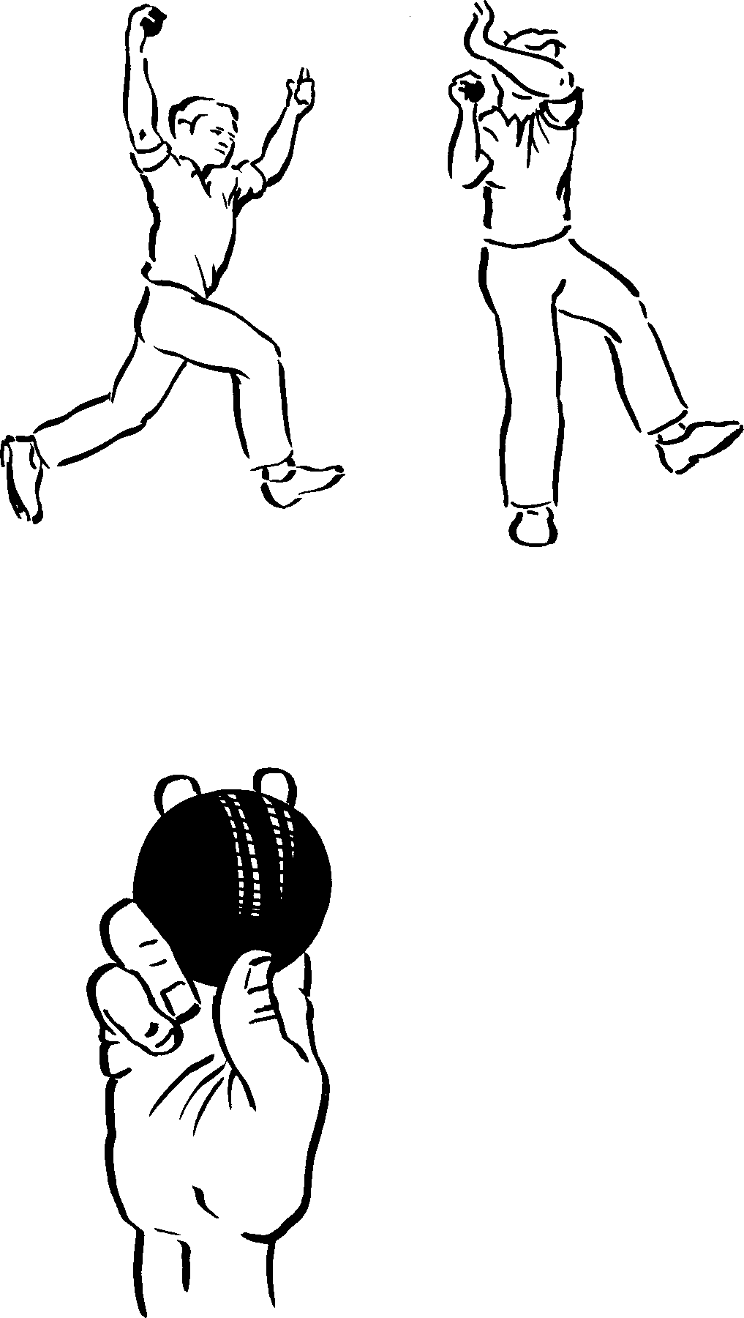

nd

*Figure 10*

e

*Figure 11*

##### Run Up and Bound

*Method:* Concentrate on line of delivery. Smooth rhythmical approach. Accelerate gradually. Control speed.

Bound (spring) off left foot. Raise both arms. Turn 90 in air.

Land in coil position leaning back from batsman. Repeat bowling action.

Practise bowling with a smooth and economical run-up a easy rhythmical well balanced delivery, finishing with a deliberate and fluent follow-through (see Figure 10).

Once players have mastered these steps they should be ready to progress to more complex skills using swing and spin.

##### THE OUTSWING OR AWAY SWING

NB To do this it is essential that the ball used has a good seam.

##### The Grip

*Method:* Seam vertical but pointing at slips.

Side of thumb on centre seam. First two fingers either sid of seam.

Polished side of ball to leg side (see Figure 11).

##### The Action

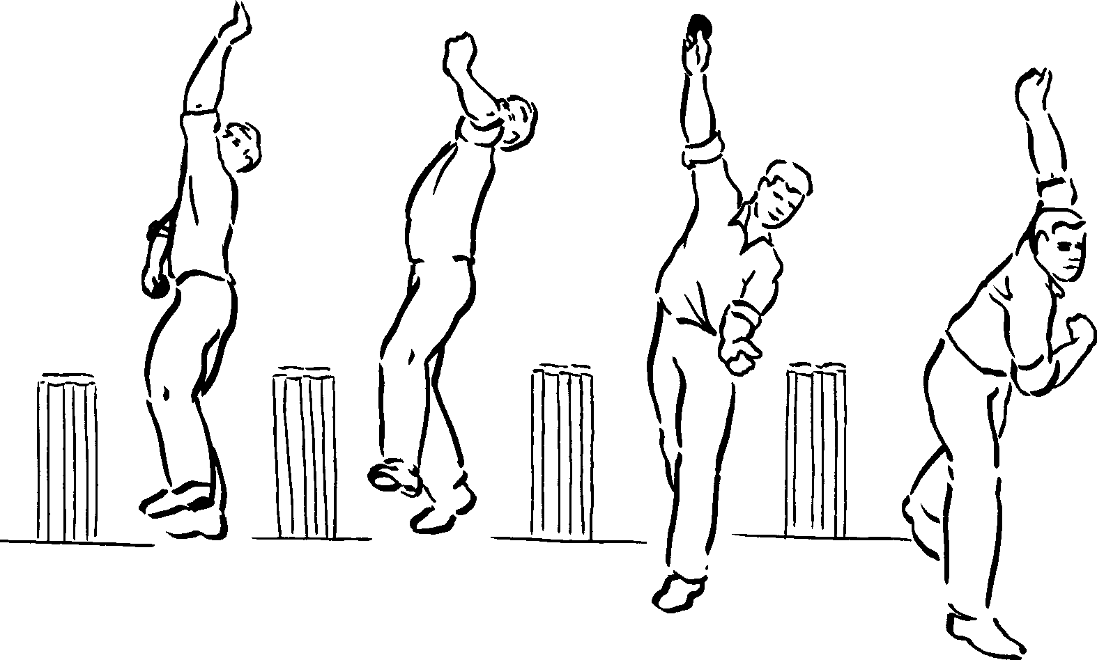*Method:* Bowl from close to stumps.

Look over front shoulder behind front arm.

Back foot parallel with crease.

Front foot lands to leg side of back foot.

High delivery, hand behind ball.

Emphasise good follow-through of bowling arm and shoulder (see Figure 12).

*Figure 12*

##### THE IN-SWING

##### The Grip

*Method*: Hold the ball with the polished side on the off side.

Seam vertical but pointing to leg side.

Ball of thumb against seam.

First two fingers close together on seam (see Figure 13).

##### The Action

*Method:* Bowl from wider position on crease.

Open coil - more chest on.

Look inside arm. Back foot points down pitch.

Front foot in line with or outside back foot. High bowling arm on release.

Feel as though pushing ball to legside.

Bowling arm does not follow- through across body (see Figure 14).

*Figure 13*

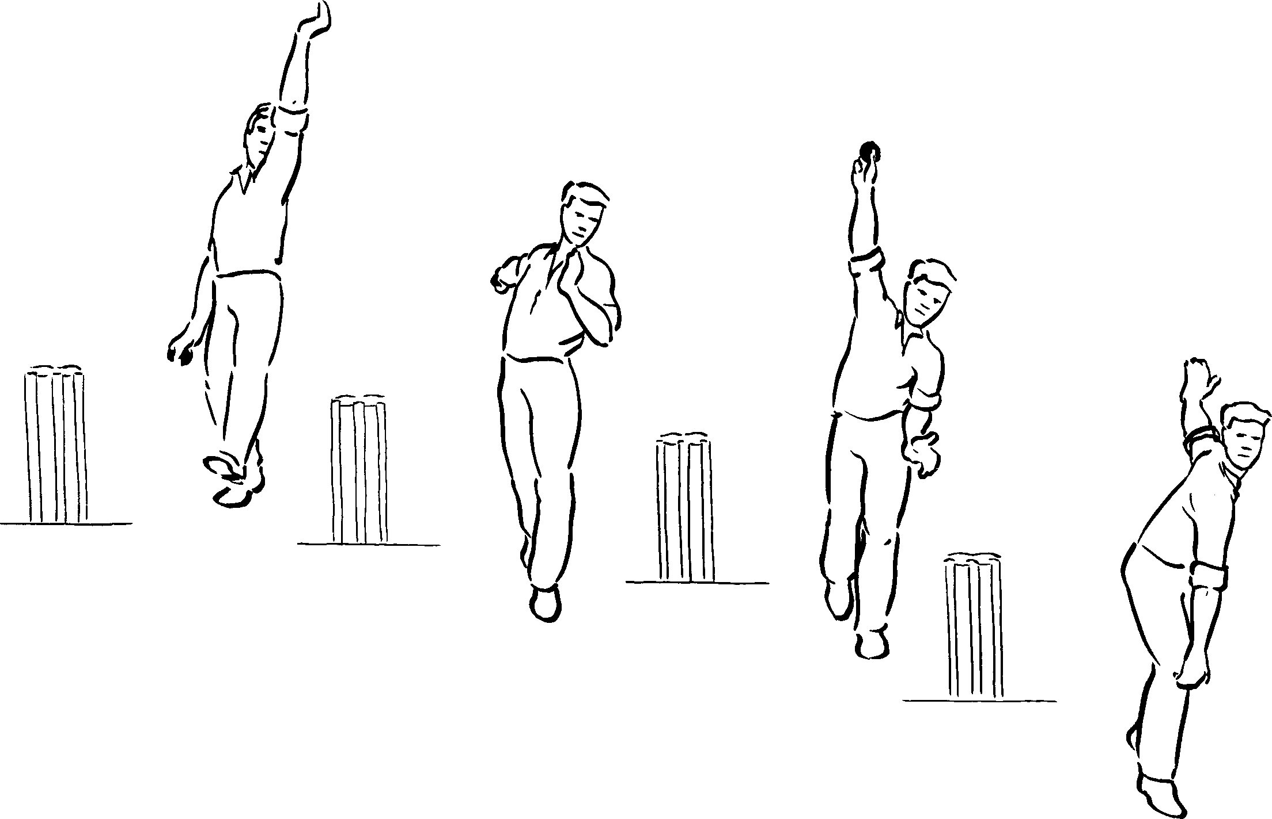

*Figure 14*

##### OFF SPIN AND LEFT ARM ORTHODOX SPIN (FINGER SPIN)

NB An off break spins the ball from off to leg, rotating clockwise from the bowler. The left arm spinner moves the ball from leg to off.

##### The Grip

*Method:* Hold ball in between first and second fingers.

Seam at right angles to the fingers.

Top joints across seam.

Knuckles of first finger and second finger grip seam.

Do not use thumb to hold ball (see Figure 15).

*Figure 15*

*Figure 16*

##### The Action

*Method:* Shortish run up.

Good coil position; look behind arm. Short delivery stride.

Front foot slightly across to leg side.

High delivery, head up. Pivot on ball of front foot. Twist hand clockwise.

Flick ball with first finger.

Pull bowling arm across the body.

Spin ball clockwise by turning hand upwards.

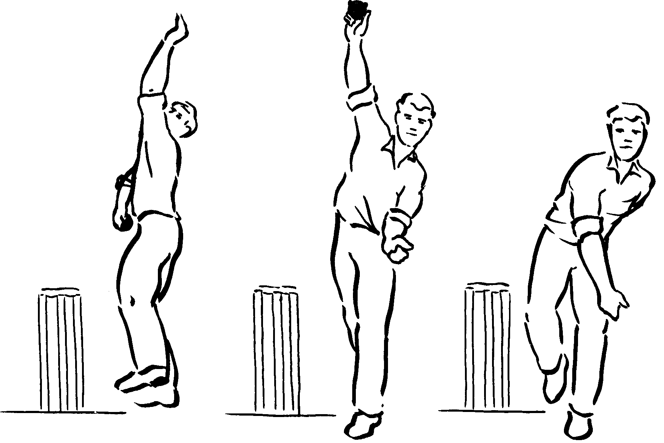Finish with palm upwards (see Figure 16).

##### LEG SPIN OR CHINAMAN

NB A legbreak spins from leg to off, rotating anti-clockwise from bowler. A left arm wrist spinner rotates the ball clockwise and is said to bowl ‘Chinamen’.

##### The Grip

*Method:* Seam at right angles to fingers.

First two fingers spread; first joints on seam. Third finger bent along seam (see Figure 17).

*Figure 17*

##### The Action

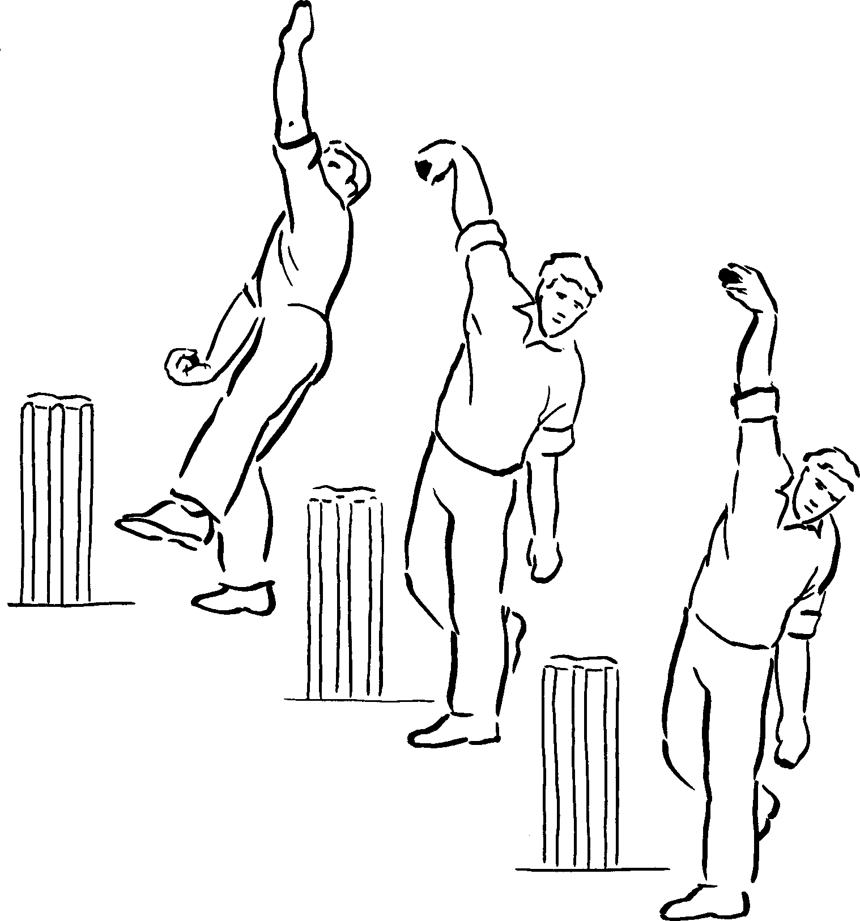*Method:* Shortish run up.

Good coil position. Look over shoulder.

Wrist bent in towards forearm.

Place front foot to leg side of back foot.

Keep head up. High delivery. Hold wrist back.

Pivot around front foot. Flick wrist forward.

Pull down with first finger. Straighten third finger.

Flick third finger straight as ball is released.

Continue across body, palm downwards (see Figure 18).

*Figure 18*

##### CUTTERS – FLOATER – GOOGLY

Within a work of this size, it is impossible to cover the advanced stages of bowling, although it is acknowledged that some GCSE or equivalent syllabi demand that these are included. Further information regarding these skills is to be found by reference to the texts listed in *Recommended Reading.*

1. **Batting**

Please note, throughout the module “batsman” also refers to “batswoman”.

Batting in cricket is probably the most popular of all skills. Firstly, it allows the player to score, and secondly he has the full attention of not only both teams, but also the spectators.

When teaching batting it is essential that staff exercise great care in selecting the surface on which the skill is performed. At school level this is often a factor over which neither staff nor students have any control. Nevertheless, staff should remain on the side of caution and on bad pitches certain strokes should *not* be taught. It is accepted that at least one Examining Board includes the hook within the syllabus.

The National Cricket Association (NCA) does *not* recommend that this stroke be taught to inexperienced players, particularly if the pitch is suspect. For this reason the hook and other advanced skills (lofted shots, the sweep and the late cut) are omitted from this text.

##### BATTING SKILLS – THE BASIC ELEMENTS

##### The Grip

*Method:* Hands close together towards top of handle.

Top hand gripping very firmly.

Fingers and thumbs of both hands around handle.

V’s formed by thumb and forefinger are in line approximately half way between splice and outside edge of bat (see Figure 19).

##### The Stance

*Method:* Feet slightly apart.

Knees slightly flexed, weight evenly distributed on balls of feet – not heels.

Eyes level and square to line of delivery. Toe of bat on ground (see Figure 20).

##### THE BACKLIFT

*Method:* Front shoulder and elbow pointing to bowler. Bat raised but pushed back over middle-stump. Head still.

Open face of bat to point.

Top forearm roughly parallel with ground. Back elbow away from body.

No movement of body backwards or forwards until selection of stroke to be played is made (see Figure 21).

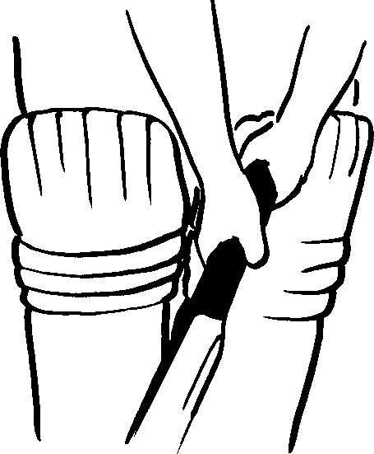

*Figure 19*

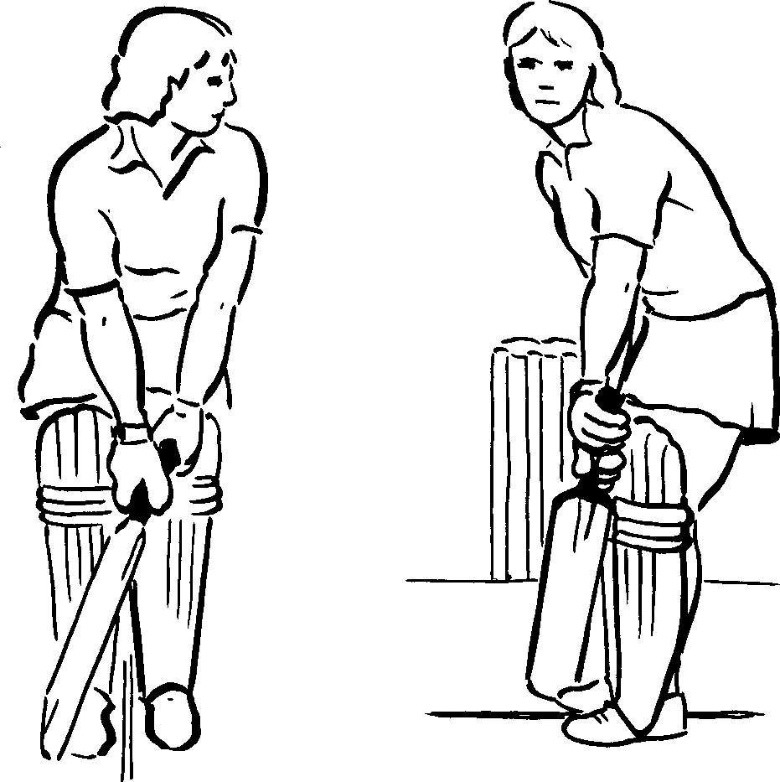*Figure 20*

*Figure 21*

##### THE BASIC SHOTS

##### The Pull

This stroke is played to a short pitched ball bouncing between knee and chest height as it arrives at the batsman. This is known as a long hop.

When learning strokes, a firm level surface is required in order to achieve an even predictable bounce from a tennis ball. Extreme care must be taken to ensure that no batsman will hit a ball into an area where others are working. Sufficient space must be allowed so that individual batsmen do not strike any person from another group with the bat. No fielder is allowed nearer than 10 paces from the batsman. If practising inside, the batsman can strike the ball towards a wall and the fielders can intercept the ball on the rebound from the wall at a position nearer the striker but on the opposite side from the direction in which the ball was struck.

*Method:* Start with high back

lift.

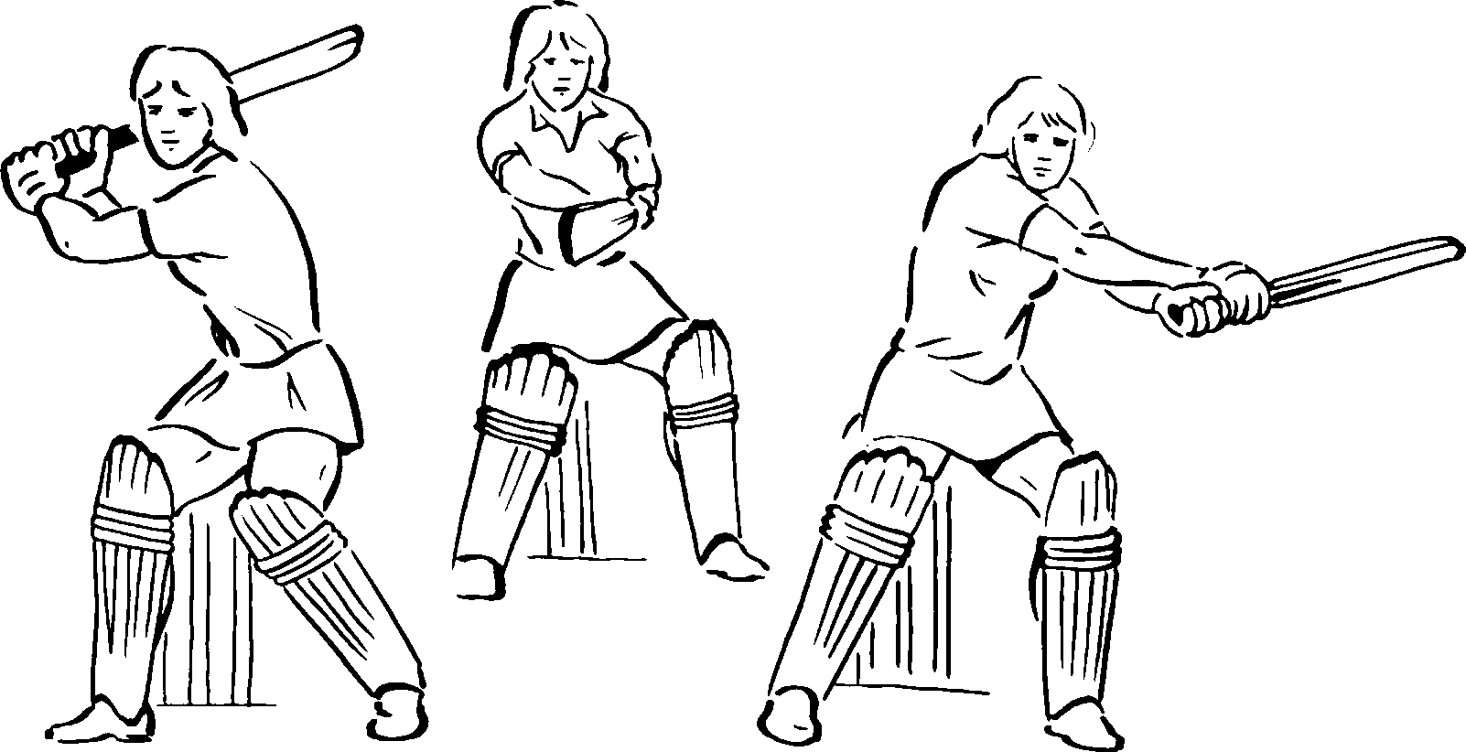

*Figure 22*

Step back and across, with both feet square to the wicket.

Fix eyes on ball and keep head still and forward of body.

Hit ball at arm’s length in line with body.

Aim to hit ball in front of square-leg and downwards.

Transfer weight from back to front leg (see Figure 22).

##### Hitting a Full Toss to Leg

*Objective:* To play a ball which

does not bounce before arriving at the batsman.

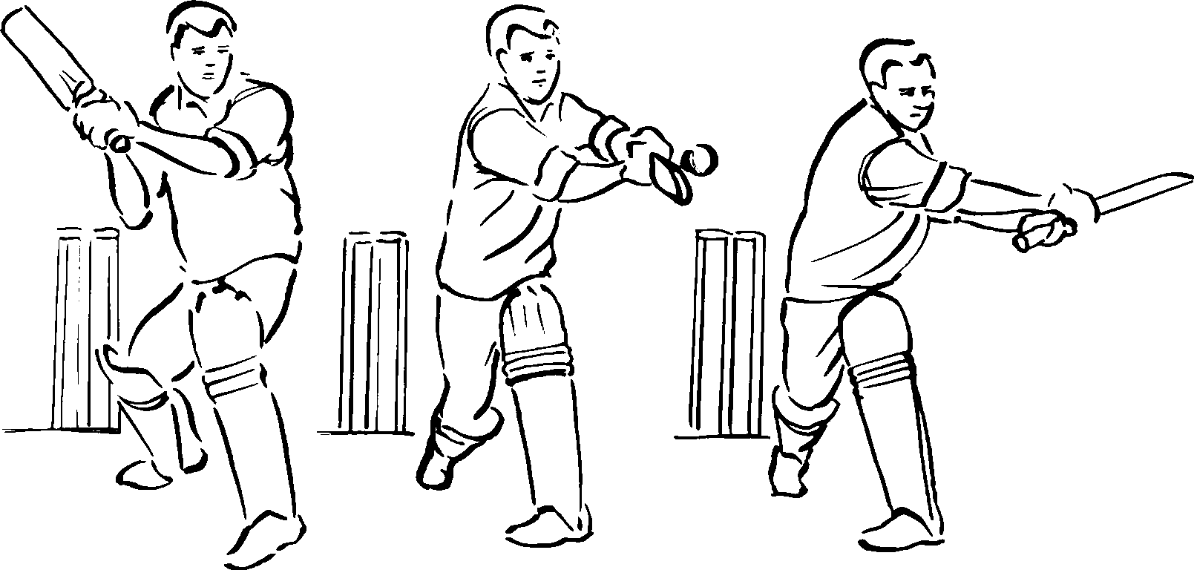

*Figure 23*

*Method:* High backlift.

Lean forward, head and front shoulder leading on to line of ball.

Fix eyes on ball.

Hit ball downwards at arm’s length.

Aim in front of square- leg.

Weight on front leg.

Keep looking at place where contact was made in order to keep head still and maintain balance (see Figure 23).

##### Back Defensive Stroke

*Objective:* This stroke is played to a ball pitching short and bouncing knee high or above.

*Method:* High back lift.

Step back and across towards off side if ball is on off stump.

Back foot parallel with crease.

Back of front shoulder turned slightly. Head on line of delivery.

Weight on back foot. Balance of body forward.

Front foot brought back naturally.

Relax bottom hand to finger and thumb grip. Top hand in control.

Ball is played under head.

Bat vertical but angled downwards so that ball is not played upwards (see Figure 24).

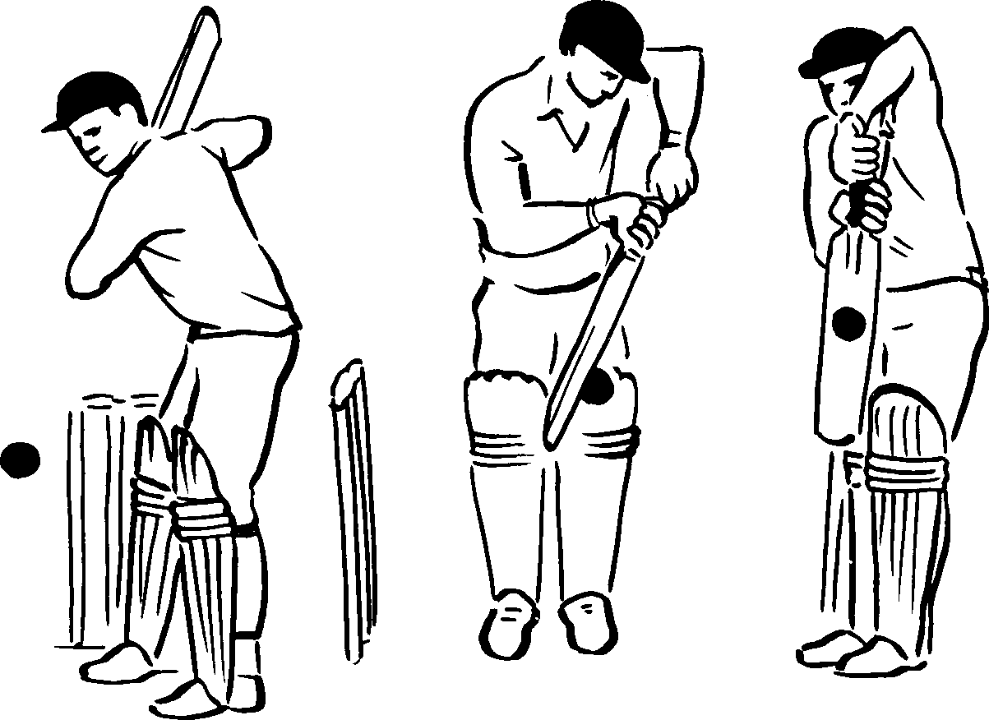

*Figure 24*

##### The Forward Defence Stroke

*Objective:* To prevent a good length ball from hitting the wicket.

The ball should not bounce as high as the knee.

*Method:* From a good straight backlift lead with head and front shoulder onto the line of the ball.

Top hand in control.

Relax bottom hand to thumb and finger grip. Front leg close to line of ball and bent at knee.

Ease back foot onto inside of foot; keep back leg straight.

Do not follow-through.

Maintain a good balance by keeping head close to front shoulder and over the bat (see Figure 25).

*Figure 25*

##### The Off Drive

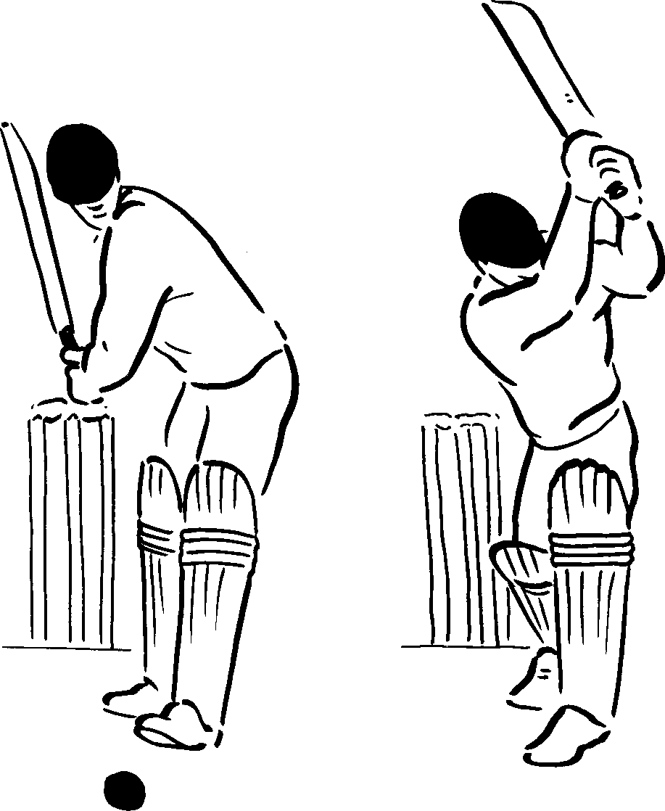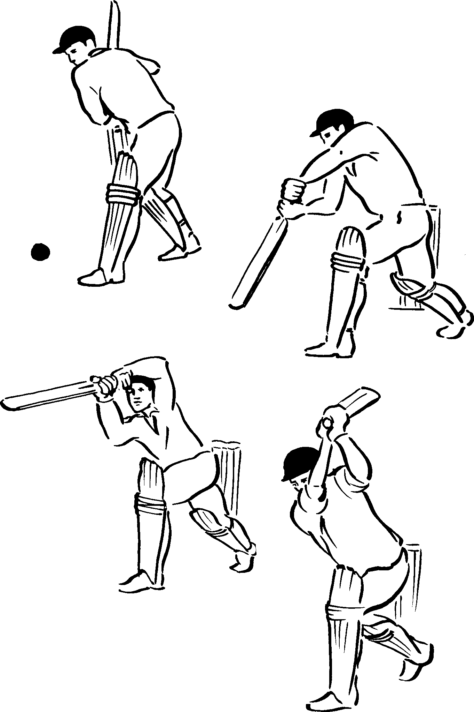

*Objective:* To play to a half-volley, a ball which pitches close to the batsman and does not bounce very high. It will be just on or outside the off stump.

*Method:* From a good high backlift, lead with head and front shoulder onto line of ball.

Top hand in control.

Play ball under head close to bent front leg. Do not lift head after contact.

Arms follow-through along line ball was struck; top hand and elbow high.

Back leg straight; weight on front foot.

The wrist can now ‘break’ allowing the bat to go over the shoulder, handle pointing roughly in direction of ball (see Figure 26).

##### The Straight Drive

*Objective:* To play to a half-volley which pitches approximately on the line of the middle- stump.

*Method:* In all ways similar to off drive but the lead of head and front shoulder is straight down the pitch.

*Figure 26*

##### The On Drive

*Objective:* This stroke is played to a half-volley, pitching on or just outside the leg stump.

*Method:* Very similar to other drives.

Lead with head and front shoulder onto line of ball.

Dip front shoulder while taking a shorter stride than for other drives.

Throw hands and arms out along line ball is intended to be struck.

Keep head close to shoulder. Top hand in control all the time (see Figure 27).

*Figure 27*

##### The Forcing Stroke Off the Back Foot

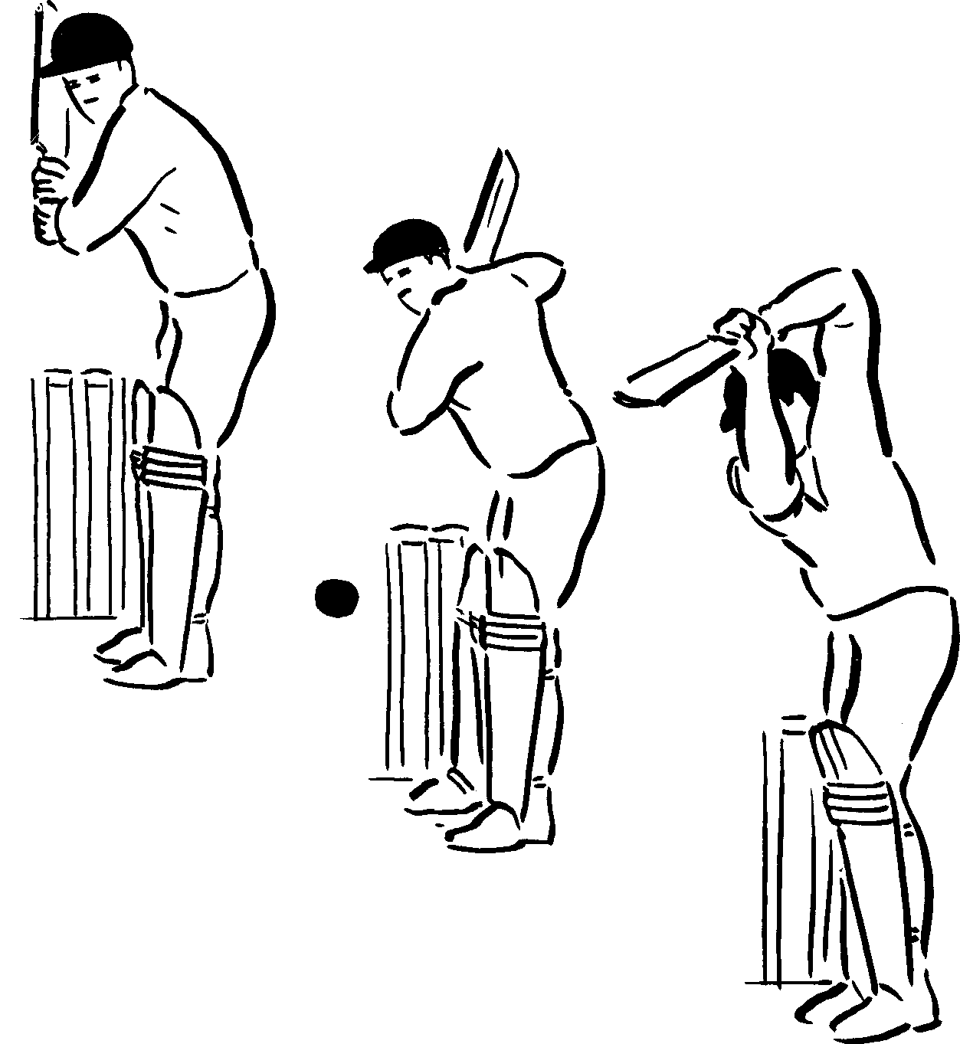

*Figure 28*

*Objective:* This stroke is played to a ball short of a length outside the off stump which does not bounce more than about knee height.

*Method:* Essential to have a good high back lift.

Step back and slightly across to offside just inside the line of ball.

Back foot parallel to crease.

Front shoulder turned slightly to off side. Weight on back foot.

Head down.

Control downswing of bat with top hand. Allow front leg to move close to back leg.

Just before contact with ball punch through with bottom hand.

Stop (check) swing of bat as shown, keeping a high front elbow.

Keep looking at spot contact was made to maintain balance and forward poise of body (see Figure 28).

##### The Square Cut

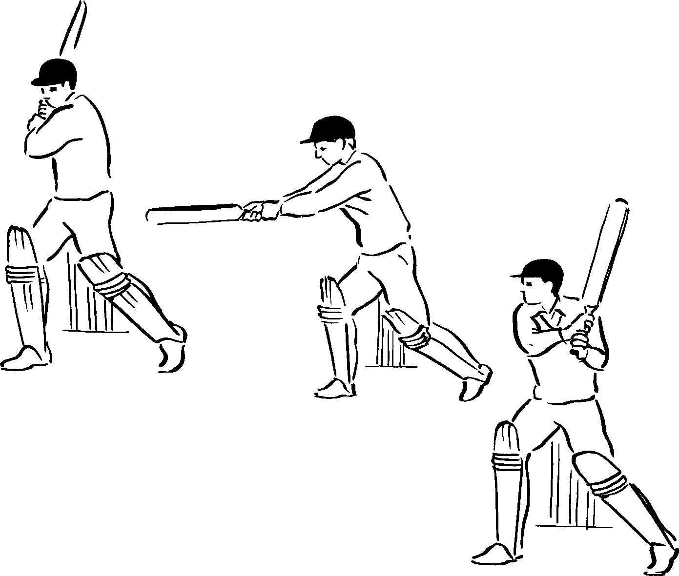

*Figure 29*

*Objective:* This stroke is played to a short pitched ball which passes wide of the off stump, ideally about waist high.

*Method:* High backlift.

Turn back of front shoulder to bowler.

Step back and across to off side with back foot.

Hit down on the ball at arm’s length.

Watch ball carefully, making contact as it is level with body.

Keep head well over back knee as bat follows through.

Weight is on back foot (see Figure 29).

##### The Forward Leg Glance

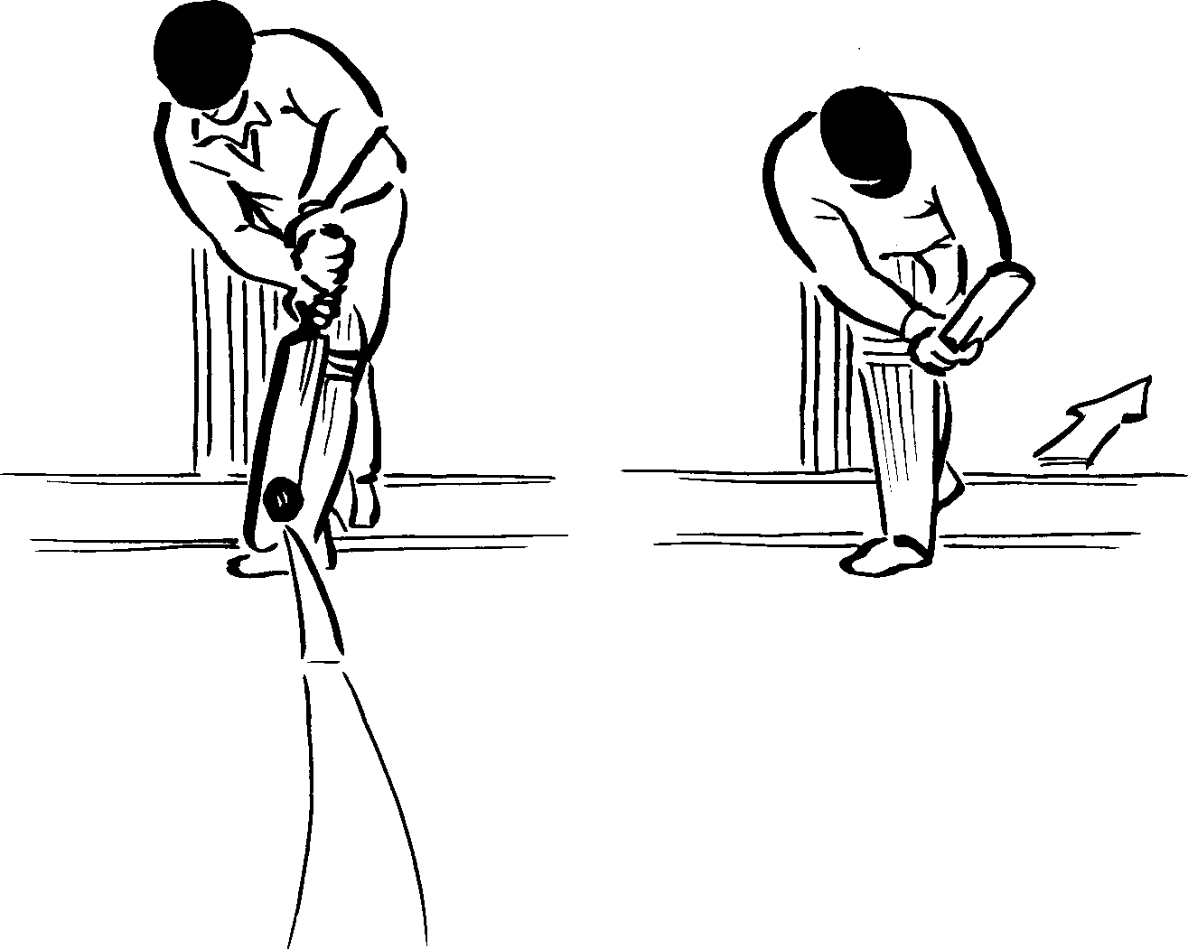*Objective:* This stroke is played to a good length or slightly over pitched ball on or outside the leg stump.

*Method:* Lead with head and front shoulder onto line of ball.

Front foot lands in line with ball; top hand in control.

Angle face of bat slightly to leg side.

Keep handle further forward than blade to play ball down.

Maintain a good balance by keeping head over front knee as ball is played and afterwards.

Allow wrists to continue to turn as bat follows through (see Figure 30).

*Figure 30*

##### The Backward Leg Glance

*Objective:* This stroke is played to a ball just short of a length which is missing the leg stump.

*Method:* Step back, allowing back foot to point to cover.

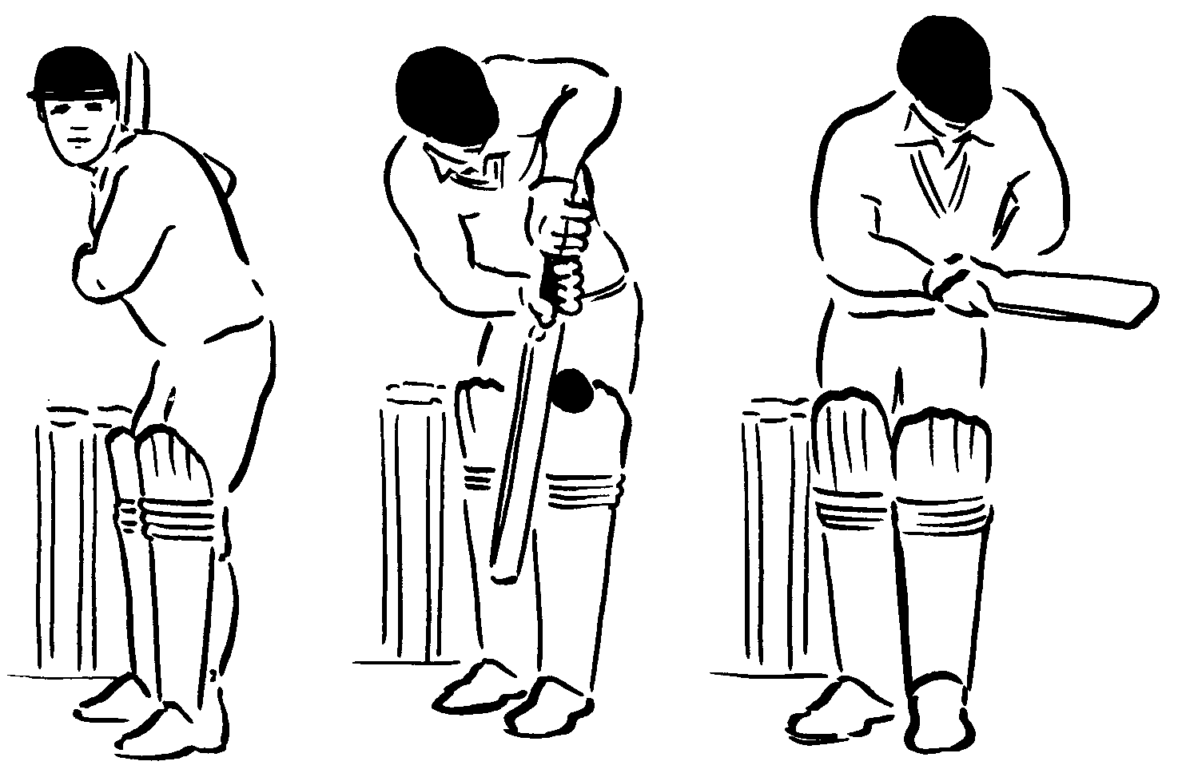Head on line of ball.

Front foot taken back naturally. Allow ball to come close.

Play ball down with angled bat, face pointing to leg side.

Control stroke with top hand.

Wrists continue to turn as bat follows through (see Figure 31).

*Figure 31*

For details and descriptions of more advanced strokes reference should be made to *Recommended Reading.*

##### Running Between the Wickets

In order to score in cricket it is necessary for the batsman to run between the wickets. While this may appear blatantly obvious, there is nevertheless a degree of judgement as well as physical skill involved, and staff are recommended to spend some time on this topic within the time allotted to teaching and practising batting.

Running between the wickets involves 5 factors:

1. Calling
2. Deciding who makes the call
3. Backing up
4. Making one’s ground
5. Multiple runs

##### Calling

There are three calls:

**Yes** – when there is definitely a run

**No** – when there is no chance of a run

**Wait** – if unsure whether the fielder can collect the ball

Wait is always followed quickly by either yes or no.

##### Whose Call

This depends on where the ball has been struck. Generally if the striker can see the ball easily it is his call. If it has gone behind the striker it would be the non striker’s call (see Figure 32).

Either batsman may refuse to run if he thinks he cannot make the run, provided he does so immediately.

##### Backing Up

The non-striker holds his bat with the hand nearest the bowler. As the bowler commences his delivery, the non striker is moving towards his partner, placing his bat just inside the popping crease. He watches the bowler deliver the

ball before leaving the crease and moving down the pitch. If the bowler does not deliver the ball, he is able to remain within his ground because the bat is grounded behind the crease.

The non striker’s duty is to run clear of the striker so that he does not impede him if the striker, due to the stroke he has played, has to run on the same side of the pitch (see Figure 33).

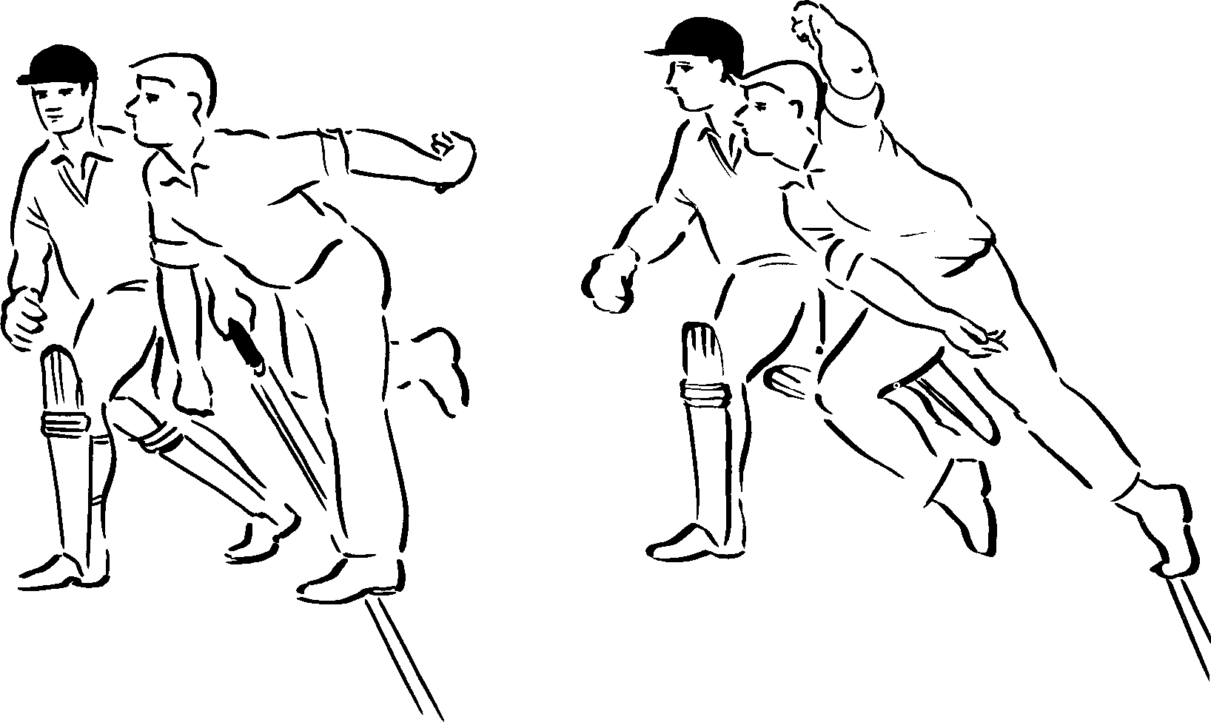*Figure 33*

*Figure 32*



**Non striker’s call**

##### Making One’s Ground

Always run the first run as fast as possible. Aim to run the bat in short of the popping crease so that it is grounded as it crosses the crease (see Figure 34).

##### Multiple Runs

When there is a possibility of more than one run, the call is yes, but as the batsmen pass each other they should quietly suggest the possibility: *“Look for two”, “Could be three”.*

Ground the bat in either left or right hand so that the turn can be made facing the direction in which the ball is being fielded.

##### Turn

Look – at the fielder to see whether there is another run.

Look – at the other batsman to ensure he can run again.

Call – run if yes, stay in ground if no (see Figure 35).

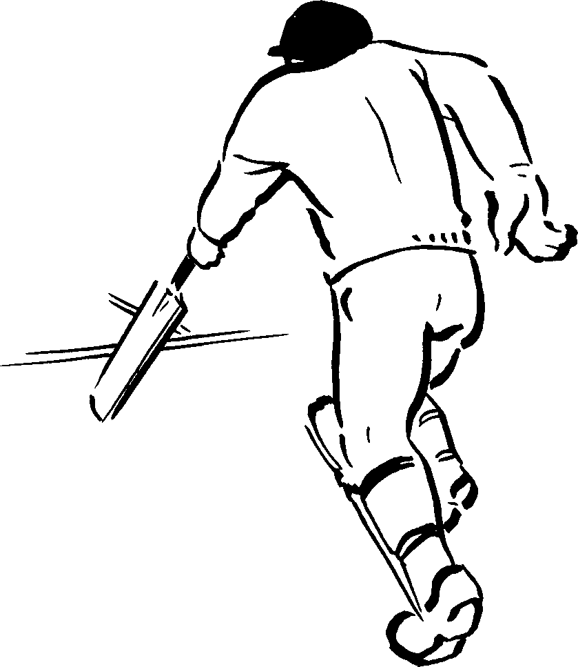*Figure 35*

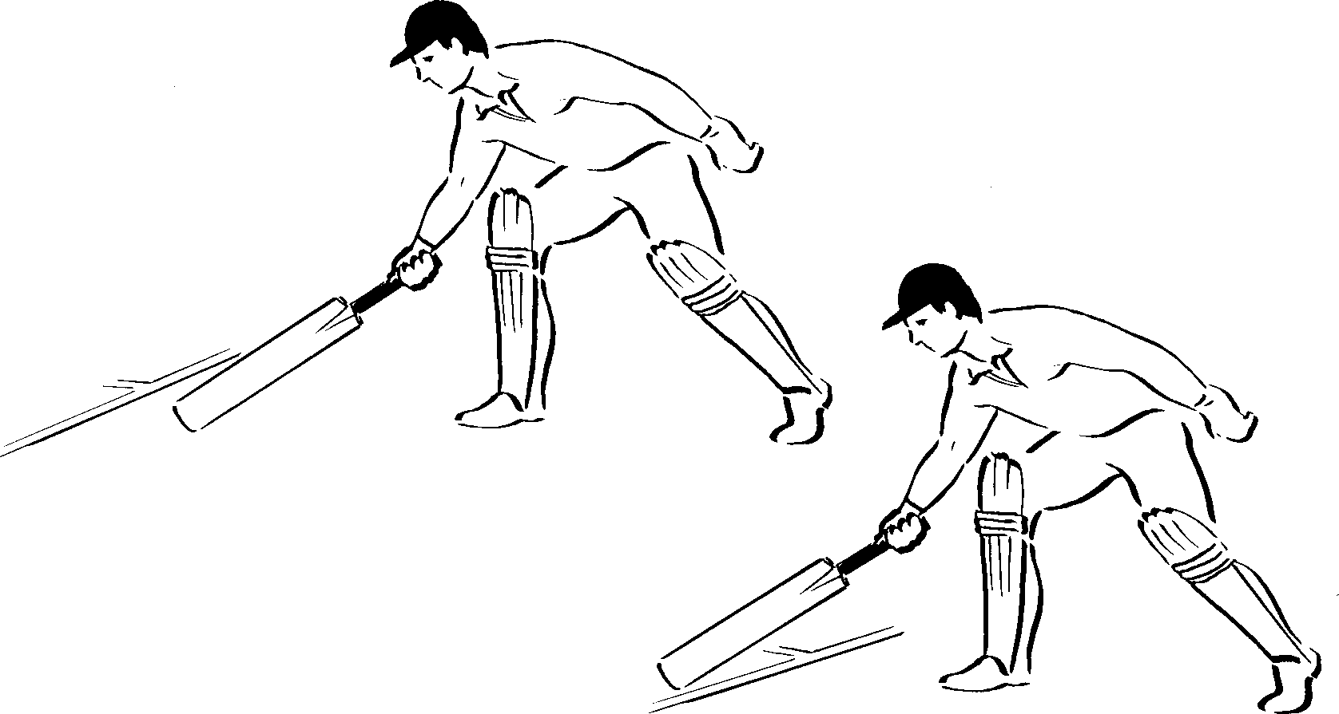*Figure 34*

##### General Points

If both batsmen start to run it is better to try and get to the other end than to stop and return to the starting point.

Ensure the bat is run in on its edge and grounded behind the popping crease before turning for the next run.

Before running for a misfield, ensure that the ball has travelled a sufficient distance from the fielder to allow a safe run. Having accepted a run, do not watch the ball when running.

1. 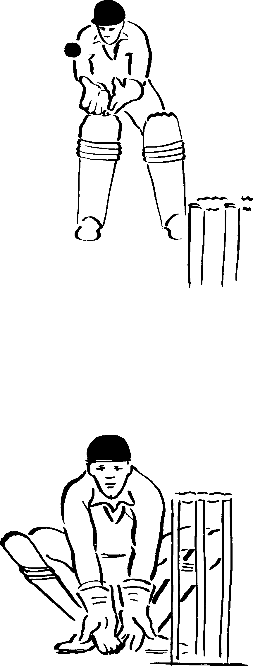**Wicket Keeping**

There are 2 positions from which to keep wicket.

* Standing back from the wicket.
* Standing up to the wicket.

##### Standing Back

*Method:* Position where ball can be taken as it drops between waist and knee height after bouncing.

Crouch to off side of stumps to get a clear view of ball. Rise with bounce of ball.

Palms facing ball, little fingers touching. Hands forward to give as ball is taken.

Eyes level; head as still as possible (see Figure 36).

*Figure 36*

##### Standing up to the Wicket – The Stance

*Method:* Squat down just wide enough to obtain a good view of ball.

Safe distance behind stumps so that no part of keeper or his/her equipment breaks back edge of bowling crease as ball is taken.

Eyes level, weight on balls of feet.

Backs of fingers resting on ground, palms facing bowler(see Figure 37).

*Figure 37*

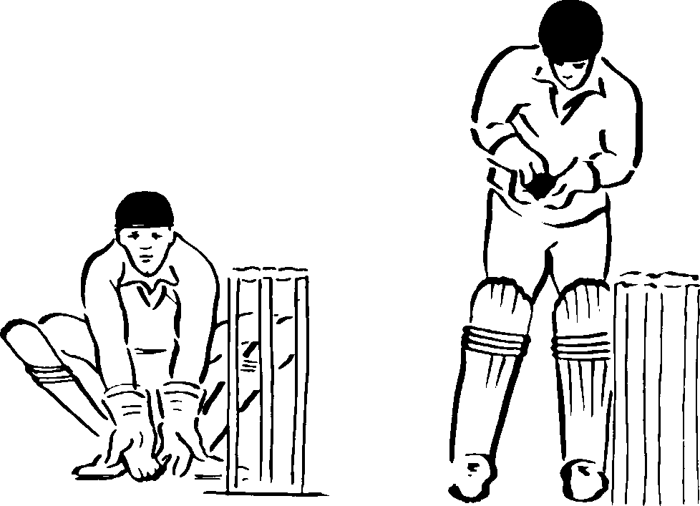

*Figure 38*

##### Standing Up to the Wicket – Taking a Straight Ball

*Method:* Head and body behind line of ball.

Rise with bounce of ball. Fingers pointing down.

Hands give and elbows clear of body as ball is taken.

Transfer weight to foot nearest stumps to commence bringing ball towards wicket in case of stumping opportunity (see Figure 38).

##### Standing Up to the Wicket – Taking a Wide Offside Ball

*Method:* Move quickly to offside with outside foot turned in.

Hands on line of ball. Give with hands.

Transfer weight towards stumps by pushing head towards them.

Swing arms towards wicket.

Knock bails off if batsman is to be stumped (see Figure 39).

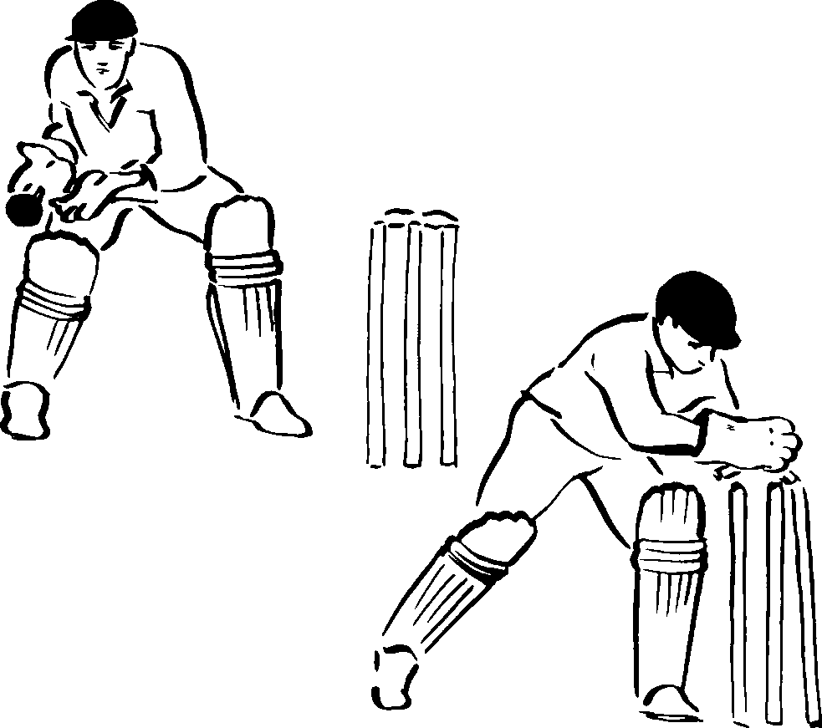*Figure 39*

##### Standing Up to the Wicket – Taking a Legside Ball

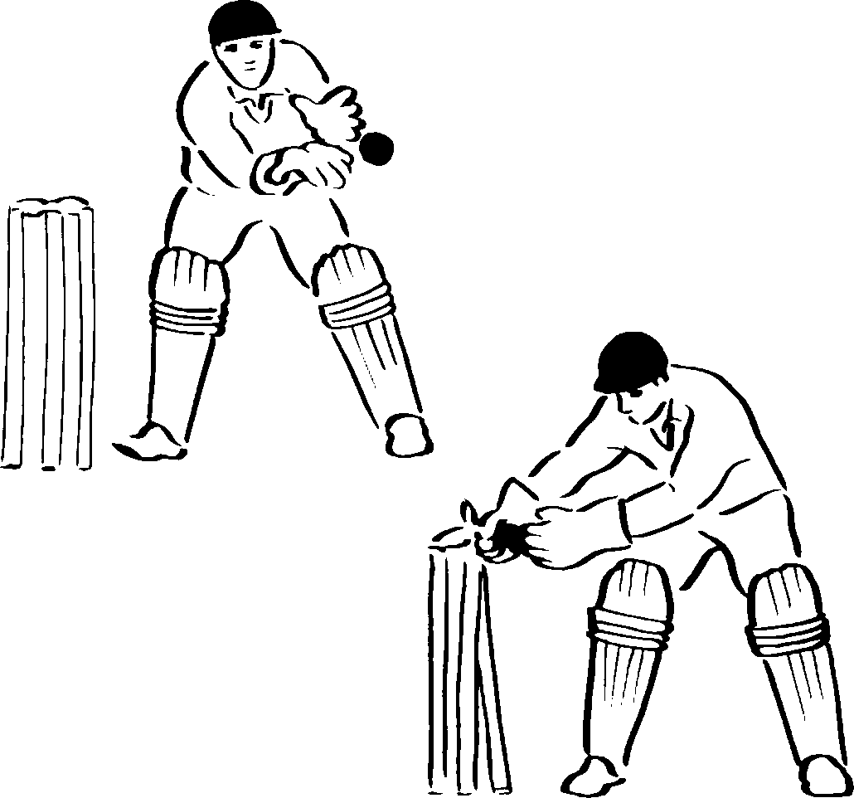

*Figure 40*

*Method:* Sight and judge ball from normal stance.

Move quickly to leg side.

Transfer weight from left foot which has turned in slightly, to right.

Take ball just outside line of body.

Push head towards wicket to assist swing of arms to break wicket if necessary (see Figure 40).

##### Standing Up to the Wicket – Taking a Rising Ball

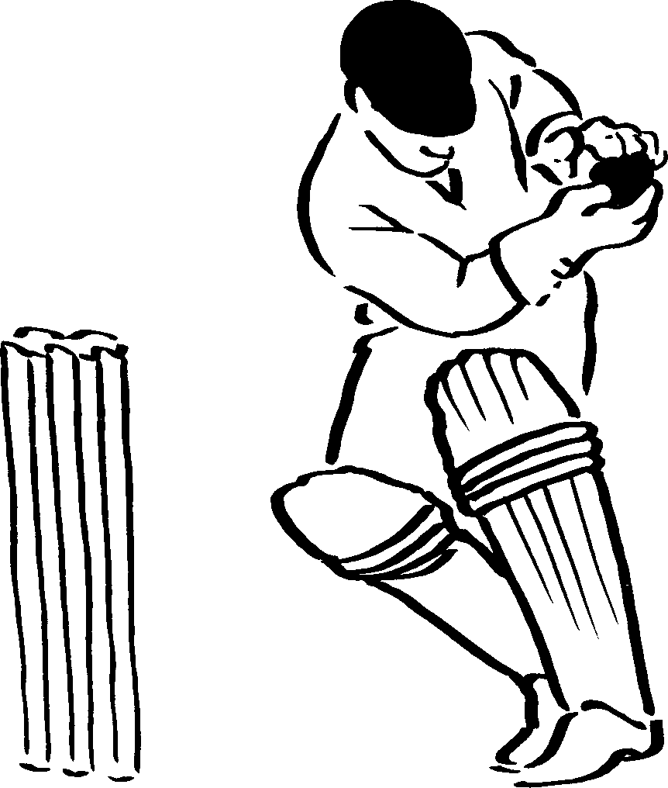*Method:* This applies to leg and offside.

Keep gloves on line of ball.

Sway head and body off the line; allow gloves to rise with ball.

Push head towards stumps to assist arm swing back for possible stumping (see Figure 41).

*Figure 41*

##### Taking Returns From the Field

*Method:* Move quickly to put the wicket between the ball and the wicket keeper.

Whenever possible take the ball on the full toss unless this would mean missing the chance of a run out.

Always try to take the ball in the gloves. Pads are for protection should the ball be missed; they are not a front line of defence.

If a fielder is chasing a ball with his back to the wicket keeper it helps the fielder to sight the keeper as he turns if a gloved hand is held above the keeper’s head.

Be prepared to remove a glove in order to throw the ball at the bowler’s wicket if a run out is possible at that end.

## UNIT 3

**Tactics and Field Placement**

It has not been possible to cover these topics in any detail, and again teachers are referred to more comprehensive texts.

In terms of tactics this section has been sub-divided into key points for consideration when examining the tactics of the game from the perspective of the bowler and the batsman.

##### THE BOWLER

##### Tactics for Seam Bowlers

Bowl at the wicket or just outside off stump.

When attempting to swing the ball, aim to pitch the ball close to the batsman to encourage front foot strokes, i.e. bowl a full length.

Vary length from time to time so that batsman has to think whether to play forward or back. Bowl the occasional bouncer.

Encourage dangerous strokes by leaving gaps in the field and pitching the ball so that it is difficult to hit the ball into those gaps.

Frustrate batsman by bowling to avoid his favourite strokes, e.g. keep front foot players on the back foot by bowling shorter length balls.

Do not bowl too many variations, e.g. outswinger, inswinger, off cutter, leg cutter. It is difficult to set fields for a great variety of balls. Do vary your position on the crease.

If one batsman is poor try to bowl at him most of the time by allowing the better batsman the opportunity of scoring singles early in the over by setting the field deeper.

Towards the end of an over do not allow the better batsman a single so that he faces the next over. Bring the field in to stop the single.

##### Tactics for Spin Bowlers

Much of the previous section on tactics for seam bowlers applies to spin bowlers with the addition of the following:

It is essential to bowl a good or even fuller length.

Always try to spin the ball even if the pitch appears unresponsive. Use the variations sparingly, e.g. floater, arm ball, etc.

Vary pace and flight, i.e. release ball earlier to give a high trajectory and later to give a low trajectory.

Use width of crease and change from round the wicket to over wicket or vice versa if necessary.

Adjust field to attack defensive batsman and set field to cut off runs for an attacking batsman.

If not successful at one end ask to bowl from the other.

##### THE BATSMAN

##### Tactics for Batsmen

Batting in cricket not only involves high levels of physical skill, but also judgemental and decision making skills. The batsman has to make decisions regarding his reaction to the tactics of the opposition. The speed of this decision making will be dictated externally, i.e. externally paced, or influenced by the speed and accuracy of the bowler, the field placement of the opposition, the stage in the innings, and the stage in the match. Often players have to make decisions based on anticipated outcomes. In other words, the speed of the ball will be too fast for the human visual system to track, and therefore a player must *predict* what will happen and base his/her decision on this judgement. At school level the task is easier in terms of the speed of bowlers, but difficult in terms of the batsman’s experience. The following should act as basic guidelines.

##### Stroke Selection

Early on, play well pitched up and straight balls between mid-on and mid- off with straight bat strokes.

Hit bad balls to side that they are swinging or spinning. Do not try to hit them too hard.

If pitch has variable bounce, do not hook and be on your guard for ‘shooters’.

Pick bat up early, particularly against faster bowlers, so that you have time to come down on the ball.

Only play defensive strokes to balls which will hit the wicket or which would otherwise hit you.

An additional judgement must be made following stroke production, and that is how and when to attempt to score runs.

##### Scoring Runs

Check the field setting for obvious gaps or fielders set too deep to stop singles.

Note which fielders are left handed, slow movers, poor throwers.

Be prepared for quick singles, back up when non-striker and run first and hard.

Relax hands when playing defensive strokes so that the ball does not roll far from the bat. Fielders may now have to remain close to wicket to prevent singles. A firm push may now beat the fielder as he is too close to react to save the single.

If a fielder is dropped back, do not try to hit the ball over him; aim for the gap he has left or try to hit to another part of the field.

If you are having difficulty scoring off or playing a particular bowler, get your partner to try to remain facing that bowler as much as possible.

Against spinners, using the feet to get to the pitch or full toss may help to pierce the field.

Be patient – sooner or later the bowler will bowl a bad ball.

The tactics of both bowler and batsmen will interact with those of the fielders. It is therefore important that players know how to set fields to support the teams’ tactical objectives.

##### Field Setting

Fielders are placed in specific places for two reasons:

* + To catch an opponent out
  + To stop the batsman scoring runs There are three types of fielding positions:
  + Close catchers – slips, gully, short leg etc.
  + Fielders saving one run – cover, mid on, square leg etc.
  + Boundary fielders stopping boundaries – deep third man, deep fine leg, long off etc.

Occasionally it may be necessary to place fielders halfway to the boundary, if it is a very long boundary and the well hit ball will not reach the normally placed boundary fielder. Alternatively a batsman may be known to hit a ball regularly to the place where the field is sited.

*Guidelines:* The faster the bowler, the faster the pitch, the finer the field is set.

The slower the bowler, the slower the pitch, the straighter and squarer the field.

Set the field so that good balls are played to the fielders.

If the bowler bowls a lot of bad balls, change the bowler not the field setting.

Fielders must also be told to move as in Figure 42 below.



•

Deep-Mid-Off

•

Deep-Mid-On

• Long-Off

* Long-On

• Deep-Extra-Cover

Move Straighter

Move Squarer

Mid-On •

* Mid-Off
* Bowler

Extra-Cover

•

Move Wider

Mid-Wicket

•

Cover •

Silly-Mid-Off •

•

Short-Extra-Cover

* Deep-Mid-Wicket

Silly-Mid-On

•

• Cover Point

Forward- Short-Leg •

Square-Leg

•

Backward- •

Silly-Point

•

* Gully
* Deep-Square-Leg

Short-Leg

•

Leg-Slip

* Wicket-Keeper
* Third-Slip

Move Backwards

First-Slip •

•

Second-Slip

•

Short-Third- Man

Move Finer

* Long-Leg

Deep-Third-Man •

* Deep-Fine-Leg

*Figure 42*

Closer means move towards the batsman.

Deeper means move farther away from the batsman.

## UNIT 4

**Umpiring**

The umpires are the sole judges of all matters concerning the game once the toss for innings has been made. They decide whether it is fit or unfit to play, make all decisions regarding the laws and officially check the scores at the end of the game to confirm the result.

#### Point

#### Ball struck here

Bowling Umpire



#### Moves to here for run out Square Leg Umpire

*Figure 43 Figure 44*

The bowling end umpire stands in line with the wickets (see Figure 43) and makes decisions about the placement of the bowler’s feet for the fairness of delivery, LBW etc. He may move up to the wicket or back if requested by the bowler, but he must be in a position to carry out his function.

When a run is being taken, the bowling umpire moves to the same side of the pitch as the ball and level with the popping crease, to get in the best position to give a decision for a run out as in the diagram.

The other umpire usually stands level with the popping crease at square leg (see Figure 44). However, if the sun or fielder interfere with his view he can stand at Point. His principal function is to give decisions on stumpings, run outs etc. at the strikers end.

The bowling umpire starts the game by calling *“Play*”. After six legitimate balls he calls *“Over”;* at the end of play he calls *“Time”* and removes the bails. During the game he gives the following signals to the scorers to inform them of what is happening. There is no signal for one or more runs scored from the bat, unless a boundary is scored. No signal will be given if a batsman is not out on appeal but the umpire will say *“Not out”.* Umpires communicate their decisions to both players and spectators through a series of signals (see Table 1).

##### Table 1: The Umpire Signals

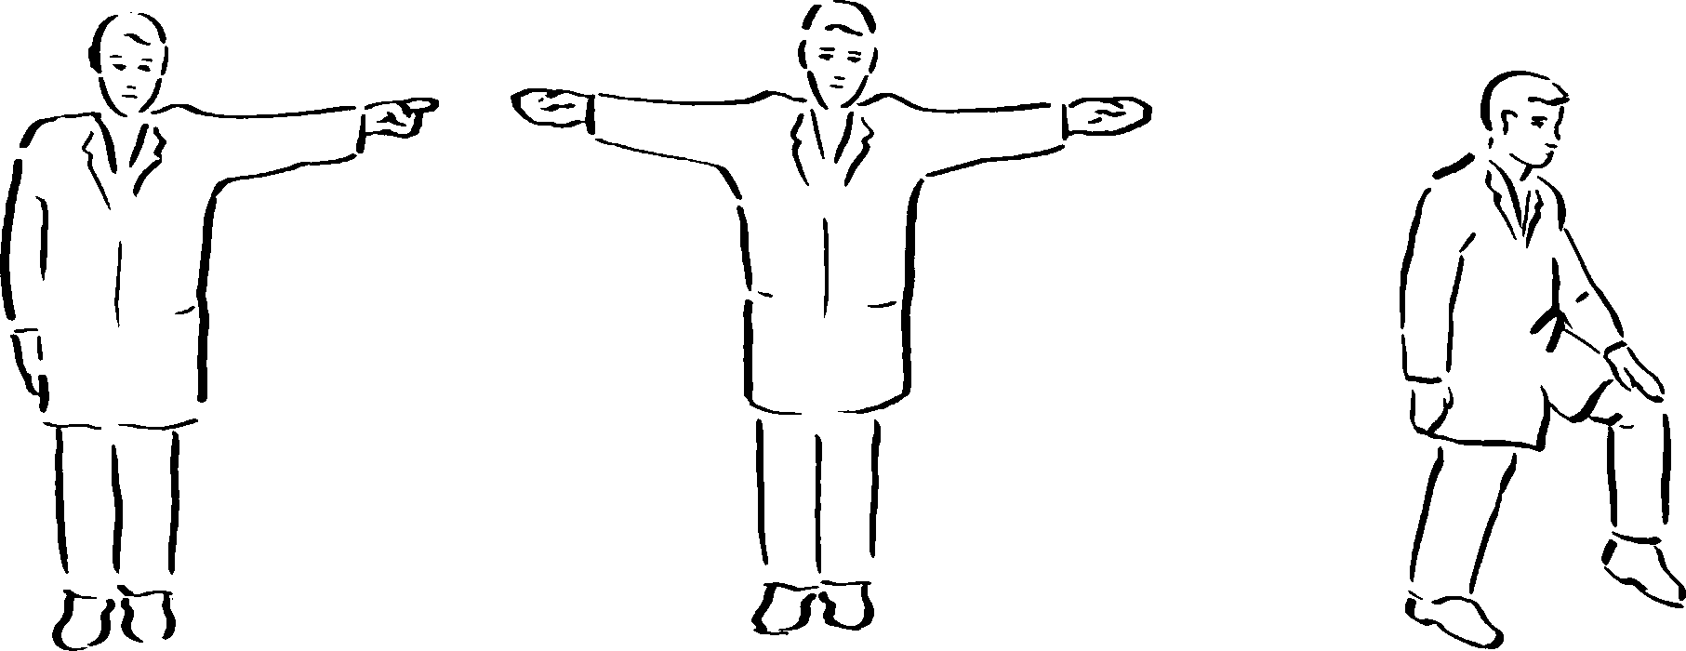

No-Ball Wide Leg-bye

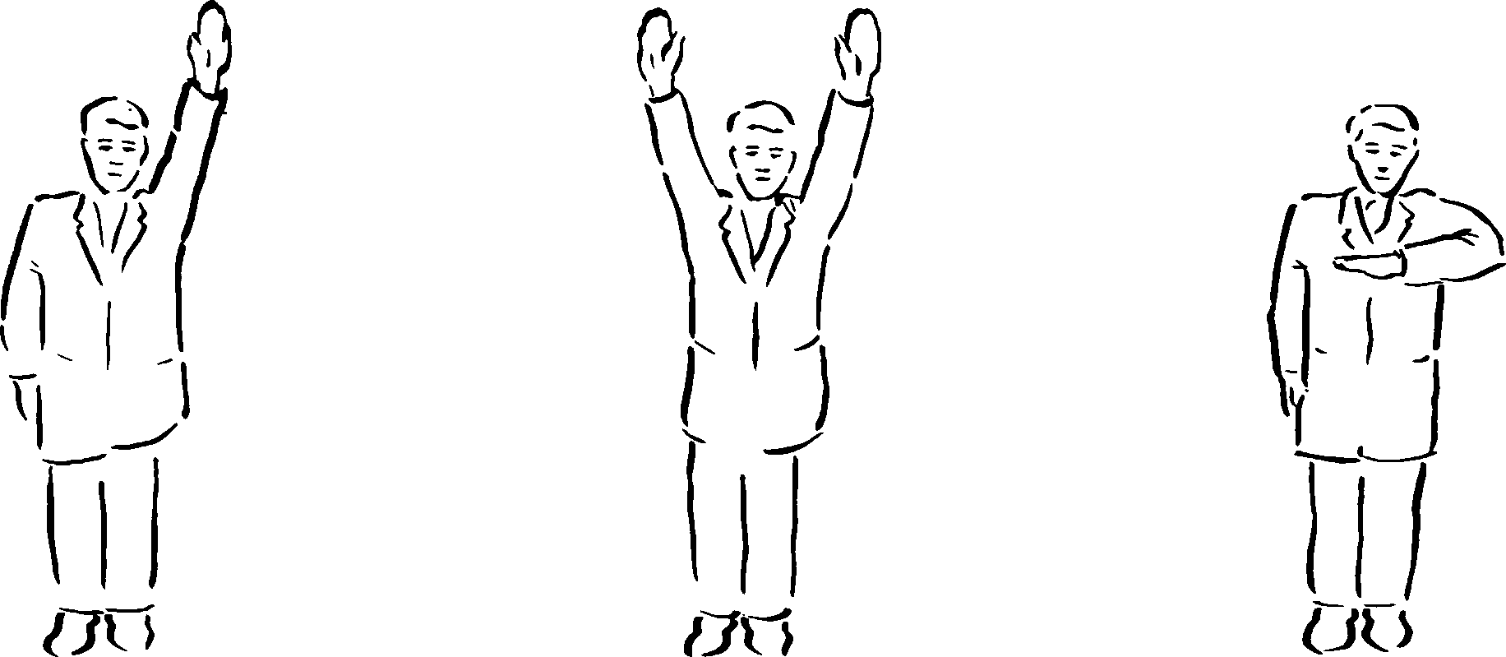

Bye Six Four. Arm waved.

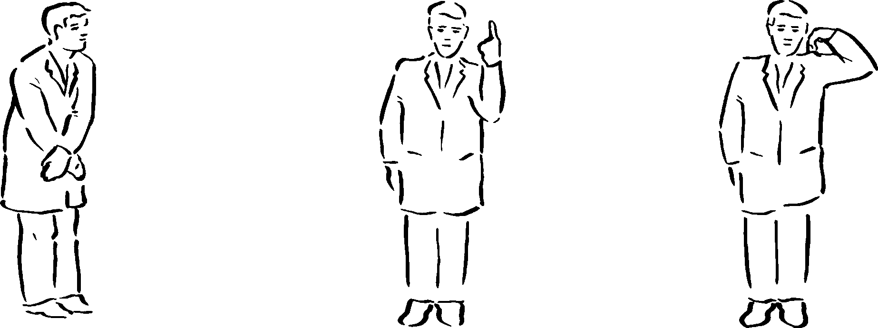

Dead Ball also called Out Short Run. The number of runs short to be called.

NB the umpire will not allow the game to continue until the scorers have acknowledged his signal.

## UNIT 5

**Physical Conditioning for Cricket**

The degree of fitness required to play depends upon the level and type of match played. Generally cricket is played over longer periods of time than other games; therefore the training has different aspects. To be successful it is necessary to have a high skill level, so there must be a great deal of time spent in skill training.

Before any vigorous activity it is wise to warm up 2/5 minutes’ gentle jogging, followed by simple stretching exercises.

General Fitness – Aerobic Endurance

Any sustained activity, preferably running, which lasts over 20 minutes.

Cross country over different surfaces – sand, shingle, ploughed fields, uphill – very useful.

Swimming and cycling may also help. General Fitness – Anaerobic Endurance

Short bursts of very high energy expenditure, activity lasting 20-40 seconds.

Shuttle running Fielding shuttles

##### Examples of fielding shuttles

10 Paces

**F**

10 Paces

**A**

**w/k**

**B**



15 Paces

**w/k**

**F**

**A**

Fielder F runs levels with A to catch thrown ball and returns it to keeper. F then runs level with B who throws another ball to be caught and thrown to keeper. Repeat 6 times.

A throws ball out. F chases pick up, throws to keeper and returns to starting point. Repeat 6 times.

##### General Fitness – Flexibility or Mobility

All players need to have a good range of movement in all joints. When fully warmed up or at the end of physical activity, take each limb and joint to its end position, press and hold for several seconds. Relax and repeat (see Figures 45 a-c).

##### Specific Fitness

Analyse each player’s activity to discover what type of training he/she needs.

1. Batsmen – have to be able to run and turn quickly wearing

equipment.

*Suggested Activity :*

*Shuttles of 5 runs, 20 yards long wearing full equipment, carrying a bat.*

– need to have strong wrists.

*Suggested Activities:*

*Wrist rolling, i. e. winding a weight on a stick up and down as quickly as possible.*

*Squeezing grips, squash balls etc.*

1. Wicketkeepers – have to move from a squatting position very

quickly.

*Suggested Activities:*

*Hopping, bounding, skipping etc.*

*Shuttle from squatting position to stumps to catch a ball and then return to squatting start position before repeating 6 times.*

– have to be able to dive and catch.

*Suggested Activity:*

*Practice from squatting position: run five paces to side, dive onto mat turning shoulder underneath. Repeat in opposite direction starting from squatting position each time (see Figure 46).*

*Figure 45a*

*Figure 45b*

*Figure 45c*

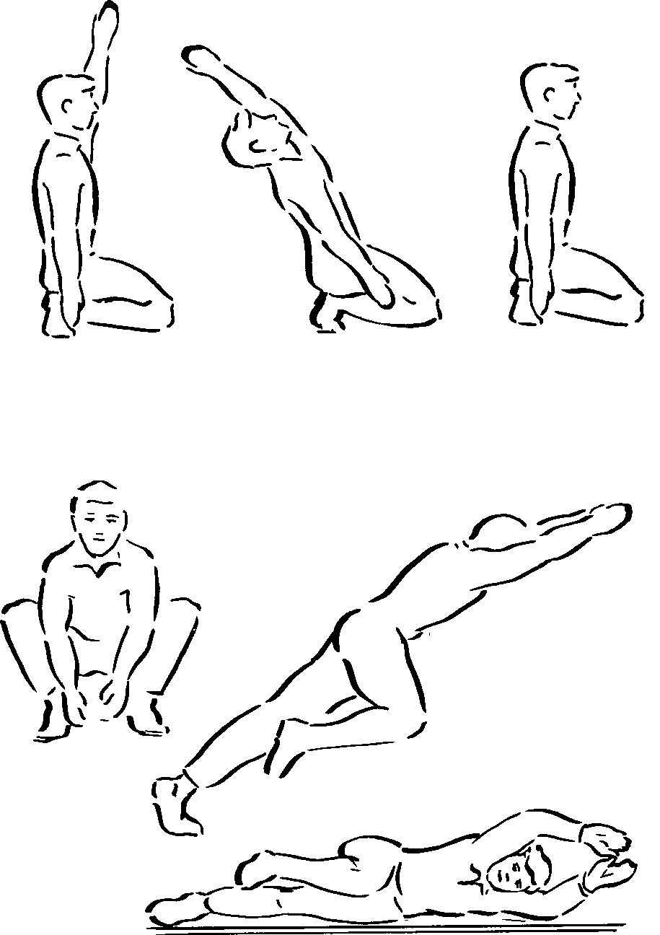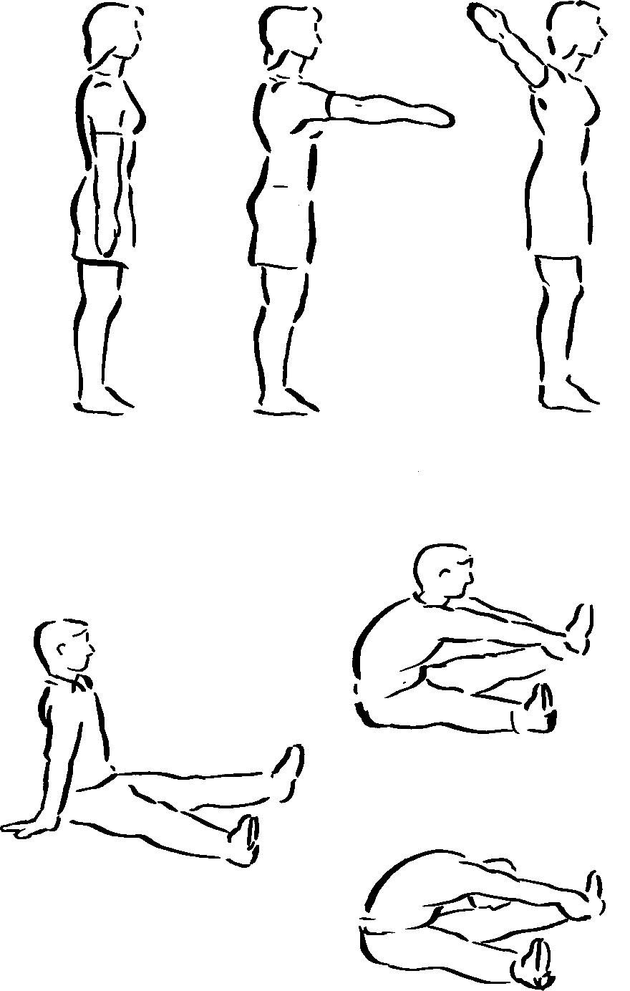*Figure 46*

3 . Bowlers – need to be fit, flexible, and strong and have a good recovery rate.

Special attention needs to be paid to warm up and stretching to prevent injury, particularly to the groin, back and shoulder.

##### Groin Exercise

Feet astride, bend right knee with left leg straight and weight pressing inwards.

Change legs (see Figure 47).

##### Back Exercise

Lie on stomach, hands behind head. Raise chest off ground (see Figure 48).

Hold a partner in wheelbarrow position; lift him/her in air. Partner helps by pushing up and arching back (see Figure 49).

Lie on back; bring right knee up, and then swing to left to touch ground with knee (see Figure 50).

*Figure 47*

*Figure 48*

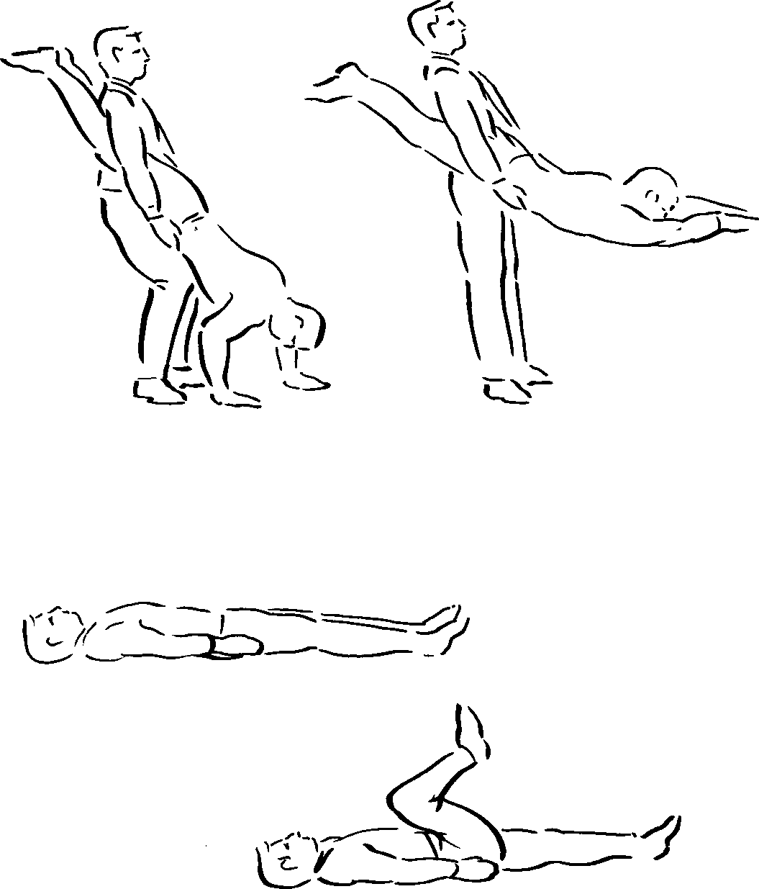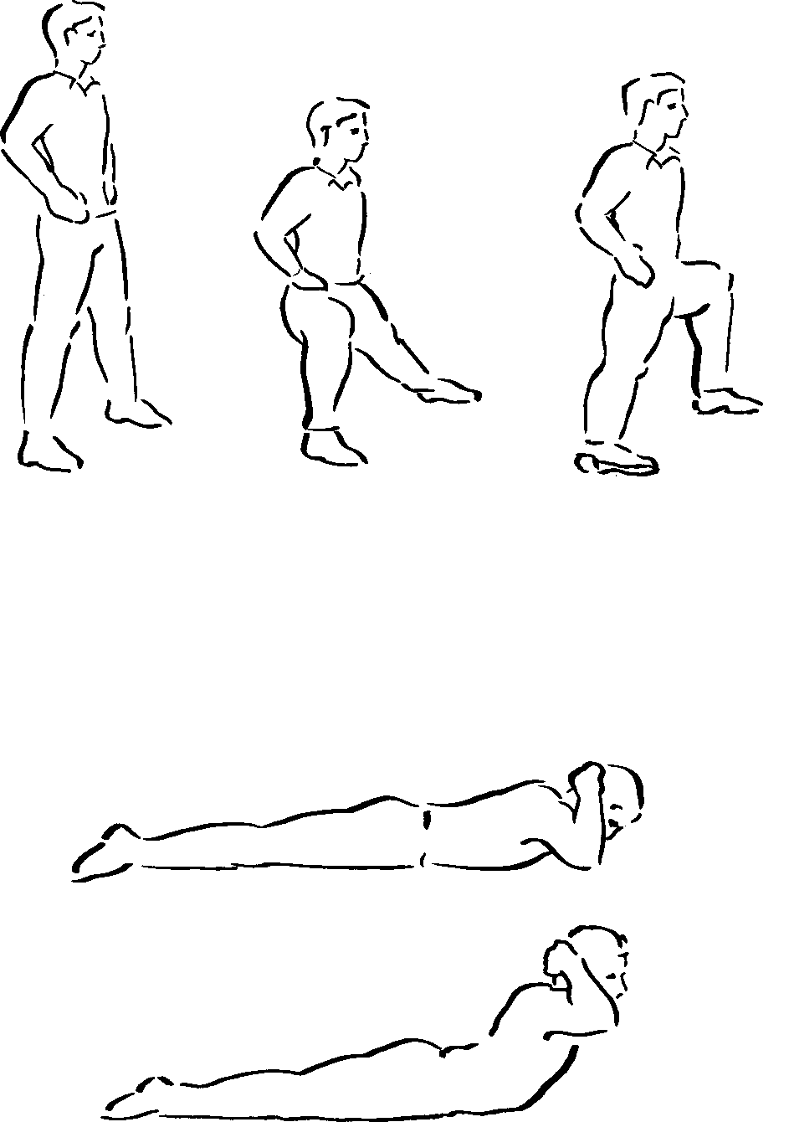*Figure 49*

*Figure 50*

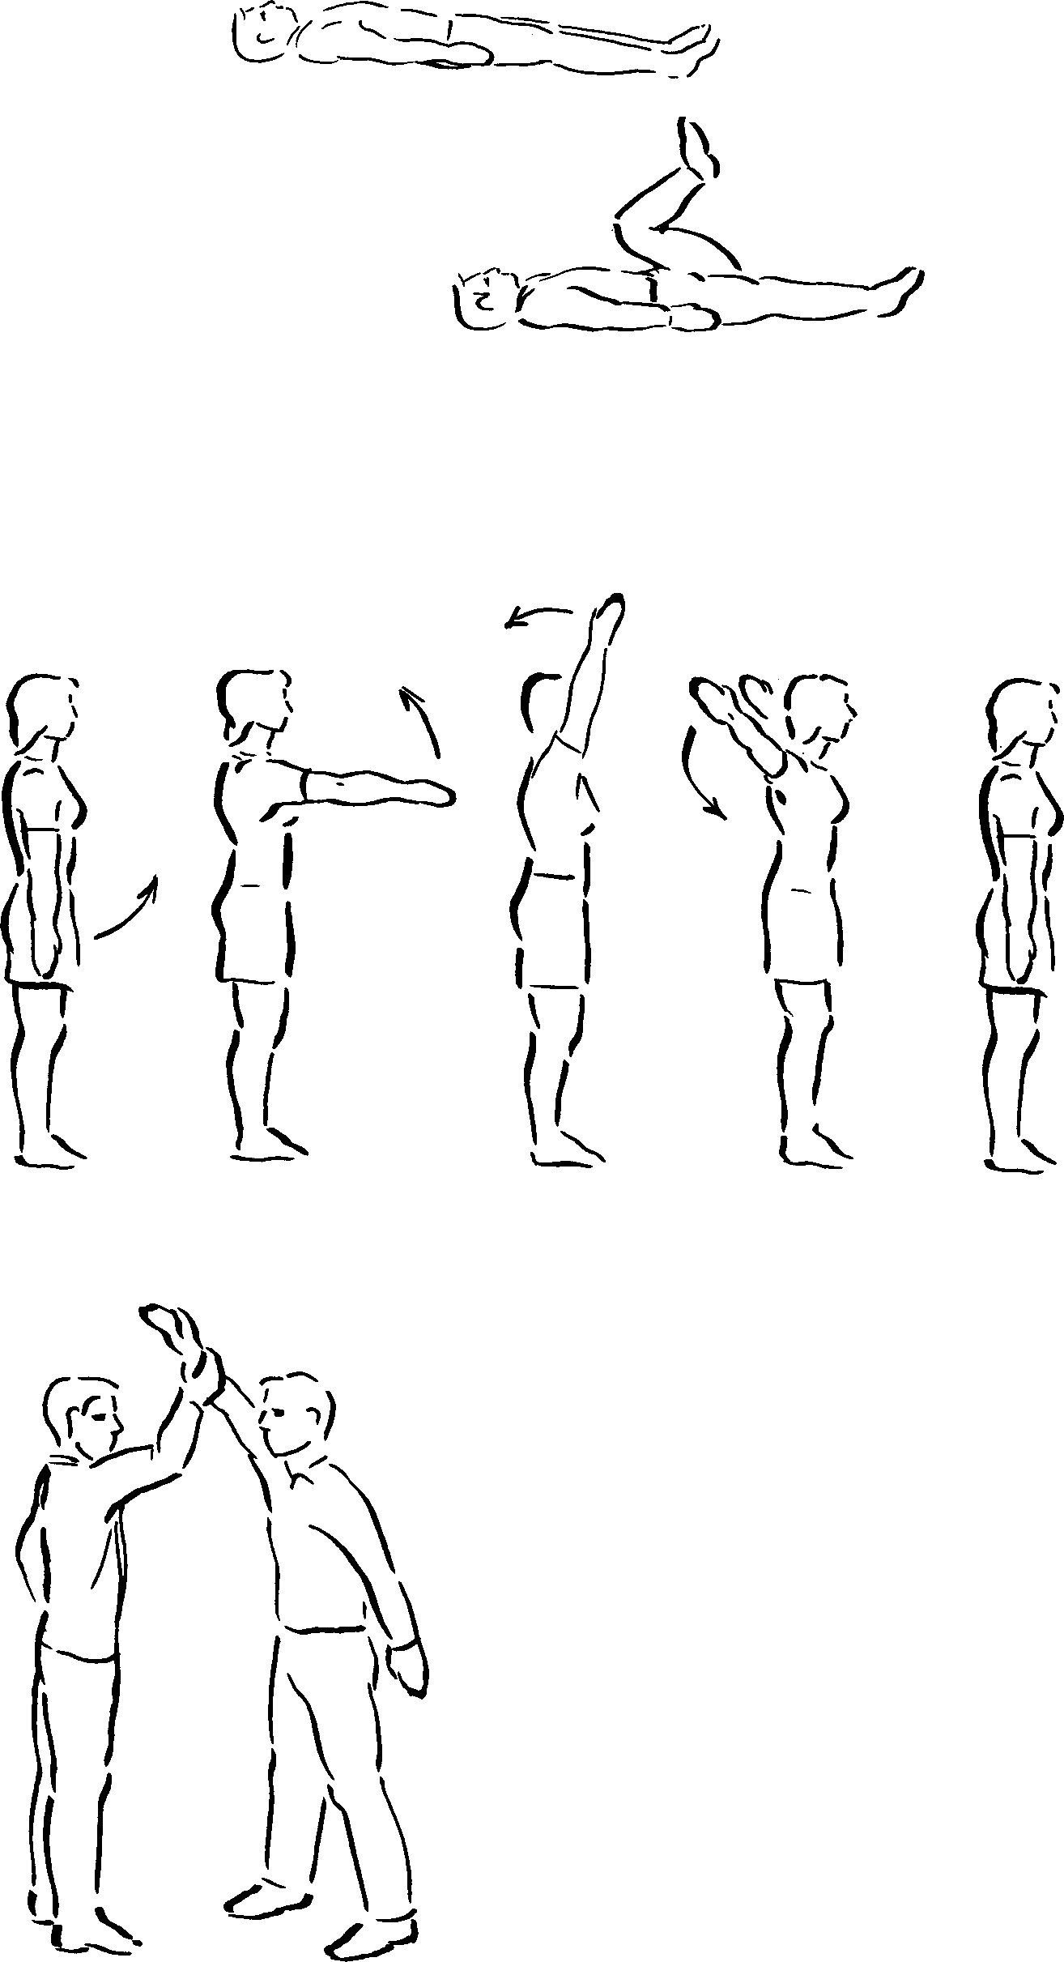Return to lie on back. Bring left knee up and swing to right to touch ground.

Return to start position and repeat (see Figure 51).

Bowlers should also do shuttles, bounding, hopping skipping etc. to strengthen legs.

*Figure 51*

##### Shoulder Exercise

Mobility and strength in the shoulders is essential for bowlers. Arm circles with one arm forwards and backwards followed by both arms together will maintain mobility (see Figure 52).

*Figure 52*

Standing in pairs, one in bowling position with arm straight at 45 to horizontal, attempts to bring his/her arm down against resistance from partner.

Use left and right arms (see Figure 53).

*Figure 53*

Within the curriculum, physical conditioning should only be included as *part* of any lesson, and while it is important that students are fit to play, the techniques, skills and tactics of the game must take the majority of time. However, it is important that students understand the theory underpinning fitness for cricket, and can apply the theory within examination and project work.

**History of Cricket**

The origins of cricket are not clearly documented. However, it is clear that from earliest times people played games which involved striking an object with a stick. Some of the more interesting or key dates are listed below. Further details may be obtained by reference to texts included in *Recommended Reading.*

##### Earliest Recordings

##### Date Event or Record

1300 Documented evidence that Prince Edward played a game called *Creag.*

1344 A document in the Bodleian Library illustrates a cricket-like game being played.

The Saxon word *“cricce”* or *“cric”* (a staff or crooked stick) *may* be the origin of the name.

1500 and 1598 Records at Guildford mention *“Creckett”* and refer to playing *“crecket and other plaies”*.

1611 Chichester Court – two men fined for playing cricket on Sunday.

1624 The first recorded fatality, when Jasper Vinall died after having been accidentally struck with a cricket bat.

17th century Some evidence that cricket may have been played in public schools.

##### The Start of the Modern Game

1744 The Laws of the game first written down and printed. 1787 The formation of the Marylebone Cricket Club (MCC). 1788 The MCC revised the laws.

1864 The modern over arm style of bowling was made legal.

The game was further developed following improvements to the grounds as a result of the use of the “heavy roller”. Additionally, between 1850-1855 mowing machines were first used.

The latter half of the 19th century was the era of W. G. Grace who, during his career, made 54,896 runs and took 2,864 wickets. He retired in 1908.

##### The History of County Cricket

##### Test Cricket

1736 Sailors recorded as playing cricket near Lisbon. 1844 First international between USA and Canada.

1859 First tour by England of USA and Canada. 1861-62 First tour of Australia.

1876-77 First test matches played. 1878 Australians travel to England.

1880 First test match played in England.

1882 England beaten by Australia at the Oval. *The Sporting Times* reported “The body will be cremated and the ashes taken to Australia”.

1882-83 England beat Australia in Melbourne. Some ladies burned a bail, sealed the ashes in an urn and gave it to the English Captain. On his death the ashes were left to the MCC, and this is the basis of the *Ashes* competition.

1909 Imperial Cricket Conference established to administer cricket worldwide.

1965 The name was changed to the International Cricket Conference.

1968 The Test and County Cricket Board was established to run test cricket, and the National Cricket Association to foster interest in coaching and the recreational game.

The MCC administer the Laws both at home and abroad.

All three of the above form the Cricket Council, the governing body of the sport. There are also the Minor Counties Association, the Irish Cricket Union, the Scottish Cricket Union and the Welsh Cricket Association.

|  |  |  |  |
| --- | --- | --- | --- |
| 1787  1853 | The first “county” club, Oxfordshire.  The first county champions, Nottinghamshire. | 1989 | The International Cricket Conference renamed the International Cricket Council. |
| NB: At this time the press decided who were the champions. 1992 South Africa re-admited to international cricket. | | | |
| 1890 | County Secretaries officially acknowledged the championships. | | |

**The Competitive Structure of the Sport.**

##### The First Class Game

The professional game in Great Britain is run in the form of a league. Eighteen counties play a mixture of sixteen 3-day and six 4-day matches regulated by the Test and County Cricket Board. This league is known as the *Britannic Assurance County Championship,* named after the present sponsors.

The number of counties remained constant since Glamorgan became a member in 1921 until 1991. Durham became the eighteenth member in 1992. Unlike football, there is no specific number of teams which should be in the league. The reason other counties, known as the Minor Counties, have not become members is the cost of setting up and running a team. A small county such as Worcestershire spent nearly £900,000 on running theirs in 1989. An additional expensive problem is the provision of a suitable ground together with the facilities required for spectators.

Because gates declined in the late fifties, limited-over cricket started in 1963 with the *Gillette Cup* competition of 65 overs per side. This was an instant financial success and was followed by the *John Player League,* 40-over matches which commenced on Sunday afternoons in 1969. This was a league competition, the teams playing each other once.

The next competition was *Benson and Hedges,* a 55-over game which was played initially as a regional league with the top two teams going forward into a knock out competition.

Over the years the sponsors have changed. The Gillette Cup is now a 60-over competition for the *Nat West Trophy;* the John Player competition became the *Refuge Assurance League* and is now awaiting a new sponsor.

The international scene has been affected in the same way, with three One-Day test matches played in addition to five or six, 5-day Test Matches played against touring teams. Texaco sponsor the One-Day matches and Cornhill Insurance the 5-day matches.

The Test Matches are staged at Birmingham, Leeds, London, Manchester and Nottingham. There is no national stadium such as Wembley for football. The nearest equivalent is Lord’s, owned by MCC and the home ground of Middlesex.

##### Recreational Cricket

Recreational or non-professional cricket is organised by the National Cricket Association.

It has a professional staff at Lord’s and several National Coaches based in the regions who are responsible for the development of play at all levels, together with the training of coaches. To assist individual clubs, there are part-time development officers who try to stimulate interest in coaching, youth development and NCA projects.

Clubs who join NCA can take part in competitions indoors and outdoors. Individual members may be nominated to play for other county associations in the *NCA County Championship* sponsored by Notts Sport Limited. Outstanding players are invited to play in the NCA England Amateur Eleven.

Many clubs run youth teams which enter competitions for various age groups, such as the U13 eight-a-side competition for the *Nat West Bank Ken Barrington Cup.* An U15 competition is for the *Sun Life of Canada Club Cricket Championship.* Texaco sponsor the U16 County Championship which is contested by the best players selected for individual county association. Schools cricket is organised by the English Schools Cricket Association and there is a good liaison between them and the NCA.

League cricket is organised by each individual league which has its own rules for membership, playing regulations, discipline etc.

The Minor Counties Cricket Association was formed in 1895 to look after and promote their interests. A minor county is one that does not play in the First Class Championship. Usually they play 2-day 2- innings matches as well as taking part in the *Nat West Knock-out Competition.*

The Women’s Cricket Association is organised on either a county or a regional area basis, depending on the strength of the game in the specific area.

## UNIT 8

**Useful Information**

##### Recommended reading

The Handbook of Cricket, K. V. Andrew ISBN 0 7207 1789 I The Skills of Cricket, K. V. Andrew ISBN 1 85223 237 4

Cricket – The Techniques of the Game, Andrew, Carter, Lenham

ISBN 0 7158 0574 6 or ISBN 0 7158 0642 4

A History of Cricket, B. Green ISBN 0 7126 2080 X The MCC Cricket Coaching Book (Fourth Edition)

Wisden Cricketers’ Almanack (Printed Annually)

Test Cricket in Clubs and Schools (Available from NCA) How to Coach Cricket, R. Dellor

ISBN 0 00 218 319 6 or ISBN 0 00 218 369 2

Games for Cricket Training, A. Oakman ISBN 0 7207 1233 8 The Laws of Cricket (1980 Code) Second Edition 1992.

(Available from MCC, price £1.50)

##### Useful addresses

E.C.B

Lord’s Cricket Ground London

NW8 8QZ

Telephone 0207 432 1200

Coach Education Office

c/o Warwickshire County Cricket Ground

Edgbaston Birmingham B5 7QX

Telephone 0121 440 1748