Job Market Analytics Pipeline Report
Assignment #3 - Tools & Techniques for Data Science
University of Central Punjab

Group Members
M. Taha Naeem L1F23BSDS0028
Abdur Rehman L1F23BSDS0043
Adil Hayat Khan L1F23BSDS0044

Faculty of IT & CS - Department of Applied Computing & Technologies

1. Introduction and Problem Statement
This report documents the development and implementation of an automated job market analytics pipeline designed to collect, clean, and analyze AI, ML, and Data-related job postings from multiple online sources. The project addresses the challenge of monitoring job markets manually, which is slow and inconsistent due to different data formats across websites.
As a junior data engineer in a recruitment analytics company, I built an end-to-end pipeline that extracts job data from free public APIs, standardizes the schema, cleans the data using KNIME, orchestrates the workflow with Apache Airflow, and sends automated notifications through n8n.

2. Source Selection and API Links

2.1 Data Sources Used
Source | Purpose | API Endpoint | Notes
Arbeitnow | General jobs with Europe focus | https://www.arbeitnow.com/api/job-board-api | Free, no API key
RemoteOK | Remote job listings with salary | https://remoteok.com/api | Public JSON feed
Himalayas | Remote jobs with filters | https://himalayas.app/jobs/api/search?q=data | Free public JSON API
RemoteJobs.org | Remote jobs by category | https://remotejobs.org/api/v1/jobs | Free, no signup

2.2 Schema Mapping
The four sources return different raw schemas. I mapped all sources to a standardized schema with fields: source, job_id, title, company_name, location_raw, remote_status, job_type, category_raw, tags_raw, description, publication_date, job_url, salary_text_raw, salary_min_raw, salary_max_raw, currency_raw, salary_min_usd, salary_max_usd, salary_mid_usd, experience_years_min, experience_years_max, experience_bracket, extracted_skills, job_category_clean, scrape_date.

3. Pipeline Architecture
The end-to-end pipeline follows this architecture:
1. Extraction: Four Python scripts collect raw data from each API
2. Merging: A merge script standardizes schemas and combines all sources
3. Cleaning: KNIME workflow cleans, filters, and transforms the data
4. Validation: Python script performs data quality checks
5. Metrics: Calculate analysis metrics and generate summary
6. Notification: n8n workflow sends email/webhook notification
7. Orchestration: Apache Airflow DAG orchestrates all tasks
Pipeline Architecture:
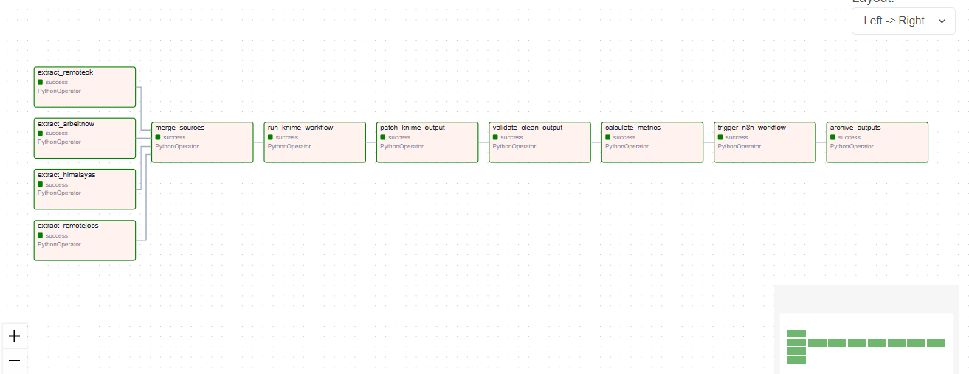

4. Extraction Process
Four separate Python scripts were created to extract data from each source:
- extract_arbeitnow.py: Fetches jobs from Arbeitnow API
- extract_remoteok.py: Fetches jobs from RemoteOK API
- extract_himalayas.py: Fetches jobs from Himalayas API
- extract_remotejobs.py: Fetches jobs from RemoteJobs.org API

4.1 Raw Data Statistics
Source | Jobs Collected | Percentage
Himalayas | 118 | 29.4%
Arbeitnow | 100 | 24.9%
RemoteOK | 99 | 24.6%
RemoteJobs.org | 85 | 21.1%
Total raw jobs collected: 402

5. KNIME Cleaning and Transformation
KNIME workflow performs the following cleaning operations:
- Remove HTML tags and special characters from descriptions
- Standardize title, company name, and location columns
- Deduplicate jobs using job_url
- Apply AI/ML/Data relevance filter
- Extract and standardize skills from title, tags, and description
- Create job_category_clean column
- Standardize remote_status (Remote, On-site, Hybrid, Unknown)
- Extract experience years and create experience_bracket
- Extract salary, normalize pay period, and convert currencies to USD
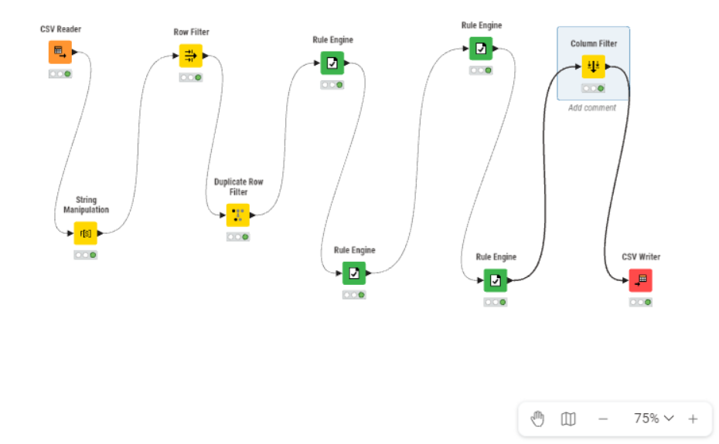

6. AI/ML/Data Filtering
Filtering logic checks job titles and descriptions for relevant keywords:
- Data Analytics: data analyst, reporting analyst, product analyst
- Data Science: data scientist, ML, NLP, predictive modeling
- Data Engineering: data engineer, ETL, pipeline, warehouse
- AI/ML: machine learning, AI engineer, deep learning, LLM
- Business Intelligence: BI analyst, Power BI, Tableau
- Analytics Engineering: analytics engineer, dbt, metrics

6.1 Filtering Results
Jobs before filtering: 402
Jobs after filtering: 223
Filter drop rate: 44.53%

7. Salary Extraction and USD Conversion
Salary data was extracted from structured salary fields and description text.
Currency conversion rates used (as of 2026-05-18):
- USD: 1.00
- EUR: 1.08
- GBP: 1.25
- PKR: 0.0036
Hourly and monthly salaries were converted to annual using:
- Hourly: 40 hours/week x 52 weeks = 2,080 hours/year
- Monthly: x 12 months/year

8. Experience Year Bracket Extraction
Experience requirements were extracted from job titles and descriptions:
- 0-1 years: Entry level, fresh graduate, internship, trainee
- 1-3 years: Junior/mid, 1+ years, 2 years
- 3-5 years: Mid-level, 3+ years, 4 years
- 5-8 years: Senior, 5+ years, 6-8 years
- 8+ years: Principal, staff, lead, director
- Not mentioned: No clear experience requirement

9. Airflow DAG Explanation
The Airflow DAG orchestrates the complete pipeline with the following tasks:
1. extract_arbeitnow: Collect raw data from Arbeitnow (parallel)
2. extract_remoteok: Collect raw data from RemoteOK (parallel)
3. extract_himalayas: Collect raw data from Himalayas (parallel)
4. extract_remotejobs: Collect raw data from RemoteJobs.org (parallel)
5. merge_sources: Standardize schemas and merge all datasets
6. run_knime_workflow: Execute KNIME cleaning workflow
7. validate_clean_output: Check row counts, columns, duplicates
8. calculate_metrics: Generate analysis metrics
9. trigger_n8n_workflow: Send notification to n8n webhook
10. archive_outputs: Save timestamped copies of output files


10. n8n Workflow Explanation
n8n workflow is triggered via HTTP webhook after metrics are calculated.
The workflow includes:
- HTTP Request node to receive pipeline status
- Email notification with job summary
- Summary includes: total jobs, jobs by source, remote ratio, 0-1 year jobs, average salary, pipeline status
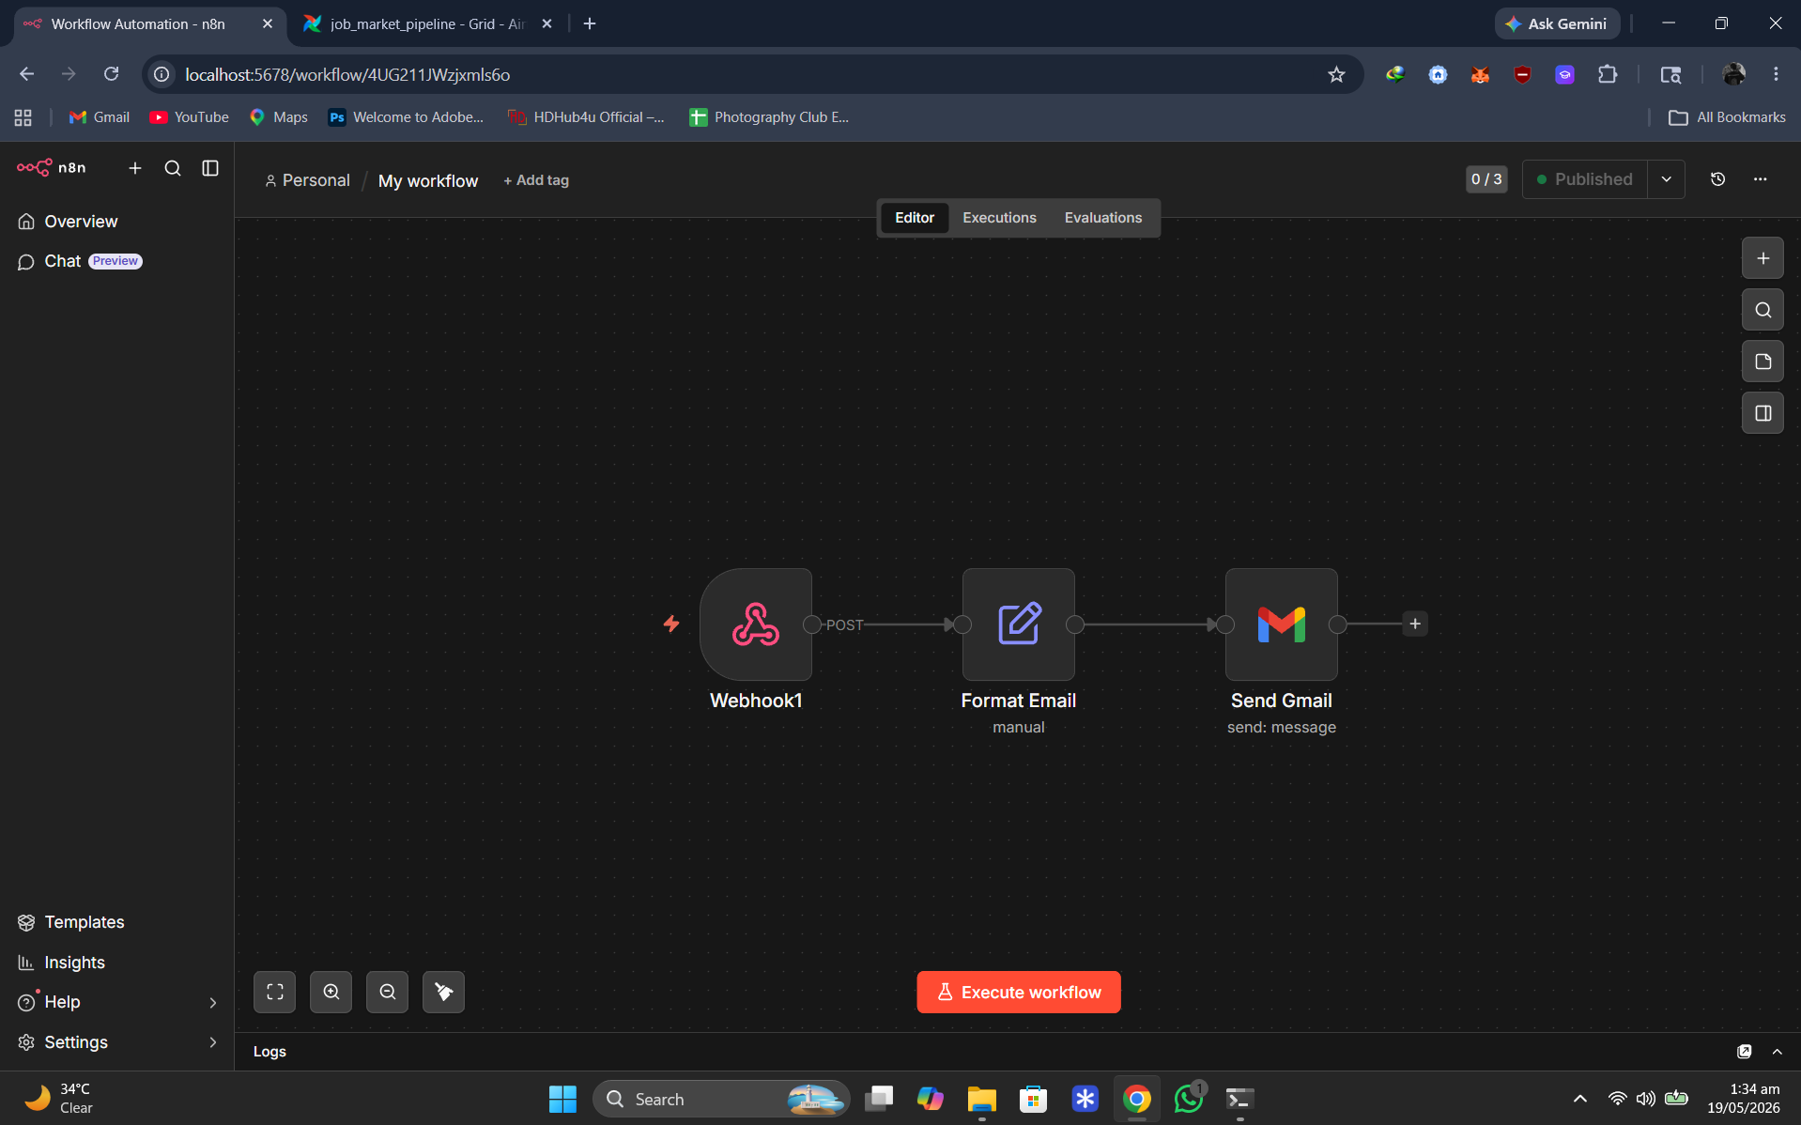

11. Data Quality Checks

11.1 Quality Check Results
Check | Result | Status
API Response | All 4 sources returned successful responses | Pass
Source Count | 402 total raw jobs from 4 sources | Pass
Schema | All 24 mandatory columns present | Pass
Duplicates | Duplicates removed during cleaning | Pass
Relevance Filter | 402 -> 223 after filtering | Pass
Missing Values | 0% missing title/company | Pass
Date Check | All publication dates valid | Pass
Salary Check | Zeros converted to null | Pass

12. Analysis Answers and Visualizations

12.1 Jobs by Source
Source | Before Filter | After Filter | Filter Rate
Himalayas | 118 | 117 | 0.8%
RemoteJobs.org | 85 | 50 | 41.2%
Arbeitnow | 100 | 28 | 72.0%
RemoteOK | 99 | 28 | 71.7%

12.2 Remote/On-site Distribution
Remote: 201 jobs (90.13%)
On-site: 22 jobs (9.87%)
Hybrid: 0 jobs (0%)
Unknown: 0 jobs (0%)

12.3 Experience Bracket Distribution
Bracket | Count | Percentage
Not mentioned | 74 | 33.2%
8+ years | 61 | 27.4%
5-8 years | 44 | 19.7%
0-1 years (Entry) | 32 | 14.3%
3-5 years | 8 | 3.6%
1-3 years | 4 | 1.8%

12.4 Salary Analysis
Overall Average Salary: $150,672.70 USD
Median Salary: $136,070.00 USD
Salary Data Coverage: 32.7% (73 out of 223 jobs)

12.5 Average Salary by Category
Category | Avg Salary (USD)
AI/ML | $179,251.81
Data Engineering | $173,001.54
Data Analytics | $141,878.59
Other Data | $112,201.50
Business Intelligence | $78,050.00

12.6 Top Skills
Skill | Count
Scala | 39
Machine Learning | 38
Python | 23
SQL | 23
NLP | 16
Excel | 11
dbt | 10
Azure | 8
GCP | 8
AWS | 7

12.7 Top Companies by Job Count
Company | Job Count
Mindrift | 7
Mercor | 5
NTT DATA | 4
acemate.ai | 3
Auralis Group | 3
RWS Group | 3
CI&T | 3
Newfold Digital | 2
Globaldev Group | 2
Highmark Health | 2

12.8 Jobs by Category
Category | Job Count
Data Analytics | 75
Other Data | 66
Data Engineering | 49
AI/ML | 31
Business Intelligence | 2

12.9 Salary Coverage by Source
Source | Coverage % | Jobs with Salary
Himalayas | 43.6% | 51
RemoteJobs.org | 36.0% | 18
RemoteOK | 14.3% | 4
Arbeitnow | 0.0% | 0

13. Challenges and Solutions
1. Schema Inconsistency: Different APIs used different field names - Solved by creating a standardized schema mapping.
2. Salary Format Diversity: Salaries came in various formats - Solved by implementing conversion logic.
3. Experience Extraction: No structured experience fields - Solved by keyword matching in titles and descriptions.
4. Remote-only Sources: RemoteOK and Himalayas only list remote jobs - Documented this limitation in analysis.

14. Conclusion
This project successfully demonstrates the implementation of a complete data pipeline for job market analytics. The pipeline collects data from four free job APIs, standardizes the schema, cleans and filters for AI/ML/Data jobs using KNIME, orchestrates the workflow with Apache Airflow, and sends automated notifications through n8n.
Key Results: 223 AI/ML/Data jobs collected, 90.1% remote positions, 32 entry-level (0-1 year) positions available, average salary of $150,672 USD, and Data Analytics as the top job category.
The pipeline is fully automated and can be scheduled to run periodically to keep track of the evolving job market.

15. Appendix - Screenshots
Airflow DAG:

KNIME Workflow:

n8n Workflow:


Cleaned Data Output:
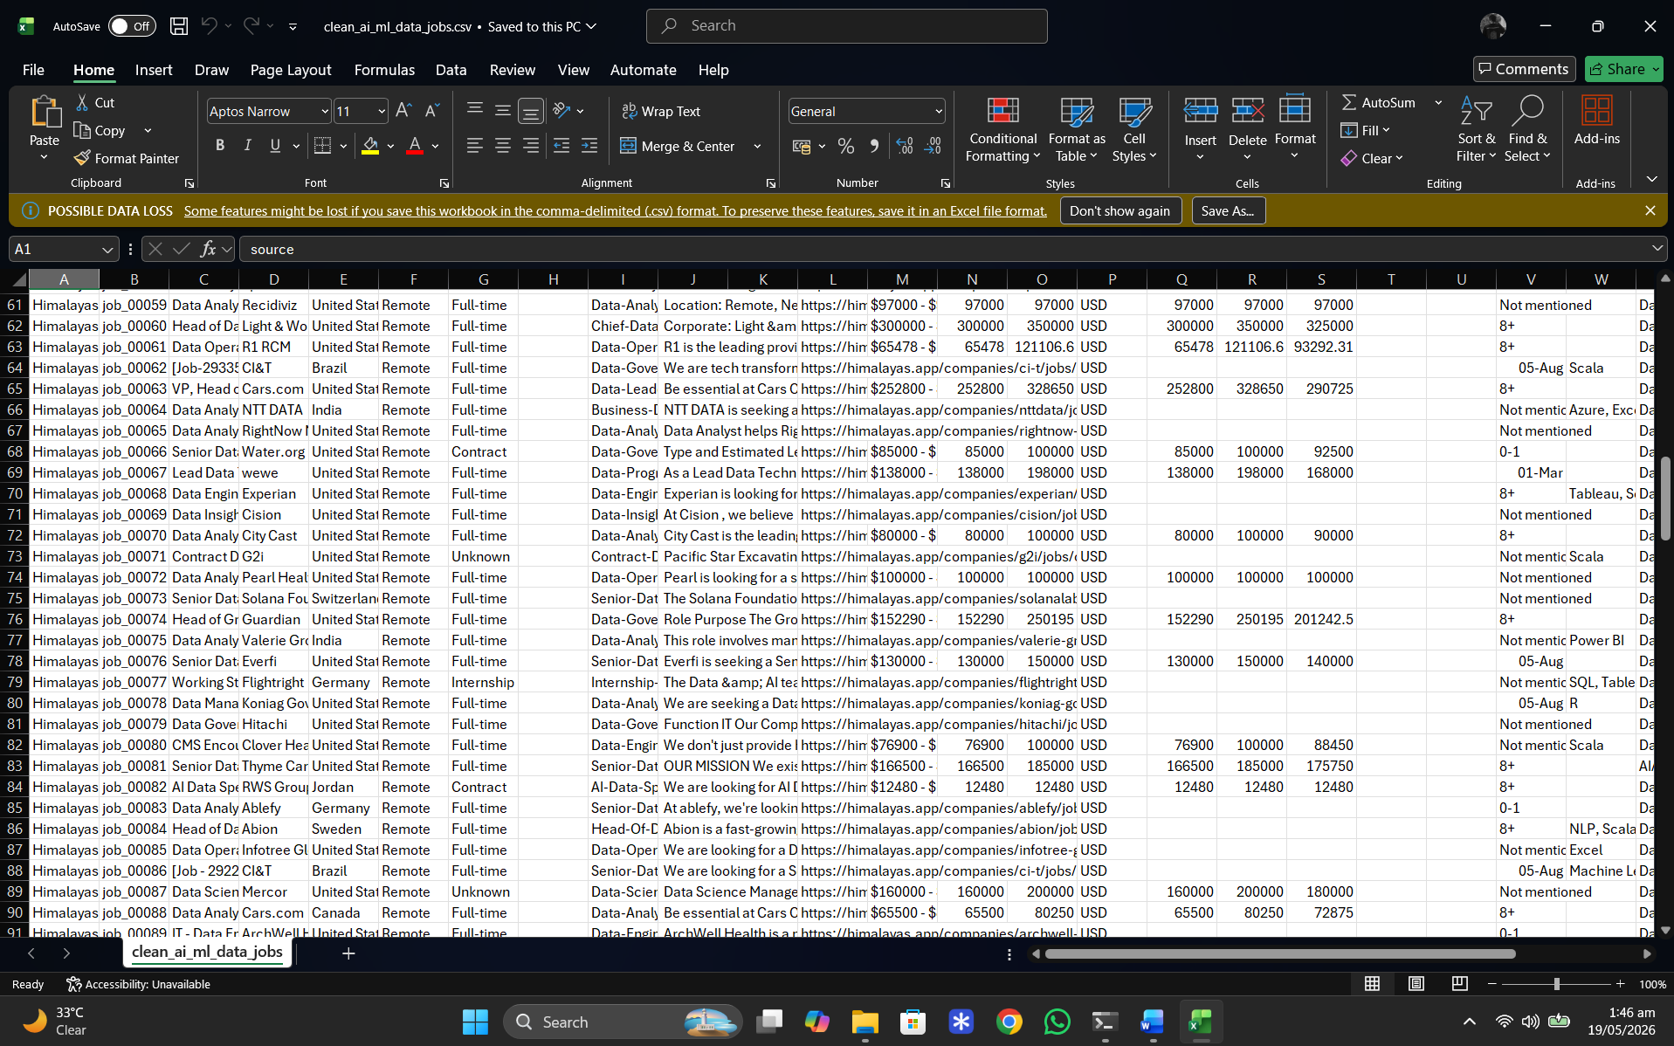
Email:
