Proof1:
Added a New user and it reflects in DB by using Admin mode:
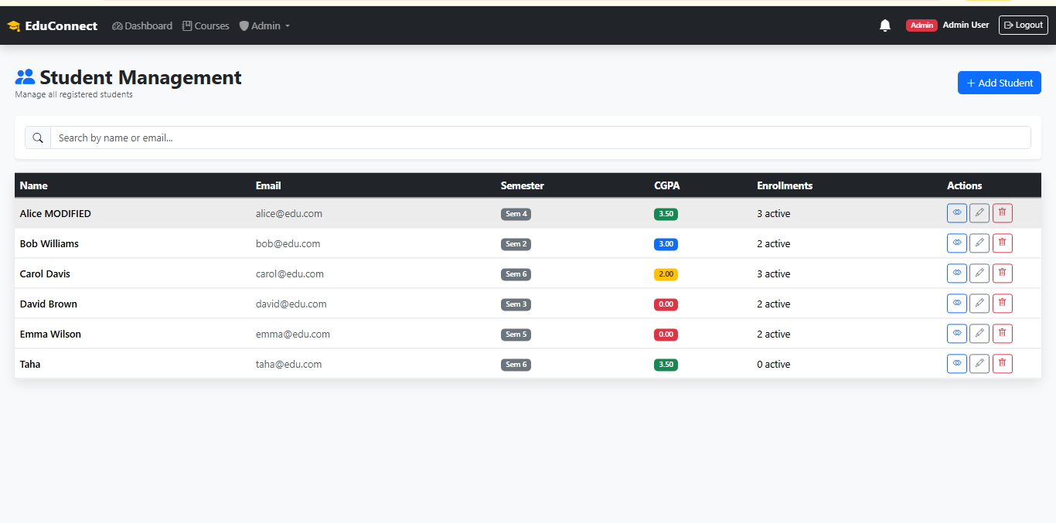
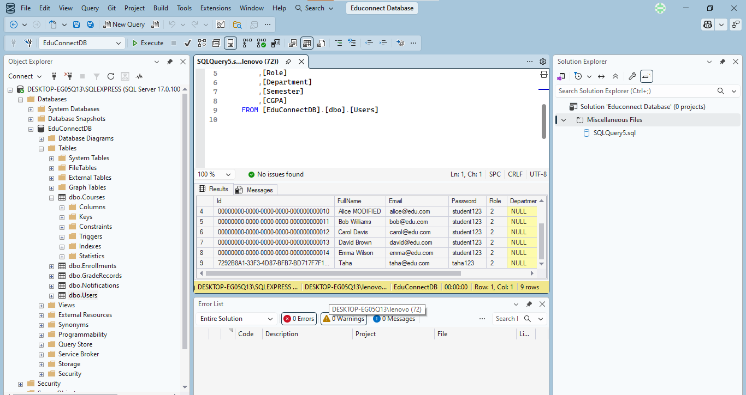

Proof2: From Database changed named of Alice MODIFIED to Alice Hadi:

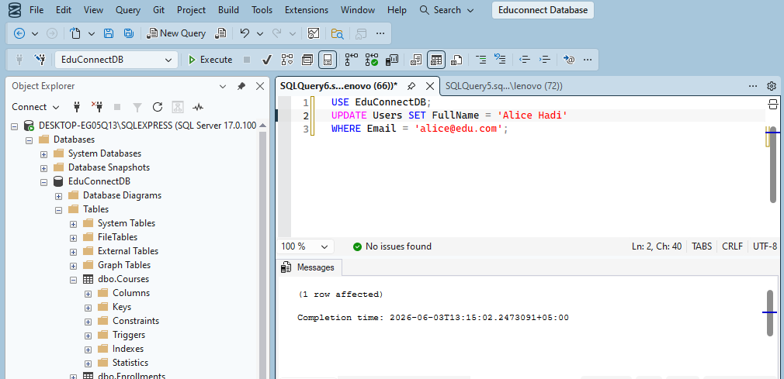

Shows in UI:

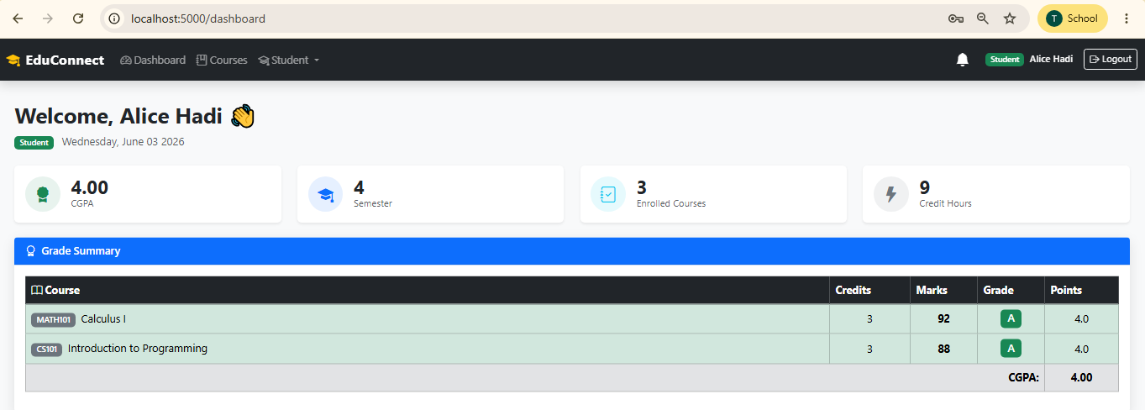

Proof3: Added a course HRM in Database which reflects in UI:
