

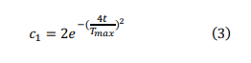



Step1:

Initialize of salps randomly xi=a=1,2,.....,u)

considering ub and lb

Step 2: while (end condition is not met)

obtain the fitness of all salp

set F as leader salp

update ci by Eq 3

For each salps (xi) in the population do

{

If i==1 then

Update the position of leader by Eq.2

else

Update the position of leader by Eq.4

update the population of salps based on

upper and lower bounds of variables.

Update F

}

Step 3: Return F