

Nov 11, 2022

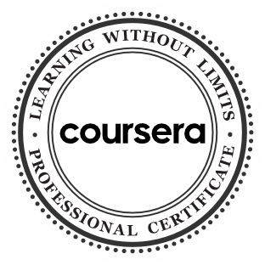

Introduction to DevOps Introduction to Cloud Computing

Introduction to Agile Development and Scrum

Hands-on Introduction to Linux Commands and Shell Scripting

Getting Started with Git and GitHub

Python for Data Science, AI & Development

Developing AI Applications with Python and Flask

Introduction to Containers w/ Docker, Kubernetes & OpenShift

Application Development using Microservices and Serverless

Introduction to Test and Behavior Driven Development

Continuous Integration and Continuous Delivery (CI/CD)

Application Security for Developers and DevOps Professionals

DevOps Capstone Project

13 Courses

Taha Zalzaly

has successfully completed the online, non-credit Professional Certificate

IBM DevOps and Software Engineering

In this Professional Certificate, learners developed essential knowledge and skills to perform the many tasks in an entry-level DevOps practitioner role. By completing over a dozen courses and projects in the program, the earner of this Professional Certificate has demonstrated a firm grasp and practical experience to: adopt a DevOps mindset in Software Engineering using Agile and Scrum methodologies and Cloud Native tools and technologies. The holder can develop applications in Python, automate tasks using Shell scripts, use collaborative coding platforms like GitHub, compose applications using Microservices, deploy them using Containers (Docker/Kubernetes/OpenShift) & Serverless technologies; and employ tools for Automation, Continuous Integration (CI) and Continuous Development (CD).

The online specialization named in this certificate may draw on material from courses taught on-campus, but the included courses are not equivalent to on-campus courses. Participation in this online specialization does not constitute enrollment at this university. This certificate does not confer a University grade, course credit or degree, and it does not verify the identity of the learner.

Rav Ahuja Global Program Director,

Skills Network

Verify this certificate at: [https://coursera.org/verify/profession al-cert/Y6HNVLMSUEF6](https://coursera.org/verify/professional-cert/Y6HNVLMSUEF6)