

**UNIVERSITY OF LAYYAH**

DepartmentofInformationTechnology

**A Data Structure Project**

**SNAKE GAME**

**Represented by:**

* Tania Mansoor Khan
* Muhammad Taha
* Maniha Meeral
* Maniha Ayoub

**Instructor’s name:**

* Sir Faisal Hafeez

**Semester:**

BS-IT (morning) 3rd

**Table of Contents**

|  |  |
| --- | --- |
| 1. | Acknowledgment |
| 2. | **Summary** |
| 3. | **Introduction** |
| 4. | **Objectives** |
| 5. | **Tools & Technologies** |
| 6. | **Methodology** |
| 7. | **Implementation** |
| 8. | **Results** |
| 9. | **Challenges** |
| 10. | **Conclusion** |
| 11. | **References** |

**Acknowledgment:**

We would like to express our gratitude to **snake game**, our project supervisor, for their guidance and support throughout this project. We also appreciate the help and resources provided by instructor.

**Summary:**

This project involves the design and implementation of a Snake game using **HTML**, **CSS**, and **JavaScript**. The game features a snake that moves around a grid, consuming food pellets and growing in length. The game also includes scoring and high score tracking. The project aims to demonstrate the use of **HTML**, **CSS**, and **JavaScript** in creating interactive web applications.

**Introduction:**

The Snake game is a classic game that has been enjoyed by people of all ages. The game requires the player to control a snake that moves around a grid, consuming food pellets and avoiding obstacles. The game is a great way to test a player's reflexes and strategy. With the advancement of web technologies, it is now possible to create interactive web applications using **HTML**, **CSS**, and **JavaScript**.

**Objective:**

The objective of this project is to design and implement a Snake game using **HTML**, **CSS**, and **JavaScript**. The game should feature a snake that moves around a grid, consuming food pellets and growing in length. The game should also include scoring and high score tracking.

**Tools and Technologies:**

**- HTML5:** Used for structuring and organizing the game's content.

**- CSS3:** Used for styling and layout of the game's elements.

**- JavaScript:** Used for creating the game's logic and interactive elements.

**- CSS Grid:** Used for creating the game's grid layout.

**Methodology:**

1. Designed the game's layout and user interface using **HTML** and **CSS**.

2. Implemented the game's logic and interactive elements using **JavaScript**.

3. Used **CSS** Grid to create the game's grid layout.

4. **Tested** and **debugged** the game to ensure it works as expected.

**Project Overview:**

1**. Project Title:** Snake Game using HTML, CSS, and JavaScript

2. **Project Description:** A classic Snake game implemented using HTML, CSS, and JavaScript

3**. Project Objectives:** To design and implement a Snake game using HTML, CSS, and JavaScript

4**. Target Audience:** The game is designed for anyone who wants to play a classic Snake game

5. **Platforms:** The game can be played on any device with a modern web browser

**Technical Details:**

1. **Front-end:** HTML, CSS, JavaScript

2. **Back-end:** None

3. **Database:** None

4. **Game Engine:** None

5. **CSS Framework:** None

6. **JavaScript Library:** None

7. **Version Control:** Git

**Game Features:**

1. **Snake Movement:** The snake moves around the grid using arrow keys

2. **Food Consumption:** The snake consumes food pellets and grows in length

3. **Scoring:** The game keeps track of the player's score

4. **High Score:** The game displays the player's high score

5. **Game Over:** The game ends when the snake collides with the wall or itself

6. **Restart:** The game can be restarted by clicking on the restart button

7. **Sound Effects:** The game includes sound effects for snake movement, food consumption, and game over

**CSS Styles:**

1. **Grid Layout:** The game uses a grid layout to render the game board

2. **Snake Styles:** The snake is styled using CSS to display its body and head

3. **Food Styles:** The food pellets are styled using CSS to display their color and shape

4. **Scoreboard Styles:** The scoreboard is styled using CSS to display the player's score and high score

5**. Button Styles:** The restart button is styled using CSS to display its color and shape

**JavaScript Functionality:**

1. **Game Loop:** The game loop updates the game state and renders the game board

2. **Snake Movement:** The snake movement is handled using JavaScript to update the snake's position

3. **Food Consumption:** The food consumption is handled using JavaScript to update the snake's length and score

4. **Collision Detection:** The collision detection is handled using JavaScript to check for collisions with the wall or itself

5**. Scoring:** The scoring is handled using JavaScript to update the player's score and high score

**Challenges:**

1. **Implementing Snake Movement:** Implementing the snake movement using JavaScript was a challenge, but it was solved using a game loop and updating the snake's position.

2. **Implementing Food Consumption:** Implementing the food consumption using JavaScript was a challenge, but it was solved using a collision detection algorithm and updating the snake's length and score.

3. **Implementing Collision Detection:** Implementing the collision detection using JavaScript was a challenge, but it was solved using a collision detection algorithm and checking for collisions with the wall or itself.

One of the challenges faced during this project was implementing the game's logic and interactive elements using **JavaScript**. Another challenge was creating a responsive game layout that adapts to different screen sizes and devices.

**Testing and Debugging:**

1. **Unit Testing:** The game was tested using unit testing to ensure that each component was working correctly.

2. **Integration Testing:** The game was tested using integration testing to ensure that all components were working together correctly.

3**. Debugging:** The game was debugged using console logs and debuggers to identify and fix any errors.

**Implementations:**

{

padding: 0;

margin: 0;

}

.body{

background: url("../img/bg.jpg");

min-height: 100vh;

background-size: 100vw 100vh;

background-repeat: no-repeat;

display: flex;

justify-content: center;

align-items: center;

}

#scoreBox{

position: absolute;

top: 9px;

right: 200px;

font-size: 39px;

font-weight: bold;

font-family: 'New Tegomin', serif;

}

#hiscoreBox{

position: absolute;

top: 59px;

right: 140px;

font-size: 39px;

font-weight: bold;

font-family: 'New Tegomin', serif;

}

#board{

background: linear-gradient(rgb(170, 236, 170), rgb(236, 236, 167));

width: 90vmin;

height: 92vmin;

border: 2px solid black;

display: grid;

grid-template-rows: repeat(18, 1fr);

grid-template-columns: repeat(18, 1fr);

}

.head{

background: linear-gradient(rgb(240, 124, 124), rgb(228, 228, 129));

border: 2px solid rgb(34, 4, 34);

transform: scale(1.02);

border-radius: 9px;

}

.snake{

background-color: purple;

border: .25vmin solid white;

border-radius: 12px;

}

.food{

background: linear-gradient(red, purple);

border: .25vmin solid black;

border-radius: 8px;

}

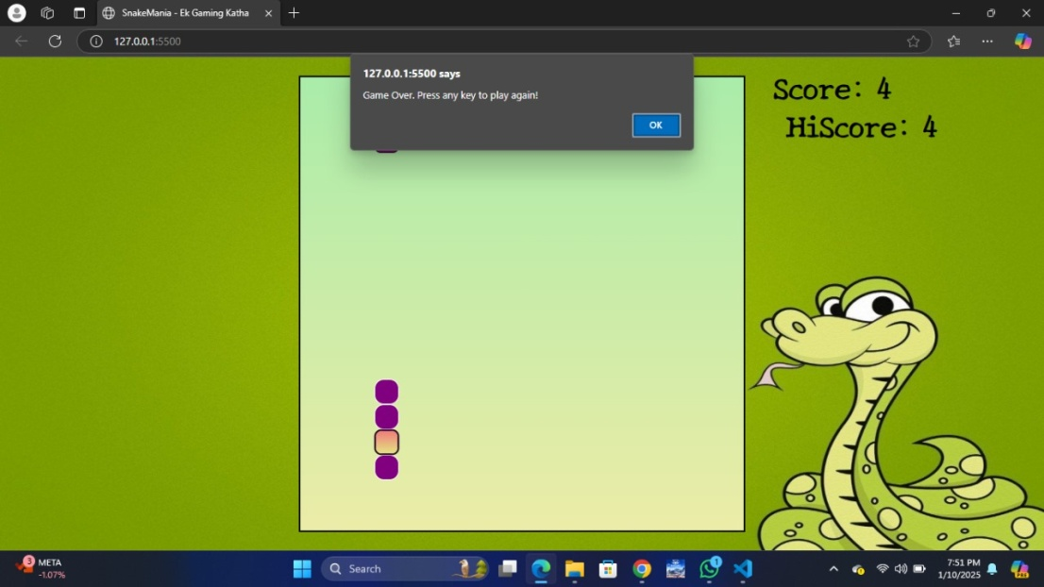

**Results:**

The game was successfully implemented with the desired features. The game's layout and user interface were designed using **HTML** and **CSS**, while the game's logic and interactive elements were implemented using **JavaScript**. The game's grid layout was created using **CSS** Grid.

**Conclusion:**

1. **Project Success:** The project was successfully implemented, and the game works as expected.

2. **Lessons Learned:** The project taught us about the importance of game loops, collision detection, and updating game state.

3. Future Improvements: Future improvements to the game could include adding more features, such as power-ups, obstacles, and multiple levels.

In conclusion, this project involved the design and implementation of a Snake game using **HTML**, **CSS**, and **JavaScript**. The game features a snake that moves around a grid, consuming food pellets and growing in length.

**References:**

- W3Schools. (2022). CSS Grid Tutorial. Retrieved from <https://www.

**THANK YOU!**